

Henrietta Mitchell

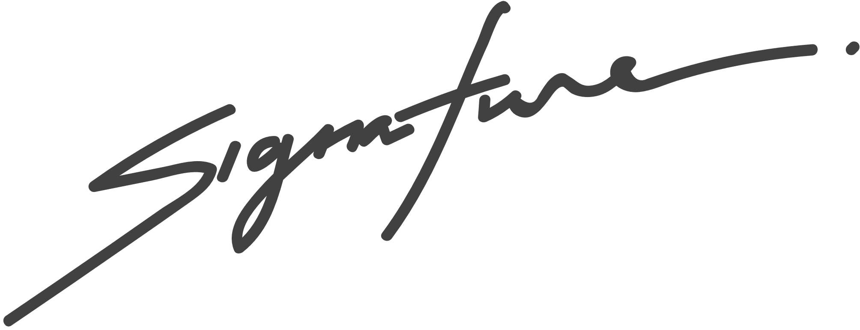

is a female rabbit born on August 8th, 2021

to parents, David and Anna.



BIRTH CERTIFICATE

RABBIT NAME

This certifies that

Pet shop manager

