

John Smith

PET SHOP MANAGER

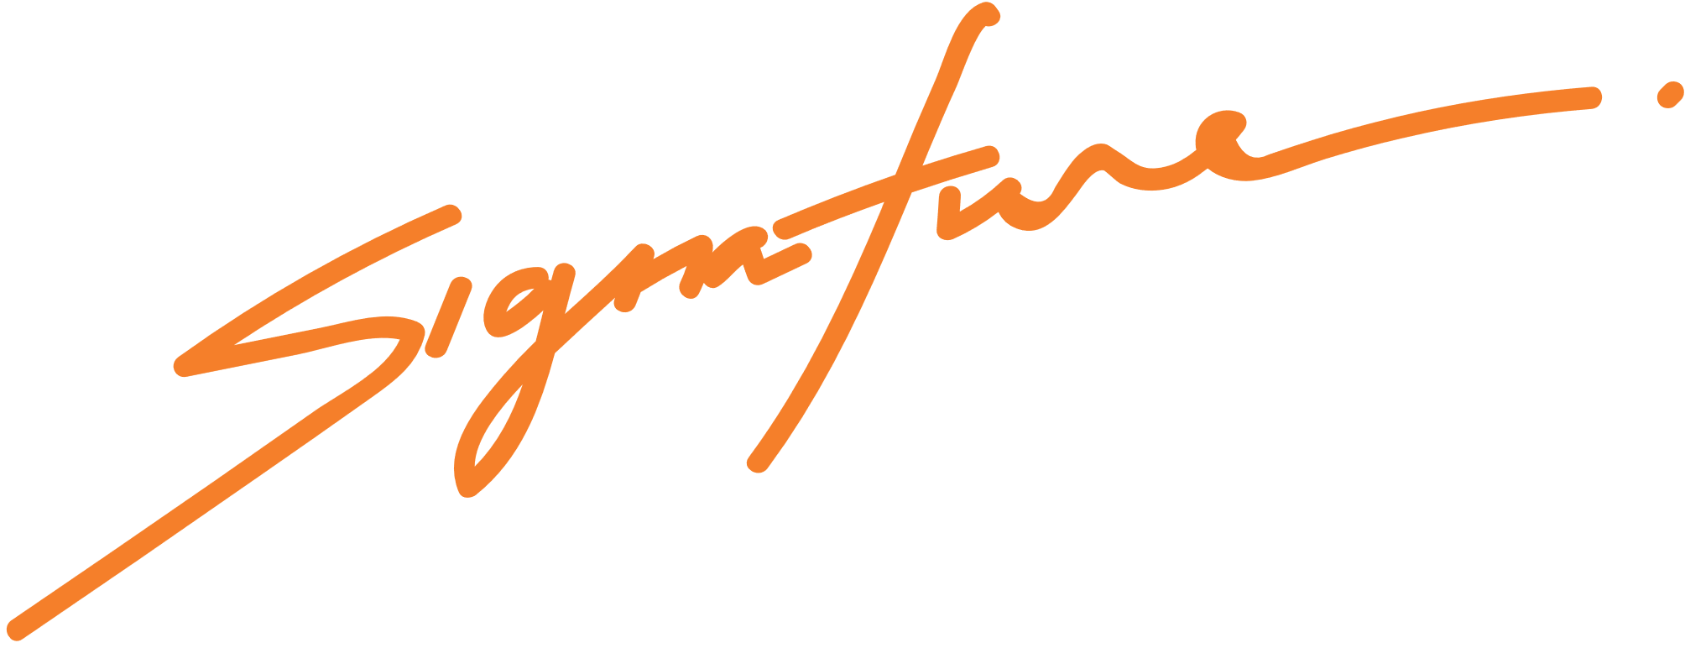

This certifies that

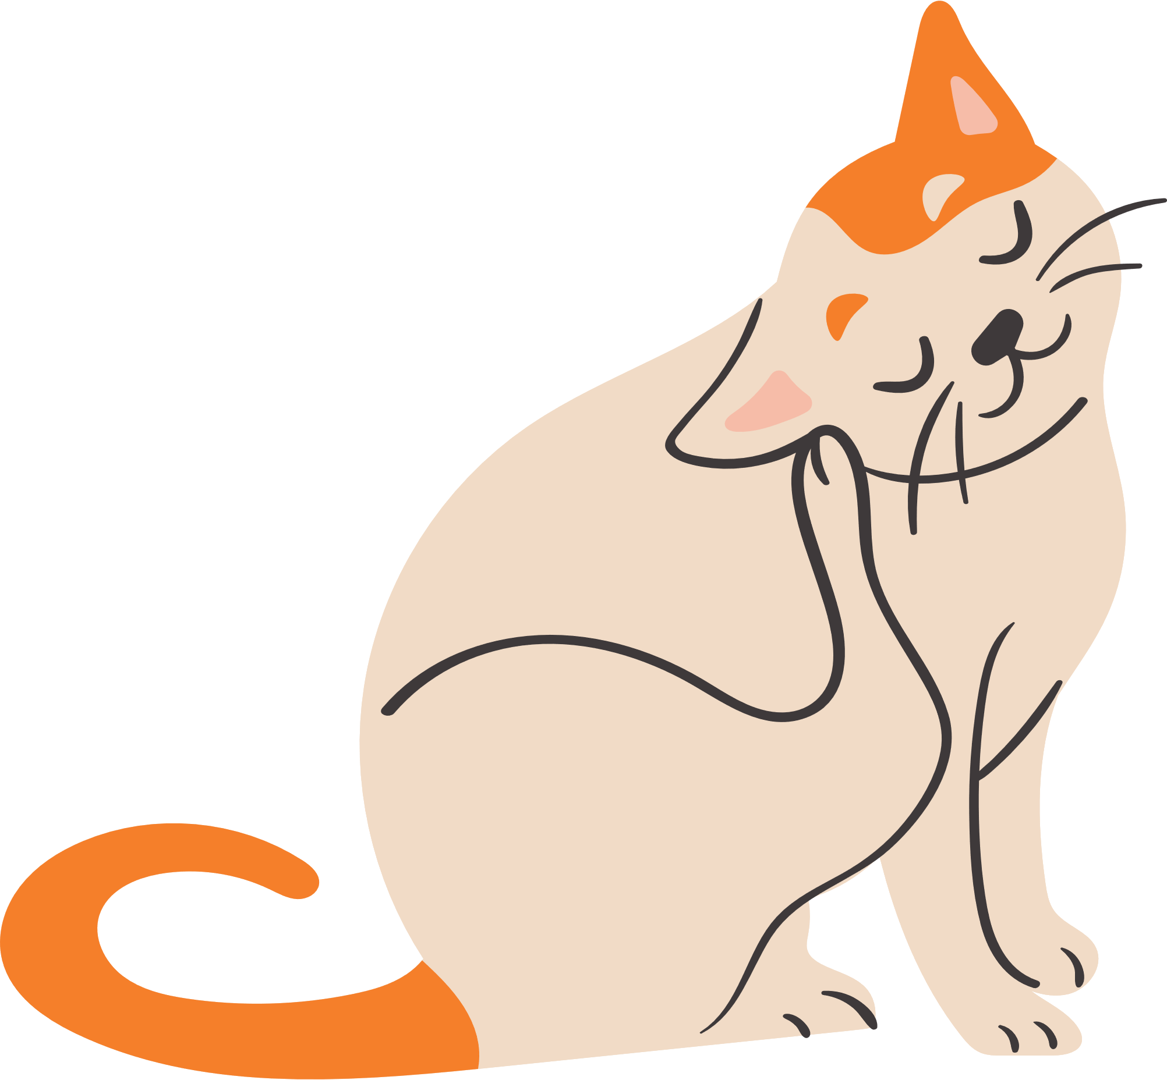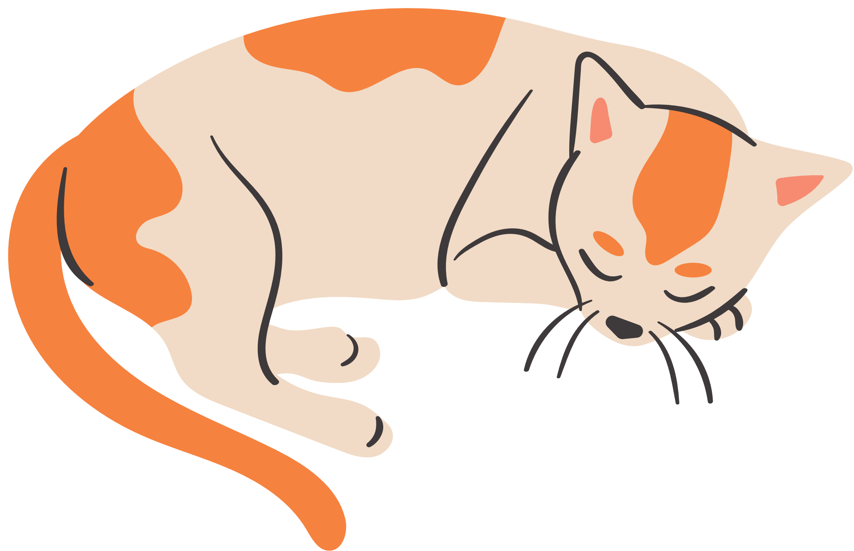

kitten name

Birth Certificate

is a female kitten born on August 8th, 2021

to parents, David and Anna.