

is a baby fish born on August 8th, 2021

to parents, David and Anna.

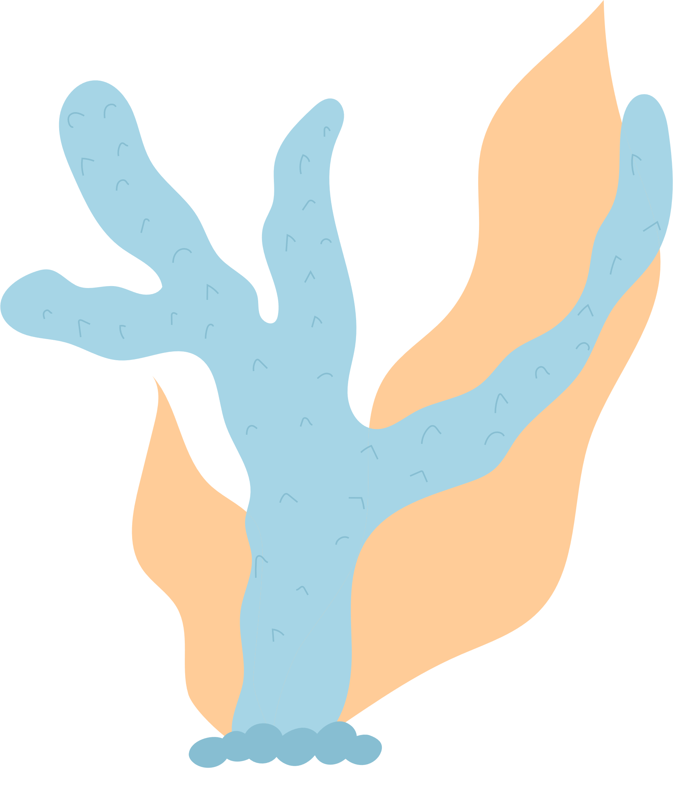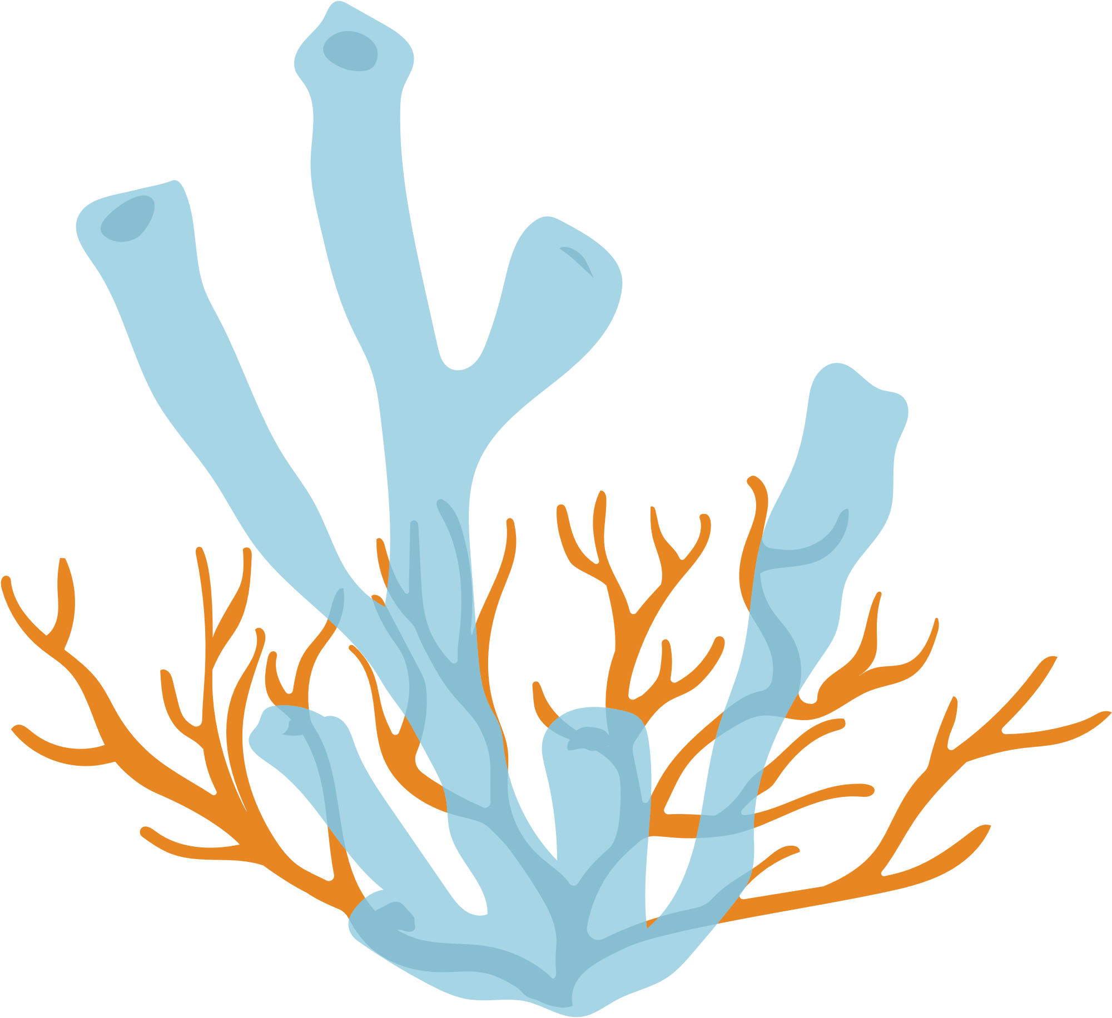

This certificate is presented to



FISH NAME

BIRTH CERTIFICATE

Mr. Richard edisson

PET SHOP MANAGER

