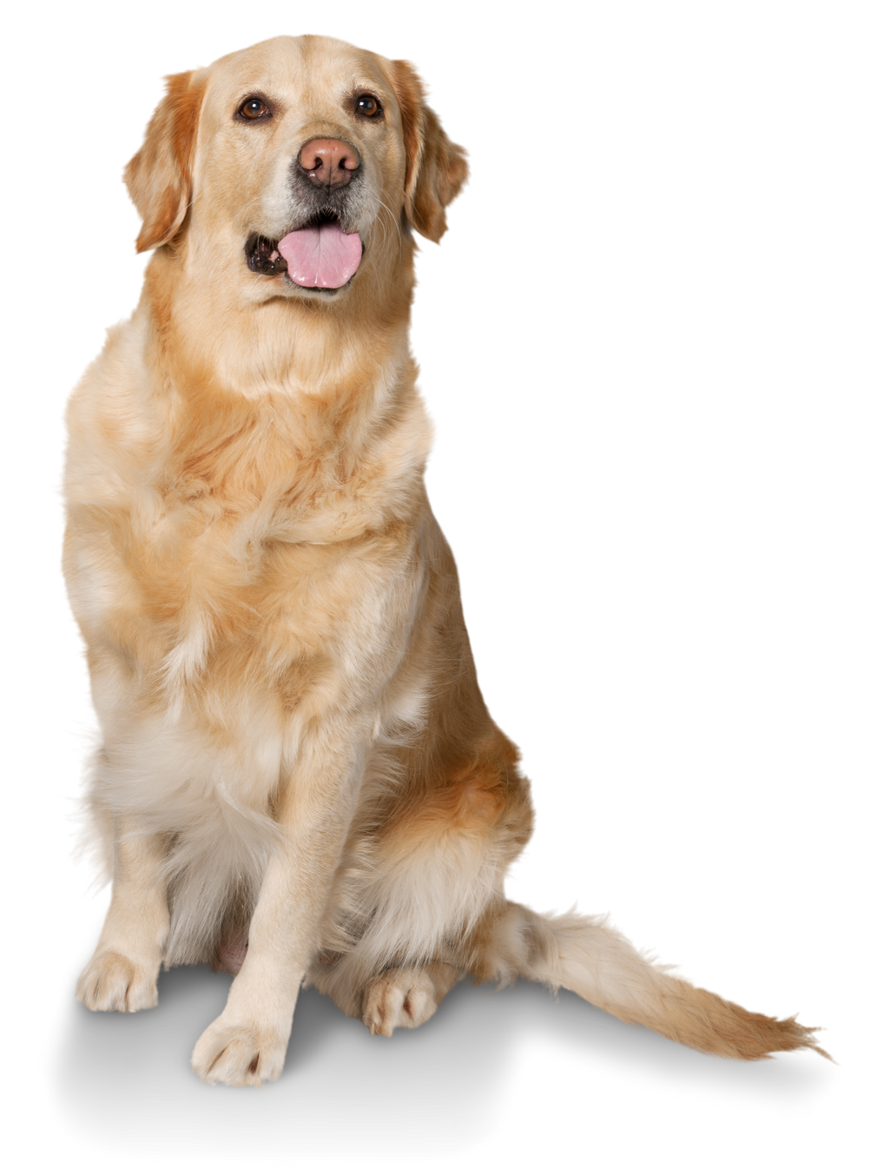

CHRISTINA SHERLY

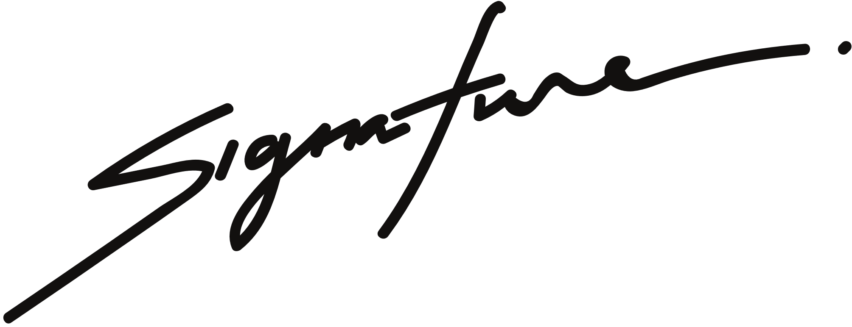

Pet shop manager

DOG NAME

This certifies that

Birth Certificate

is a male puppy born on August 8th, 2021

to parents, David and Anna.