 | 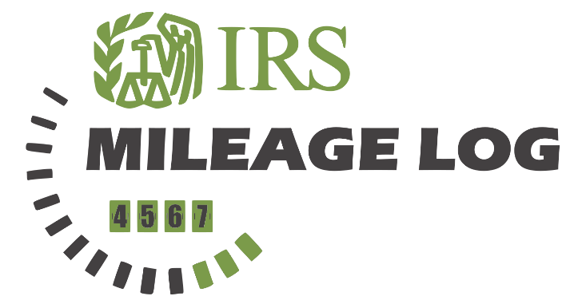
 |  |  |  |  |  |  | NAME: John Doe
 |  |  |  |  |  |  | COMPANY: MYCOMPANY NAME
 |  |  |  |  |  |  | PERIOD: June - November 2022
 |  |  |  |  |  |  | IRS MILEAGE RATE: |  |  |  |  | $0.56
 | TRAVEL  DATE | START  LOCATION | END  LOCATION |  | PURPOSE | MILEAGE  START |  | MILEAGE  END |  | TRIP  MILEAGE |  | EXPENSE
 | 01/06/2022 | Portsmouth | London |  | Site surveillance | 25,000 |  | 25,245 |  | 245 |  | $137.20
 | 06/06/2022 | Grimsby | London |  | Business Lunch | 25,408 |  | 25,658 |  | 250 |  | $140.00
 | Notes: |  |  |  | Total Miles: |  |  |  | Total Expense:
 | Vehicle was out of usage until 01/06/2022 |  |  |  | 495 |  |  |  | $277.20
 |  |  |  |  |  |  |  |  |  |  | © TemplateLab.com

