[](https://templatelab.com/)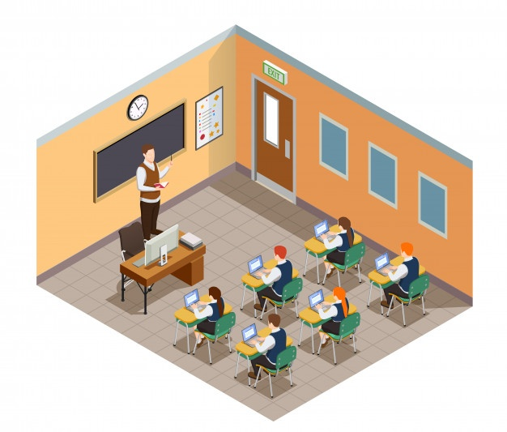

Low/declining enrollment

**WEAKNESSES**

Need for updated facilities

Limited volunteer help

Communication to stakeholders

No long term vision documented

Excellent and passionate school staff

**STRENGTHS**

Small class sizes

Strong community

New gymnasium

Free books for youngest classes

Parent ambassador program

**OPPORTUNITIES**

Homeschool population

Population growth

Government programs for schools

Organizing camps in nature

Misconceptions about education

**THREATS**

New charter schools

Changing needs of parents & students

Neighborhood safety

Transportation from school

[© TemplateLab.com](https://templatelab.com/)

**SCHOOL**

**SWOT ANALYSIS**