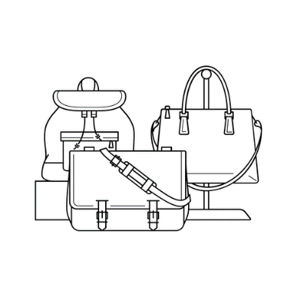

**T**

* **Lorem ipsum dolor sit amet, consectetuer adipiscing elit maecenas porttito**
* **Large number of new competitors with promising growth**
* **Economic conditions in US might lower consumer spendings**
* **New health studies related to materials that we use on our products**

**O**

* **Product inovations – new inside layers**
* **Expend interational segment**
* **Lorem ipsum dolor sit amet, consectetuer adipiscing elit maecenas porttito**
* **Bitcoin investments**

**W**

* **Future growth is dependent on leather products**
* **Lorem ipsum dolor sit amet, consectetuer adipiscing elit maecenas porttito**
* **Dependent on relationships with suppliers**
* **Competition in Canada is getting stronger (20% growth)**

**S**

* **Internationally known, strong, valuable brand**
* **Strong relationships with suppliers, low non-delivery probability**
* **High quality of products and service**
* **Lorem ipsum dolor sit amet, consectetuer adipiscing elit maecenas porttito**

**:: PRODUCT**

**:: NAME**

**$ 6.99**

**FAUX LEATHER**

**TOP HANDLE WITH 2“ DROP**

**PUSH-CLASP CLOSURE**

**8“x9“x3“**

**1 ZIP AND 2 SLIP POCKETS**

**LOREM IPSUM**



[© TemplateLab.com](https://templatelab.com/)