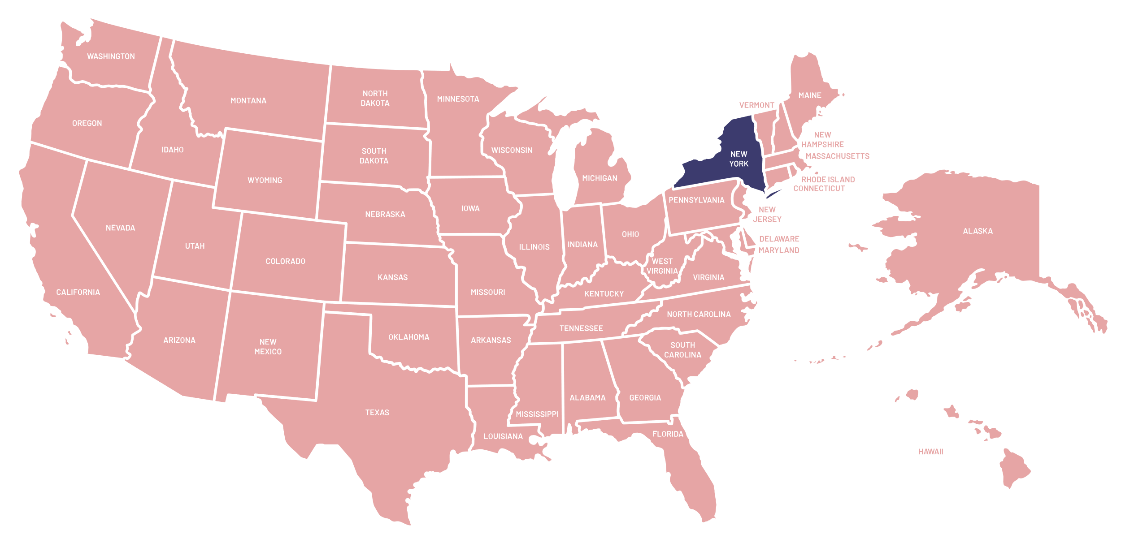

STATE FACT SHEET

Nickname

Statehood

Capital city

Biggest city

Population

Total area

State bird

State flower

The Empire State

1788; 11th state

Albany

New York

8,804,190

1,223.59 km2

bluebird

rose

Native Americans came to the area now called New York about 5,000 years ago. Thousands of years later, their descendants included Native American tribes such as the Mohawk, Cayuga, Oneida, and Seneca.

In 1624 the Dutch established a colony on what’s now Manhattan Island called New Amsterdam. It was renamed New York once the British took control of the area in 1664.

But after the American Revolution in 1776, New York became a U.S. colony, then a state in 1788. One year later, George Washington was sworn in as the United States’ first president in New York City, then the country’s capital. (It would move to Washington, D.C., the next year, in 1790.)

On September 11, 2001, hijackers flew planes into the twin towers of New York City’s World Trade Center; the Pentagon just outside Washington, D.C.; and a field in Somerset County, Pennsylvania. Learn more about the history-making attack and meet some of the heroes who helped save lives that day.