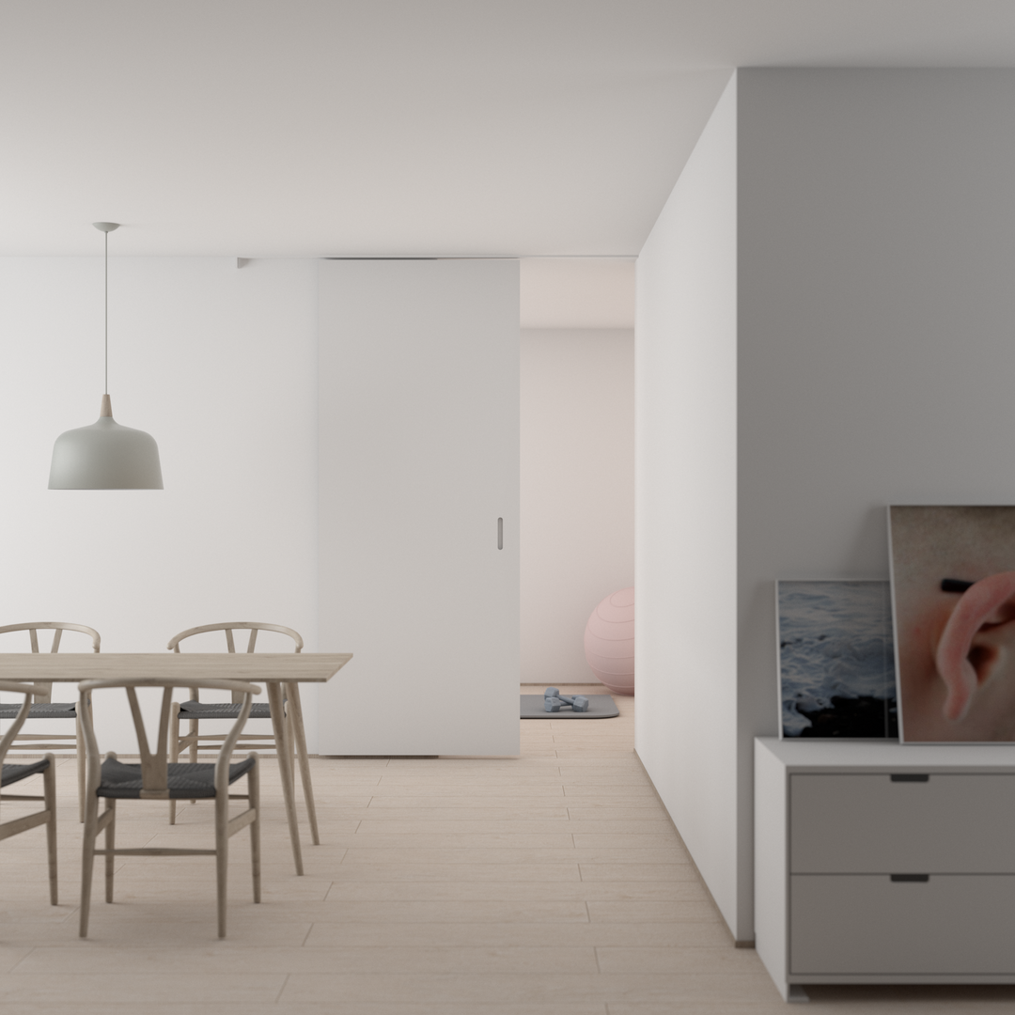

PROPERTY

FACT SHEET



Company name

hello@templateLAB.com

www.templateLAB.com 



123

Road Name,

City Name

2,400 square feet

2 bedrooms

3 bathrooms

Modern kitchen

Renovated roof deck

2-car garage

Home with an ocean view

This two-story house is situated five minutes from the beach and offers stunning views from all bedrooms.

Property highlights

The property is for sale, but the owner is open to long-term rental. Visit our website for a video tour of the property or contact us for a one-on-one virtual walkthrough or on-site visit.

Offered at $1,200,000