[](https://templatelab.com/)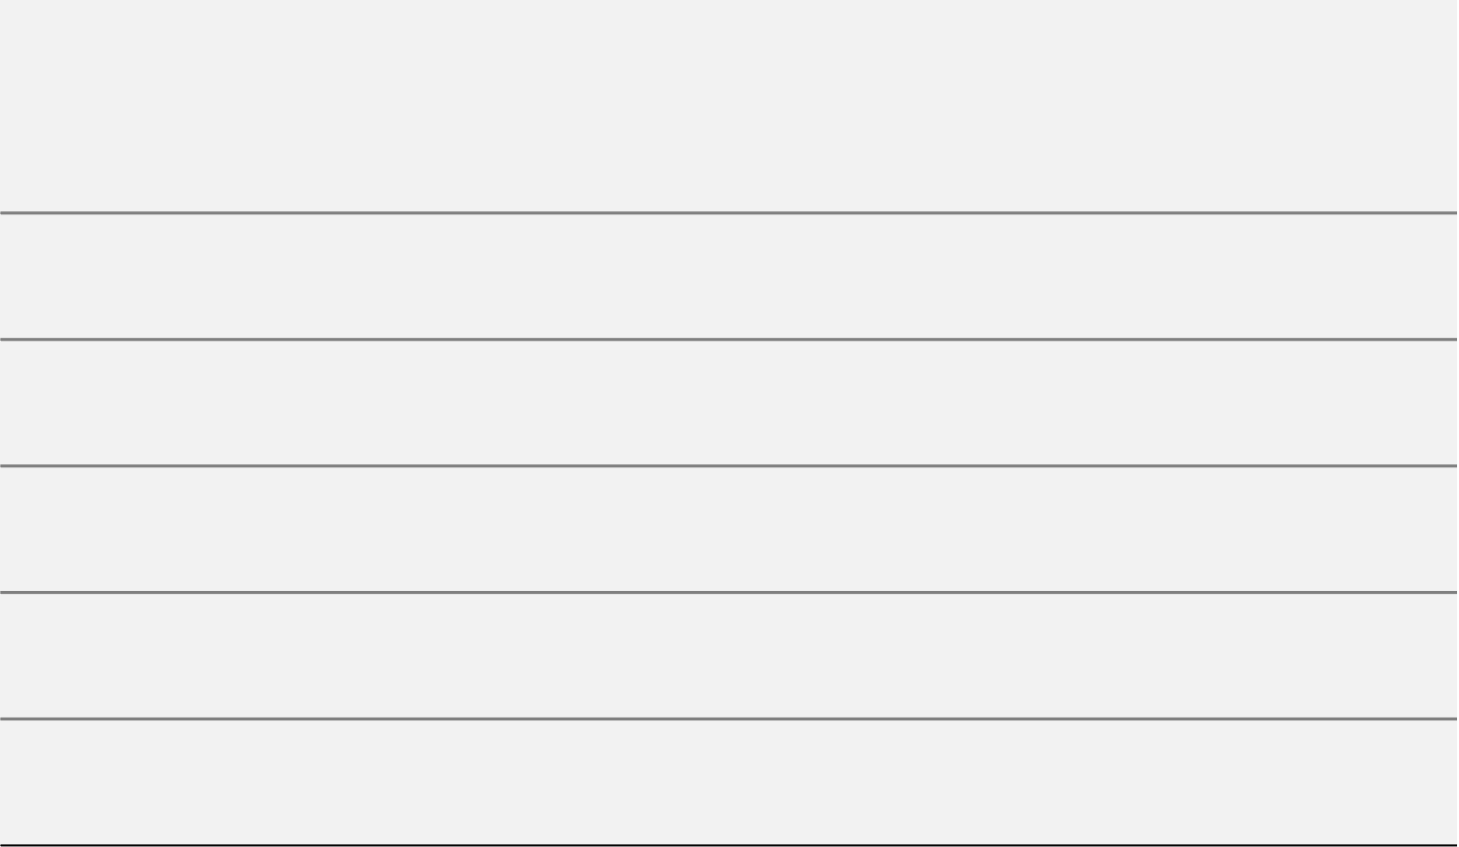

**1**

**15**

**30**

**1**

**15**

**31**

**1**

**15**

**30**

September

October

November

**John Doe**

Identify consumer buying habits in the industry, market size, growth or decline, and any current trends.

Lorem Ipsum.

**Marketing Research**

**Ellie Morgan**

To identify our most likely buyers. In addition, discuss at least two or three levels of segmentation.

**Target Market**

**Sandra Goodwill**

Look at the entire marketplace and then break down specific tactics including such as events, direct mail, email, social media - that will help us gain access to customers.

**Market Strategy**

**Flavia Gomes**

Develop a month-by-month schedule of what we plan to spend on marketing. Also include a “red light” decision point.

**Budget**

**Alexandra Hollins**

Track our marketing success with Google Analytics for website conversions and a simple Excel sheet to compare our budget against the actual ROI.

**Metrics**

**YEAR 2022**

[**© TemplateLab.com**](https://templatelab.com/)

MARKETING GANTT CHART

**PROJECT NAME GOES HERE**

**September 01 – November 30, 2022**

**Prepared By: John Doe**