 | VEHICLE  PURCHASE ORDER  # 200154/2022 |  |  |  |  |  |  |  |  |  |  | 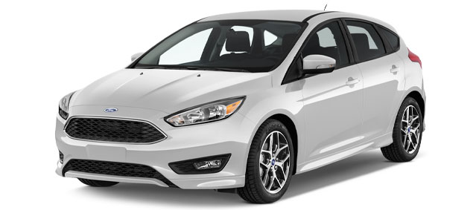
 | JOHN DOE |  |  |  |  |  |  |  |  |  |  | COMPANY NAME
 | Purchaser Name |  |  |  |  |  |  |  |  |  |  | Car Dealer
 | 201 ARLINGTON ROAD, LANAGSBY, 25989 CA |  |  |  |  |  |  |  |  |  |  | 180 CAR DEALER BAY, RACCO, 18105 NY
 | Address |  |  |  |  |  |  |  |  |  |  | Address
 | 555 - 2500 - 25669 |  |  |  |  |  |  |  |  |  |  | JOHN SMITH
 | Phone |  |  |  |  |  |  |  |  |  |  | Sales Person
 | VEHICLE INFORMATION
 | Please enter my order for: |  |  |  |  | ☐ | New Vehicle |  |  |  | ☐ | Used Vehicle |  |  |  | ☐ | Demo Vehicle
 | Make |  |  |  |  | FORD |  |  |  |  |  |  | Year |  |  | 02/2022
 | Model |  |  |  |  | Focus 1.9TDI |  |  |  |  |  |  | Colour |  |  | Magenta
 | Mileage |  |  |  |  | 100,250 |  |  |  |  |  |  | Fuel Type |  |  | Petrol
 | Vehicle ID Number |  |  |  |  | VVXCDS-111TZFCVT-AACFDC256 |  |  |  |  |  |  | Delivery Date |  |  | 03-Mar-22
 | VEHICLE PRICE
 | VEHICLE AND ACCESSORIES |  |  |  |  |  |  |  |  |  |  |  |  |  |  | AMOUNT
 | FORD Focus 1.9TDI, 100 HP, 5 Doors |  |  |  |  |  |  |  |  |  |  |  |  |  |  | $26,580.00
 | Security System |  |  |  |  |  |  |  |  |  |  |  |  |  |  | $280.00
 | Car Cover |  |  |  |  |  |  |  |  |  |  |  |  |  |  | $250.00
 | Parking Sensors |  |  |  |  |  |  |  |  |  |  |  |  |  |  | $850.00
 | Multi Pin Car Charger |  |  |  |  |  |  |  |  |  |  |  |  |  |  | $250.00
 | Blind Spot Mirrors |  |  |  |  |  |  |  |  |  |  |  |  |  |  | $400.00
 |  |  |  |  |  |  | TOTAL: |  |  |  |  |  |  |  |  | $28,610.00
 |  |  |  |  |  |  | TAX: |  |  |  |  |  |  |  |  | $2,861.00
 |  |  |  |  |  |  | DEALER FEE: |  |  |  |  |  |  |  |  | $450.00
 |  |  |  |  |  |  | TOTAL SALE PRICE: |  |  |  |  |  |  |  |  | $31,921.00
 |  |  |  |  |  |  | TOTAL DOWN PAYMENT: |  |  |  |  |  |  |  |  | $4,000.00
 |  |  |  |  |  |  | BALANCE DUE: |  |  |  |  |  |  |  |  | $27,921.00
 | PURCHASER SIGNATURE |  |  |  |  |  |  | AUTHORIZED PERSON SIGNATURE |  |  |  |  |  |  | DATE
 | DOWN PAYMENT METHOD |  |  |  |  |  |  |  |  |  |  | MANUFACTURER NAME
 | A vehicle down payment receipt is a written record of the initial payment from a buyer to seller towards the purchase of a vehicle. While this purchase order has information regarding the down payment, the buyer is advised to keep down payment receipt at all times as a proof of payment. |  |  |  |  |  |  |  |  |  |  | 178 Expensive Avenue
 |  |  |  |  |  |  |  |  |  |  |  | Philadelphia, 20100 PH
 |  |  |  |  |  |  |  |  |  |  |  | (555) 400-8888-2200
 | IMPORTANT NOTES |  |  |  |  |  |  |  |  |  |  | info@carbrandname.com
 | Where the dealer arranges financing, the dealer may receive a portion of the finance charge from the vehicle manufacturer.
 |  |  |  |  |  |  |  |  |  |  |  |  |  |  |  |  |  | © TemplateLab.com

