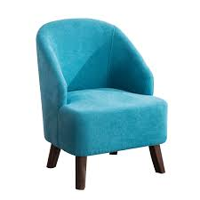
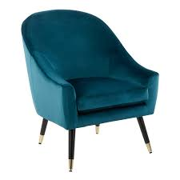
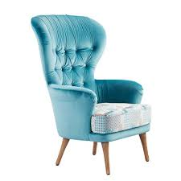
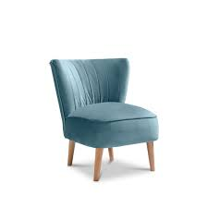
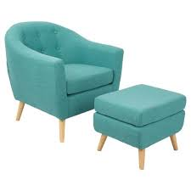
 | PURCHASE ORDER
 | PO #: B-23476 |  | Aug 20,2022
 | Contact: Margaret ext.110
 | To: John Doe |  |  | Ship to: Emily Dorson
 | 202 Creative Street |  |  | 142 Palmolive Avenue
 | Philadelphia, PA 19103 |  |  | Philadelphia, PA 19103 |  |  |  | INTERIOR DESIGN
 | Image |  | Item |  |  |  | Supplier | Price Info
 |  |  | Charleston Blue Seat Sofa |  |  |  | WEST ELM |  | Qty: | 1
 |  |  | Reference: CSB-5253 |  |  |  |  |  | Price: | $250.00
 |  |  |  |  |  |  |  | Delivery Charges: |  | $40.00
 |  |  | Flex Fabric Polyamid
 |  |  | Distressed Mahagony Finish |  |  |  |  |  | Total: | $290.00
 |  |  | Honolulu Light Blue Sofa |  |  |  | FIX+ |  | Qty: | 2
 |  |  | Reference: AMV-5200 |  |  |  |  |  | Price: | $280.00
 |  |  |  |  |  |  |  | Delivery Charges: |  | $60.00
 |  |  | Cotton
 |  |  | Aluminium Sabots |  |  |  |  |  | Total: | $620.00
 |  |  | Bilbo Seat |  |  |  | DOLLORESS ART |  | Qty: | 1
 |  |  | Reference: XAF-1450 |  |  |  |  |  | Price: | $300.00
 |  |  |  |  |  |  |  | Delivery Charges: |  | $20.00
 |  |  | Flex Fabric Polyamid
 |  |  | Distressed Mahagony Finish |  |  |  |  |  | Total: | $320.00
 |  |  | Lorem ipsum dolor |  |  |  | WEST ELM |  | Qty: | 1
 |  |  | Reference: GOH-2500 |  |  |  |  |  | Price: | $350.00
 |  |  |  |  |  |  |  | Delivery Charges: |  | $20.00
 |  |  | Consectetuer Adipiscing
 |  |  | Sit Amet Commodo Magna Eros |  |  |  |  |  | Total: | $370.00
 |  |  | Lorem ipsum dolor |  |  |  | VERSO |  | Qty: | 4
 |  |  | Reference: GOH-9850 |  |  |  |  |  | Price: | $200.00
 |  |  |  |  |  |  |  | Delivery Charges: |  | $50.00
 |  |  | Consectetuer Adipiscing
 |  |  | Sit Amet Commodo Magna Eros |  |  |  |  |  | Total: | $850.00
 | 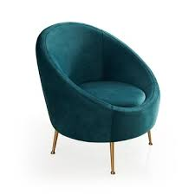 |  | Lorem ipsum dolor |  |  |  | GINKO BAY |  | Qty: | 1
 |  |  | Reference: GOP-8140 |  |  |  |  |  | Price: | $560.00
 |  |  |  |  |  |  |  | Delivery Charges: |  | $40.00
 |  |  | Consectetuer Adipiscing
 |  |  | Sit Amet Commodo Magna Eros |  |  |  |  |  | Total: | $600.00
 | Service |  |  |  |  |  |  |  |  | Price
 | Site Measurements & Drawings |  |  |  |  |  |  |  |  | $150.00
 | Space Planning & Design Concept |  |  |  |  |  |  |  |  | $300.00
 | Install & Final Styling |  |  |  |  |  |  |  |  | $450.00
 |  | INTERIOR DESIGN, Inc. |  |  |  |  |  | GRAND TOTAL: |  | $3,950.00
 |  | 217 West End Bay, NY 21585
 |  | (555) 1234-567-9000
 |  |  |  |  |  |  |  |  |  | © TemplateLab.com

