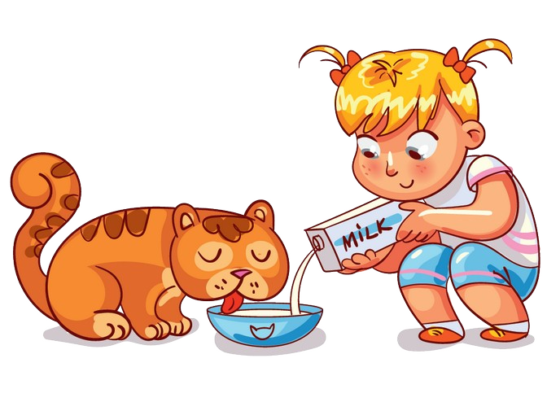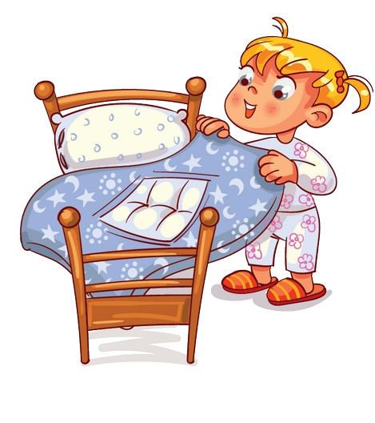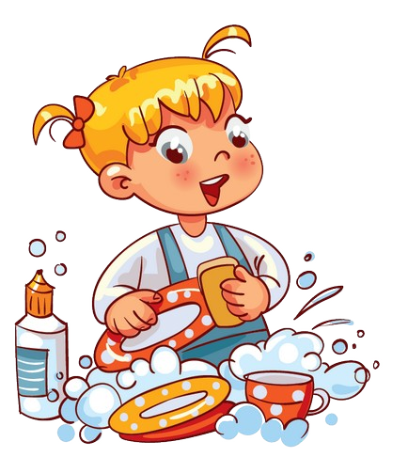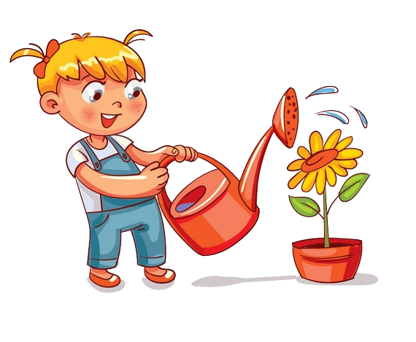

$

$

$

Rewards

Pocket

Money

$

$

$

$

$

tuesday

saturday

wednesday

thursday

dishes

friday

Feed

the dog

Watering

the plants

Empty

trash bin

Wash

toys

Sweep

the floor

Clean

bedroom

Empty

bin

Clean up

toys

Wash

toys

Feed

the dog

Watering

the plants

Empty

trash bin

dishes

Sweep

the floor

Clean

bedroom

Empty

bin

Clean up

Reward

Reward

Reward

Reward

Reward

Reward

Reward

Sweep

Feed

the dog

Watering

the plants

Empty

trash bin

Wash

dishes

Clean up

the floor

Clean

bedroom

Empty

bin

Clean up

toys

Total rewards

Empty

Empty

bin

Clean up

toys

monday

Feed

the dog

Watering

the plants

bedroom

trash bin

Wash

dishes

Sweep

the floor

Clean

bedroom

Empty

Sunday

Feed

the dog

Watering

the plants

Empty

trash bin

Wash

dishes

Sweep

the floor

Clean

trash bin

Clean up

toys

Feed

the dog

Watering

the plants

Empty

bin

Wash

dishes

Sweep

the floor

Clean

bedroom

Empty

bin

bin

Clean up

toys

Feed

the dog

Watering

the plants

Empty

trash bin

Wash

dishes

Sweep

the floor

Clean

bedroom

Empty