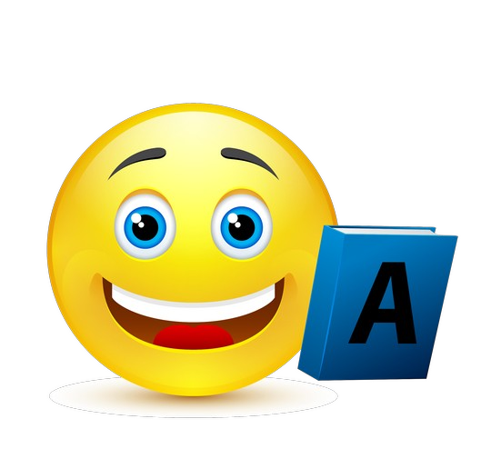

DIFFICULT!

BEST!

GREAT!

IT’S

MONDAY

TUESDAY

WEDNESDAY

THURSDAY

SATURDAY

FRIDAY

DONE

I TRY MY