

Agile Software Development

1

Agile Software Development

Classical methods of software development

huge effort during the planning phase

poor requirements conversion in a rapid changing environment

treatment of staff as a factor of production

New methods:

Agile Software Development Methodology

2


The Manifesto for Agile Software Development

“We are uncovering better ways of developing software by doing it and helping others do it. Through this work we have come to value:

Individuals and interactions over processes and tools

Working software over comprehensive documentation Customer collaboration over contract negotiation Responding to change over following a plan

That is, while there is value in the items on the right, we value the items on the left more.”

- http://www.agilemanifesto.org
Agile Methods

Agile methods:

Scrum

Extreme Programming

Adaptive Software Development (ASD) Dynamic System Development Method

(DSDM)

4

What is “Agility”?

Effective (rapid and adaptive) response to change

Effective communication in structure and attitudes among all team members, technological and business people, software engineers and managers

Drawing the customer into the team. Eliminate “us and them” attitude.

Planning in an uncertain world has its limits and plan must be flexible.

Organizing a team so that it is in control of the work performed

5

What is “Agility”?

Emphasize an incremental delivery strategy as opposed to intermediate products that gets working software to the customer as rapidly as feasible.

Rapid, incremental delivery of software

The development guidelines stress delivery over analysis and design although these activates are not discouraged, and active and continuous communication between developers and customers.

6

Why and What Steps are "Agility” important?

Why? The modern business environment is fast-paced and ever-changing. It represents a reasonable alternative to conventional software engineering for certain classes of software projects. It has been demonstrated to deliver successful systems quickly.

What? May be termed as “software engineering lite” The basic activities- communication, planning, modeling, construction and deployment remain. But they morph into a minimal task set that push the team toward construction and delivery sooner.

The only really important work product is an operational “software increment” that is delivered.

7

Agility and the Cost of Change

Conventional wisdom is that the cost of change increases nonlinearly as a project progresses. It is relatively easy to accommodate a change when a team is gathering requirements early in a project. If there are any changes, the costs of doing this work are minimal. But if the middle of validation testing, a stakeholder is requesting a major functional change. Then the change requires a modification to the architectural design, construction of new components, changes to other existing components, new testing and so on. Costs escalate quickly.

A well-designed agile process may “flatten” the cost of change curve by coupling incremental delivery with agile practices such as continuous unit testing and pair programming. Thus team can accommodate changes late in the software project without dramatic cost and time impact.

8

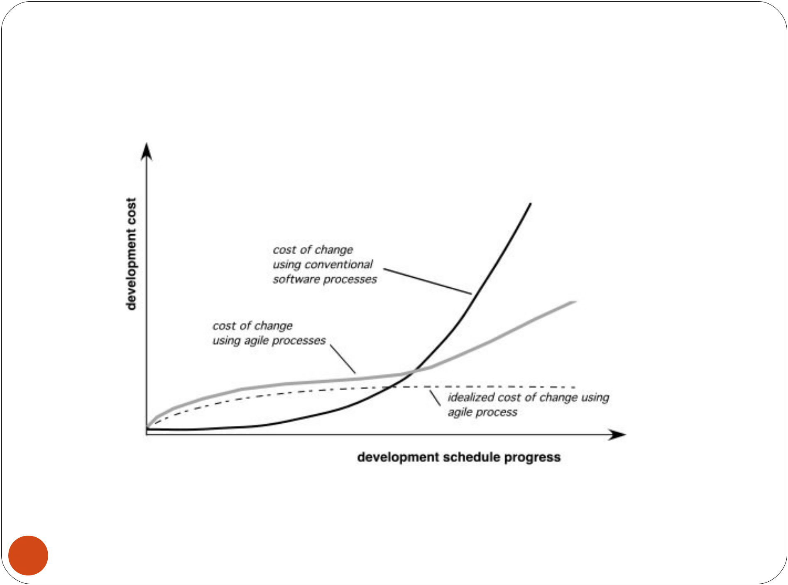
Agility and the Cost of Change

9

An Agile Process

Is driven by customer descriptions of what is required (scenarios). Some assumptions:

Recognizes that plans are short-lived (some requirements will persist, some will change. Customer priorities will change)

Develops software iteratively with a heavy emphasis on construction activities (design and construction are
interleaved, hard to say how much design is necessary before construction. ).

Thus has to Adapt as changes occur due to unpredictability

Delivers multiple ‘software increments ’, deliver an operational prototype or portion of an OS to

- collect customer feedback for adaption.
Agility Principles - I

1.Our highest priority is to satisfy the customer through

early and continuous delivery of valuable software.

- Welcome changing requirements, even late in development..

- Deliver working software frequently, from a couple of weeks to a couple of months, with a preference to the shorter timescale.

- Business people and developers must work together daily throughout the project.

- Build projects around motivated individuals. Give them the environment and support they need, and trust them to get the job done.

- The most efficient and effective method of conveying information to and within a development team is face–to– face conversation.

11

Agility Principles - II

7.Working software is the primary measure of progress.

- Agile processes promote sustainable development. The sponsors, developers, and users should be able to maintain a constant pace indefinitely.

- Continuous attention to technical excellence and good design enhances agility.

10.Simplicity – the art of maximizing the amount of work not done – is essential.

11.The best architectures, requirements, and designs emerge from self–organizing teams.

- At regular intervals, the team reflects on how to become more effective, then tunes and adjusts its behavior accordingly.

12

Human Factors

the process molds to the needs of the people and team, not the other way around

key traits must exist among the people on an agile team and the team itself:

Competence. ( talent, skills, knowledge)

Common focus. (deliver a working software increment )

Collaboration. ( peers and stakeholders)

Decision -making ability. ( freedom to control its own destiny)

Fuzzy problem-solving ability.(ambiguity and constant changes, today problem may not be tomorrow’s problem)

Mutual trust and respect.

- Self-organization. ( themselves for the work done, process for its local environment, the work schedule)
SCRUM

Scrum is an agile process that allows us to focus on delivering the highest business value in the shortest time.

It allows us to rapidly and repeatedly inspect actual working software (every two weeks to one month).
The business sets the priorities. Our teams self-manage to determine the best way to deliver the highest priority features.

Every two weeks to a month anyone can see real working software and decide to release it as is or continue to enhance for another iteration.

14

SCRUM

A software development method Originally proposed by Schwaber and Beedle (an activity occurs during a rugby match) in early 1990.

Scrum—distinguishing features

Development work is partitioned into “packets”

Testing and documentation are on-going as the product is constructed Work units occurs in “sprints” and is derived from a “backlog” of

existing changing prioritized requirements

Changes are not introduced in sprints (short term but stable) but in backlog.

Meetings are very short (15 minutes daily) and sometimes conducted without chairs ( what did you do since last meeting? What obstacles are you encountering? What do you plan to accomplish by next meeting?)
“demos” are delivered to the customer with the time-box allocated. May not contain all functionalities. So customers can evaluate and give feedbacks.

15

Characteristics

Self-organizing teams

Product progresses in a series of month-long “sprints”

Requirements are captured as items in a list of “product backlog”

No specific engineering practices prescribed

Uses generative rules to create an agile environment for delivering projects

One of the “agile processes”

16

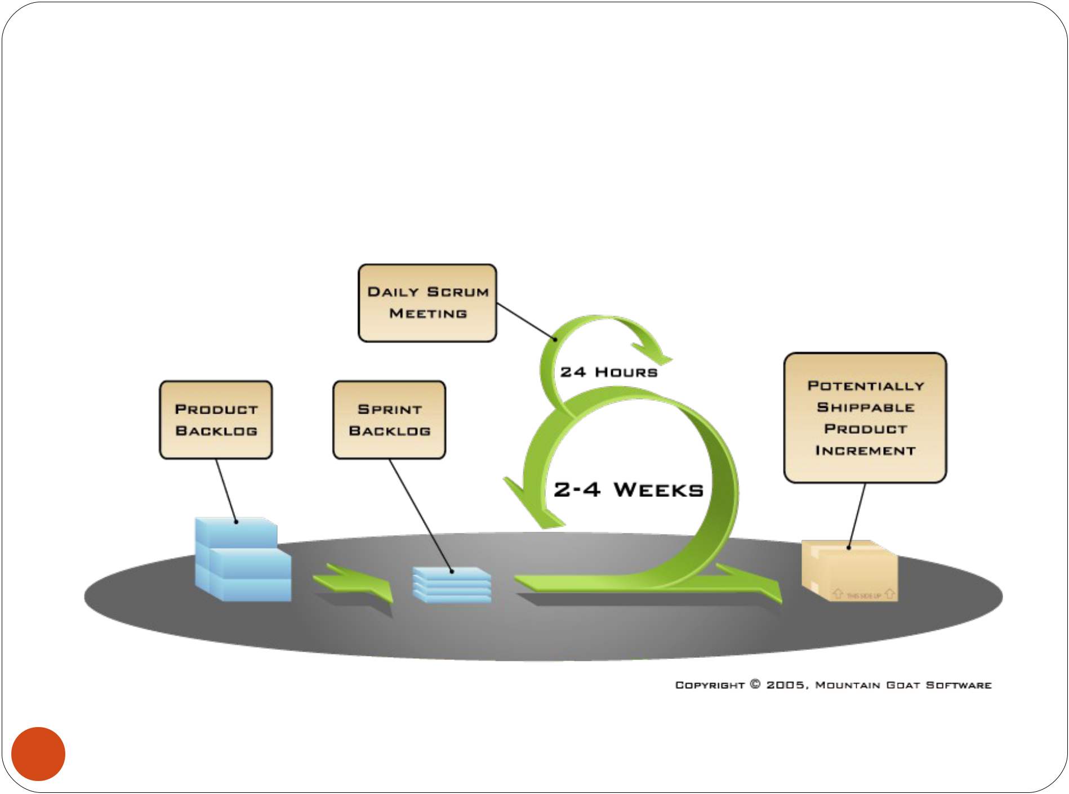
How Scrum Works?

17

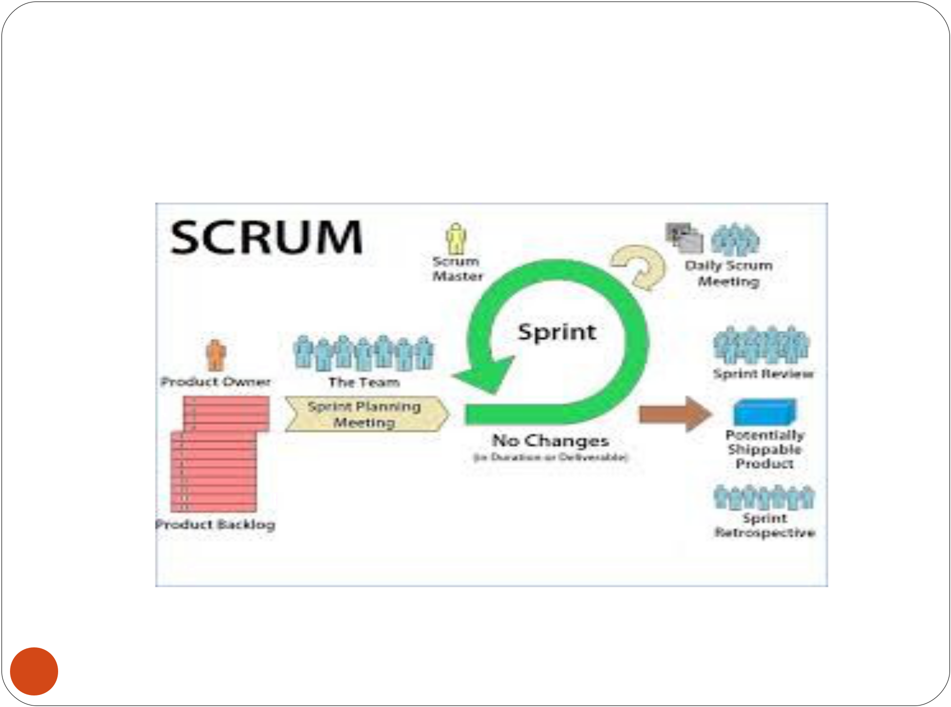
Scrum

18

Sprints

Scrum projects make progress in a series of “sprints”

Analogous to XP iterations

Target duration is one month

+/- a week or two

But, a constant duration leads to a better rhythm

Product is designed, coded, and tested during the sprint

19

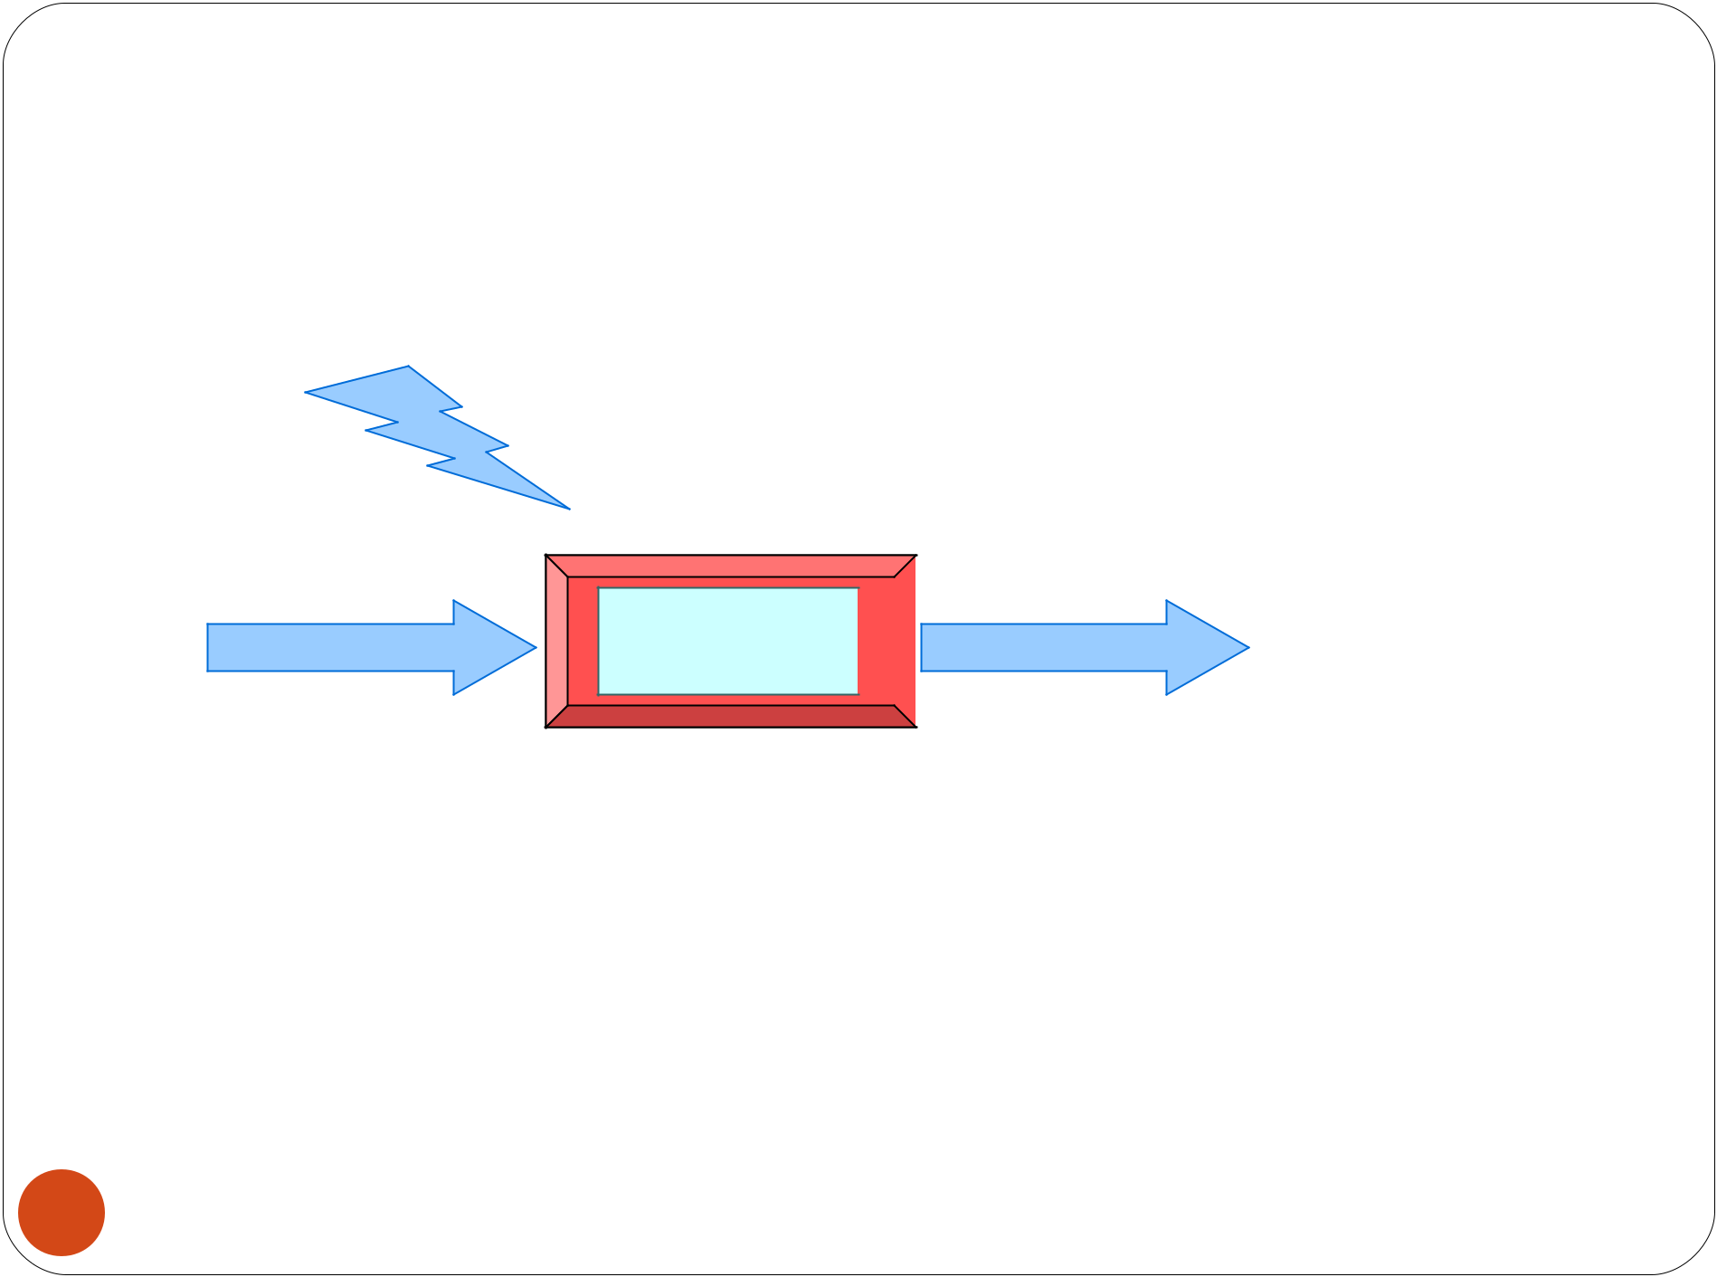
No changes during the sprint

Change

Inputs

Sprint Tested Code

Plan sprint durations around how long you can commit to keeping change out of the sprint

20

Scrum Framework

Roles : Product Owner, ScrumMaster,

Team

Ceremonies : Sprint Planning, Sprint

Review, Sprint Retrospective, & Daily Scrum Meeting

Artifacts : Product Backlog, Sprint

Backlog, and Burndown Chart

21

Product Owner

Define the features of the product

Decide on release date and content

Be responsible for the profitability of the

product (ROI)

Prioritize features according to market value

Adjust features and priority every iteration, as needed

Accept or reject work results.

22

The Scrum Master

Represents management to the project

Responsible for enacting Scrum values and practices

Ensure that the team is fully functional and productive

Enable close cooperation across all roles and functions

Shield the team from external interferences

23

Scrum Team

Typically 5-10 people

Cross-functional

QA, Programmers, UI Designers, etc.

Members should be full-time

May be exceptions (e.g., System Admin, etc.)

Teams are self-organizing

Membership can change only between sprints

24

Ceremonies

Sprint Planning Meeting Sprint

Daily Scrum

Sprint Review Meeting

25

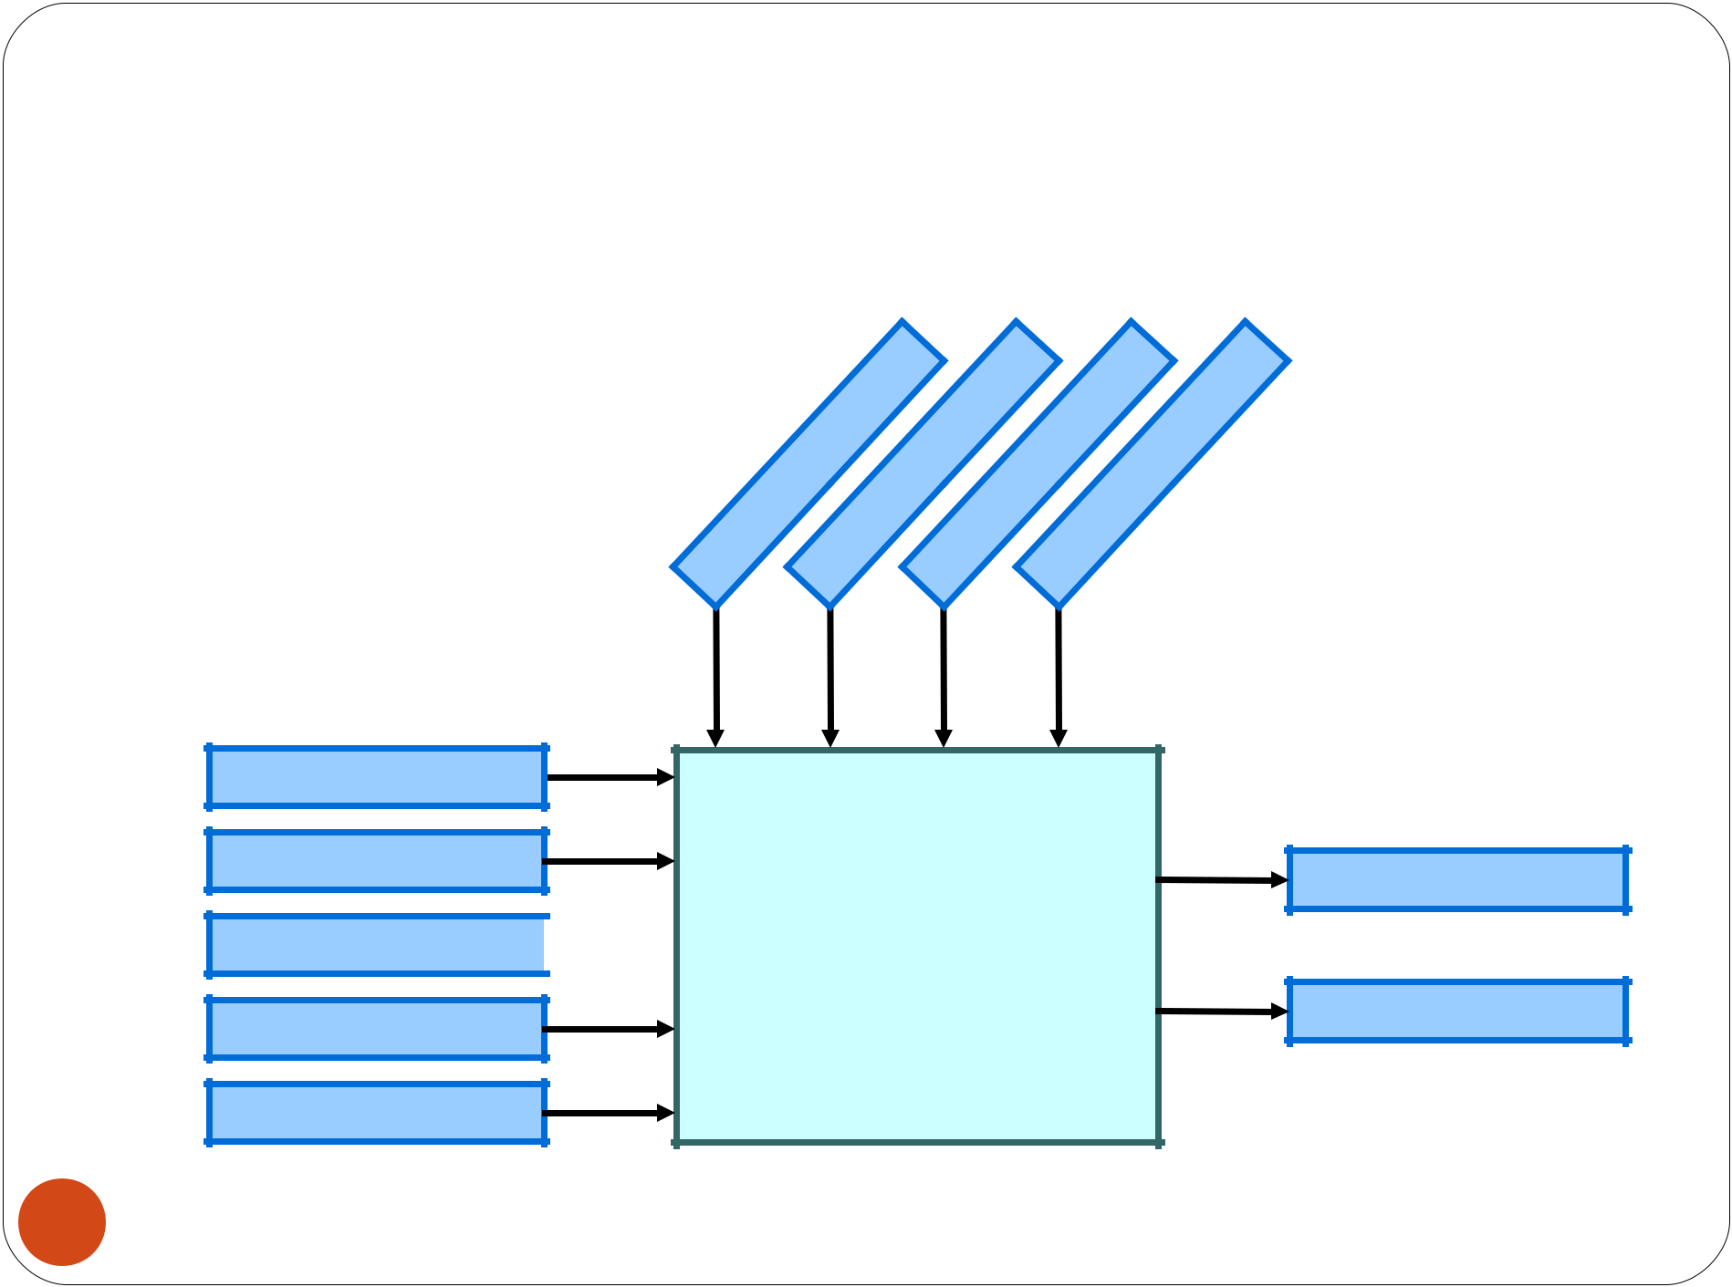
Spring Planning Meeting

 |  |  |  |  |  |  |  |  | r |  |  |  |  |  |  |  |  |  |  |  |  |  |  |  |  |  |  |  | t
 |  |  |  |  |  |  |  | e |  |  |  |  |  |  | m |  |  |  |  |  | s |  |  |  |  |  |  |  | t
 |  |  |  |  |  |  | n |  |  |  |  |  |  |  | m |  |  |  |  |  | s |  |  |  |  |  |  | n
 |  |  |  |  |  | w |  |  |  |  |  |  |  | a |  |  |  |  |  | r |  |  |  |  |  |  | e
 |  |  |  |  |  |  |  |  |  |  |  |  | e |  |  |  |  |  |  | e |  |  |  |  |  |  | m
 |  |  |  |  | t | O |  |  |  |  |  |  | T |  |  |  |  |  |  | m |  |  |  |  |  | e
 |  |  |  |  | t |  |  |  |  |  |  | m |  |  |  |  |  |  | o |  |  |  |  |  | g
 |  |  |  | c |  |  |  |  |  |  |  | m |  |  |  |  |  | t
 |  |  | u |  |  |  |  |  |  |  | u |  |  |  |  |  | s |  |  |  |  |  |  | a
 |  | d |  |  |  |  |  |  |  | r |  |  |  |  |  | u |  |  |  |  |  |  | n
 | o |  |  |  |  |  |  |  | c |  |  |  |  |  | C |  |  |  |  |  |  | a
r |  |  |  |  |  |  |  | S |  |  |  |  |  |  |  |  |  |  |  |  | M
P

Product Backlog

Team Capabilities

Business Conditions 

Technology

Current Product

Sprint Planning

Meeting

Sprint Goal

Sprint Backlog

26

Parts of Sprint Planning Meeting
1st Part:

Creating Product Backlog

Determining the Sprint Goal.

Participants: Product Owner, Scrum

Master, Scrum Team 2nd Part:

Participants: Scrum Master, Scrum

Team

Creating Sprint Backlog

27

Pre-Project/Kickoff Meeting

A special form of Sprint Planning Meeting Meeting before the begin of the Project

Sprint

A month-long iteration, during which is incremented a product functionality

NO outside influence can interfere with the Scrum team during the Sprint

Each Sprint begins with the Daily Scrum Meeting

28

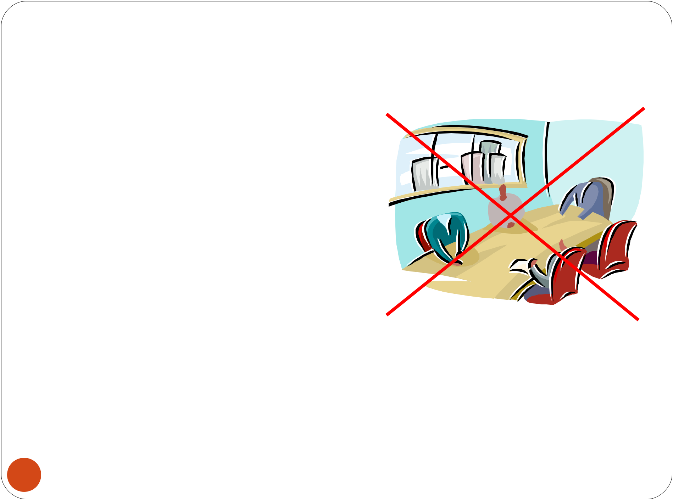
Daily Scrum

Parameters

Daily

15-minutes  Stand-up  Not for problem solving 

Three questions:

1.What did you do yesterday

2.What will you do today?

3.What obstacles are in your way?

29

Daily Scrum

Is NOT a problem solving session

Is NOT a way to collect information about WHO is behind the schedule

Is a meeting in which team members make commitments to each other and to the Scrum Master

Is a good way for a Scrum Master to track the progress of the Team

30

Scrum FAQs

Why daily?

“How does a project get to be a year late?” “One day at a time.”

Can Scrum meetings be replaced by emailed status reports?

No

Entire team sees the whole picture every day

Create peer pressure to do what you say you’ll do

31

Sprint Review Meeting

Team presents what it accomplished during the sprint

Typically takes the form of a demo of new features or underlying architecture

Informal

2-hour prep time rule

Participants

Customers

Management

Product Owner

Other engineers

32

Sprint Retrospective Meeting

Scrum Team only

Feedback meeting

Three questions

Start

Stop

Continue

Don’t skip for the first 5-6 sprints!!!

33

Product Backlog

A list of all desired work on the project Usually a combination of

story-based work

task-based work

List is prioritized by the Product Owner Typically a Product Manager,

Marketing, Internal Customer, etc.

34

Product Backlog

Requirements for a system, expressed as a prioritized list of Backlog Items

Is managed and owned by a Product Owner Spreadsheet (typically)

Usually is created during the Sprint Planning Meeting

Can be changed and re-prioritized before each PM

35

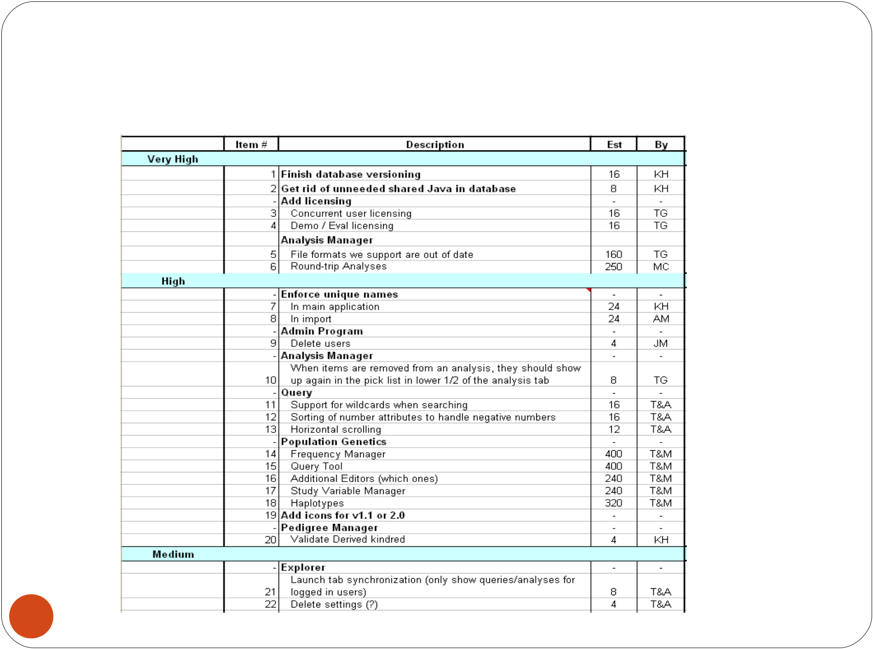
Sample Product Backlog

36

From Sprint Goal to Sprint Backlog
Scrum team takes the Sprint Goal and decides what tasks are necessary

Team self-organizes around how they’ll meet the Sprint Goal

Manager doesn’t assign tasks to individuals

Managers don’t make decisions for the team

Sprint Backlog is created

37

Sprint Backlog during the Sprint

Changes

Team adds new tasks whenever they need to in order to meet the Sprint Goal

Team can remove unnecessary tasks

But: Sprint Backlog can only be updated by the team

Estimates are updated whenever there’s new information

38

Sprint Backlog

A subset of Product Backlog Items, which define the work for a Sprint

Is created ONLY by Team members

Each Item has it’s own status

Should be updated every day

No more than 300 tasks in the list

If a task requires more than 16 hours, it should be broken down

Team can add or subtract items from the list. Product Owner is not allowed to do it

39

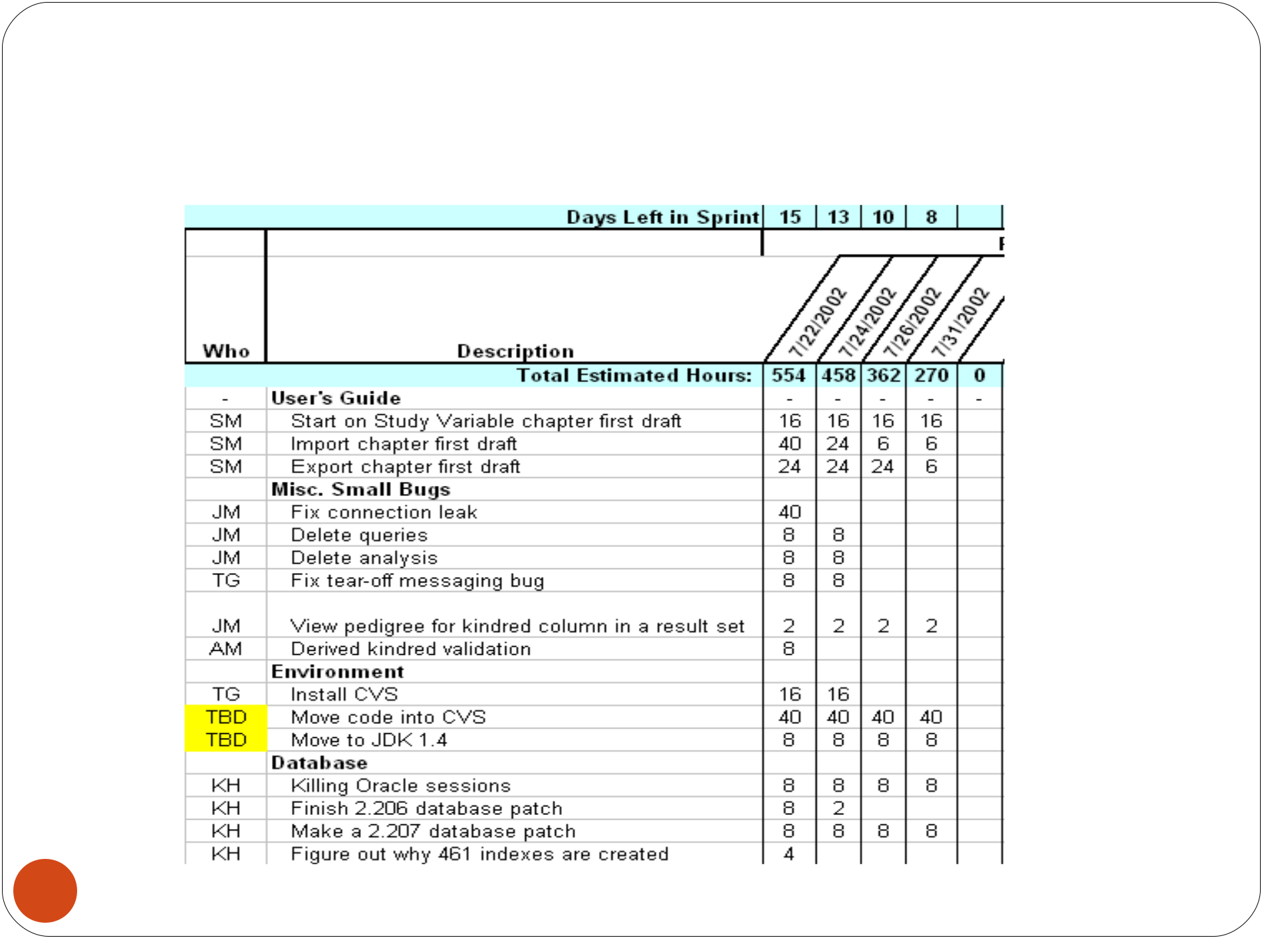
Sample Sprint Backlog

40

Sprint Burn down Chart

Depicts the total Sprint Backlog hours remaining per day

Shows the estimated amount of time to release

Ideally should burn down to zero to the end of the Sprint

Actually is not a straight line

41

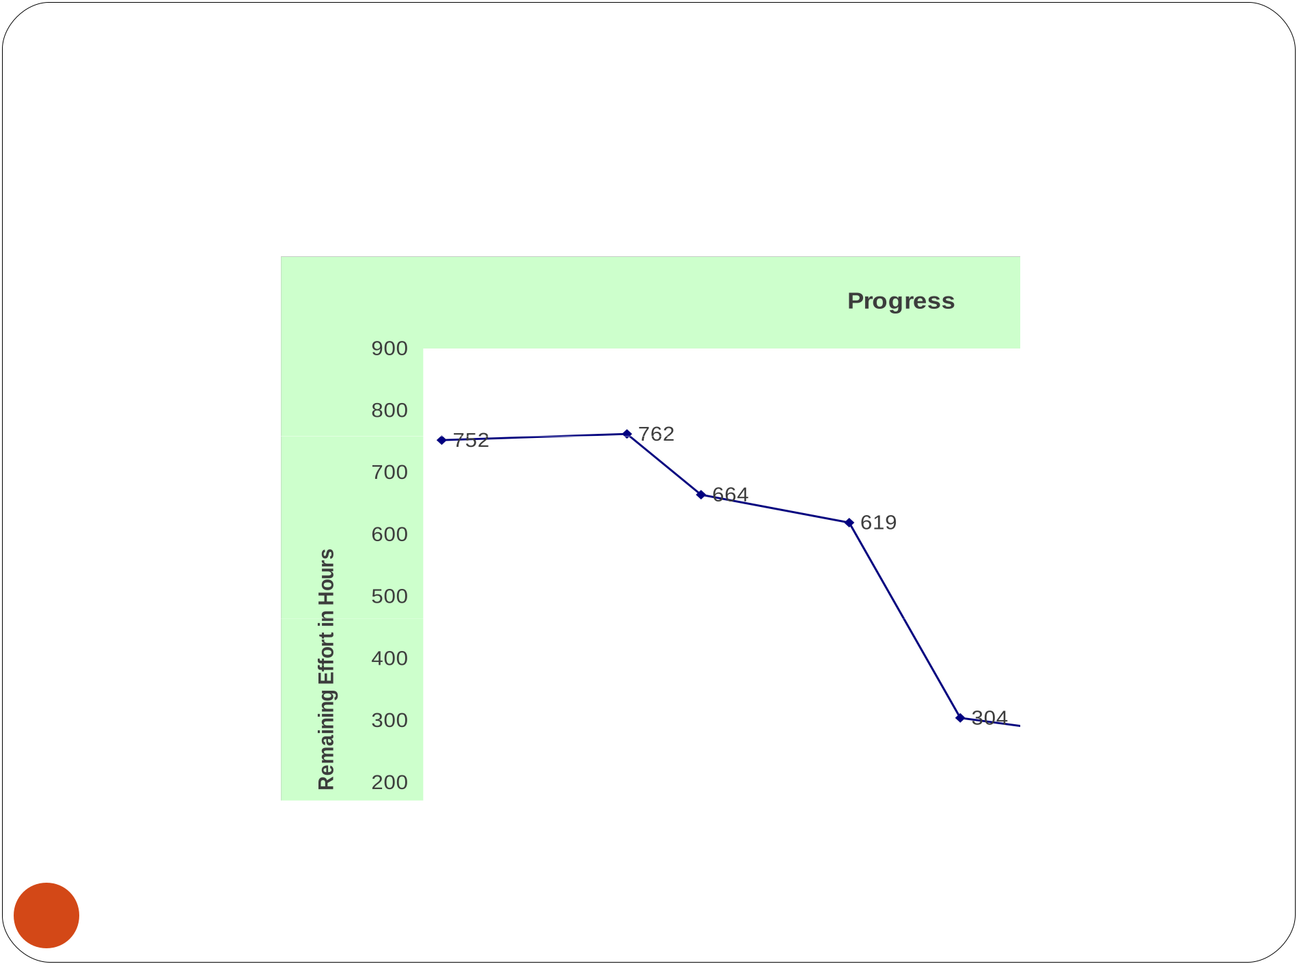
Sprint Burn down Chart

42

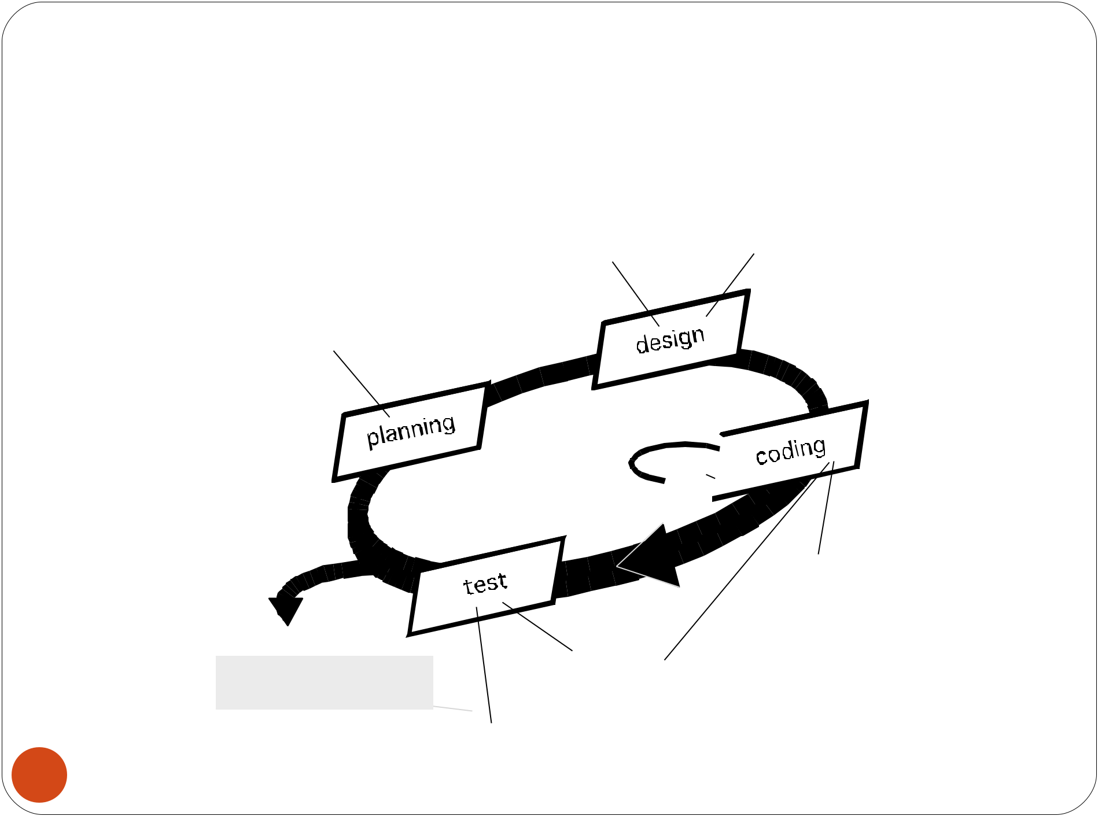
Extreme Programming (XP)

simple design | spike solutions
simple design | prototypes
CRC cards | prototypes
user stories
values
acceptance test criteria
iteration plan

refactoring

pair

programming

Release | unit test
software increment | unit test
project velocity computed | continuous integration
 | acceptance testing

43

XP Values

Communication

Simplicity

Feedback

Courage

Respect

44

Extreme Programming (XP)

The most widely used agile process, originally proposed by Kent Beck in 2004. It uses an object-oriented approach.
XP Planning

Begins with the listening, leads to creation of “user stories” that describes required output, features, and functionality. Customer assigns a value(i.e., a priority) to each story.
Agile team assesses each story and assigns a cost (development weeks. If more than 3 weeks, customer asked to split into smaller stories)

Working together, stories are grouped for a deliverable increment next release.

A commitment (stories to be included, delivery date and other project matters) is made. Three ways: 1. Either all stories will be implemented in a few weeks, 2. high priority stories first, or 3. the riskiest stories will be implemented first.

After the first increment “project velocity”, namely number of stories implemented during the first release is used to help define subsequent delivery dates for other increments. Customers can add stories, delete existing stories, change values of an existing story, split stories as
- development work proceeds.
User Stories

Easy to Understand Written by the Customer Small and Estimable Testable

Becomes more detailed over the time

46

User story template

As a <type of user>,

I want <to perform some task> so that I can <achieve some goal/benefit/value>.

47

User story example

User story title: Customer withdraws cash.

As a customer,

I want to withdraw cash from an ATM So that I don't have to wait in line at the bank.

48

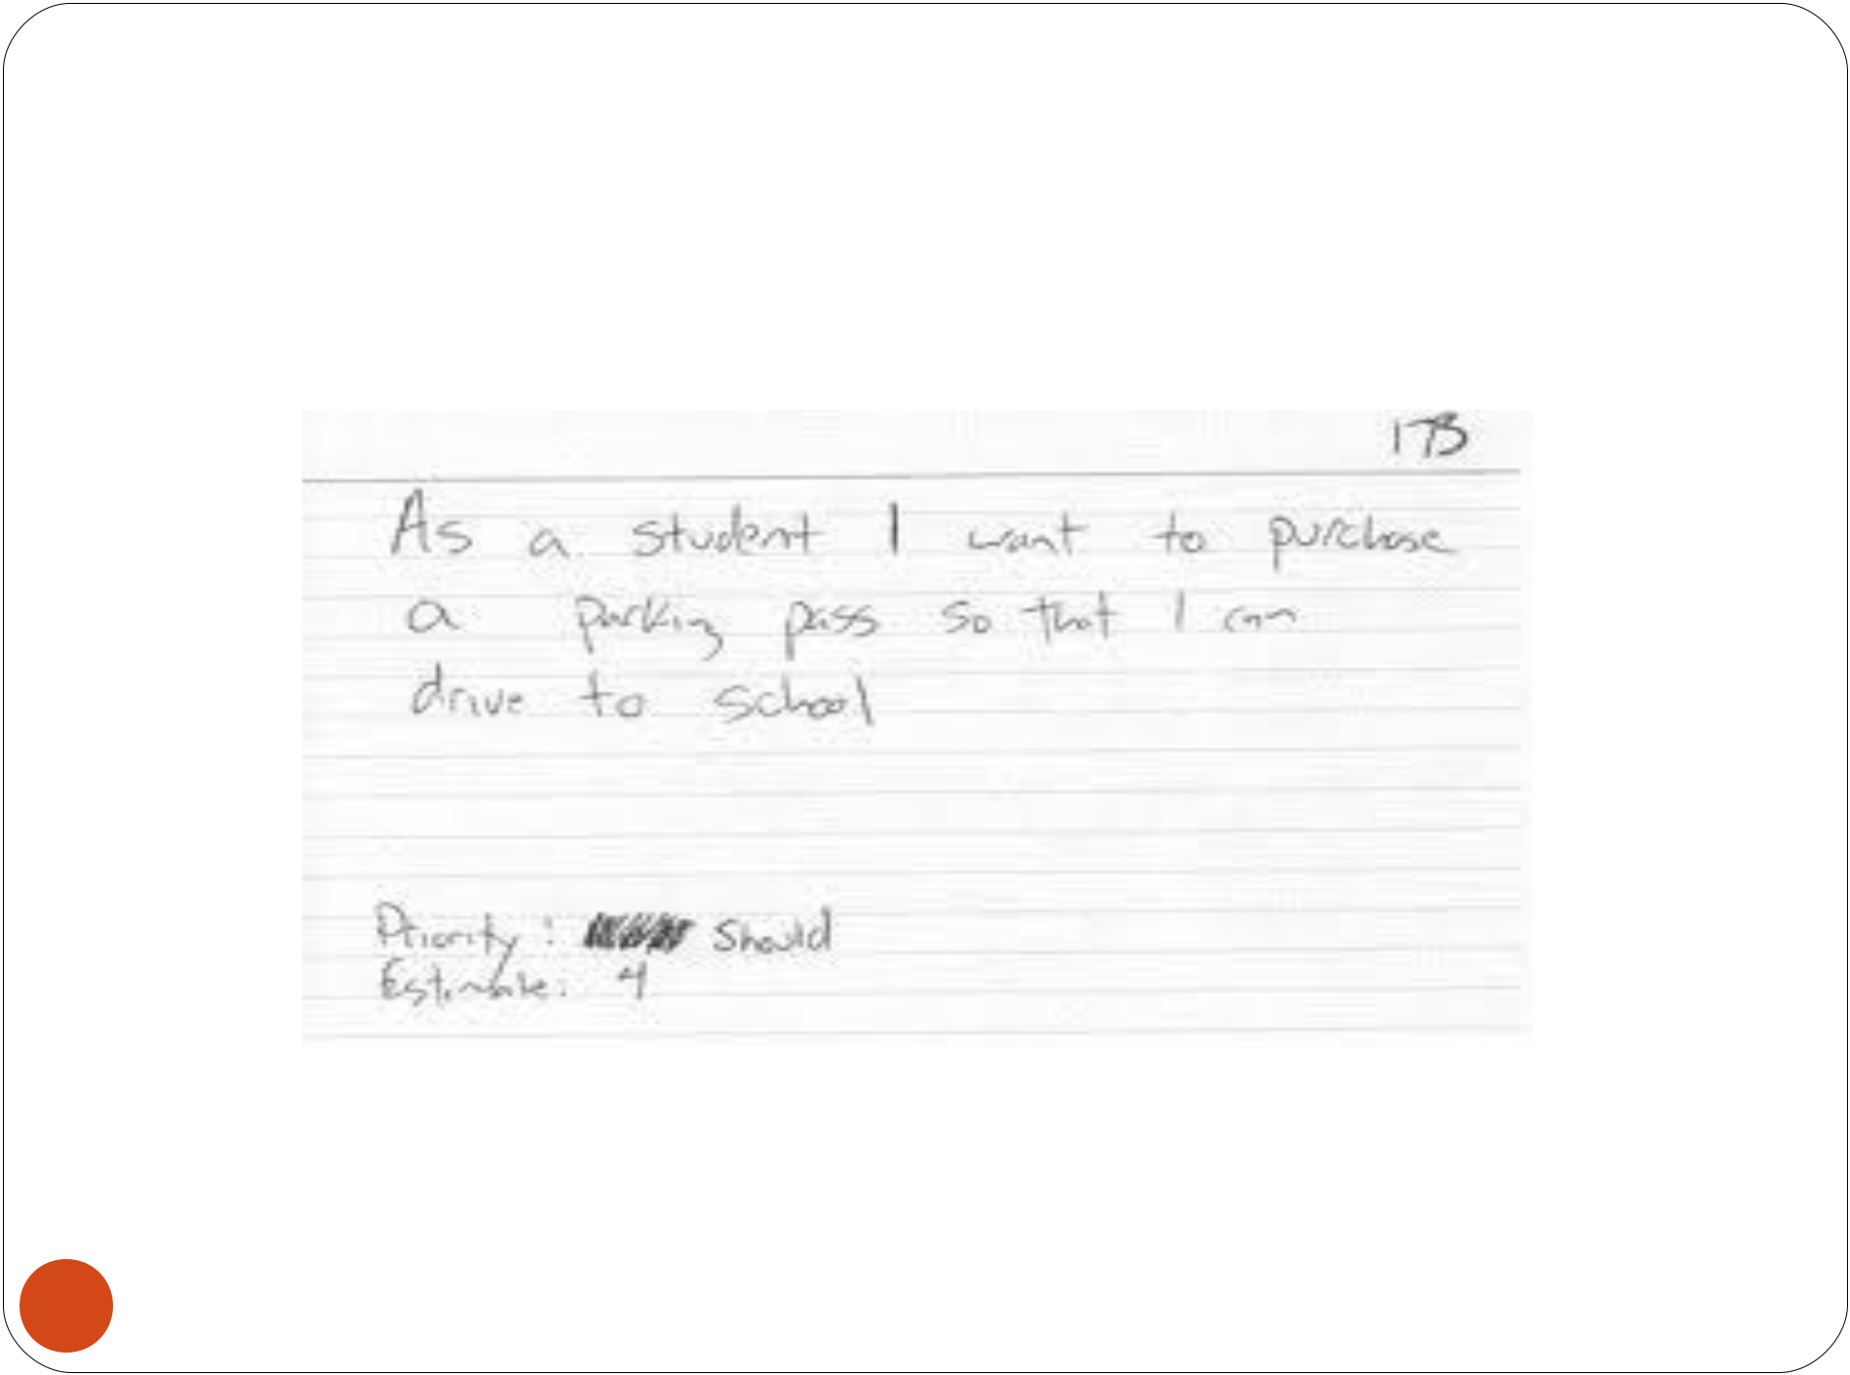
User story example

49

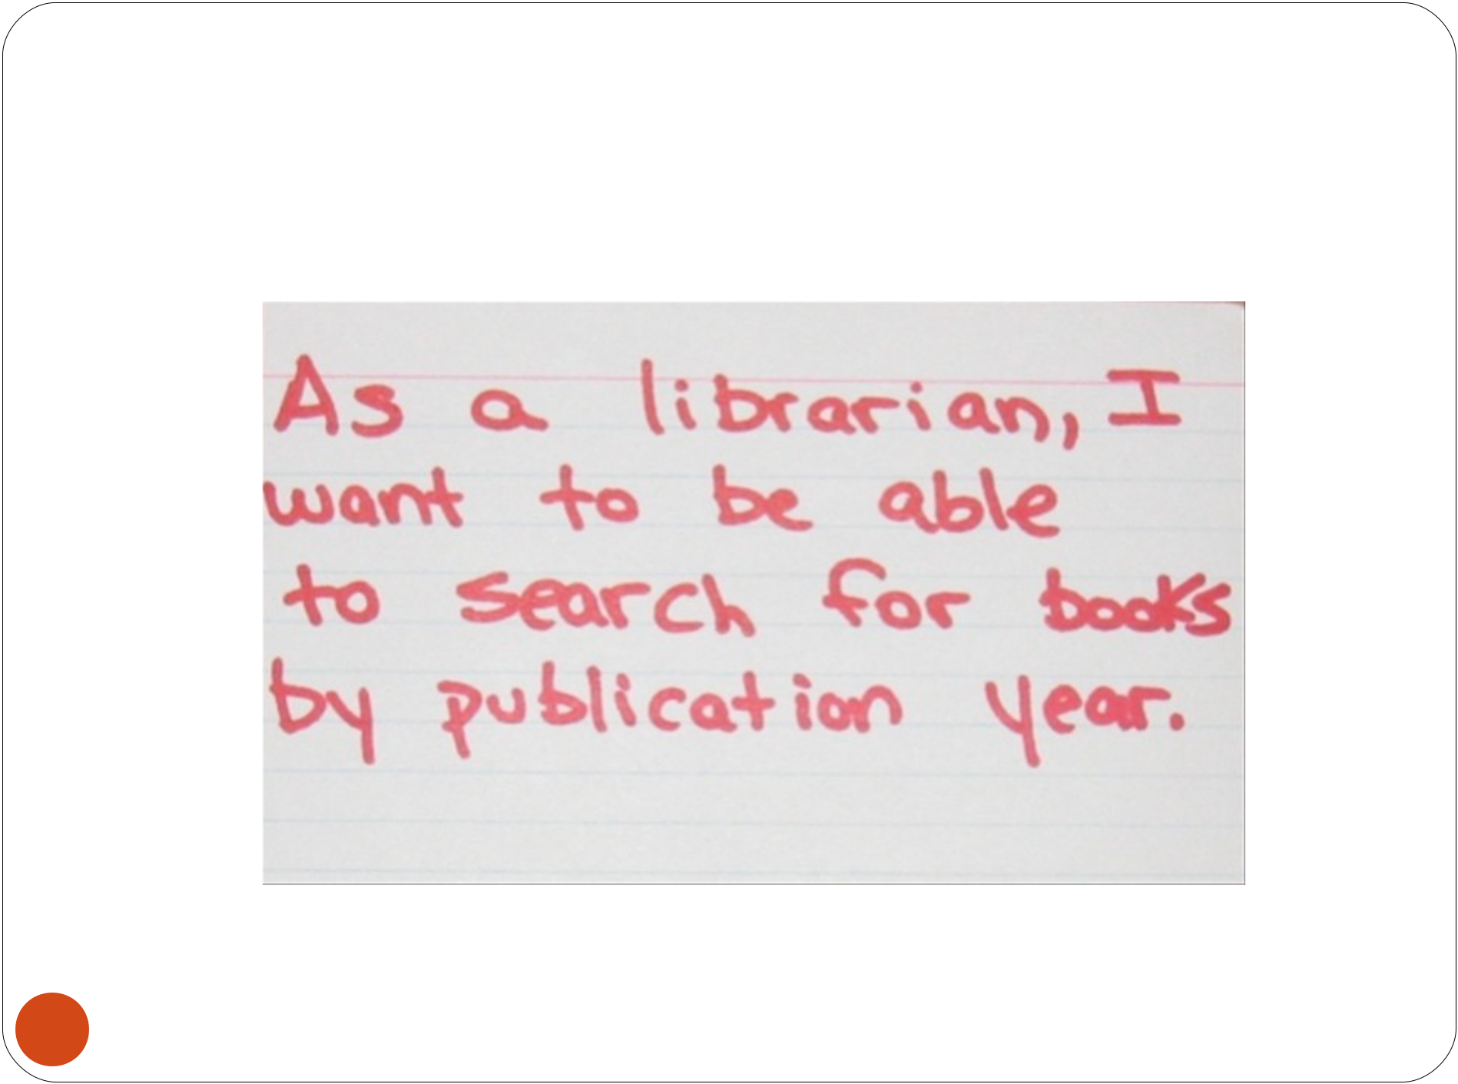
User story example

50

User Stories Acceptance Criterion
Acceptance Criterion 1:

Given that the account is creditworthy And the card is valid
And the dispenser contains cash,

When the customer requests the cash

Then ensure the account is debited

And ensure cash is dispensed And ensure the card is returned.

51

User Stories Acceptance Criterion

Acceptance Criterion 2:

Given that the account is overdrawn And the card is valid,
When the customer requests the cash Then ensure the rejection message is displayed

And ensure cash is not dispensed.

52

Extreme Programming (XP)

XP Design

53

Follows the KIS principle (keep it simple) Nothing more nothing less than the story.

Encourage the use of CRC (class-responsibility-collaborator) cards in an object- oriented context. The only design work product of XP. They identify and organize the classes that are relevant to the current software increment.

For difficult design problems, suggests the creation of “spike solutions”—a design prototype for that portion is implemented and evaluated.

Encourages “refactoring”—an iterative refinement of the internal program design. Does not alter the external behavior yet improve the internal structure. Minimize chances of bugs. More efficient, easy to read.

Extreme Programming (XP)

XP Coding

Recommends the construction of a unit test for a story before coding commences. So implementer can focus on what must be implemented to pass the test.

Encourages “pair programming”. Two people work together at one workstation. Real time problem solving, real time review for quality assurance. Take slightly different roles.

XP Testing

All unit tests are executed daily and ideally should be automated. Regression tests are conducted to test current and previous components.

“Acceptance tests” are defined by the customer and

54 | executed to assess customer visible functionality

The XP Debate

Requirements volatility: customer is an active member of XP team, changes to requirements are requested informally and frequently.

Conflicting customer needs: different customers' needs need to be assimilated. Different vision or beyond their authority.

Requirements are expressed informally: Use stories and acceptance tests are the only explicit manifestation of requirements. Formal models may avoid inconsistencies and errors before the system is built. Proponents said changing nature makes such models obsolete as soon as they are developed.

Lack of formal design: XP deemphasizes the need for architectural design. Complex systems need overall

structure to exhibit quality and maintainability. Proponents

- said incremental nature limits complexity as simplicity is a core value.
XP and Scrum

Scrum teams typically work in iterations (called sprints) that are from two weeks to one month long.

Scrum product owner prioritizes the product backlog but the team determines the sequence in which they will

- develop

XP teams typically work in iterations that are one or two weeks long.

XP teams work in a strict priority order.

XP and Scrum

Scrum teams do XP teams are much

not allow more amenable to

changes into change within their

their sprints. iterations.

Scrum doesn't XP prescribes

prescribe any engineering

engineering practices, particularly

practices things like test-driven

development, the

focus on automated

testing, pair

programming, simple

design, refactoring.

57

Pros/Cons

Advantages

Completely developed and tested features in short iterations

Simplicity of the process

Clearly defined rules Increasing productivity Self-organizing

each team member carries a lot of responsibility

Improved communication

Combination with Extreme Programming

Drawbacks

“Undisciplined ” (no written documentation)

Violation of responsibility

Current mainly carried by the inventors

58

Test Driven Development

We produce well-designed, well-tested, and well-factored code in small, verifiable steps.

Test-driven development, or TDD, is a rapid cycle of testing, coding, and refactoring

If you do this correctly and in incremental steps you can reduce the defects in your system.

59

Test Driven Development

Benefits

Makes finding mistakes easy.

You express your intent twice, once with a test and another with production code.

All these tests are checked in and become part of your continuous integration.

60

Test Driven Development-Challenges
It will increase your effort. But should reduce effort at the end of delivery cycle.

If you have legacy code extra effort and time is required to place hooks for TDD.

The basic steps of TDD are easy to learn, but the mindset takes a while to master.

This is a skill and requires continuous practice to get better.

61


Is this Pair Programming?

62

Pair Programming

We help each other succeed. This practice comes from XP.

When you pair, one person codes—the driver. The other person is the navigator, whose job is to think

The driver focuses on writing syntactically correct code.

The navigator sometimes works on understanding how the current work fits in the over-all design and sometimes thinks of the next task.

Since we are trying to do simple design things are evolving the developers require a lot of discipline and pair programming enforces this.

Above all it allows and forces individuals to collaborate and share knowledge.

63

Pair Programming-Challenges

Pair programming can be uncomfortable in the beginning, especially if you are not used to collaborating.

Comfort needs repeating. Communication issues. Isn’t it more expensive?

64

Continuous Integration

We keep our code ready to ship

The ultimate goal of continuous integration is to be able to deploy all code.

Although you won’t release in the middle of a sprint, the point is to be technologically ready, even if you are not functionally.

With Continuous integration, you are integrating in short cycle and thus have smaller changes to deal with as you integrate.

Continuous integration does not make sense unless it’s automated, has a short turn around time (fast builds).
You need tests to fail or pass a build. Tests are the backbone that give you a green or a red light to take a snapshot of your build.

65

Continuous Integration-Challenges
CI also requires some setup, if you don’t have one.

Keeping build times short. This might require some serious effort and might show you the deficiency of your builds.

And you need a good version control system – VC systems like subversion that allows atomic check-in.

66

Exploratory Vs Scripted Testing

Scripted testing usually supposes two roles:
test-designer and tester.

Test-designer creates test scenarios beforehand: and then tester executes these test scenarios.

Test-designer is a high skilled specialist and tester is a beginner at software testing.

Exploratory testing doesn't divide activities by roles and time

Tester thinks up test cases himself, executes them at once and according to the test results, he creates new test cases.

It's obviously, that such tester must be an experienced specialist.

67

Exploratory Vs Scripted Testing

Scripted testing gives you facilities of high planning and predictability. we can estimate efforts on tests executing precisely enough

Scripted testing is not flexible and adaptive to changes

Scripted testing is seemed as a strict and serious process

Exploratory style, planning is very difficult . There's no guaranty, too, that tester will execute all needed tests and not forget anything

Exploratory testing is flexible and adaptive to changes

Exploratory one is seemed free and easy

68

69
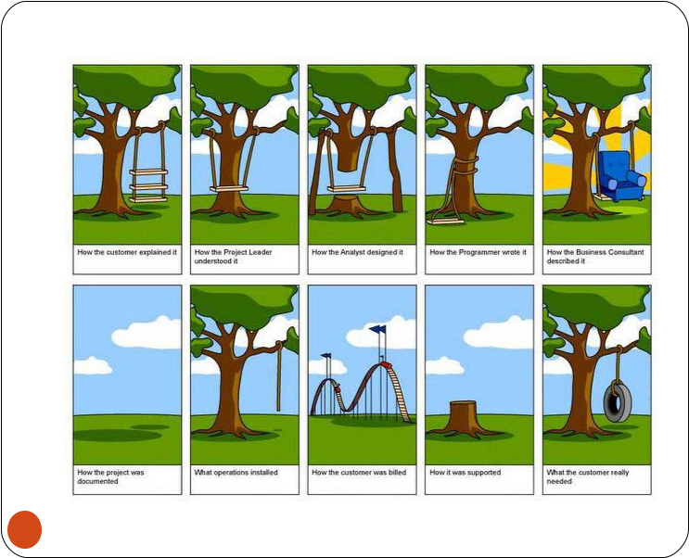

70
Client: “Our next requirement, this is something big, you know, we need an elephant…”

IT team : but why don’t you adjust with a buffalo, even it is big…. and black?”

C: No, we need only elephant, let me explain our current process……………..” (client explains for an hour)

IT :Fine, i understand ur requirement. But our system supports only buffalo…

- We need only elephant!

IT: Ok.. Let me see if i can customize”

Requirement taken : Client wants a big black four legged animal, long tail, less hair. Having trunk is mandatory. The same was documented, signed off and sent to offshore for development!

71



72
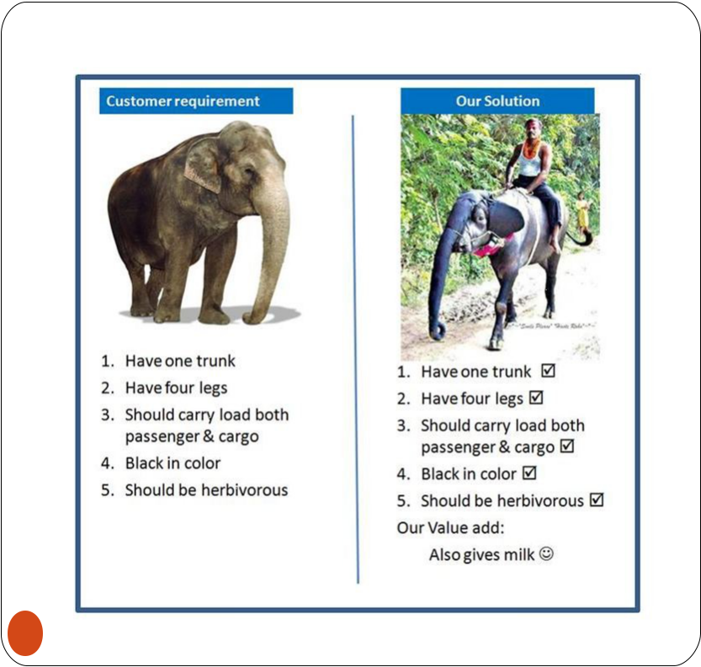

73

END

74

