Agile Project Management using SCRUM

Alfredo E. Flores Jr.

Facilitator

JRU and September 2017
Facilitator

- Alfredo E. Flores Jr.

– Certified Project Management Profession

– Certified Scrum Master

– Masters in Information Management

– Agile Coach and Facilitator

– Lean Practitioner

– Experienced IT professional with exposure to global organizations and various industries like Oil & Energy, Healthcare and Pharmaceuticals, Corporate and Finance Shared Services, and Training and Consulting.

2



Topic | Size | Est. Duration | Start
History | S | 10 | 9:30
What is Agile? | S | 10
Agile vs Traditional | S | 5
Scrum Overview | M | 20
Writing ‘Agile’ Requirements | L | 45 | 10:30
Lunch Break |  | 45
Estimation | M | 20
Planning | L | 45 | 2:00
Task breakdown | M | 15
Tracking Progress | M | 10
Timeboxed Meetings | M | 15
Wrap up |  |  | 3:00

3

History of Agile

4

Before Agile

Waterfall
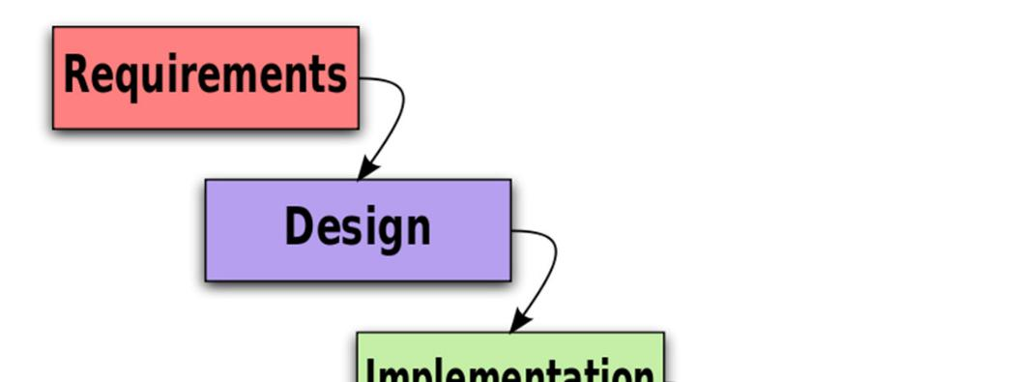

1970 article

by Winston W. Royce. Royce

Page 1: “What we have is an effective fallback position that tends to maximize the
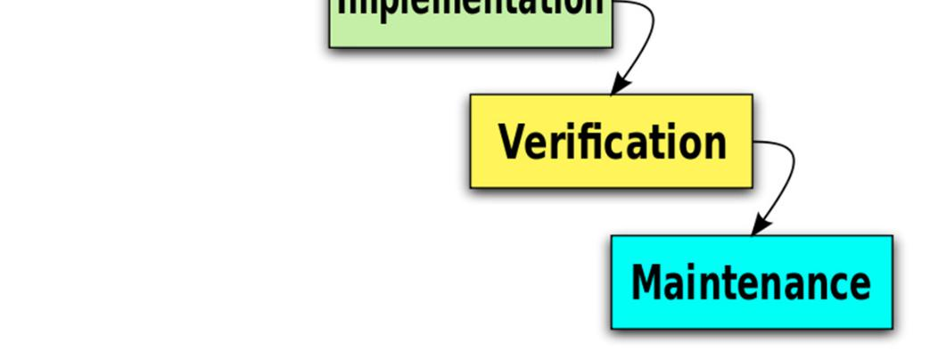

extent of early work that is salvageable and preserved.” …but on Page 2:

“I believe in this concept, but the implementation described above is risky and invites failure”

Traditional “waterfall” development depends on a perfect understanding of the product requirements at the outset and minimal errors executing each phase.

Source: Royce, Winston (1970), Managing the Development of Large Software Systems | 5

5

Project Management Crisis
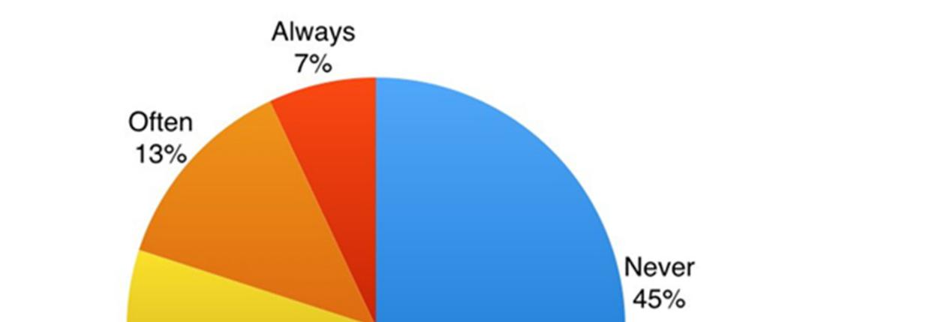

Standish Group Report

84% of projects were either

challenged or critical failure

64% of features are never
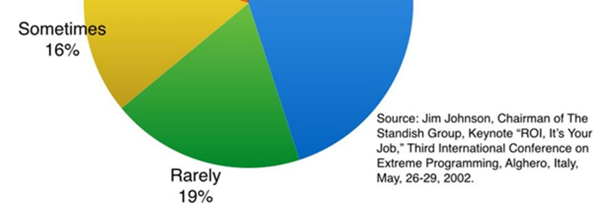

and rarely used

It’s not the people, it’s the process. There should be a fundamental shift on the way we do things.

6

What is Agile?

7

What is Agile?

Agile is a set of values and principles. It is not a process, methodology,

practices, or tool. It doesn’t really matter what processes, methodologies, and practices you apply. What is important is to shape the implementation around agile values and principles with the goal of gaining Agile mindset and delivering business results or value.


Methodology Framework Process

Values and Principles _{Practices}

Tools

Though there is value in the items on the right, we value the items on the left more

There is nothing called ‘Agile methodology’. Remember Agile is a set of values and principles

8

Agile Manifesto

We are uncovering better ways of developing software by doing it and helping others do it. Through this work we have come to value:

Individuals & | over | Processes & tools
interactions | over | Processes & tools
Working software | over | Comprehensive
Working software | over | documentation
Customer collaboration | over | Contract negotiation

Responding to change | over | Following a plan

That is, while there is value in the items on the

right, we value the items on the left more.

Source: www.agilemanifesto.org

9

9

Agile Manifesto Principles


Satisfy the |  | Welcome |  | Deliver |  | Collaborate
Customer |  | Change |  | Frequently |  | Daily


Support & Trust |  | Promote |  | Deliver |  | Promote
Motivated |  | Face-to-Face |  | Working |  | Sustainable
Teams |  | Conversations |  | Software |  | Pace

Promote |  | Maximize |  | Have |  | Reflect &
Technical |  | Through |  | Self-Organized |  | Adjust
Excellence |  | Simplicity |  | Teams |  | Regularly

Source: www.agilemanifesto.org

10

10

My favorites

#1 Our highest priority is to satisfy the customer through early and continuous delivery of valuable software.

#2 Welcome changing requirements, even late in development. Agile processes harness change for the customer's competitive advantage

#5 Build projects around motivated individuals. Give them the environment and support they need, and trust them to get the job done

#6 The most efficient and effective method of conveying information to and within a development team is face-to-face conversation

#7 Working software is the primary measure of progress

#10 Simplicity--the art of maximizing the amount of work not done--is essential
11

11

Agile vs Traditional

12

Delivering Business Value: Agile vs Waterfall


Analyze
Analyze |  | Design
 |  | Design | Code
 |  |  |  | Test
Waterfall |  |  |  | Test | Document |  |  | $
 |  |  |  |  |  |  | Deploy | $

Invest up front, only realize value at end, assuming value proposition hasn’t changed


Analyze Analyze Analyze

Design Design Design

Code Code Code

Test Test Test

Document Document Document

Deploy Deploy Deploy

$ $$ $$$

Agile

- Incrementally – opt to extend, redirect or cancel at a very granular level

- Deliver & realize value steadily

- Validate designs with users & customers

- Continuously adapt to risk and change

- Integrate early & often

13

13

Agile Methods and Practices
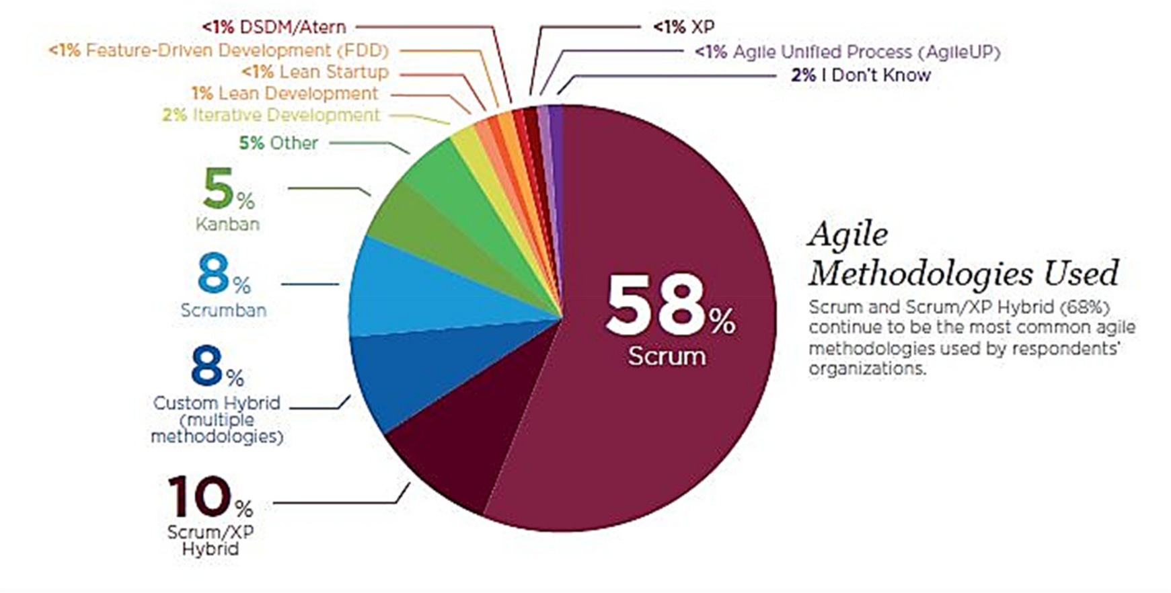

80% Scrum

related

Agile development is an umbrella term that describes several agile methodologies to handle IT teams and projects.

Source: 11th State of Agile Report

14

Reasons for adopting Agile
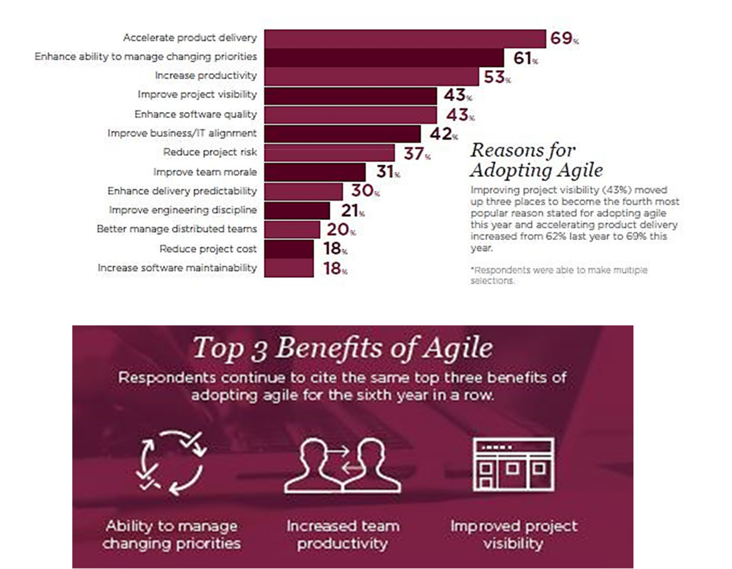

Source: 11th State of Agile Report ₁₅

Basic Concepts

16


Some Basic Terminology


Scrum | Definition
Sprint | Fixed-length period of time (timebox)
Release | Release to production
Sprint/Release Planning | Agile planning meetings
Product Owner | Business representative to project
Retrospective | “Lessons learned”-style meeting
Scrum Master | Process facilitator and helps team perform
Development Team | Empowered Cross-Functional team
Daily Scrum | Brief daily work update meeting

17

17

Incremental and Iterative Delivery


Iterating allows you to move from vague idea to realization. Going from rough to polished
1 2 3 4 5


Incrementing is more about delivery.
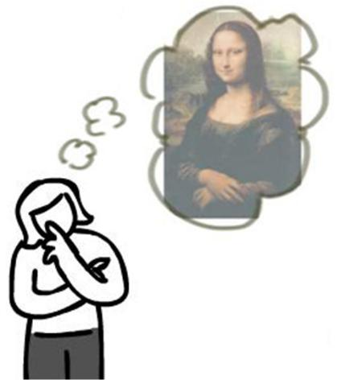

1 2 3 4 5


Image Credit: Jeff Patton

18

18

?

19

Scrum Overview

20

Scrum in a nutshell

- Scrum is an leading agile framework that allows us to focus on delivering the highest business value in the shortest time

- It allows us to rapidly and repeatedly inspect actual working product

- The business sets the priorities. Teams self-organize to determine the best way to deliver the highest priority features

- Anyone can see real working product and decide to release it as is or continue to enhance it for another sprint

21

Scrum Flow

For One Sprint

22

Scrum Flow


Scrum Master

Product Owner | The Team | The Team | The Team + Chickens | The Team
Inputs from Executives, | Team selects starting from | Daily Scrum Meeting | Demo of the product
Team, Stakeholders, | the top as much as it can | Daily Scrum Meeting | Demo of the product
Team, Stakeholders, | the top as much as it can | Team commits and work | Review of Work and
Customers, and Users | deliver by the end of sprint | Team commits and work | Review of Work and
Customers, and Users | deliver by the end of sprint | on the committed PBI | Decide on next steps
(Project Business Case |  | on the committed PBI | Decide on next steps
(Project Business Case | Planning and Grooming | Sprint (1-4 weeks) | Review | Retrospective
and Vision)
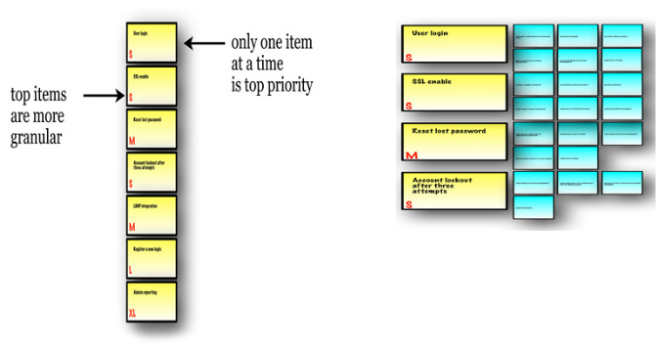


Potentially
Sprint Backlog
Releasable
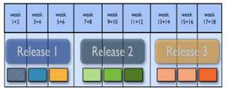
Project

Product Backlog

Release Planning
Schedule | 23

Scrum Roles

24

The Scrum Team


Product Owner

1. Facilitates (team decision and

process)

2. Helps team Perform

3. Detects and strive to Remove

Impediments

4. Achieve Transparency and

Visibility

5. Promotes Engineering

1. Sets Goals and Product Vision Practices


2. Create & Maintain the Product

Backlog

- Approves product

- Prioritize the Product Backlog

- Attends meetings

Scrum Master

The Development Team


- Cross-functional

- Commits to sprint

- Self-organizing

- Ideally in one room.

Most Successful with

long-term, full-

time membership

- 3 to 9 members

25

Artifacts

26

What do you notice about this chart?

Story | Priority | Points
Story A | 1 | 3
Story B | 2 | 8
Story C | 3 | 5
Story D | 4 | 1
Story E | 5 | 3
Story F | 6 | 3
Story G | 7 | 5
Story H | 8 | 13
Story I | 9 | 21
Story J | 10 | 8

27

Product Backlog
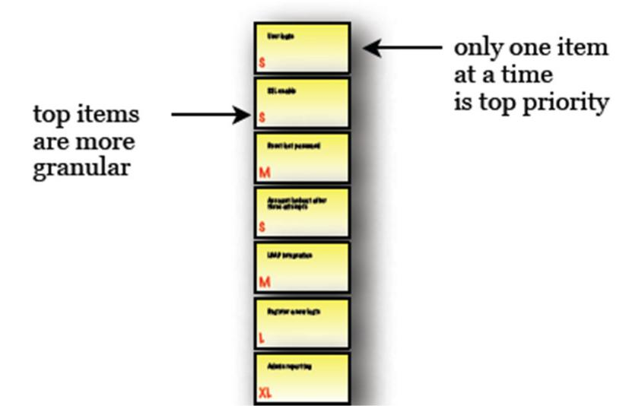

- Force-ranked list of desired functionality

- Visible to all stakeholders

- Any stakeholder (including the Team) can add items

- Constantly re-prioritized by the Product Owner

- Items at top are more granular than items at bottom

- Maintained during the Backlog Refinement Meeting

28

Sprint Backlog
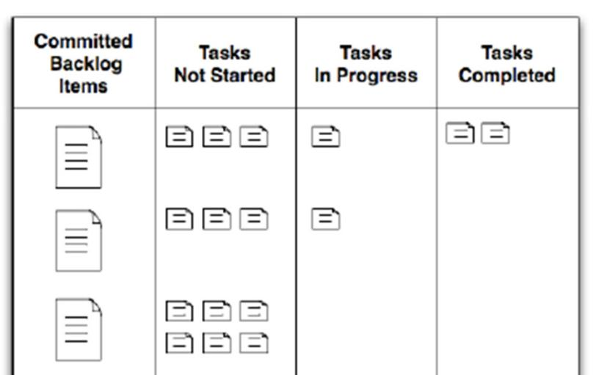

- Consists of committed PBIs negotiated between the team and the Product Owner during the Sprint Planning Meeting

- Scope commitment is fixed during Sprint Execution

- Initial tasks are identified by the team during Sprint Planning Meeting

- Team will discover additional tasks needed to meet the fixed scope commitment during Sprint execution

- Visible to the team
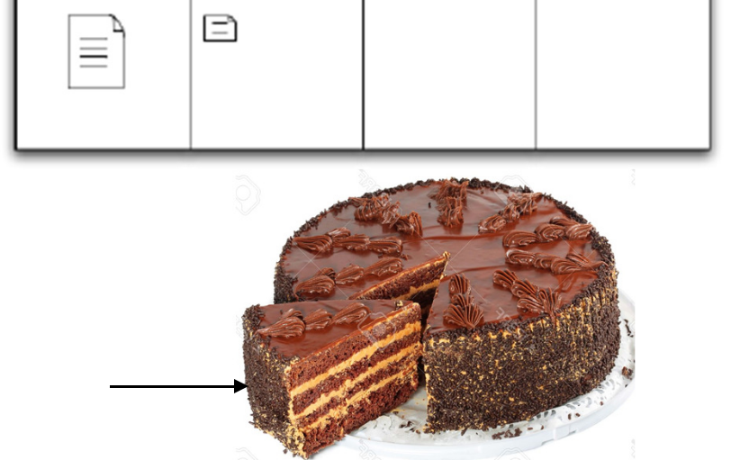

Sprint Backlog

29

#6 Law of Chaos


Law of the edible elephant: The only

way to eat an elephant is one bite at a time.

30

Ceremonies

31

Scrum Ceremonies

Ceremony | Time Box | Input | Output | Value
Backlog | <1 hr | Draft User Stories, | Finalized User Stories | Product Backlog &
Grooming* | <1 hr | Epics from Product | Technical Stories | Team are ready for
Grooming* |  | Owner | Ranking for top PBIs | Sprint Planning
 |  | Ranked Product | Sprint Backlog: | Team has a plan to
Sprint Planning | 2 - 8 hr | Backlog with | •Selected stories + | implement Sprint
Sprint Planning | 2 - 8 hr | Acceptance Criteria | estimates | Backlog
 |  |  | •Tasks + estimates
 |  | In-progress Tasks | Tasks updated | Team members on
Daily | <15 min |  | Impediments raised | same page re: Sprint
Daily | <15 min |  |  | progress and
Stand-Up | <15 min |  |  | progress and
Stand-Up |  |  |  | impediments
 |  | Demo prepared for | New Stories, based on | Ensure
Sprint Review | < 1 hr | completed stories | review by Product | appropriateness of
Sprint Review | < 1 hr |  | Owner Ranking may be | deliverables
 |  |  | revised
Retrospective |  | Sprint performance | Short list of | Learn from
Retrospective |  | data, e.g. Burndown | improvements for next | experience, enable
 | 1 - 1.5 hr | data, e.g. Burndown | improvements for next | experience, enable
 | 1 - 1.5 hr | chart | Sprint, with owners | continuous
 |  |  |  | improvement

* Not officially a Scrum Ceremony, but important

32

The Scrum Bible


The Definitive

Guide to Scrum:

The Rules of the Game

Developed and sustained by Ken Schwaber and Jeff Sutherland

https://www.scrumguides.org/docs/scrumguide/v2016/2016-Scrum-Guide-US.pdf

33

?

34

Writing ‘Agile’ Requirements

35

Introductory Exercise

- Find a partner

- Start telling them about yourself

- When they hear something you both have in common, they will say “Me Too!” and find a new partner
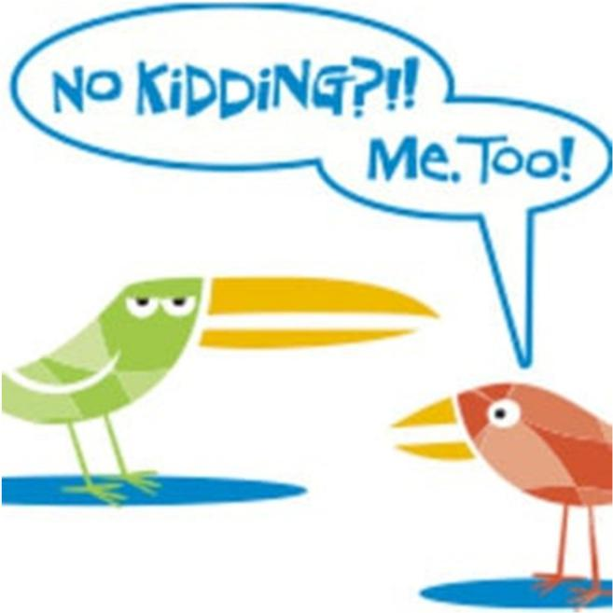

36

Requirements and Progressive Elaboration

We’ve learned that

- Detailed requirements are often wrong and incomplete

- The real details emerge over time, as we work

Scrum formalizes this progressive elaboration

- Start with brief written requirements

- Develop improved understanding over time
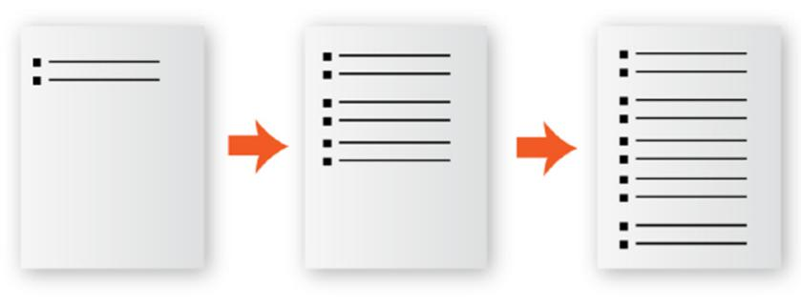

Users don’t know what they want until they see a working product or software - Haumprey’s Law

IKIWISI

37

Progressive Elaboration in Scrum

Work | When | Result
Writes one-line summary | Anytime | Story Title
Writes description of the | Anytime | Story Narrative
deliverable
Summarizes what to | Anytime | Story Acceptance Criteria
validate
Team reviews the PBI | Backlog Grooming | List of questions, issues
before planning
Team estimates PBI | Sprint Planning | Estimates
Team identifies and | Sprint Planning | Task breakdown
estimates tasks
Team develop | Sprint Execution | Test Cases
acceptances test

38

User Story

A short narrative description of user-facing functionality that one Team can implement in a few days

Title | Any short and meaningful title

Narrative

Start with summary in one of these standard forms: As a <Role>, I want to <Action> so that <Benefit> A <Role> can <Action> so that <Benefit> <Role><Action> so that <Benefit>

If necessary, elaborate on how user interacts with this new deliverable. Include links to images, screen designs, or other external documents of interest. Make sure that the results are testable.

Acceptance Criteria

List specific criteria that must be met for deliverable to be accepted

39

Example: User Story

Title

View grades online

Narrative

As a student, I want to see my grades on line so that I won’t have to go to school to check if I pass.

Acceptance Criteria

- Runs in popular web browsers like Mozilla, Chrome and EI11

- I should see grades for the current semester’s grades by subject in a columnar form:

Subject | Grades
English | A
Science | A
Math | B+
Music | B-

40

What makes a good user story?

INVEST | Description
Independent | Make Stories as independent from each other as
 | possible
Negotiable | Brief description. Details emerge in discussion
Valuable | Users and customers perceive value in the
 | deliverables
Estimable | Domain, technical knowledge allow Team to provide
 | estimate
Small | Team can finish one Story in a few days, several in
 | one Sprint
Testable | Validation criteria and techniques are specified
 | clearly

41

Are users stories equivalent to requirements?

42

Requirements, More than Just a Story


Requirements


Context (Project Vision, Business Case, etc)


User | Conver- | Acceptan | Supporting
User | Conver- | ce | Supporting
Story | sation | ce | information
Story | sation | Criteria | information






Common Understanding of the need

43

Exercise – Write User Stories

- Create at least five sprint-sized User Stories based on your project

- Use the user story template

44

?

45

Estimation

46

Estimation

- Each PBI takes time to implement

- We need estimates to plan for sprints

- Rough estimates will do –Good enough is good enough

–Precision cost time we can’t afford and there isn’t available anyway


47

Estimation using Fibonacci
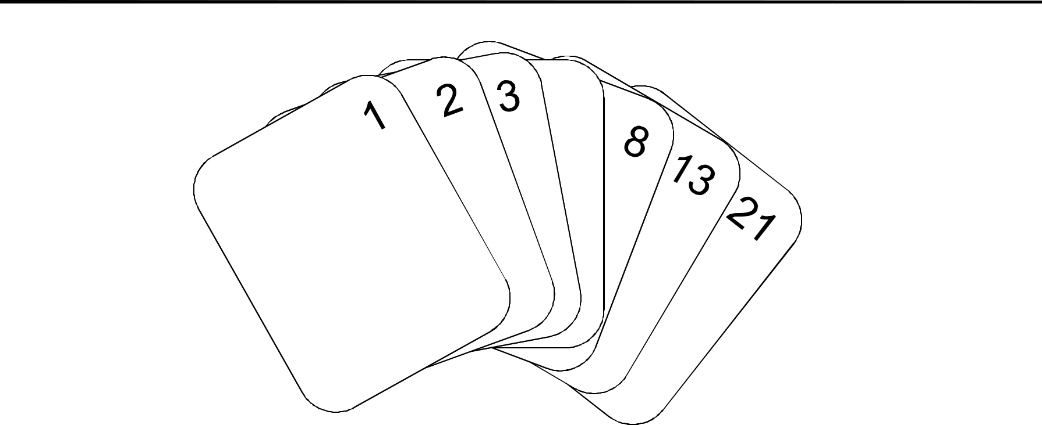

5

- Fibonacci sequence is a series of number that follow unique integer sequence.

- These numbers generate mathematical patterns that can be found in most aspect of life.

- Patterns that can be found in everything from the human body to the physiology of plants and animals
48

48

Planning Poker Instruction

- Product Owner/Moderator reads PBI to team

- Team, Product Owner discuss & clarify for up to 10 minutes (time boxed!)

- Facilitator asks Team members to pick and hide card with estimate

- Facilitator asks all Team members to show cards

- If all agree, Facilitator records estimate and moves on

- Otherwise, Facilitator asks low & high voters to explain the reasoning for their votes

- Facilitator asks for re-vote, after discussion.

- Vote up to three times, if necessary to converge

Can’t converge?

If close, Team picks “good enough” value

If not close, can’t estimate, so ask Product Owner to revise PBI for later estimation
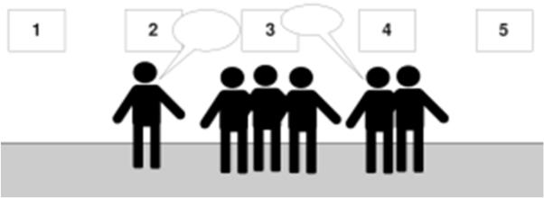

49

Estimation Practice
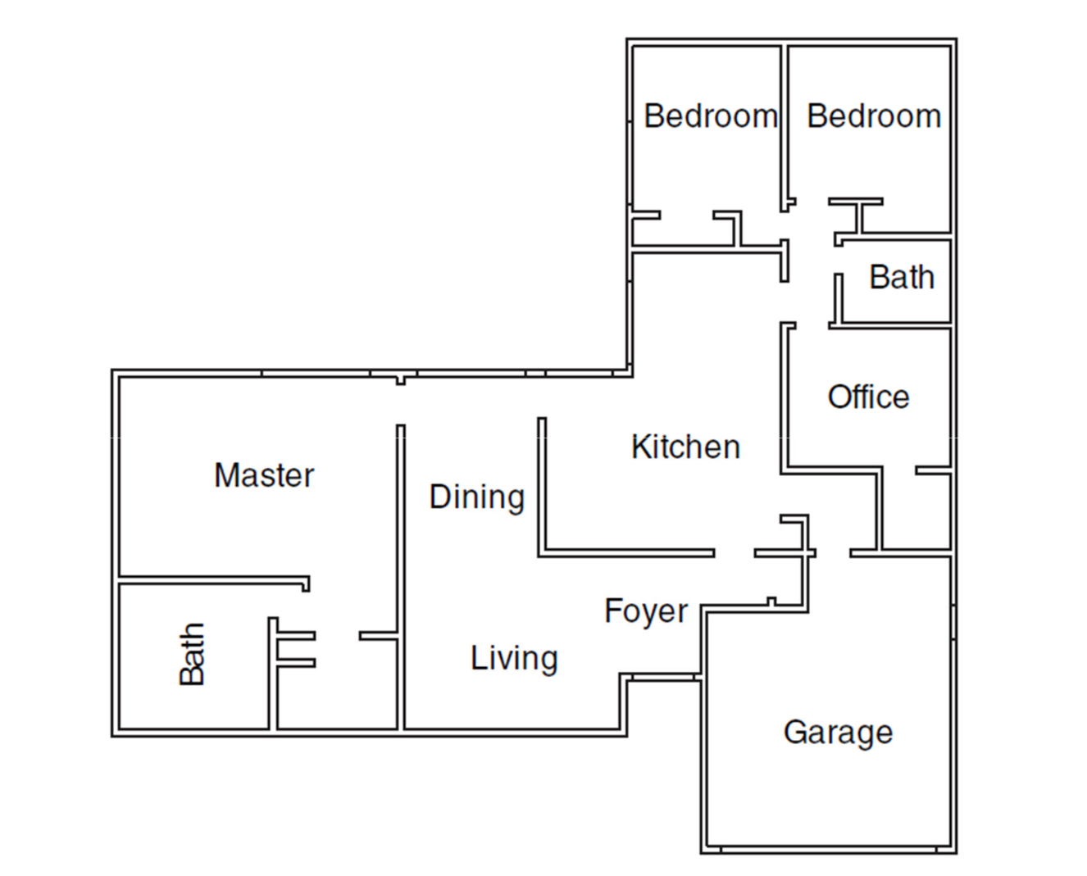

How long will it take to paint the house?

50

Team Exercise: Estimate Stories

Use Planning Poker® decks

- Story’s author will be Product Owner

- Pick Scrum Master to facilitate estimation session

- Estimate effort

- Estimate Stories written in previous exercise

• Record final Story estimate on Story’s template

Time: 20 minutes

51

51

?

52

Task Breakdown

53

The Task Breakdown

The Task Breakdown
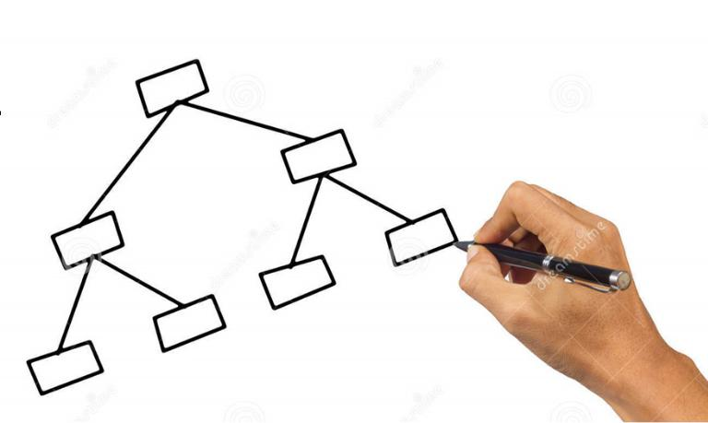

- Is list of tasks required to implement a PBI

- Is created by the Team at or before start of Sprint

Why we need the Task Breakdown

1.To provide a clear to-do list for the Team

- Important for Swarming

2.To enable us to track progress effectively

3.To gain additional understanding of requirements Progressive elaboration!

4.To provide a more refined estimate of size for Backlog Items

54

Contents of Task Breakdown

- Trackable tasks (2—16 hours)

- All work required to achieve the Definition of Done

- Design solution, define tests, implement tests, implement solution, deploy to QA, execute tests,…

- Ordered (roughly) by time

- We want parallel task work, so true ordering is not possible

55

Exercise: Create Task Breakdowns

- Review sample Story and Defect breakdowns

- Use task-breakdown template

- Create a Task Breakdown for the Story you developed earlier

- Tasks should include all implementation, testing, and bug fixing work Do not estimate tasks at this point

- Let’s review by team

Time: 10 minutes

56

Estimating Tasks

- Planning Poker provided initial PBI estimate

- Task-breakdown improves understanding of work

- Team estimates all tasks, in units of Person-Hours

– “How many hours will one person need to finish this task?”

- Estimate with informal team discussion

– Overhead of Planning Poker not justified

- Sum of task estimates provides improved PBI estimate

– Divide total person-hours by 8 to get Person-Days

57

Team Exercise: Estimate Tasks

Use Task Breakdowns previously developed

- Discuss each task, estimate it in person-hours

- Put estimates on the template, by the tasks

- Compute new Story estimate

  - Sum task estimates for each Story to provide a task total

  - Divide by 8 to get Person-Days

  - Update Story template with revised Story estimate

Time: 15 minutes

58

?

59

Planning for Sprint

60

The Sprint

- Smallest unit of scheduled working time for a project

– Fixed-length period during which work for a set of PBIs is done

– Larger cycles are built out of multiple Sprints

- Time-boxed interval, typically 2—4 weeks, focused on a particular type of work

– Boundaries are firm!

– Sprints are not extended to finish work

- Sprints should have standard

– Experiment, then standardize

61

Defining Velocity

- Velocity is a crucial concept in Sprint Planning

- We define Velocity to be the amount of work done in a Sprint

- For a completed Sprint:

Velocity = sum of estimates of PBI’s completed in the Sprint

- Same PBI estimates used in planning for that Sprint

– Not defined based on Task estimates

– Items started but not finished in the Sprint do not contribute to the Sprint’s Velocity

- We need a forecast of a future Sprint’s Velocity in order to plan that Sprint

62

The Three Phases of Planning Sprints

- Develop the Sprint Schedule

– Activities, milestones

– Schedule usually repeated without modification

- Forecast Sprint Velocity

•Responsibility of Scrum Master

3.Allocate work to the Sprint

– Estimated by Team

– Facilitated by Scrum Master

– Requirements supplied by Product Owner

63

Introduction to Sprint Scheduling

Schedule of activities includes

- Sprint Planning Meeting*

– Part 1: Estimate PBIs, create initial Sprint Backlog

– Part 2: Create Task Breakdowns, finalize Sprint Backlog

- Daily Stand-Up Meeting

- Backlog Grooming (for next Sprint)

– Team & Product Owner review, refine, fill gaps in Product Backlog

- Sprint Review Meeting

– Retrospective Meeting Capture lessons learned, plan for improvement

* Product Owner must be present for Part 1, but usually does not attend Part 2

64

Sample Two-Week Sprint

(Planning for sprint in yellow boxes)

 | M | T | W | TH | F | M | T | W | TH | F
8am
 | Sprint
9am | Sprint
9am | Planning
10am
11am
12nn
1pm
2pm
3pm |  |  |  |  |  |  |  |  |  | Sprint
 |  |  |  |  |  |  |  |  |  | Review
4pm |  |  | Backlog |  |  |  |  | Backlog |  | Retrospe
 |  |  | Groomin |  |  |  |  | Grooming |  | ctive
 |  |  | g
5pm

65

Any question?

66

Four Techniques for Forecasting Sprint Velocity

- Estimate how much work Team can do in the Sprint

– Based on Team membership, Sprint duration.

– Technique depends on choice of units (Relative or Absolute)

- Should be informed by history

– Revise assumptions based on experience

- For Relative units, methods include 1.Est. Velocity = Same as last Sprint

2.Est. Velocity = Average of last three Sprints

- For Absolute units, methods include the above and 3.Est. Velocity = people × days × focus factor

4.Estimate from detailed resource model (follows)

Scrum Master estimates prior to Sprint Planning Meeting

67

Forecasting Velocity via Resource Model

- Determine available working time in Sprint, per person

- Determine effective resources of team

  - Subtract meeting times, vacation, holiday time per person

  - Estimate availability per person

- Compute working time

  - Per person: Availability * (workdays – time off)

  - Per team: Sum of per-person capacities

- Maximum availability is 75%

  - Leads have 50% or less

  - Shared people have much smaller numbers per Team

DEFINITIONS:

Availability

Fraction of workday an individual can work on PBIs

•Excludes scheduled Sprint activities

Net Team Resources Effective number of full-time Team members

68

Sample Velocity Forecast for One-Week Sprint

Assume 8 hours in Scrum Meetings per Sprint (of 40 hours)

Team Member | % Avail |  | Hrs Off | Hours
Nathan |  | 25% |  | 8
Lisa |  | 40% |  | 12.8
Audrey |  | 75% |  | 24
Ivan |  | 75% |  | 24
Walline |  | 75% |  | 24
Yam |  | 50% | 16 | 8
Joshua |  | 75% |  | 24
Velocity |  | 15.6 | Team Hours | 124.8

- Hours = Avail. * (Net work hours in Sprint – Hours off)

- Team Resources = Team Hours / (Work hours in Sprint)

- Velocity = Team Hours / 8

69

Limitations, Benefits of Velocity Forecasting

Limitations Benefits


- These forecasting methods assume work is generic

- They do not account for specialization of resources

- They will not work if specialization is extreme

- Analysis is optimistic

- Best-case scenario, because it omits specialization

- Straightforward and easy to understand

- •Simplicity has value! Bounds what can be done

- •Work that exceeds the optimistic estimate is unlikely to be completed

Velocity forecasting is an effective planning technique for a Team of Generalizing Specialists

70

Exercise: Forecast Velocity

- Use template

- Estimate Velocity for each of 2 teams of 4 people, with two-week Sprint

- Let’s review

Time: 25 minutes

71

?

72

Tracking Progress

73

Acquiring Task Information

- What we want to know about Tasks

– Estimate for task effort (person-hours), from Task Breakdown

– Status: Not Started, In Progress, or Complete

– If In Progress, the Effort Remaining (maybe)

    - Often not reliable. Beware of “1 hour remaining” for 3 days!

– After completion, the actual time required (maybe)

    - Required for billable hours, hard to get from Team otherwise

    - Can be used to refine estimation process over time

- •When we need to know these things

– Now (whenever status changes)

– Each Team member is responsible for providing status information!

– Scrum Master has to prompt occasionally…

74

Summarizing Progress via Burndown Chart

Red: Amount of remaining work (“Estimate to Complete”)
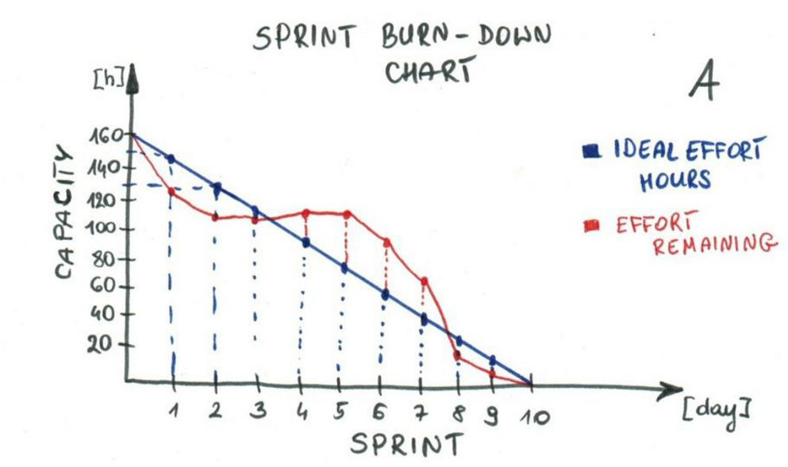

Sum of estimates for

uncompleted tasks

Blue: Plan

Goes to zero at end of Sprint

Usage: Primarily for time span of a Sprint

75

Exercise: Make a Burndown Chart

- Use Burndown chart template

- Draw ideal progress line from 90 at Day 0 to 0 at Day 10

- Use these “Work Remaining” figures for column chart
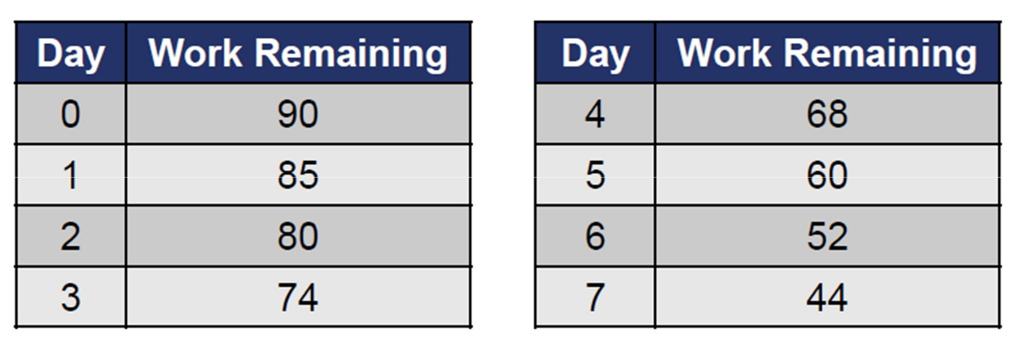

Time: 5 minutes

Question: Is planned work likely to complete in Sprint?

•What do you predict for the deviation from plan?

76

?

77

Time box meetings

78

Backlog Grooming

Purpose

- Ensure Product Backlog & Team are ready for future Sprint Planning Meetings

– When: 1—2 hours per week

– Who: Team, Product Owner

- Actions in meeting

– Provide feedback on clarity, quality, acceptance criteria, dependencies, ranking of Stories

– Identify “holes” (esp. technical) for which Stories must be written

– Break Epics into Stories

– Do long-term technical (architecture / infrastructure) planning

– Identify, update list of, risks / threats / issues, & incorporate into Backlog


Follow-up actions

• Team, Product owner write or revise Stories, as needed

79

Sprint Planning Meeting

Purpose: Assign PBIs to Sprint Backlog

– Scrum Master facilitates, enforces selected time box

– E.g., 1 hour, if Team has reviewed PBIs carefully in advance

Part 1:

For each Product Backlog Item (PBI), in rank order 1. Product Owner reads PBI to Team

2. Team discusses, asks Product Owner to clarify details

3. Scrum Master facilitates estimation & records results

4. Scrum Master adds PBI to Sprint Backlog

5. Planning is finished when Sprint Backlog is filled to Velocity limit

Part 2:

- Team creates Task Breakdowns for Sprint Backlog items

- Revise scope of Sprint Backlog as needed based on Task estimates

80

The Sprint (Each Day’s Major Activities)

Purpose: Implement PBIs in Sprint Backlog

- Scrum Master monitors work, facilitates issue resolution

- Team members swarm to implement PBIs in rank order

– Ask Product Owner to clarify requirements

– Ask Scrum Master to resolve issues the Team cannot resolve

- Team members update status of each task

– On starting, finishing, revising “to-do” effort, …

- Team members don’t start PBIs they can’t finish in Sprint

– Maintain discipline of finishing what is started!

81

Daily Stand-Up Meeting

Purpose: Promote common understanding of Sprint status, and identify issues to be resolved

– Scrum Master facilitates, enforces 15-minute time box

– Team members, Scrum Master, Product Owner attend

Agenda

1.Scrum Master shows burndown chart, describes progress

2.Each Team member describes

What I’ve done since the last Daily Stand-Up meeting

What I plan to do before the next Daily Stand-Up meeting What issues I’m facing that I need help to resolve

In meeting

- Decide who will collaborate to resolve each issue after the meeting (“sidebar discussions”)

82

Sprint Review Meeting

Purpose: Confirm acceptability of implementations

- Scrum Master facilitates, enforces selected time box Agenda

- 1.Team demonstrates finished PBIs to the Product Owner

– Team members decide who will do the demonstrations.

– One person does all; round-robin style; etc.

2.Product Owner provides final decision on whether implementations are acceptable for release

– If not, then they are not released

– Should be rare, since PO monitors & evaluates throughout Sprint.

After

• Product Owner writes Stories for changes to implementations

83

Retrospective Meeting

Purpose: Learn from experience, and improve

– An example of “kaizen” concept of continuous improvement

– Scrum Master facilitates, records, enforces time box

– Say, 60 minutes total: 30 for recording, 30 for discussion

Agenda

1. Review status of work items from previous Retrospective

2. Team members, Product Owner, Scrum Master answer What went well, that we should do again?

What would we like to be better?

3. Specify follow-up actions

1.Prioritize improvements

2.Select top few to address

3.Select owners to drive improvements

84

How to Conduct a Retrospective Meeting

How to capture “went well, want to be better” items

- Don’t ask to give info one at a time Sequential query is slow Risks anchoring

- Do ask everyone to write items on sticky notes, post on board Parallel data collection is quick

Minimizes anchoring

How to define follow-up actions

– Consolidate similar items

– Use multi-voting to rank suggested improvements

– Discuss, re-vote as needed to get consensus

– Ask for volunteers to own each item that requires follow-up effort

– Stop when consensus is that we’re tackling enough

85

Wrap Up

86

