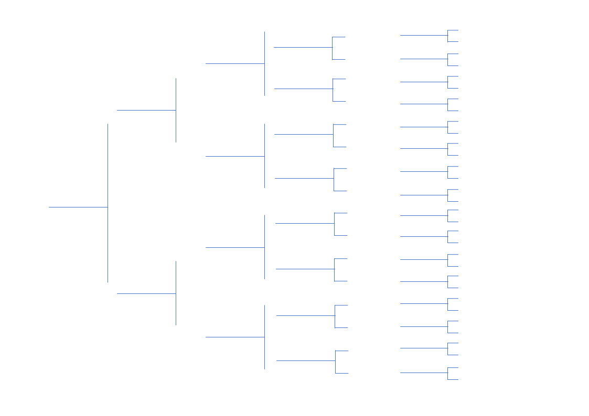

Alan Smith (1950-2018)

Alan Smith (1950-2018)

Alan Smith (1950-2018)

Alan Smith (1950-2018)

Alan Smith (1950-2018)

Alan Smith (1950-2018)

Alan Smith (1950-2018)

Alan Smith (1950-2018)

Alan Smith (1950-2018)

Alan Smith (1950-2018)

Alan Smith (1950-2018)

**Family Tree**

**6 Generation**

Betty Wang (1960-2019)

Alan Smith (1950-2018)

Alan Smith (1950-2018)

Betty Wang (1960-2019)

Alan Smith (1950-2018)

Jeremy Hinn (1980- )

Betty Wang (1960-2019)

Betty Wang (1960-2019)

Alan Smith (1950-2018)

Betty Wang (1960-2019)

Betty Wang (1960-2019)

Betty Wang (1960-2019)

Betty Wang (1960-2019)

Alan Smith (1950-2018)

Alan Smith (1950-2018)

Alan Smith (1950-2018)

Alan Smith (1950-2018)

Alan Smith (1950-2018)

Alan Smith (1950-2018)

Alan Smith (1950-2018)

Alan Smith (1950-2018)

Alan Smith (1950-2018)

Alan Smith (1950-2018)

Alan Smith (1950-2018)

Alan Smith (1950-2018)

Alan Smith (1950-2018)

Alan Smith (1950-2018)

Alan Smith (1950-2018)

Alan Smith (1950-2018)

Alan Smith (1950-2018)

Alan Smith (1950-2018)

Alan Smith (1950-2018)

Alan Smith (1950-2018)

Betty Wang (1960-2019)

Betty Wang (1960-2019)

Alan Smith (1950-2018)

Alan Smith (1950-2018)

Alan Smith (1950-2018)

Alan Smith (1950-2018)

Alan Smith (1950-2018)

Alan Smith (1950-2018)

Alan Smith (1950-2018)

Alan Smith (1950-2018)

Alan Smith (1950-2018)

Alan Smith (1950-2018)

Alan Smith (1950-2018)

Alan Smith (1950-2018)

Alan Smith (1950-2018)

Alan Smith (1950-2018)

Alan Smith (1950-2018)

Alan Smith (1950-2018)

Alan Smith (1950-2018)