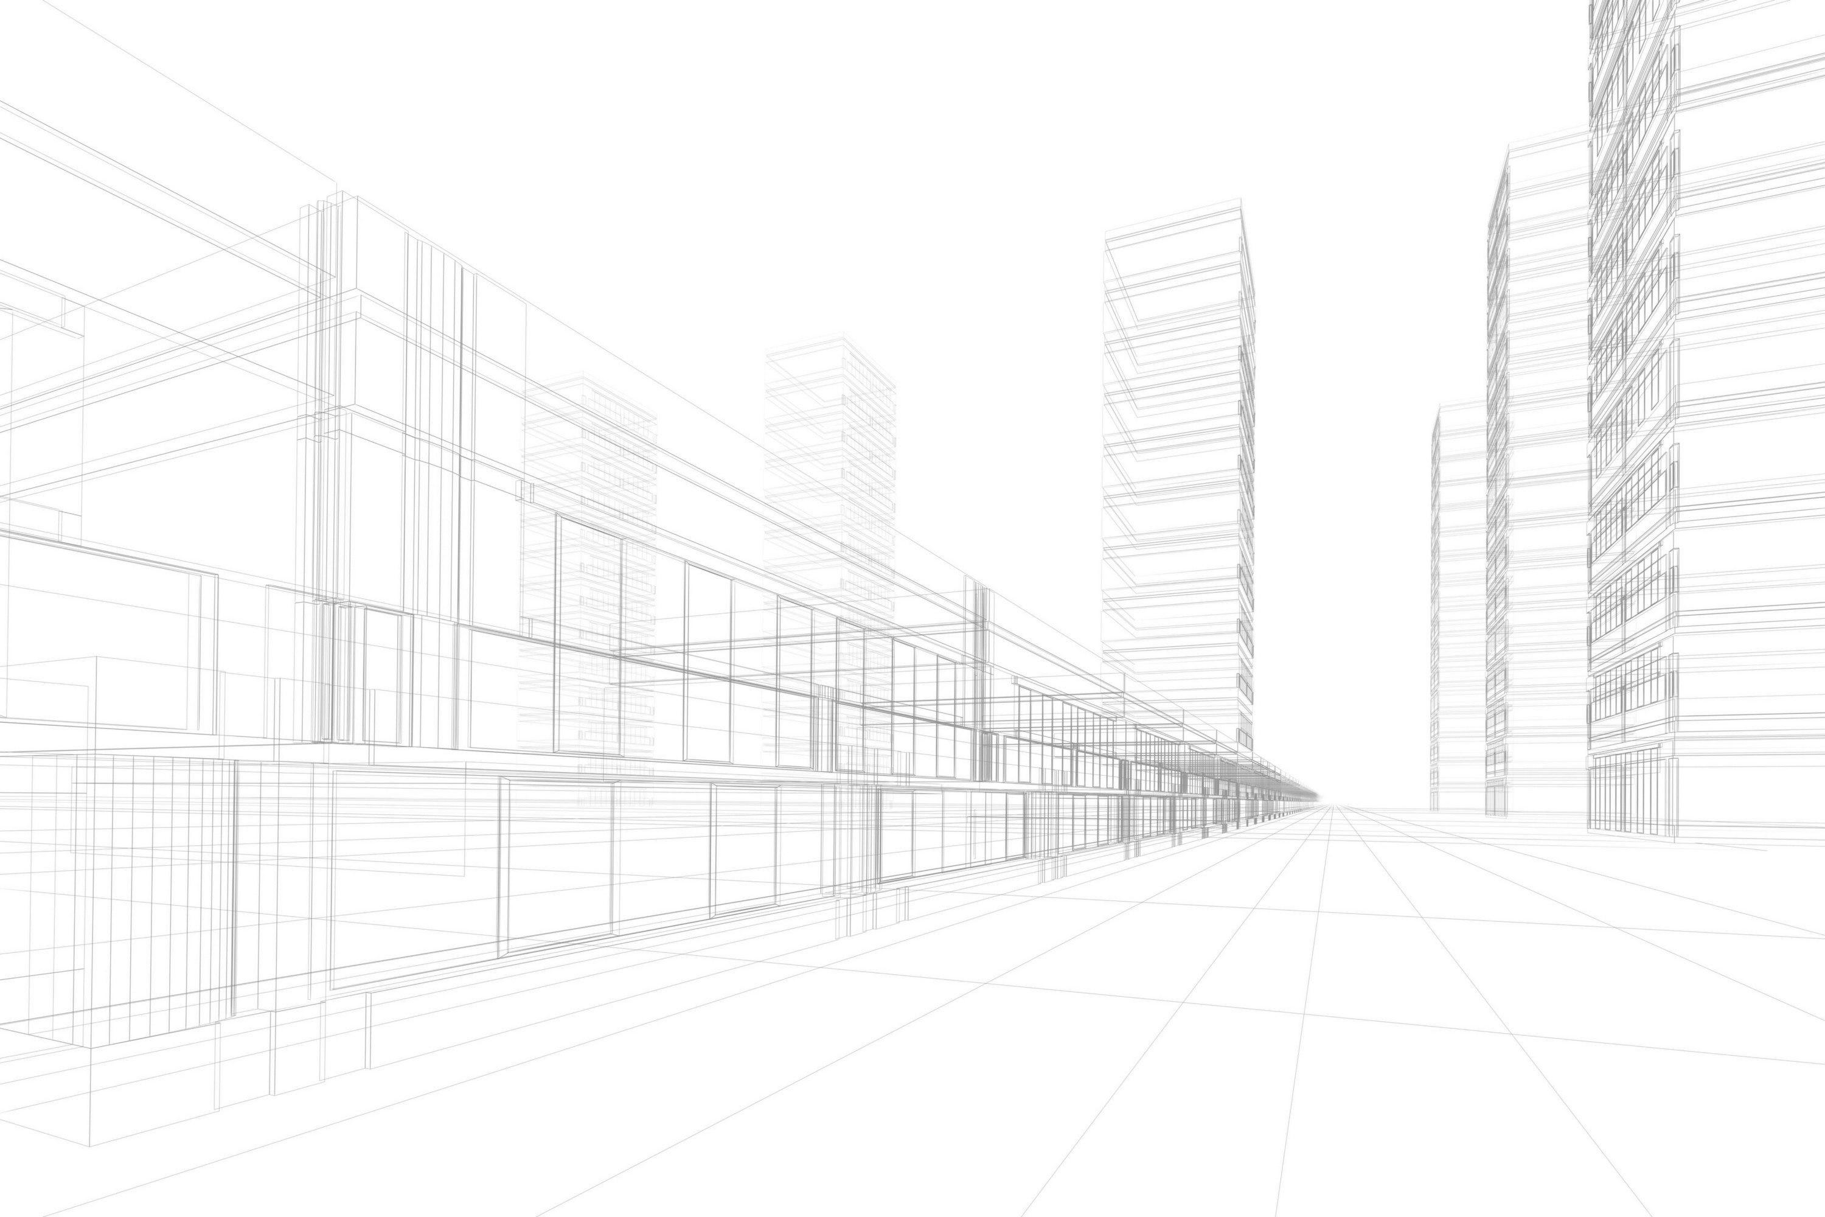

EMPLOYEE

Adam Smith

EMPLOYEE

Adam Smith

EMPLOYEE

Adam Smith

EMPLOYEE

Adam Smith

EMPLOYEE

Adam Smith

**CONSTRUCTION ORGANISATIONAL CHART**

Adam Smith

EMPLOYEE

Adam Smith

SUPERSIVOR

Adam Smith

PROJECT MANAGER

Adam Smith

GENERAL MANAGER

EMPLOYEE

Adam Smith

EMPLOYEE

Adam Smith

EMPLOYEE

Adam Smith

SAFETY DEPARTEMENT

Adam Smith

CONTRACT DEPARTEMENT

Adam Smith