IN THE SUPREME COURT OF THE STATE OF NEVADA
1
- In the matter of Amendments to SCR)
- 214, SCR 98 and SCR 121.1 regarding)
)

completion of the Introduction to)
- Nevada Practice and Procedure) Program, establishing mentorship)
- program, and suspending an attorney’s)
)
- license for noncompliance, respectively ) 7
ADKT NO.: 0464

- REPORT TO THE COURT AND REQUEST TO PERMANENTLY
- ESTABLISH THE TRANSITIONING INTO PRACTICE PROGRAM
- On November 16, 2011, the Court submitted Order 0464 Establishing the Pilot
- Program for the Transitioning Into Practice (TIP) Program for newly admitted
- attorneys. The Court requested that within one year, the State Bar of Nevada’s
- Board of Governors (“Board of Governors”) provide the Court its permanent Rule
- amendments and a report regarding the status of TIP.
- On October 29, 2012, the Board of Governors submitted a status report and
- amended rule; both are attached hereto in their entirety as Exhibit A. On
- December 5, 2012, the Court issued a second Order extending TIP until
- November 30, 2013.
- Since the Court’s authorization of TIP in November 2011, the State Bar of
- Nevada has piloted three six-month TIP cycles, with the fourth TIP cycle
- scheduled to begin September 2013. More than 400 newly admitted attorneys
- have completed or are near completion of an extensive program introducing them
- to the legal community and to the ethical and professional conduct expected of
- Nevada’s legal practitioners. To support these newly admitted attorneys, the State
- Bar of Nevada has:

1

  - • Recruited more than 280 attorneys to serve as Court approved mentors;
  - • Successfully petitioned the Nevada Board of Continuing Legal
  - Education (CLE) to increase the number of CLE credits granted to
  - mentors per TIP cycle from three to six (two ethics) credits;
  - • Surveyed mentors and new attorneys after each TIP cycle and used
  - survey results to make administrative changes to the program;
  - • Partnered with Legal Aid of Southern Nevada to host a luncheon for TIP
  - participants where they learn about pro bono and have an opportunity to
  - meet members of the local judiciary (a free video is also available for
  - those unable to attend);
  - • Continued its outreach campaign to encourage experienced attorneys to
  - serve as mentors, including articles and advertisements recognizing their
  - contributions to the program in the Nevada Lawyer, and through public
  - speaking events;
  - • Offered live CLE courses of interest to TIP participants at reduced fees;
  - • Held kickoff events for each TIP cycle in Las Vegas and Reno where
  - participants get to know members of the legal community; and
  - • Put plans in place to produce short mentoring videos to supplement the
  - online library of mentor resources. 20
- The Board of Governors has evaluated TIP and considers the program to be an
- effective and valuable tool to transition newly admitted attorneys to the practice of
- law. Therefore, the Board of Governors respectfully requests that the Court take
- into account the October 2012 status report, the 2013 addendum included in 25

2

- Exhibit A, as well as the update provided in this report and permanently establish
- the TIP program.
- Administrative Docket 0464 is attached for the Court’s consideration as
- Exhibit B. 5
- Respectfully submitted this day of July 2013.
- STATE BAR OF NEVADA
- BOARD OF GOVERNORS

9 _
- ALAN F. LEFEBVRE, President Nevada Bar No. 848
- State Bar of Nevada
- 600 E. Charleston Boulevard
Las Vegas, NV 89104
13 (702) 382-2200
14
15
16
17
18
19
20
21
22
23
24
25

3

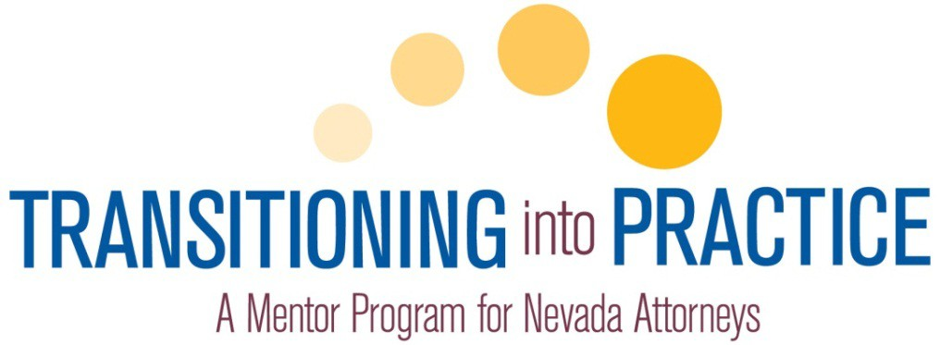

State Bar of Nevada
TIP Status Report to the

Supreme Court of Nevada
Chief Justice Michael Cherry

October 24, 2012

STAT E B A R O F N EVA D A

October 29, 2012


Chief Justice Michael Cherry Supreme Court of Nevada
201 South Carson Street, Ste. 250 Carson City, NV 89701-4702

Re: Transitioning into Practice (TIP) Dear Chief Justice Cherry:
On November 16, 2011,the Court submitted Order 0464 Establishing the Pilot Program for the Transitioning into Practice (TIP) Program for newly admitted attorneys. The Court also requested that within one year, the State Bar of Nevada's Board of Governors provide the Court its permanent Rule amendments and a report regarding status of the TIP Program.

The State Bar of Nevada has implemented two, six-month pilot TIP cycles, with the fist cycle set to end this month. We are pleased to present to the Court the valuable feedback gained from our volunteer mentors and the newly admitted attorneys participating in the Program. Overall,we consider TIP to be a valuable experience to both new attorneys and their mentors, and believe its continued operation will be of benefit to the legal community. Therefore, the Board of Governors respectfully submits the Transitioning into Practice report and ADKT amending SCR 214, SCR 98 and SCR 121.10 establishing TIP permanently.

We appreciate the Court's support and attention to this matter. As always, please do not hesitate to contact me with questions or concerns.

Respectfully,
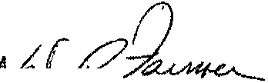


Executive Director

cc: Justice Michael L. Douglas Justice Mark Gibbons Justice James W. Hardesty Justice Ron Parraguirre Justice Kristina Pickering Justice Nancy M. Saitta Tracie Lindeman
Francis C. Flaherty, State Bar of Nevada President

600 East Charleston Blvd. Lis v g,,,NV 89104,1563 phone 702.382.2200
rollfre 800.254.2797
fax 702.385.2878

94S6 Double R Blvd., Ste. B Reno, NV 89521·5977 phon<C 775.329.4100
fu 775.329,0522

www.nvbar.org

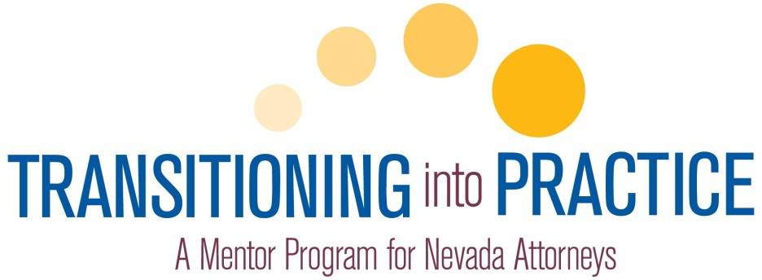

TABLE OF CONTENTS

  - TIP Executive Summary

    - Mentor Demographics
    - New Attorney Demographics
    - Program Administration

  - TIP Highlights

  - ADKT

  - Mentor Survey Results

  - New Attorney Survey Results

  - Mentor Program Manual

  - TIP Mentor Plan
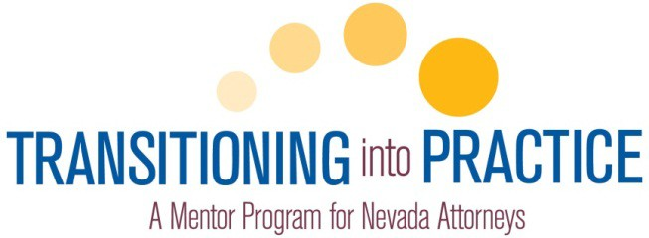

TIP Executive Summary

October 3, 2012

The State Bar of Nevada’s Transitioning into Practice Program is underway. The spring pilot cycle began in April 2012 and ends October 30, 2012. That cycle paired 182 new attorneys located throughout the State with 165 mentors. New attorneys and mentors were matched based on practice areas, location and firm/organization size as well as the mentor’s preferred mentoring relationship (i.e. in house, outside, circle, etc.).

The fall pilot cycle began on August 1, 2012 and will continue through February 1, 2013. In this cycle, 76 new attorneys have been paired with 72 mentors. With few exceptions, mentors serving in the spring TIP cycle were not used in the fall cycle.
Mentor Demographics

Mentors: 227 attorneys formally appointed by the Supreme Court.

Mentor Practice Settings:

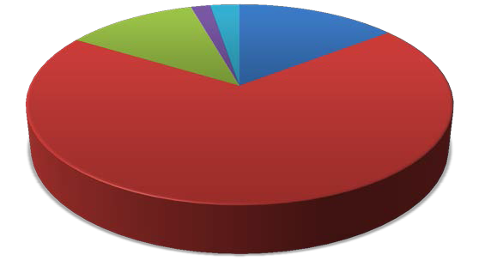
In- House/Corp. 2%

Other 3%

Solo
14%

Government
12%

Law Firm 69%

Mentor Locations:

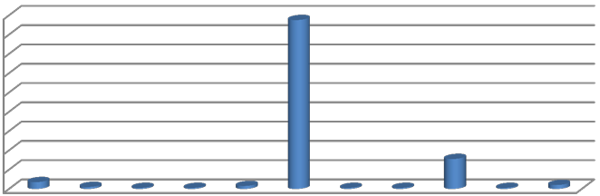
180
175
31
7
2
1
1
3
1
1
1
4
160
140
120
100
80
60
40
20
0


Mentor Years in Practice:

21+ years
32%

  - years
16%
7-10 years
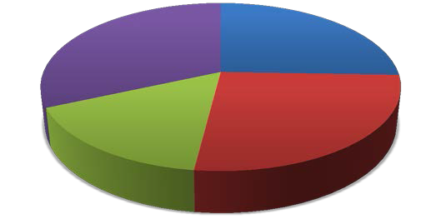
26%

11-15 years
26%

Mentor Office Size:1

Large 22%

Medium 22%

Solo
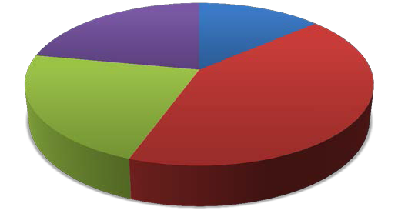
14%

Small 42%

1 Solo (1), Small (2-9), Medium (10-39), Large (40+)

New Attorney Demographics

New Attorney Practice Settings:

In- House/Corp 2%

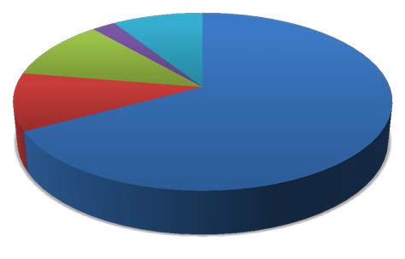
Other 9%

Governmen t
11%

Solo 11%

New Attorney Locations:

New Attorney Office Size:

180
160
140
120
100
80
60
40
20
0


Law Firm 67%
169
 | 15
 | 3 |  | 1 | 1 | 1 | 5 | 1 | 1 | 5

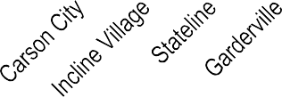

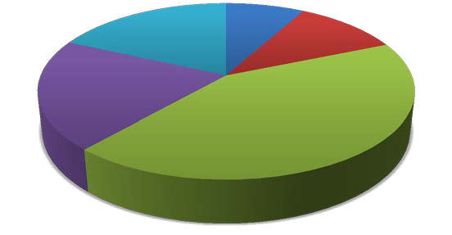
Unemployed
8% Solo

Medium 20%
Large 18%

Small 43%
11%

Program Administration

Deferrals, Exemptions and Fee Waivers:

    - Deferred: 552
    - Exempted: 123
    - Fee Postponements: 9

New attorneys may request deferral from TIP for up to two years if they are unemployed or working as a judicial law clerk. All deferrals are subject to approval by the TIP Standing Committee.

Newly admitted attorneys residing in another state, who are on inactive status, or who have been in practice for five years or longer may request exemption from TIP. Exemptions are granted upon verification of residence or years in practice by TIP staff.

Attorneys who cannot afford the $350 TIP participation fee may request a waiver due to financial hardship from the TIP Standing Committee. To date, the Committee has not granted any waivers; however, the Committee has granted postponement of TIP fees until December 31, 2012.

TIP Opportunities:

In addition to the relationships new attorneys build with their mentors and others in the legal community through the Program, the bar and other groups have made other opportunities available to new attorneys and their mentors. They include:

    - TIP Kickoff Events in Las Vegas and Reno: New attorneys, mentors, members of the judiciary, members of the Board of Governors and SBN staff and section representatives gather at the beginning of each TIP cycle to get to know each other and learn about the services and benefits available to them through the bar. More than 150 people were present for the spring Kickoff and more than 70 were present for the fall Kickoff events.

    - Trial Academy: This ongoing program offered through the Young Lawyers Section was marketed to TIP participants as an opportunity to gain valuable trial experience while also meeting several TIP requirements.

    - Pro Bono Event: Legal Aid of Southern Nevada hosted a pro bono luncheon to introduce new attorneys and their mentors to the benefits of pro bono work. More than 60 mentors, new attorneys and District Court judges were present for the first luncheon. Discussions are in place to make this event part of each TIP cycle in both northern and southern Nevada.

    - Free and Reduced Cost CLE: The bar’s CLE department has made available relevant CLEs at no or reduced cost to TIP participants.

2 Does not include attorneys who deferred from the spring Pilot cycle and who are now enrolled in the fall cycle.
Program Budget:

The TIP Program is supported through enrollment and completion fees, which may be paid at once or divided between the cycle start and end dates. The annual Program revenue will vary from year to year depending on the number of applicants admitted to practice. Despite the revenue variability, the Program has certain fixed costs associated with:

    - Program Administration (.75 FTE): includes coordinating enrollment, deferrals and exemptions; tracking completion; developing additional resources; and Program evaluation.
    - TIP Kickoff Events in Las Vegas and Reno twice a year.
    - Ongoing Mentor Recruitment.
    - TIP Standing Committee Meetings.
    - Loss of CLE revenue related to free CLEs earned by mentors.

Additionally, if the Court approves TIP, plans are in place to build additional resources including:

    - Developing CLEs, in conjunction with the Young Lawyers Section, geared toward new attorneys entering into solo practice.
    - Online videos to address TIP Plan components.
    - An online networking portal where mentors and new attorneys can engage in discussions and share resources.

Mentor CLE Credits:

Mentors may receive three continuing legal education (CLE) credits (two ethics) for each TIP cycle in which they serve. Mentor survey results show that the majority of mentors (70%) are spending between 10 and 25 hours completing the Mentor Plan with their new attorneys and another 19% stated that they spent in excess of 25 hours during the six-month TIP cycle. These estimates are consistent with anecdotal feedback received during the first TIP cycle.

The bar has already engaged in preliminary discussions with the Nevada Board of Continuing Legal Education to determine if additional CLE credits should be provided for mentor service, consistent with CLE credits provided by other state mentoring programs. A breakdown of CLE credits offered in other states is as follows:

Utah: 12 CLE credits per cycle (1 year cycle) New Mexico: 12 CLE credits per cycle (1 year cycle) Oregon : 8 CLE credits per cycle (1 year cycle)
Ohio: 12 CLE credits per cycle (1 year cycle); includes 1 hr. of professionalism, 1 hr. ethics, and
½ hr. substance abuse
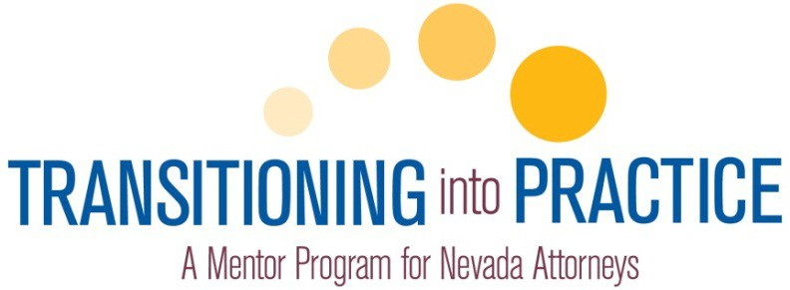

TIP Highlights
Mentors

96% of mentors stated they would recommend serving as a mentor to other experienced practitioners.
“Have fun. Impart important information and don't worry as much about "training" or "teaching" the mentee every little aspect of the law - it’s impossible. Focus on larger, important issues like ethics, treatment of other attorneys, treatment of clients, etc.”

“Relax. Lawyering can be fun. Make it an enjoyable experience.”

“This is a great opportunity to pass on your "wisdom" and help out a new attorney.”

96% of mentors found the Mentoring Plan and TIP elements easy to follow.

“My mentee was very professional and stayed on target.”

85% of mentors found areas of interest in common with their new attorneys.

“We discussed my strengths and his interests. We tried to match them where we could. We also tried to find out where he could get more information beyond what I knew. He was transactional and I am in litigation. But we had fun talking and learning from each other.”
95% of mentors ranked their relationship with their new attorneys as “Excellent” or “Good” and expect to maintain a relationship with their new attorney after the TIP cycle ends.
“I really enjoyed meeting with my two mentees on a regular basis, and if I encouraged them to try something new, I had to likewise do something new myself. I think it made me a better attorney to mentor someone. I became a mentor because I wish I had had a mentor when I was a new attorney, particularly a female mentor. I think it is very important for female attorneys to know other female attorneys.”
65% of mentors stated that TIP was a better program for new attorneys than its predecessor, Bridge the Gap.

“Bridge the Gap is as to TIP as a Wikipedia page is to the Encyclopedia Britannica. Bridge The Gap was a three hour, "hear it today, forget it tomorrow" type of session which had little or no impact on me. TIP, because of its various components and depth of requirements, will, if nothing else, get new attorneys to think about the type of practice they want and confront the down-to-earth "nuts and bolts" tasks of that practice. It's like night and day.”
“Bridge the Gap was not useful. It was required, we received a book & that was the end of it. The TIP program however, if both parties are vested, provides a very unique forum to ask "anything", participate in activities related to areas of law that you otherwise may not have available at work & develop a relationship with an experienced practitioner that may prove very valuable in the future.”

“Bridge the gap was very dry... TIP can be tailored to the mentee's interests.”

“Due to the hands-on nature of the TIP program, it vastly outweighs the Bridge the Gap program in my opinion as I was able to pass along specific things that my father taught me and spend time talking about things that really matter.”
“They don't compare. TIP offers an opportunity to discuss law practice. We discussed everything, including intake, conflict checks, accounting, trust accounting, etc.”
82% of mentors ranked their satisfaction with TIP as “Satisfied” or “Very Satisfied” and 64% stated that they were “Likely” or “Very Likely” to continue serving in the Program.
“IMHO, TIP is a vast improvement over Bridging the Gap and far more effective for the realities of practicing law in the public or private sector. It, however, requires a sustained commitment of time, devotion to purpose, sacrifice by both parties at all times, flexibility, mutual cooperation at all times, and an interest in completing TIP for improvement of not only a particular mentee, but to enhance the quality of the practice of law throughout Nevada. No doubt a few mentors and mentees will not take the Program seriously, but my 30 years of experience with the good, bad, and ugly aspects of practicing law cannot be learned reading books. These lessons can only be learned by sharing with a willing mentee how to minimize traps for the unwary and maximize the positive ways to represent one's clients AND the legal profession in Nevada in an effective, ethical, and competent manner consistent with best practices and the rule of law….”

TIP Highlights
New Attorneys

70% of new attorneys stated that their participation in TIP has made them better prepared for the practice of law.
“I definitely feel better prepared. My mentor was very thorough and practical in reviewing TIP highlighted issues. He also addressed many personal concerns that I had (finding a job and career development).”
“I was blessed with a fantastic mentor who truly took me under his wings and shared his knowledge with me. It is also comforting knowing that I have a highly experienced attorney that I can turn to for advice regarding my legal career or issues with cases in the future.”
“We got to cover the little details that people just assume you know, but no one actually ever tells you or talks about.”
93% of new attorneys responded that they were aware the TIP Mentoring Plan could be modified to reflect their personal interests and goals and 67% stated that their mentors assisted them to craft a modified Plan.
“My mentor always asked what I wanted to get out of the program and out of each section of the program and then did what he could to help.”
“My mentor gave me suggestions and helped guide me in understanding what my goals were because I did not have a clear picture of what my background had to offer.”
“We have done a lot of work in the specific area that I am interested in by requiring me to do "real" assignments with research and writing.”
100% of new attorneys responded that they enjoyed meeting with their mentor and 95% ranked their relationship with their mentor as “Good,” “Very Good” or “Excellent.” Advantages of having a mentor include:

“Having a mentor allowed me to ask questions that I would not normally ask other attorneys.”

“Having someone who has "been there and done that" and who supports my development as an attorney. My mentor did a fantastic job at sharing his wisdom with me and discussing all of the
questions and concerns I had about being a new attorney. It is a wonderful feeling knowing that I have a mentor who is highly experienced, incredibly knowledgeable, and highly respected and who was and is always willing to make himself available to help with my growth and development.”
“I am relatively new to the area, so I know only a handful of attorneys in town. Was great getting to know another attorney who was willing to help me get off my feet and give me encouragement. Also, I work at a firm with all male attorneys - nice to have a female mentor.”
“It is wonderful to get a more seasoned perspective on the practice of law.”

“It's good to build a rapport with someone experience who you can trust. I have not had any professional difficulties so far, but if I ever do, I feel like I have someone I can turn to for advice. I also learned a lot of the soft skills involved in my position, and in terms of thinking about planning a career.”
“The advantage was his experience; not only of the law, but of life. He truly was an attorney and a counselor to me.”
93% of new attorneys would recommend their mentor to other new lawyers and 98% stated that they will attempt to maintain a relationship with their mentor when the TIP Program concludes.
“Absolutely. A good long term relationship with my mentor will be personally and professionally beneficial.”

“I hope to have an ongoing relationship with him. I would like to use his expertise in reviewing my work. And as always, his advice.”

“My mentor and I work in the same government entity and he previously served in the same position as I now hold. He is an incredible resource and I plan to take advantage of his advice in the future.”

72% of new attorneys rated their experience with TIP as “Good” or “Excellent.”

“I went to law school in Wisconsin and was licensed there the year prior to becoming licensed in Nevada. I have told my colleagues from law school to encourage the WI State Bar to do this as well - it's been an absolutely excellent experience, from developing a relationship with a respected attorney in town to gaining skills in my practice area, and I'm thankful for the Nevada Bar in that it took the time to implement this program. I think the state is better off because of it.”

“It is absolutely fantastic. Very organized and easy to understand what is expected.”

IN THE SUPREME COURT OF THE STATE OF NEVADA
1

- In the matter of Amendments to SCR

- 214, SCR 98 and SCR 121.1 regarding completion of the Introduction to
- Nevada Practice and Procedure

ADKT NO.:

- Program, establishing mentorship program, and suspending an attorney's
- license for noncompliance, respectively 7
8 PETITION
9 The Board of Governors of the State Bar of Nevada (State Bar) hereby
- petitions this Court to amend SCR 214 regarding exemptions to minimum
- continuing legal education requirements as defined in SCR 210. The State Bar
- also petitions this Court to amend SCR 98 establishing a mandatory mentorship
- program, Transitioning into Practice (TIP), and SCR 121.1( 1) concerning the
- entity responsible for suspending an attorney's license for noncompliance.
- The proposed rules, as amended, are attached hereto in their entirety as
- Exhibit A.
- DISCUSSION
- The proposal would amend SCR 214(1) in relevant part to read: 19
- 1. The following attorneys are entitled to an exemption from the requirements of Rule 210:
- (a) Any active member who has successfully completed the Nevada state bar examination in the present calendar year. The exemption shall be for the
- remainder of the calendar year in which the examination was successfully
- completed and the first full calendar year thereafter. Commencing on January 1 of the second calendar year after the successful completion of the
- examination, the active member becomes subject to these rules.
- Notwithstanding this exemption, each active member of the state bar, [within the first year] following admission shall complete the [Introduction

1

to Nevada Practice and Procedure program] Transitioning into Practice
1 program.
2

- The proposal would also amend SCR 98(2) establishing the Transitioning into
- Practice (TIP) program as mandatory for all active members upon admission. 5
- 2. Active practice in Nevada. Every person actively engaged in the practice
of law in this state shall enroll as an active member. Every active member
- admitted on or after November 16, 2011, shall, within 4 weeks, enroll in the
- Transitioning into Practice (TIP) program, certify exemption from TIP, or request deferment. Completion of TIP, pursuant to the guidelines
- established by the Standing Committee on Transitioning into Practice, shall
- be by December 31 of the first full calendar year following admission.
.(fil Exemption. Members may certify exemption from TIP based on prior
- practice in another jurisdiction or current residency as set forth in the
- Mentor Program Manual.
.(hl Deferral. Active members who are unemployed or judicial law clerks
- may request deferral from TIP until they begin practicing, at which time they must enroll in the next available TIP cycle. The Standing
- Committee on Transitioning into Practice may grant deferrals for up to
- two years from the date of admission.
ill Penalty for noncompliance. An attorney subject to this rule who fails to
- timely comply with its provisions shall be subject to suspension and a
- $250 fine upon order of the board of governors from membership in the state bar until compliance with the requirements of this rule is met.
- @ Conflicts and confidentiality in outside mentoring. An outside mentoring relationship exists when the mentoring lawyer and new
- lawyer are not members of the same law firm or organization.
- 1. The mentoring lawyer may provide or the new lawyer may seek short-term limited guidance or counsel, within the mentoring
- relationship, without expectation by either lawyer or the new
22 lawyer's client(s) that a lawyer-client relationship has been formed or that representation is being provided in the matter by the
- mentoring attorney.
- 11. Where practical, the mentoring lawyer and the new lawyer shall discuss new lawyer client specific issues in hypothetical terms. If
- hypothetical terms are not practical under the circumstances as

2

determined by the lawyers, Nevada Rule of Professional Conduct
1 l.6(b)(4) applies.
2
3 The proposal would also amend SCR 121.1(1) making the State Bar the entity
- responsible for issuing notices of suspension for failure to timely complete TIP.
- 1. Entity responsible. Ifthe attorney's suspension was imposed under Rule 98 for failure to pay state bar dues or under Rule 214(1) for failure to
- timely complete TIP, then the state bar shall be responsible for issuing
- the notices required by Rule 121.1(2) and (3). If the attorney's suspension was imposed under Rule 212 for failure to comply with
8 continuing legal education requirements, then the board of continuing
- legal education shall be responsible for issuing the notices required by Rule 121.1(2) and (3). In all other cases, bar counsel shall be responsible
- for issuing the notices required by Rule 121.1(2) and (3).
11

- Overview
- For years, the State Bar has operated the Introduction to Nevada Practice
- and Procedure program, commonly referred to as "Bridge the Gap." This one-day
- program was designed as a one-size-fits-all model for attorneys, regardless of the
- attorney's area of practice or level of experience. To make this program more
- meaningful to those attorneys in attendance, the State Bar, in conjunction with the
- Professionalism Summit Committee, developed TIP to replace Bridge the Gap and
- provide a more personal experience to newly admitted attorneys.
- The TIP program is modeled after similar programs in Georgia, New
- Mexico, Oregon, Texas, Utah and Wyoming where experienced attorneys are
- paired with new attorneys practicing in the same or similar areas of law. These
- programs are designed to introduce new attorneys to the high standards expected
- in the profession, including, but not limited to: integrity, professional conduct,
- professional competence and service to the public.

3

1 Program Goals
- The TIP program provides transitional support to newly admitted attorneys
- as they enter into the practice of law. The program is not intended to provide
- substantive advice or training in the practice of law. Instead, the goals of the
- program are to:
- • Assist new lawyers in acqmrmg the practical skills and judgment
- necessary to practice in a highly competent manner;
- • Train new lawyers on Nevada-specific rules and procedures not
- specifically taught in traditional learning environments;
- • Sharpen and enhance the practical skills necessary to compete in today's
- legal environment;
- • Match new lawyers with more experienced lawyers for training m
- professionalism, ethics and civility;
- • Provide support, foster relationships and create networking opportunities
- for newly admitted members; and
- • Provide a means for all Nevada attorneys to learn the importance of
- organizational mentoring, including the building of developmental
- networks and long-term mentoring relationships.
- Program Operation
- Within four (4) weeks of admission to the State Bar, unless exempt or
- granted deferment by the State Bar's Standing Committee on TIP, all newly
- admitted attorneys must enroll in TIP. Subject to Court approval, the TIP program
- will operate on two (2) six (6)-month cycles per year, beginning in January 2013.
- Upon completion of TIP and no later than December 31 of the first full year
- admitted to practice, the attorney must submit to the State Bar proof of program

4

- completion, which is verified by the mentor. Those not completing this
- requirement will be subject to suspension and a $250 fine. The State Bar will be
- responsible for monitoring timely completion of TIP and will be responsible for
- administering orders of suspension pursuant to Rule 121.1 and imposing the fine.
- TIP Curriculum
- The State Bar has established a TIP Mentor Plan that sets forth a core
- curriculum of mandatory activities and elective elements that must be completed
- during the six (6) month program cycle. The curriculum is designed to cover
- topics such as:
- a. The Nevada legal community;
- b. Personal and professional development and ethics;
- c. Law office management and the practice of law; and
- d. Client communications, advocacy and negotiation.
- In addition to these topics, mentors and attorneys are encouraged to develop
- and complete electives in the attorney's area of practice, as well as in other
- elements such as: litigation and transactions; alternative dispute resolution;
- negotiation; and client interviewing and counseling.
- Attorneys and their mentors are encouraged to meet at least once a month.
- The number of meetings and time needed to complete the program vary depending
- on each mentoring relationship and the mentoring plan developed between each
- attorney and mentor. Meetings may occur in person, by conference call or
- videoconference , and through email communication. Additionally, attorneys
- mentored within their law firm, corporate legal department or governmental unit
- may complete some of their required activities in small group settings. 25

5

  - TIP Mentors
  - Potential mentors submit an application with the State Bar and provide a
  - general profile including practice type, office size and area(s) of practice. Mentors
  - must be a member in good standing for at least seven (7) years; however, the
  - Standing Committee on TIP and the Board of Governors may grant a waiver for
  - years of service if the attorney can demonstrate sufficient experience in another
  - jurisdiction . State Bar staff screens each applicant for prior disciplinary actions
  - and pending complaints and submits the applications for approval by the Standing
  - Committee on TIP and the Board of Governors. Following formal appointment by
  - the Court, mentors undergo training and are provided a TIP manual outlining
  - program policies and procedures, including instruction on how to engage in
  - communications that do not reveal client confidentiality.
  - There are currently 227 Court appointed mentors located throughout the
  - State. Newly admitted attorneys may select a mentor from a list of approved
  - mentors or ask to be assigned a mentor. In the event an attorney's mentor of
  - choice is not available or a specific mentor is not requested, the State Bar matches
  - the attorney with a mentor based principally on geographic location and practice
  - areas.
  - Mentor recruitment will continue on an ongoing basis and the State Bar will
  - submit petitions to the Court to appoint new mentors on a semi-annual basis. 21
22
23
24
25

6

    - Program Evaluation
    - On November 16, 2011, the Court submitted an order suspending Bridge
    - the Gap and establishing the TIP pilot program . The first six (6) month TIP pilot
    - cycle began in April 2012 and ends on October 30, 2012. The second six (6)
    - month TIP pilot cycle began in August 2012 and will end in February 2013.
    - Throughout the TIP cycles, State Bar staff solicited comments from
    - program participants informally. In September 2012, the State Bar conducted
    - focus group program evaluations with mentors participating in the first pilot cycle
    - in northern and southern Nevada. The State Bar also sent surveys to all mentors
    - and attorneys participating in that cycle. The purpose of the focus group
    - evaluations and surveys was to gain insight into how well the program operates
    - and gain suggestions for future program changes. The comments received from
    - the focus group evaluations and surveys generally support the concept of TIP and
    - provided suggestions for improvement related to mentor resources, training and
    - communication. 16
17
18
19
20
21
22
23
24
25

7

      - CONCLUSION
      - The State Bar of Nevada supports the TIP program as an effective means of
      - introducing newly admitted attorneys to the practice of law in Nevada. The
      - program creates one-on-one mentoring relationships, networking opportunities
      - and important instruction critical to the development of professional habits,
      - practices and character. Additionally, TIP is flexible enough to compliment and
      - coordinate with existing law firm training programs as well as the special training
      - needs of government, corporate, and public interest practices.
      - Respectfully submitted this ;)q/1, day of October, 2012.

10
11 STATE BAR OF NEVADA
BOARD OF GOVERNORS


12
.hM6A -,,,.
13
FRANCIS C. FLAHERTY, Presi
- Nevada Bar No. 5303
- State Bar of Nevada
600 East Charleston Boulevard
- Las Vegas, Nevada 89104
(702) 382-2200
17
18
19
20
21
22
23
24
25

8

1
2 Rule 214. Exemptions.
EXHIBIT A

  - The following attorneys are entitled to an exemption from the requirements
3 of Rule 210:
4 (a) Any active member who has successfully completed the Nevada state bar examination in the present calendar year. The exemption shall be for the
- remainder of the calendar year in which the examination was successfully
- completed and the first full calendar year thereafter. Commencing on January 1 of the second calendar year after the successful completion of the examination, the
7 active member becomes subject to these rules. Notwithstanding this exemption,
8 each active member of the state bar, [within the first year] following admission shall complete the [Introduction to Nevada Practice and Procedure program]
9 Transitioning into Practice program.
(b) Any active member who is a full-time member of the federal judiciary.
- (c) Any member of the state bar who, while not in default of the obligations
- imposed by these rules, has been voluntarily placed on inactive status; provided, however, that such voluntary placement must have been given in writing to the
- state bar and the board prior to the expiration of the applicable calendar year for
- which the exemption is claimed.
(d) Any active member who has attained the age of 70 years.
- (e) Any active member who is deployed on full-time active duty in the armed
- forces of the United States, until the member's release from active military service and resumption of the practice of law.
- 2. The board, in its discretion, may grant an attorney subject to these rules an exemption upon circumstances constituting exceptional, extreme and undue
- hardship unique to the attorney, subject to the following:
- (a) The attorney seeking the exemption shall promptly file with the board a verified application, specifying in detail the circumstances which the attorney
- believes afford a basis for an exemption;
- (b) The board may, but need not, exempt the attorney from all or a portion of these rules; and
- (c) The board may condition the exemption upon such terms and conditions,
22 and limit the exemption or partial exemption to such period of time, as the board may deem appropriate.
23

24

25

9

Rule 98. Mem bership in state bar; classes; resignation; membership fees;
1 penalties for nonpayment of fees; register of mem bers.
2
- Classes. Members of the state bar shall be divided into four classes:
- (a) Active members admitted to practice in any jurisdiction 5 years or more.
- (b) Active members who are also members of the federal judiciary, regardless of years of admission prior to practice in any jurisdiction.
- (c) Active members admitted to practice in any jurisdiction less than 5 years.
- (d) Inactive members.
- Active practice in Nevada. Every person actively engaged inthe practice of
- law in this state shall enroll as an active member. Every active member admitted on or after November 16, 2011, shall, within 4 weeks, enroll in the Transitioning
- into Practice (TIP) program, certify exemption from TIP, or request deferment.
9 Completion of TIP, pursuant to the guidelines established by the Standing Committee on Transitioning into Practice, shall be by December 31 of the first full
- calendar year following admission.
- (a) Exemption. Members may certify exemption from TIP based on prior practice in another jurisdiction or current residency as set forth in the Mentor
- Program Manual.
- (b) Deferral. Active members who are unemployed or judicial law clerks may request deferral from TIP until they begin practicing, at which time they must
- enroll in the next available TIP cycle. The Standing Committee on Transitioning into Practice may grant deferrals for up to two years from the date of admission.
- (c) Penalty for noncompliance. An attorney subject to this rule who fails to
- timely comply with its provisions shall be subject to suspension and a $250 fine upon order of the board of governors from membership in the state bar until
- compliance with the requirements of this rule is met.
- (d) Conflicts and confidentiality in outside mentoring. An outside mentoring relationship exists when the mentoring lawyer and new lawyer are not employed
- by the same law firm or organization.
- i. The mentoring lawyer may provide or the new lawyer may seek short- term limited guidance or counsel, within the mentoring relationship, without
- expectation by either lawyer or the new lawyer's client(s) that a lawyer-client relationship has been formed or that representation is being provided in the matter
22 by the mentoring attorney.
- ii. Where practical, the mentoring lawyer and the new lawyer shall discuss new lawyer client specific issues in hypothetical terms. Ifhypothetical terms are
- not practical under the circumstances as determined by the lawyers, Nevada Rule
- of Professional Conduct 1.6(b)(4) applies.

10

- Active practice in other jurisdictions . Members of the state bar residing in
1 other jurisdictions and engaging in the practice of law therein may enroll as
2 inactive members of the state bar if they are not actively engaged in the practice of law in this state.
3 4. Inactive status. Any member of the state bar who is not actively engaged in
4 the practice of law in this state, upon written request, may be enrolled as an inactive member. No member of the state bar actively engaged in the practice of
- law in this state, or holding any judicial office in this state, or occupying a
- position in the employ of or rendering any legal service for an active member, or occupying a position where he is called upon to give legal advice or counsel or
- examine the law or pass upon the legal effect of any act, document or law in this state, shall be enrolled as an inactive member. Law clerks and staff attorneys of
8 the supreme court, and law clerks and legal assistants employed by the state and
9 federal courts, who are precluded by their employers from actively engaging in the practice of law, may enroll as inactive members.
10 Active members who retire from practice shall be enrolled as inactive members
11 at their request. Inactive members shall not be entitled to hold office or vote. They may, on application and payment of all registration fees required, become active
- members. Inactive members shall have such other privileges, not inconsistent with
- these rules, as the board of governors may provide.
5. Resignation.
- (a) By members in general. Any member of the state bar who is not actively engaged in the practice of law in this state, upon written application on a form
- approved by the state bar, may resign from membership in the state bar if the
- member:
  - has no discipline, fee dispute arbitration, or clients' security fund matters
- pending and
- (2) is current on all membership fee payments and other financial commitments relating to the member's practice of law in Nevada. Such
- resignation shall become effective when filed with the state bar, accepted by the board of governors, and approved by the supreme court.
20 (b) By members withpending disciplinary charges. A member of the state bar
21 against whom disciplinary charges are pending may tender a written application resigning from membership in the state bar and relinquishing the right to practice
22 law. No such resignation shall become effective unless and until ordered by the
- supreme court after consideration and recommendation by bar counsel.
(c) Resignation is irrevocable. A member who has resigned may return to the
- practice of law in Nevada by making application as a new admittee, subject to the
- provisions of these rules and applicable law, including the requirements that the resigned member :

11

  - demonstrates that he or she is of good moral character and willing and able
1 to abide by the high ethical standards required of attorneys and counselors at law
2 and
  - takes and passes the Nevada State Bar Examination.
3 (d) State bar 's continuing jurisdiction. The state bar shall retain jurisdiction to
4 investigate and take action with respect to matters involving a past member's conduct prior to the member's resignation from the state bar.
- (e) Notice. An attorney who resigns must comply with Rule 115. If the
- attorney fails to do so, then the state bar shall proceed under Rule 118. The state bar shall also comply with Rule 121.l.
7 6. Transfer from active to inactive member. An active member, if in good standing, may be enrolled as an inactive member upon written request, and there
- shall be no rebate of any membership fee after March 1 of the year in which such
- request is filed.
- Transferfrom inactive to active member. An inactive member, if in good
- standing, may be enrolled as an active member upon written request. Upon the
- filing of such request and the payment of a $1 registration fee and the full annual membership fee for an active member, for the current calendar year, less any
- membership fee paid by him as an inactive member for such year, the applicant
- shall be immediately transferred from the inactive to the active roll.
- Rights of inactive members. An inactive member may attend the annual and
- special meetings and participate in any debates at such meetings, may be appointed by the board of governors upon any committee other than a local
- administrative committee, and may be employed in a clerical position by the state
- bar.
- Membership fees. Subject to approval by the supreme court, the board of
- governors shall have the power to fix annual membership fees. The annual
- membership fees are:
- Active members admitted to practice in any jurisdiction 5 years or more.... $450 Active members who are also members of the federal judiciary , regardless of
- years of admission to practice law in any jurisdiction .................................... $100
- Active members admitted to practice in any jurisdiction less than 5 years ... $250 Inactive members ........................................................................................... $125
22
- 10. Payment offees. Membership fees cover the calendar year and shall be due on January 1 of each year and shall be payable by those already members of the
- state bar on or before March 1 in each year, and shall be due and payable by those
- admitted to practice at the time of admission and registration.

12

No part of the membership fee shall be apportioned to fractional parts of the
- year and no part of the membership fee shall be rebated by reason of death,
- resignation, suspension or disbarment.
l l .Delinquent fees. On March 2 of each year a penalty shall attach to all
3 delinquent membership fees as follows:
4
Membership Category Penalty Amount
5 Active.............................................................. ........................... $100.00
6 Inactive......................................................................................... $50.00
- 12.Suspension for failure topay fees. Any member, active or inactive, failing to pay any fees after the same become due, and after 2 months' written notice of
- his or her delinquency, must be suspended from membership in the state bar, but
- may be reinstated upon the payment of accrued fees and such penalties as may be imposed by the board of governors, not exceeding double the amount of the
- delinquent fees. All fees shall be paid into the treasury of the state bar, and when
- so paid shall become part of its funds.
Upon the expiration of a period of 70 days after the date of mailing the notice
- provided in these rules, the executive secretary shall deliver to the board of
- governors a list of all members who have failed to make the required payment, with proof of the mailing of the notice to them. The board of governors shall make
14 an order suspending the delinquent members, and a certified copy of such order thereupon shall be filed with the clerk of the supreme court and with the county
15 clerk of each county.
16 A member who is suspended for failure to pay dues must comply with Rule
115. Ifthe member fails to comply with Rule 115, then the state bar shall proceed
- under Rule 118. The state bar shall also comply with Rule 121.1.
- 13.Reinstatement after fee suspension. Whenever a member so suspended for nonpayment of membership fees has paid all accrued fees and penalties, the
- executive secretary may reinstate him as a member of the state bar, and shall
- thereupon certify his reinstatement to the clerk of the supreme court and to the county clerk of each county. The state bar shall also comply with Rule 121.1.
- 14.Membership records. The state bar under the direction of the executive director shall maintain a database and other records of the membership of the state
- bar. In appropriate places therein entries shall be made showing the address of
- each member, date of admission and category of membership, date of transfer from one category to another, if any, date and period of suspension, if any, and
- such other useful data as the board of governors may from time to time require
- each member to furnish.

13

Every member shall at a minimum furnish the following information to the
- state bar in whatever form requested :
- (a) Surname and given name or names.
(b) All information and disclosures required by Rule 79.
- (c) When admitted to practice in Nevada, giving date.
4 (d) Places and dates of practice prior to admission in Nevada (city and state).
(e) Date and place of birth. If not born in the United States, stating when and
- where naturalized.
- (f) If admitted to U.S. District Court, U.S. Circuit Court of Appeals, or U.S. Supreme Court.
- (g) Membership, if any, in bar associations, giving name of each.
(h) Whether ever disbarred, and if so, when and where, and when readmitted.
- (i) Whether any disbarment or other proceedings of a like nature have ever
- been instituted against him, or whether by resignation, withdrawal or otherwise the member has terminated or attempted to terminate his office as an attorney,
- and, in either or any of the cases above referred to, giving full particulars.
- l 5 .Exemption from payment of fees. A person licensed to practice law in this state who has reached the age of 70 years, shall be exempted from the payment of
- annual membership fees commencing with the calendar year succeeding the year
- in which the member reaches age 70.
- Rule 121.1. Dissemination of discipline and disability information.

- 1. Entity responsible. If the attorney's suspension was imposed under Rule 98
- for failure to pay state bar dues or under Rule 214(1) for failure to timely complete TIP, then the state bar shall be responsible for issuing the notices
- required by Rule 121.1(2) and (3). If the attorney's suspension was imposed under
- Rule 212 for failure to comply with continuing legal education requirements, then the board of continuing legal education shall be responsible for issuing the notices
- required by Rule 121.1(2) and (3). In all other cases, bar counsel shall be responsible for issuing the notices required by Rule 121.1(2) and (3).
20 2. Public notice of change in license status and discipline imposed. The entity
- responsible under Rule 121.1(1) shall cause notices of orders that subject an attorney to disbarment or any form of suspension, including suspension under
- Rule 98 or Rule 212, that transfer an attorney to or from disability inactive status,
- that reinstate an attorney to the practice of law, or to be published in the state bar publication. The responsible entity also shall make these notices available to a
- newspaper of general circulation in judicial district of this state in which the
- attorney maintained an office for the practice of law or carried on a substantial portion of his or her practice.

14

The responsible entity shall also cause a notice of a public reprimand issued by
1 the supreme court to be published in the state bar publication.
2 The entity responsible for compliance with this provision has discretion in drafting public notices required by this rule, which may consist simply of the
3 orders themselves. However, notices of orders that impose discipline should
4 include sufficient information to adequately inform the public and members of the bar about the misconduct found, the rules violated, and the discipline imposed.
- 3.Notice to the courts. The entity responsible under Rule 121.1(1) shall
- promptly advise all courts in this state of orders that suspend or disbar an attorney, that transfer an attorney to or from disability inactive status, that approve an
- attorney's resignation, or that reinstate an attorney to the practice of law.
4.Disclosure to National Discipline Data Bank. Bar counsel shall notify the
- National Discipline Data Bank maintained by the American Bar Association
- Standing Committee on Professional Discipline of all public discipline imposed by the supreme court on an attorney, transfers to or from disability inactive status,
- reinstatements to the practice of law, and resignations with discipline pending.
- 5.Publication of supreme court orders. The clerk of the supreme court shall cause any order issued by the supreme court that subjects an attorney to any form
- of public reprimand, suspension or disbarment, that transfers an attorney to or
- from disability inactive status, that approves an attorney's resignation, or that reinstates an attorney to the practice of law to be published in pamphlet form and
- disseminated to all subscribers of the advance sheets of the Nevada Reports and to all persons and agencies listed in NRS 2.345.
- 6. Publication ofpublic reprimand issued by state bar. Bar counsel shall cause
- a public reprimand issued by the state bar under Rule 113 to be published in the state bar publication.
17
18
19
20
21
22
23
24
25

15
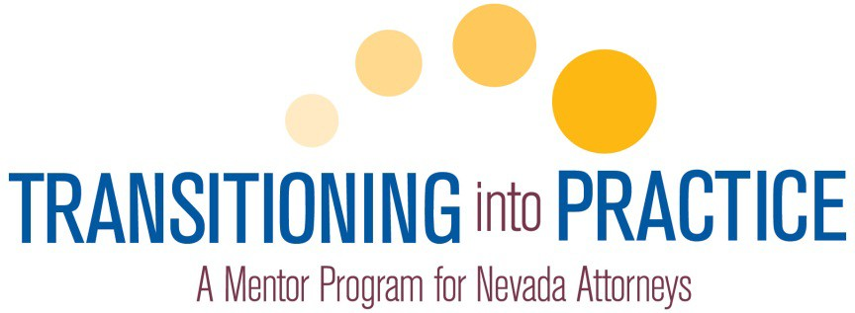

SURVEYS

In September 2012, state bar staff sent a survey to the 168 mentors participating in the first TIP cycle and asked them to rate their experiences with the Program and provide comments about the Program’s strengths and weaknesses. Of those surveyed, 75 responded.
A survey was also sent to the 185 new attorneys participating in the cycle requesting feedback about the Program and its effectiveness. Of those surveyed, 43 responded.
Mentors and new attorneys were offered the opportunity to reply confidentially, and/or restrict their comments for viewing to the TIP Standing Committee, the Board of Governors and to the Court. Additionally, all survey questions were optional; therefore, not every question garnered a response. The survey responses follow.
TIP Mentor Surveys

Mentor Background

- Please select the mentoring relationship that best describes you and your new attorney:

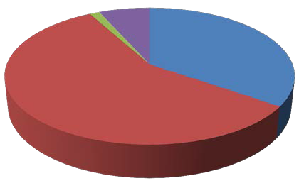
1%
7%
35%
57%

In House Outside Combination Circle

- If engaged in an in-house mentoring relationship, were you the direct supervisor of the attorney or attorneys practicing in your firm?

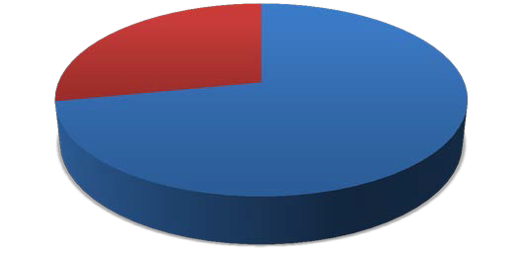
Yes No
28%
72%

- When you were a new lawyer, did you have a mentor or mentors who helped you develop as an attorney?

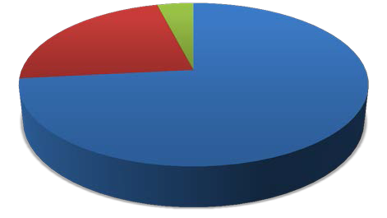
Yes No
4%
23%
73%

No Response

- Who or what encouraged you to become a mentor? (Mark all that apply)


I embrace the importance and concept of mentoring

Letter from the bar encouraging

7%
7%
3%
3%
5%

17%

7% 8%

31%

12%
me to apply
Recommended to serve by a member of the judiciary

Recommended to serve by another attorney

A new lawyer asked me to become his/her mentor

My firm or legal organization nominated me

Earning three CLE credit hours per TIP cycle

Hour for hour service on my annual pro bono reporting form

Opportunity to network with other

“Other” Comments:
attorneys

Giving back to the legal community.
Bar Requirement
Someone helped me
To help improve the practice skills of new attorneys not being hired into law firms due to the economy.
I was a member of the committee that proposed the program
Kim asked me.
I volunteered to be a TIP mentor
Set Examples
Lisa McGrane encouraged me to apply
Encouraged as a member of the CLE Committee

- Would you recommend serving as a mentor to other experienced practitioners?

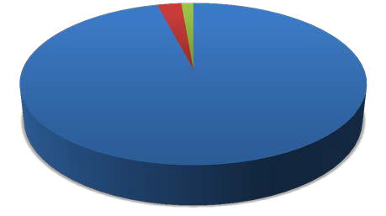
Yes No
3%
1%
96%

No Response

- What advice would you give to new mentors as they begin mentoring?

I would be proactive getting in touch with the attorney. I would encourage someone to put aside a block of time to help the new person. I would give the new attorney my home, mobile, and office number for discussions outside of the work place.
allocate the time and make yourself available
Be accessible.
Be available
Be flexible in scheduling appointments and in providing mentoring to mentees. Since I knew the mentees, I was able to tailor my mentoring to their needs, enabling us to spend more time on certain topics and less time on others, thus enabling the mentees to complete their requirements in an expedient manner.
BE HONEST, PATIENT AND REMEMBER WHAT IT WAS LIKE WHEN YOU WERE A BRAND NEW ATTORNEY
Be patient and answer any questions asked.
Be responsible for a quality experience for the new lawyer.
Clear and frequent discussion on the goals and needs of mentoring.
Develop a plan early, with reasonable deadlines.
Embrace the opportunity of imparting some helpful advice to new attorneys
Enjoy the experience, and take advantage of the networking and learning opportunities. Also, keep working, and don't
expect the program to take the place of the value of hard work.
Frankly ,the process is a little difficult to accomplish unless the mentee is highly motivated, Fortunately, mine was
Give the mentee freedom to set the parameters
Have fun. Impart important information and don't worry as much about "training" or "teaching" the mentee every little aspect of the law - it’s impossible. Focus on larger, important issues like ethics, treatment of other attorneys, treatment of clients, etc.
I was not able to complete my mentorship as I never connected with my mentor
I would tell them that it takes a considerable amount of time to be a mentor under the current TIP program. The concept of mentoring new admittees to the bar is an excellent idea. The current program, however, is way too time- consuming for both the mentor in the new attorney. I already have devoted well in excess of 40 hours of my time serving as a mentor under the TIP program, and I still have it least one or two more meetings with the new attorney. While I thoroughly have enjoyed working with the new attorney, I believe the time requirements under the current program are way to extensive.
It takes much more time than you think, so plan ahead and schedule regularly with your mentee.
Keep an open mind and always be ready to assist.
Keep in mind that the mentee is just starting out, and often an explanation of things and procedures that an
experienced attorney takes for granted will be necessary.
keep in regular contact with your mentee
Keep the relationship open.
listen to your mentees questions
Listen, often they want to ask questions but may be afraid to ask their employer or other members of their firm. Treat
them with respect (they are new but worked hard). However, make sure they know how to conduct themselves professionally, dress, manner, ethics.
Listen to the new attorney and offer suggestions that may help them rather than tooting your own horn.
Be patient and have an open door policy
Make sure to calendar dates and times to call, speak and meet with your mentee. If it isn't actually on your calendar, you're less likely to make time for it.
Make sure you have the time to do it.
Make the process as interesting for you as possible and planning field trips so to speak with the mentee.

Meet with your protégé often.
Realize there is flexibility in developing the plan.
Relax. lawyering can be fun. Make it an enjoyable experience.
Schedule a time weekly to meet/talk with your mentee and adhere to a regular schedule.
Schedule meetings in advance.......Include mentees in things you do....
Spend the bulk of your time with your mentee early in the process.
Spend the time to get to know your mentee, take him/her to lunch, understand what he/she really wants to focus on and learn.
Stay in close contact with the mentee during this process
Stay organized and keep up with your new lawyer. Make sure you have an open relationship with them.
Take it seriously. New attorneys have lots of good questions.
Take some time to get familiar with what you need to do
Take the time and make the effort. It is a rewarding experience and you will undoubtedly learn something.
Take the time to provide as much information and guidance as possible.
That this is a great opportunity to pass on as much else as you can outside of the requirements and outlines.
The book is good, but just set meetings, issues and concerns will arise by simply sitting down and discussing with their person "how are they doing."
The experience is rewarding and it allows you to re-focus on what you do and why you do it.
The materials made available by the State Bar help make the program a learning experience for both the mentor and mentee.
The need to recognize that mentees are often fresh, optimistic and idealistic. As a result, experienced practitioners need to carefully balance tales of real life experiences so as to not disillusion new attorneys.
The TIP Program is extremely valuable to the mentee. It, however, if properly applied, observed, and consistently engaged by both mentor and mentee, takes time and effort by both parties. Mentors should LISTEN intently to what the mentee has to say as their goals for TIP and the future of their professional career. Mentors should never presume a mentee has, or has not, experienced some aspects of the agenda formulated by mentor and mentee as a TEAM CONCEPT. TIP is outrageously rewarding regardless of time.
This is a great opportunity to pass on your "wisdom" and help out a new attorney.
Try to listen and ask questions to lead the mentee to answers. Resist the temptation to lecture them on how to practice law.
Try to mix it up and include other attorneys and people to assist, instead of just one on oine the whole time
work hard to learn and pay attention to detail
You only have one chance to make a first impression.

Mentor Training/Resources

- How did you receive your mentor training?

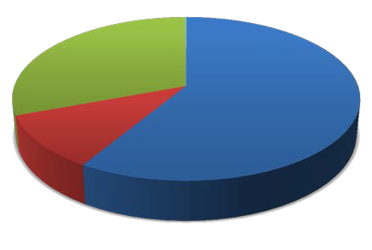
Live Las Vegas Live Reno Online Video
31%
58%
11%

- Did you find the mentor training to be helpful prior to serving as a mentor?

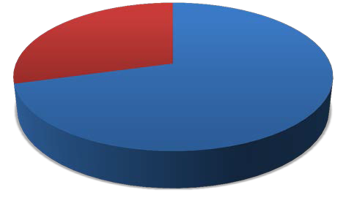
Yes No
29%
71%

- What do you remember being the most helpful/beneficial aspect of the training?

a reminder of the important aspects of mentoring and the outline provided
an entry base
Can't point out any one aspect that was more beneficial than others.
development of the mentoring plan
Discussion of the ethical rules as they apply to one's practical practice of law.
Explanations of how to help the mentee without letting that relationship transform to a joint practice of law.
Fed defender, can't remember her name, reminded us to be there to explain balance, and how to lose.
Going over the basics of mentoring -- remembering not to lecture.....Going over the list of things to cover.
How to arrange a program of mandatory and elective events to experience as time progresses. This was also the portion of training which needed more attention.
I thought some of the materials I downloaded were helpful. I think the list of items necessary to complete the mentor program were in themselves helpful and self explanatory.
I was impressed by the quality of attorneys who were participating in the project. The training provided encouragement to go forward.
Information provided regarding getting help for areas in which I do not practice.
Judge Linda Bell's advice on being an effective and proactive mentor and Shea Backus' discussion of how the program can benefit mentors and mentees.

JUDGE LINDA BELL'S PORTION OF THE TRAINING
just giving a guideline of what is expected
Knowing the boundaries.
Laying the groundwork.
Not really anything in particular
Receiving information to ensure our understanding about how important this new approach is.
Reflections by speakers in the training session
reminder of the importance of mentoring
Resources
Reviewing the training manual.
Seing the other people doing the same thing. also, receiving the book and going over the most important parts of it and being able to ask questions or hear the questions of others.
Sharing important practice tips; advising re. ethics.
The discusssion of what we were trying to do and the CD to review
The explanation of the process.
The item-by-item walk through of the mentoring plan and how we are supposed to conduct the mentorship itself was most helpful.
The materials and the question and answer session.
The objectives of the mentor relationship.
The overview as to the expectations and mechanics of the program.
Understanding the expectation and time commitment and direction regarding the resources available.
Written materials

- If you did not find the mentor training beneficial what could we do differently to make the training better?

Don't really think you need training as long as you have the topics.
Focus only on the details of the program and exactly what is expected rather than on how great a program it is or how it was developed.
Have attorneys who had good experiences being the mentee explain what was beneficial and what wasn't.
I appreciated the general comments about the importance of being a mentor, but I was already there. The specific comments on what to do, however, were too general.
I do not think that one can be trained to be a mentor. Guidelines can be suggested but overall the mentor has to be able to impart advice to the mentees in their own way.
I have been a mentor before so the training was nothing new. was nothing new
I'm not sure it really was necessary - it wasn't really training, it was just common sense advice (which hopefully at this stage of our careers we already know).
It was difficult going through the plan step by step. I think hitting the highlights of each section and then giving practical examples of how best to discuss ethical topics with the mentee would have been more helpful than simply going through the plan itself.
Make it more practical training, and make it much shorter.
Make it more practical; walk through an actual hypothetical mentoring plan.
Make sure the mentor have all the materials or online access to them in advance of any training. Also have copies or access of what the mentees will have. It's hard to know what is expected of the mentee if you have to ask them. Call in support is helpful so when you sit down at your own desk to look at the materials you can ask questions you have. It was helpful to meet the other mentors.

More practical training. We can read the manual, perhaps some small group breakout sessions with examples of
challenges, etc.
Shorter
Sorry, the presentations were too repetitive, elementary and boring.
Specific training on the requirements of the program.
The Program should be laid out in an easy to understand format of exactly what you need to do, how to do it, etc.
There are ,in my opinion, too many variables to suggest there is a right/ wrong way to do the training
Live training is not necessary since you have put together such a great written resource
Tailored towards each firms practice

- Are you aware of the mentor resources provided online at www.nvbar.org/tip?
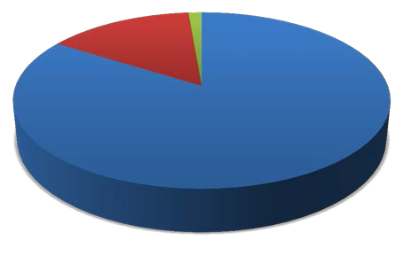
1%
15%
84%

Yes No

No Response

- Did you use any of the mentor resources linked online at www.nvbar.org/tip during the course of your mentoring relationship?

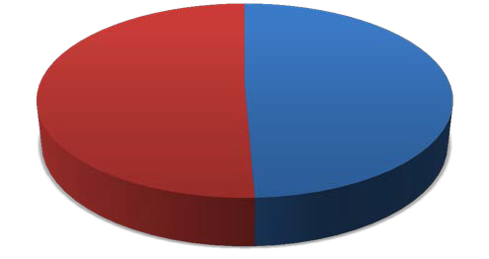
Yes No
49%
51%

- Please indicate which mentor resources you used (click all that apply).

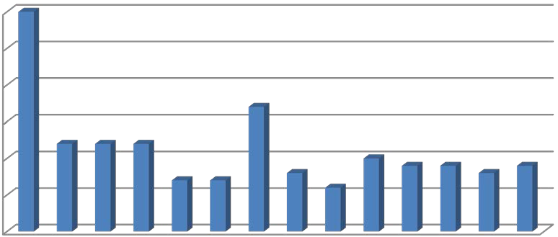
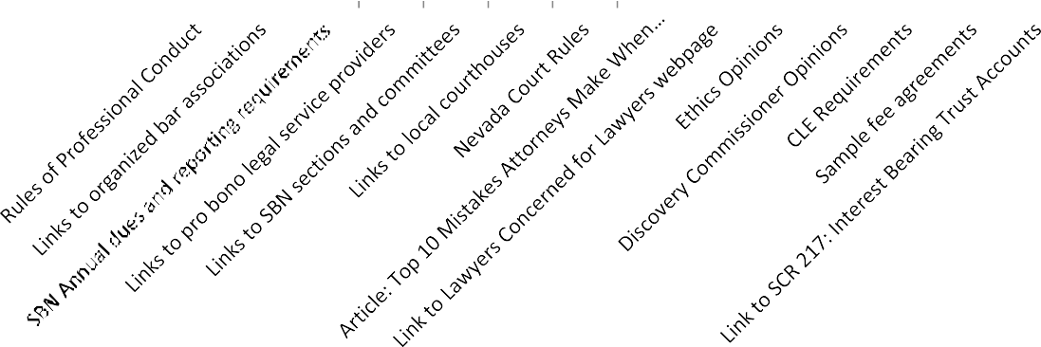
30
30

25

20
17
15
121212
10
10
9
9
9
7
7
8
8
6
5

0

Other mentor resources used 5 times or less include:

Resource | Number of Times Used
IOLTA: Participating financial institutions | 4
IOLTA Enrollment form | 3
Links to PACER, WizNet, Fastcase | 3
Cornell University Law School Legal Information | 3
Link to Nevada Secretary of State webpage | 3
Link to Nevada Law Library | 3
Links to Clark & Washoe County Recorder Offices | 1
Links to Clark & Washoe County Assessor Offices | 0
Links to Clark & Washoe County Fictitious Name Search sites | 0
Link to Fee Dispute Presentation | 1
Link to Court Annexed Arbitration Program | 2
Article re: Consequences of Bad Legal Writing | 0
Article on Plain Language and the Law | 2
Link to CLE Board webpage | 3
Publication: Legal Argument: The Structure and Language of Effective Advocacy | 0
Links to miscellaneous articles | 3
Links to SBN Member Benefits | 1

- Is there a reason why you did not use the mentor resources provided?

Again, it seemed like such trouble to sort through and determine what needed to be done, etc.
Bad habits.
I actually did ise them in the beginning, but then I went with a more specific approach as the relationship developed.
I already had most of the information available there, and much of it never became relevant to my situation.
i didn't find a need for them
I didn't know they were there. I called in early on and they were "coming soon" I should have followed up but
thought I'd get an email.
I didn't really need them.
I forgot they were there.
I had plenty of resources on hand, and learned that my mentee had accessed resources as well.
I have not needed them yet.
I think perhaps my mentee was using something so I just responded to his prompts.
I utilized a more customized program with my mentee.
In all candor, the balance between devoting time to my practice and devoting time to my mentee became a tricky one. Thus, I was never able to free up the time to explore these resources. In the future, however, I expect that this will change.
It did not occur to me and did not seem necessary.
It was not necessary
just forgot they were available
No
No
no
no need
No reason. Just thought I did not need the same.
Relating to a younger lawyer in a meaningful way is not something these materials can teach.
time
time constraints
unaware
Unaware
Unnecessary
Yes. I had numerous previous mentoring experiences, plus my mentee was extremely intelligent, easy to work
with, and highly co-operative.
Because I chose to mentor with the type of our practice in mind

- Are there other resources you used that were not linked to the Mentor Resources webpage?

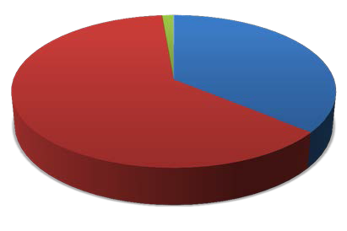
Yes No
1%
36%
63%

No Response

Related Comments:

47 yrs of practice
Book Handed out at training
Certain intellectual property sites and organizations
DA TRAINING MATERIALS
Family Law Practice Manual
I already have links to the court rules but I also discussed certain items with colleagues during the mentorship program.
in house training
Lexis
Michie books of rules
Mostly my own materials gathered throughout my years in practice.
my own CLE materials that I wrote
my own library
NRS, Ethics rules
NRS/NAC
Other atty's
Our internal policies and procedures
Personal resources
pro bono materials
The CD provided with the training

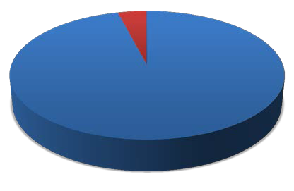
- and elective TIP program elements
Did you find the Mentoring Plan that outlined the mandatory
easy to follow?
4%
Yes
No
96%

11
- Please tell us if there any mandatory or elective elements in the Mentoring Plan that you would like to see added or removed in the future, and why.

I do not believe any part of the mentoring plan should be mandatory
I do not feel qualified to talk about repayment of student loans and substance abuse
I do not think there is much guidance that mentors can practically offer to mentees about managing law school debt. Likewise, many of the elective activities, such as participating in client interviews, drafting documents, etc. are really limited to in-house mentoring and therefore are inapplicable to those situations where the mentee is not employed by the mentor's law firm.
I think bringing someone to a bar function that they can go to themselves is somewhat "cheesy."
I think it may be appropriate to provide for waiver of certain financial transations training, where the mentor and the new attorney being mentored are both exempt. For example, both the attorney I am mentoring and me work for instriutional offices,without IOLTA accounts.
I thught the program was well done and don't have any suggestions regarding content.
I would like to see a revised juvenile curriculum.
I wouldn't delete any, but felt strongly that a number of the elements had unrealistically long mandatory time
elements placed upon them. In other words, having just taken the bar, my mentee knew as much as I did about a few things that we were 'required' to spend many hours upon.
If the mentee is not in your firm, you cannot effectively do the document section of the program as it violates attorney client privilege.
LARGE NUMBER OF ELECTIVES IN OUR AREAS OF PRACTICE ARE APPRECIATED
Many of the elective elements in the criminal portion were more prosecution, and not defense oriented.
My mentee suggested immigration and I thought that was a good idea
N/A
NA But I will give it some thought.
no
no
None
None
none
The plan was relatively easy to follow but some of the topics were a bit difficult to understand at times (but not on
the whole). There seemed to be a significant emphasis on conflicts and, while important, seemed to carry over a bit in the sections.
Yes- Attending trials in justice or district court if the mentee does not practice trial law. Next, visiting the mentee's office environment, as that is disruptive. Participating in or observing a client interview as an outsider is invasive and uncomfortable. Visiting a legal aid office is extremely time consuming and not really related to encouraging pro bono participation. Most neophyte lawyers are struggling to survive the initial years of practice, much less contemplate pro bono work.

- Were there any aspects of the Mentoring Plan that you found to be onerous or difficult to achieve within the six-month TIP cycle?

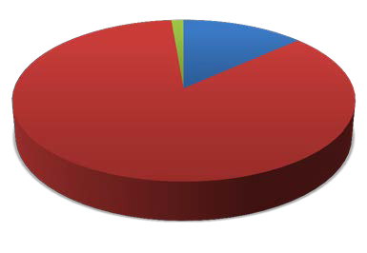
Yes No
1%
14%
85%

No Response

Related Comments:

Court appearances.
Generally, this plan needs one year rather than six months.
hours per session
I felt the entire process was time consuming and not created in an easy to understand format
It seemed to be a lot of material to cover in six months. I would have preferred nine months.
most of the formal aspects - lack of time
My mentee is unemployed. That creates some unique issues with respect to the number of activities that can actually be performed.
Onerous, yes. Difficult to achieve, no, but it requires a considerable amount of time to achieve it within 6 months.
Too much beurocratic papwork, guidlines, etc.
Yes, it seemed like a lot to cover in 6 months for two busy attorneys.
Too much detail required for mentoring process. A good concept but it needs to be simplified.

- Were there particular sections of the Mentoring Plan that you found to be more time consuming than others?
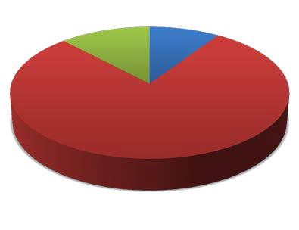

12%
9%

79%

Yes No

No Response

Related Comments:

Covering all the mandatory topics took a long time. It was necessary, but it did take a long time.
most
The elective portion for the reason stated above.
Yes, reviewing civil rules and rules of professional conduct

- During the entire six-month TIP cycle, how many hours do you estimate that you spent with your new attorney completing the elements in the Mentoring Plan (in person, by phone, etc.)?

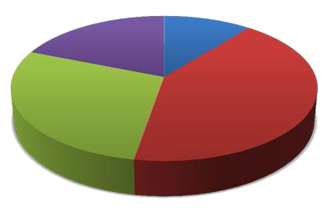
Less than 10 hrs. 10-15 hrs.
19%
11%
28%
42%

16-25 hrs.

More than 25 hrs.

- How did you deal with issues of time constraints?

"Just do it!"
Any successful lawyer has time constraints and other commitments. Lessen the paperwork, guidelines and let the
mentor share her/his experience and knowledge.
AS A TEAM CHIEF, ONE OF MY PRIMARY DUTIES IS TRAINING NEW ATTORNEYS ON MY TEAM
Chipped away at it with many meetings.
Did not have any.
I did not find any issues in this regard.
I didn't since I never made contact with my mentee
I engaged first in informal conversations and not too subtly worked in certain concepts. It was easier with both
people in the same building.
I often met with my two attorney mentees for dinner when we all had more time to know each other better, to relax a bit, and discuss things in greater detail.
I planned out several meetings with my assigned mentee so we could have designated times to discuss both mandatory and elective topics.
I waited for Mentee to complete tasks before overloading him.
It wasn't a problem.
Just as any other time conflicts that arise; just budget the time and get it done.
Lots of lunch meetings; some early morning court appearances
Made a point of talking/meeting weekly even if it was after hours.
meeting every 2 to 4 weeks
My mentee is a second career lawyer with a large and excellent firm, so he required less input than most new lawyers probably require. The problem was that we getting together was difficult, because he and I were both very busy.
My mentee was very professional and stayed on target.
My mentee was very self motivated to keep track of what things we had to accomplish.
Not an issue. I will go as long as the new attorney wants to.
Not as well as I might have liked. When work got busy for both myself and my mentee, it became difficult for us to switch gears and focus on the mentorship. But, this is a learning process and I expect to strike a better balance next time out.
Not very well! But you make the best of the time you have.
Our bigger issue was distance. I am i Reno. Dawn is in Elko. She is smart, hardworking, terrific. But, I think it would have been a better experience for her if she had had a local mentor.
Proper planning

set up luncheon appointments
simply coordinated our calendars on a regular basis
The requirements can become very time-consuming, if done properly. Fortunately, we already had to do the requirements for our in-house mentoring program.
There were no issues of time constraints
There were no such issues
This mentor explained to the mentee that managing the inherent time commitment conflict between TIP, practicing
law, and private life was simply a function of the realities of practicing law. Not taught in law school and only learned by hard knocks. The mentor must be willing to sacrifice also and be willing to make adjustments to their schedules. This mentor found mentees [generally per other mentor discussions] very resistant to devoting any weekend time to TIP meetings or events.
Tried to keep in touch by email to keep going when scheduling was difficult to meet.
try to be flexible with everyone's schedule.
try to work around them the best way possible...time is always an issue for mentor & mentee
We agreed to set up one morning each week to make it happen
We just tried to work out the schedules
we met in the evenings or the weekend
We met several times during lunch hours, exchanged emails, and scheduled telephone conversations.
We scheduled as much time as was necessary
We scheduled lunch meetings in our conference room every two or three weeks so we could get together and address the topics.
We scheduled mandatory meetings a stuck with it most of the time. Because we worked in the same office it was easier to schedule meetings, discuss the mentorship program, and provide the practical observation portion.
We set a monthly breakfast meeting to go over the various requirements.
We set aside 4 to 8 hour meetings on Fridays and over the weekends.
We set aside whole afternoons. The attorney I worked with lives and works in California. So we needed to schedule time when he was in town on business.
We work together.
with much difficulty
Worked around them.
Worked with each other’s schedule I had one of the mentee's schedule the meetings.
As best as you can.

- Did you receive adequate communication from state bar staff about what was expected of you as a mentor?

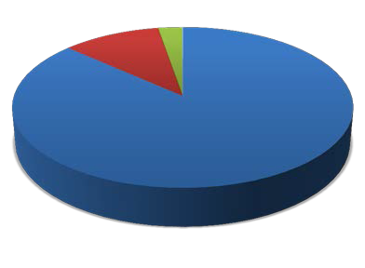
Yes No
3%
10%
87%

No Response

- What can we do better to communicate program expectations, upcoming activities of interest to you and your new attorney, and/or available resources?

Again, I was approached by the mentee with the paperwork. I dealt with it from there
CURRENT EMAIL PROCESS IS FINE
E-mail updates about the program were not as extensive as I thought. While overdoing e-mail can be a problem for all attorneys, I really respond to e-mail more than any other form of communication. A periodic e-mail flash update might have been helpful throughout just as a reminder about the mentor resources on the state bar's website.
e-mail updates are fine
E-mails would be best.
Hard to squeeze in some the preferred activities, including viewing jury trial, depo, arbitration, pro bono activity or
even a bar function, especially with a new attorney who was working for the NV Sup Ct.
Having a designated State Bar staff member (Lisa McGrane) available for contact on specific questions is beneficial, even though I did not end up needing to use that particular resource.
I cannot think of anything at all.
I think the notices were helpful.
I thought the notices and communications were done well.
I thought the program was well run.
I would like more than one session, rather than a single, multi-hour session.
IMHO, the mentees must understand that the mentor is NOT attempting to dominate their time, but rather working as a team concept; that the mentors are volunteering valuable time and resources to benefit the mentee; that the mentee should expect to make sacrifices of time, energy, feedback, and cooperation if the TIP Program is to be effective; and that working toward a common TIP goal is reflective of the practice of law generally. My first mentee was delightful and easy to work with due to intellect, personality, and sincere desire to learn from the experiences of the mentor.
Improve the online reporting and make the process more interactive with the Bar.
Just let them know how much time is going to take in order for them to properly complete the program.
Keep the e-mails coming
lessen duties put on mentor to report, and complete periods of mentoring.
Make it clear that we are not expected to fill anything out except this at the end. It feels a little strange we don't
check anything off as the mentee is going along.
Make the process more of a checklist of exactly what needs to be done, when, where, etc.
maybe some email tips/updates
More Mentor/Mentee activities
N/A
N/A
Somehow the networking function needs to be better attended.
The materials clearly explained the process
We were not so sure about when the exact deadlines were.
Check-in via e-mail re: timelines, prod mentors a bit so things don't slip.

Mentor-New Attorney Relationship
- Did you and your assigned new attorney have practice areas or areas of interest in common?

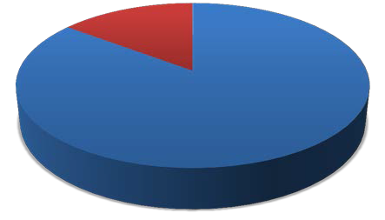
Yes No
15%
85%

- Were you and your new lawyer aware that the Mentoring Plan could be modified to reflect the new lawyer's professional interests and goals?

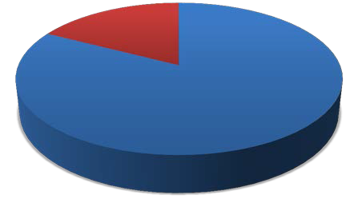
Yes No
17%
83%

- Did you assist the new lawyer in crafting his/her Mentoring Plan to meet specific goals? Please explain.

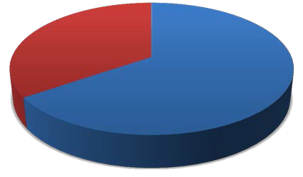
Yes No
35%
65%

Related Comments:

As we went along we made sure the discussions we had were as tailored to her interests as possible and tried to think of ways to meet her specific requests regarding practical experience.
Assisted in fee setting, office opening, getting new clients.
client development and malpractice issues
Close planning
did not get into that detail; just did the work
Discussed various aspects
frequent inquiry

Had him discuss with prior mentee what was beneficial and what wasn't and focused on areas he was interested in.
He actually described his career goals and we focused on electives that best fit those goals.
I encouraged my mentees to do things outside of their comfort zones (like going to lunch more frequently with all
male colleagues, or taking the initiative on a new project at work, and when we met next, we discussed whether these goals were reached.
I referred cases to the new lawyer and supervised her work.
In the sense that the existing mentoring plan allowed for specific elective requirements, we discussed what would be
of interest, we tailored the plan to fit those electives
mentee had already had a plan in place
My mentee practiced in another state for a few years so we modified some of the requirements that were for brand
new admittees.
My mentee is more focused at this point upon criminal matters and we tailored our program around his desires.
Never made contact with my mentee
new attorney had an interest in family & immigration so we picked projects in both areas
Offered opinions on what options to pursue.
she had it planned out
She selected the optional areas to be addressed
She simply let me know what her special goals were, and I worked with her on.
She was very organized and she crafted it to her interests herself
Since we are all in the safe office and have the same requirements and practice areas, it was not necessary for us to formally craft the mentoring plan.
Specific areas of need.
Tailored to our primary practice area of bankruptcy
We discussed and made the plan together.
We discussed my strengths and his interests. We tried to match them where we could. We also tried to find out where he could get more information beyond what I knew. He was transactional and I am in litigation. But we had fun talking and learning from each other.
we discussed the issue
We discussed them and she incorporated these discussions into formulating her Mentoring Plan.
We discussed this during our first face to face meeting.
we focused on activities that were relevant to her interests
We had serious work to do and id it.
We met and decided what the mentee wanted to achieve via TIP.
We met at the beginning to set up a proposed schedule.
We met at the outset to go through the requirements and what he wanted to achieve.
We went off the page and developed a particular relationship, totally unexpected. I imagine I will be more routine
with the next mentee.
We went through the areas and chose what he wanted to do and what I thought he should do
we went through the concerns he had ad addressed them
We worked on an immigration plan
went through plan together
Yes. He was interested in intellectual property. That is his sole area of practice.
My attorney had practiced Patent Prosecution before but had recently been admitted and wished to explore family
law and litigation. Many basic exercises were unnecessary, so it was great to have the flexibility to adjust the program's Mentoring Plan to suit her interests.
Towards our area of practice

- If you and your new attorney did not practice in the same firm/organization, did you experience difficulty with issues of maintaining client confidentiality or avoiding conflicts of interest?
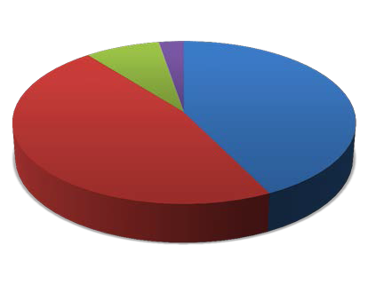

3%

8%

47%

42%

N/A (Same Firm/Org) No

Yes

No Response

- If you experienced difficulty with maintaining client confidentiality or avoiding conflicts of interest, please describe the issues and how you were able to resolve them.

He was interested in seeing how we were handling intellectual property litigation, but the confidentiality in that area made it difficult.
it limited what we could discuss about her work
Only participated in public proceedings. No client contact or participation in client meetings etc.
We experienced no such difficulty.
You cannot actually do cases together as it violates attorney client privilege.

- Please rank in order the factors that may have made the mentoring relationship difficult.

Top ranked: Finding time to complete the Mentor Plan tasks; “None, “and Establishing or maintaining contact with my new attorney.

100%

None

90%

80%

70%

60%

Other

Personality conflicts

Mentor Plan

50%

Distance between me and my new attorney

40%
Lack of training

30%

20%

10%

0%

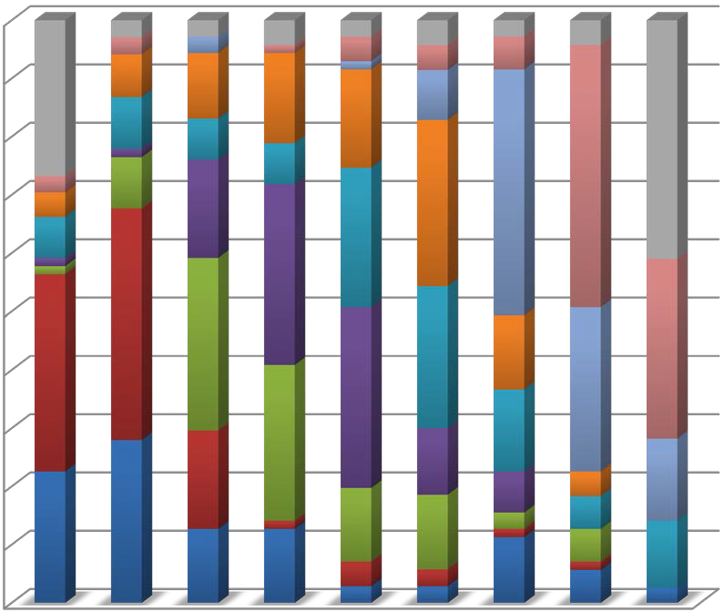
First Second Third Fourth Fifth Sixth Seventh Eighth Ninth
2
2
2
0
3
0
5
2
1
0
2
3
1
3
3
2
4
3
8
19
11
6
6
1
12
5
32
5
2
0
3
6
32
12
20
30
5
17
1
1
22
27
21
17
9
24
24
22
20
10
19
8
12
5
19
1
9
16
9
2
1
3
4
0
4
1
4
11

0

9
9
9
3
2
2
2
8
02
Lack of available resources

Finding time to complete the Plan tasks

Establishing or maintaining contact

“Other” Comments:

I didn't find it difficult.
i didn't have issues with most of these
i don't understand how to use this section
It was not difficult at all for me, but a pleasurable experience. I felt that i truly helped my mentee and have
helped send him off on the 'right path'. I didn't ever look at any aspect of this as something difficult.
Mentoring an experienced, practicing attorney seemed rather pointless.
Outstanding new attorney. Worked for the NV Sup Ct. I did not have some of the activities going on during this
period that he indicated he was most interested in, and he could not get away for some of the ones he could have observed.
Scheduling mutually convenient time to meet
The amount of time required to complete the program.
Unemployment

- Did you attend the TIP Kickoff (Las Vegas or Reno) with or without your new attorney?

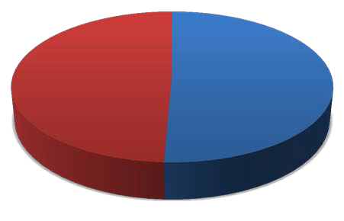
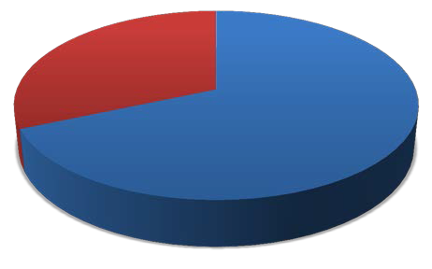
49%

51%

Yes No

- If yes, did you find the TIP Kickoff event to be worthwhile?

32%

68%

Yes No

- Please provide feedback about the TIP Kickoff event that you believe would make it better, or would entice you to attend in the future.

an agenda that encouraged parties to interact
Color coded or color coordinated badges would help, so that you can look at a person's name badge and instantly
know whether they are a mentor or a mentee. I spent a lot of time with fellow mentees trying to locate their mentees and this could be time spent in more productive fashion.
For some reason it seemed to sneak up on me.
For various reasons, I connected with my mentee very late in the process, so i have no comment.
I believe that any group ideas are helpful. Because my mentee and I work together there are only a limited number of practical activities happening in the office. It would be helpful for the mentees to get together with other mentors to try to fill in gaps in the plan if the mentee is interested in things I cannot provide her.
I did not actually attend the TIP kickoff event. Sorry.
I did not attend, so I cannot comment on this issue.
I think showing new lawyer that the members of the profession--including the judges--care about the public, about
pro bono and about the profession had a great impact.
I would have attended if my attorney had been able to join me.
It was a real plus to have the Supreme Court judges, District Court judges, and members of the BOG there, along with
bar counsel and other staff members from the Bar.
It was not well attended in Reno. While it was nice to meet a few new attorneys other bar functions better suit that purpose.
it was very sparsely attended but we did get to chat with some interesting people.
It was worthwhile because it allowed me to meet my mentee in person and we were able to set a specific schedule to meet complete the plan

Like any other social event, it gives you an opportunity to meet and mingle, which can be valuable.
more attendance. strictly social setting to relax the members
More opportunity for mentees and lawyers to talk as a group about issues.
My mentee had a preexisting scheduling conflict. However, I sponsored and attended with my mentee at the final year end Program of the McKibben American Inns of Court in June of 2012.
n/a
NOT ON THE STRIP
not really helpful
Promotion as a social event is good so that people can right away feel camaraderie and collegiality.
see prior comments
The event was not quite as well attended as we hoped, and there really weren't any organized ways of meeting other people besides just introducing yourself to the others who were there. It was not really helpful for networking, or otherwise for the mentee. In addition, although the food and ice sculpture were nice, I would prefer to see less money spent on the catering so the mentees didn't have to pay so much for the TIP program.
The first event was well-attended. The second event at the new City Hall had very few people attending, but it gave my mentee a better opportunity to chat with a Supreme Court justice, and eat delicious food.
There needs to be a way to make the initial connection between the mentor and mentee better. Events need to be more seriously attended by both.
Vdara was nice but a bit of a pain to get to traffic wise.
I had a previous commitment that day. Get the date out early!!

- How would you rank the quality of your relationship with your new attorney?
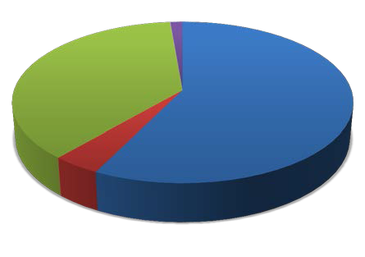
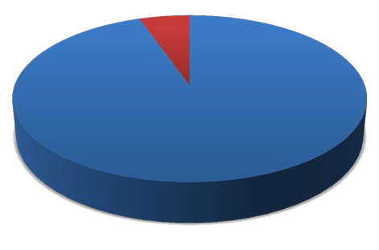
1%

37%

58%

Excellent Fair Good

Very Poor

4%

- Will you maintain a relationship with your new attorney after the mentoring term concludes?

22

5%

95%
Yes No

Overall Program Rating

- If you previously completed the Bridge the Gap seminar, or were part of that program for newly admitted attorneys, how would you compare TIP as a replacement for that program?

12%

13%

10%

65%
Bridge the Gap was a better program for new attorneys than TIP
TIP is a better program for new attorneys than Bridge the Gap
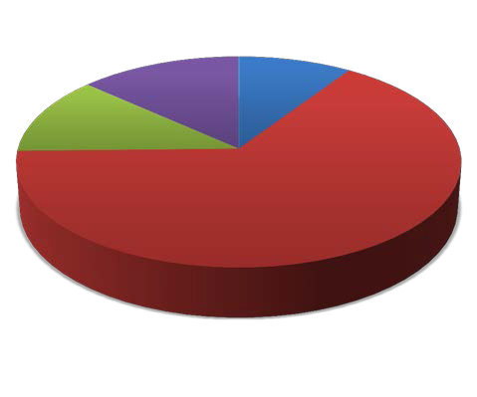

TIP is on par with Bridge the Gap

No Response

- Please provide any additional comments regarding TIP as compared to Bridge the Gap.

A mentorship program is always going to be more helpful than any CLE in terms of promoting practical and real world experience.
Although I like the TIP Program and am probably one of the few attorneys responding to this survey that liked the Bridge The Gap course (which I took in January 1998), I think the one-day format works better simply because of the extra time constraints inherent in the TIP Program. Best solution: TIP should be a 1 or 2 day session between the mentor and mentee(s), with the CLE award being based on both the preparation and meeting time investment.
Bridge the Gap felt too quick to provide meaningful learning and information. Having ongoing access for information and a continuing relationship with anew attorney impresses me as more valuable.
Bridge the gap gave a broader input to the new attorney. I am not sure it should not take place with mentoring as a supplement
Bridge The Gap is as to TIP as a wikipedia page is to the Encyclopedia Britannica. Bridge The Gap was a three hour, "hear it today, forget it tomorrow" type of session which had little or no impact on me. TIP, because of its various components and depth of requirements, will, if nothing else, get new attorneys to think about the type of practice they want and confront the down-to-earth "nuts and bolts" tasks of that practice. It's like night and day.
Bridge the Gap is just another book/seminar learning environment while TIP is actual practice which is what is so very necessary. TIP provides the guidance for a new lawyer actually beginning to deal with clients, other lawyers, and the court.
Bridge the Gap was not useful. It was required, we received a book & that was the end of it. The TIP program however, if both parties are vested, provides a very unique forum to ask "anything", participate in activities related to areas of law that you otherwise may not have available at work & develop a relationship with an experienced practitioner that may prove very valuable in the future.
Bridge the gap was very dry... TIP can be tailored to the mentee's interests
Depends on the expectations of new attorney and mentor
Due to the hands-on nature of the TIP program, it vastly outweighs the Bridge the Gap program in my opinion as I was
able to pass along specific things that my father taught me and spend time talking about things that really matter.
I believe the one on one personal interaction of the TIP program is much better than Bridge the Gap.
I do not recall Bridge the Gap with any specificity. That was a long time ago.
I don't even remember the Bridge the Gap course. I do remember thinking it was not very helpful or beneficial.
I really enjoyed meeting with my two mentees on a regular basis, and if I encouraged them to try something new, I
had to likewise do something new myself. I think it made me a better attorney to mentor someone. I became a

23

mentor because I wish I had had a mentor when I was a new attorney, particularly a female mentor. I think it is very
important for female attorneys to know other female attorneys.
I think TIP would be a good add on to bridge the gap, make it more informal.
It was a great opportunity to start a significant relationship with the mentee attorneys.
Just nice to have it compressed all at once.
Night and day.
Quite frankly, I believe Bridge the Gap was sufficient for the purpose of assisting a new attorney in entering the practice of law. There's no question, however that the TIP program is a much better training experience. The real issue becomes whether the significant time commitment required of both the mentor and the new attorney is worth the additional benefit to the new attorney.
The materials provided in Bridge the Gap were more extensive (big binder) but now things are online so it's probably comparable. I think an ongoing relationship with a specific attorney is more helpful than one day sitting and listening to a lecture.
They don't compare. TIP offers an opportunity to discuss law practice. We discussed everything, including intake, conflict checks, accounting, trust accounting, etc.
This program has the potential to be far better than bridge the gap due to hands on and tailored mentor plan.
TIP is more enjoyable.
TIP is more hands on and the longer time period allows more to be accomplished
TIP is more useful, hands on, but shouldn't really be required if the firm already has an established mentoring program.
TIP IS MUCH MORE INVOLVED AND USEFUL TO THE NEW ATTORNEYS
TIP provided an opportunity for a more thorough examination of the issues than Bridge the Gap did. BTG was one and done, while TIP required the new attorney to consider the issues for the period of the program.
tip was hands on BTG was just a classroom exercise-passive involvement
TIP is personal and tailored to the individual's interests and questions. Bridge the Gap was very impersonal and general.

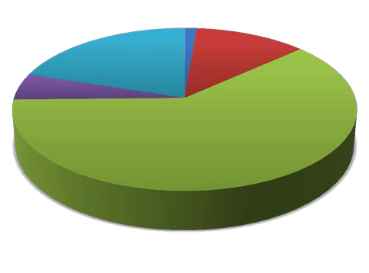
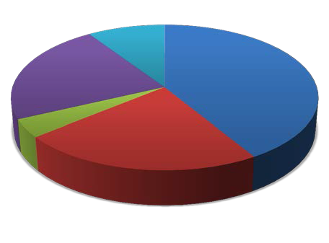
- Overall, how satisfied are you with the TIP program and your involvement as a mentor?
1%
20%
12%
5%
Dissatisfied
Neutral Satisfied
62%
Very Dissatisfied
Very Satisfied
How likely are you to continue serving as a mentor in future years?
23%
4%

38.

24

9% | 41% | Likely Undecided
 |  | Unlikely
 |  | Very Likely
23% |  | Very Unlikely

- What can we do to encourage your future service or the service of other attorneys who are not yet mentors?

Add or continue social meetings for TIP.
change the format regarding issues that involve attorney client privilege issues.
CLE Additional Hours
Continue to get the word out.
encourage firms to allow mentors & mentees the time to participate in the program
Expand the timeframe as 6 months is much too short.
Find ways to give recognition to mentors to make mentoring look like an esteemed position.
I recommend continuing to work with the CLE Board to ensure that all mentors receive the three credits of CLE, which is a big "carrot" to offer to prospective mentors.
I would have done some pro bono work with my mentees if something other than family law were available. They had very little time to do any pro bono work, and perhaps the agencies involved could make it easier to volunteer.
Increase the CLE credit given.
Invitation
IT IS AN IMPORTANT PART OF MY JOB AND I WOULD DO IT REGARDLESS
make service mandatory for each licensed attorney with at least 10 years of experience
More CLE credit for mentors, perhaps?
More CLE credit.
Pay me???
Perhaps a one year commitment instead of two. I don't need anything different, just undecided because of limited time. It's a worthwhile program.
Pick mentors who are willing to commit the time, resources, and enthusiasm to make TIP successful. Impress on mentees the critical importance of cooperation and flexibility in dealing with mentors. My second mentee was unwilling to be flexible in scheduling meetings or to be cooperative despite extensive efforts to make my schedule conform to theirs. This indicated to me a mentee under extreme stress to perform as a newly hired associate who was incapable of balancing the pressures inherent in the practice of law with the stress of private life. Not uncommon in our legal industry.
Promote the program at State Bar CLE seminars
Provide some more incentives for the attorney to participate -- more CLE credit, or ethics credits, perhaps?
Providing more group based activities will be helpful for me since I am in a pretty specific practice that isn't necessary helpful for those interested in a more broad based areas and experience.
Publicize more. When I was chosen most of my co-workers were unaware they could have applied.
The lunch with the Judges is nice.
The thing that was probably the toughest for me was putting in about 25 hours and getting what was for me, an insignificant amount of CLE credits. That having been said, I am not at all complaining and am satisfied that this was simply 'part of the program' and what I signed up for.
The time requirement was not as onerous as I first thought it might be. Communicating that it doesn't take as much time as one might think could encourage more attorneys to participate.
Unfortunately, time is the biggest issue for me and there really is nothing you can do to help with that.
Well the only reason I would not do it is simply the time constraints of having a family with young children, and a small practice with three attorneys which requires almost daily court attendance in the family division.
Government types should be paired with those who are interested in Administrative Law. We didn't have enough to talk about because the only commonality was location! Luckily I have a strong litigation background and a great relationship with other members of the bar who stepped up to fill the gaps.
Less paperwork.

- Please provide any additional comments about the TIP program in general, experiences you had with the program (positive and negative), and/or suggestions for improvement.

All of my experiences have been positive.
COMPLETED PROGRAM WITHIN 3 MONTHS SO 6 MONTHS IS MORE THAN PLENTY OF TIME
Dawn traveled to Reno several times to meet with me. This was professional and thorough. But, it felt like a lot to expect from her.
I believe the TIP fee for the mentees should be reduced -- $350 is a quite a lot of money for a new attorney to pay for a mandatory program -- especially since they have just shelled out quite a bit for the bar exam and the bar prep course, and as a new admittee may not have even found employment yet.
I found the program a bit challenging in the sense that my outside mentee relationship really limited the types of activities we could accomplish within the Mentoring Plan. As a result, the majority of our time was spent having discussions in my office about both the mandatory and elective topics. While I tried to make these topics as practical as possible, I'm not certain if they all resonated with the mentee. My mentee seemed enthusiastic about the program, and asked me questions at times, but for a considerable part of the program I felt like I was lecturing to an audience of one.
I think it is good for the new attorneys to have someone show them the practical ropes of practicing law in Clark County.
I think this survey is too lengthy
I wanted to have my mentees get to know other new attorneys, and other than the kick-off event, there weren't any
events we could have attended other than SNAWA lunches that consisted of small groups of attorneys they could meet.
I was asked to mentor a person who had been practicing for two years. He never did Bridge the Gap, so he had to do this. There was in my estimation little or no value to him from this exercise at his stage of practice. We did the things required, discussed rules and ethics and etc., but it was all already well known to him.
I would only say that I thought that the program was a bit too long. In other words, not enough credit was given to (at least) my mentee for a great working knowledge as to the rules and ethics in general.
IMHO, TIP is a vast improvement over Bridging the Gap and far more effective for the realities of practicing law in the public or private sector. It, however, requires a sustained commitment of time, devotion to purpose, sacrifice by both parties at all times, flexibility, mutual cooperation at all times, and an interest in completing TIP for improvement of not only a particular mentee, but to enhance the quality of the practice of law throughout Nevada. No doubt a few mentors and mentees will not take the Program seriously, but my 30 years of experience with the good, bad, and ugly aspects of practicing law cannot be learned reading books. These lessons can only be learned by sharing with a willing mentee how to minimize traps for the unwary and maximize the positive ways to represent one's clients AND the legal profession in Nevada in an effective, ethical, and competent manner consistent with best practices and the rule of law. TIP was not intended to be burdensome, although some mentees no doubt perceive it as yet another layer of bureaucratic red tape to overcome. TIP can, and should be, helpful to BOTH mentor and mentee. IMHO, both mentors and mentees must understand initially that this is
It may have been nice to meet at least once with other mentors/mentees in my practice area to discuss have a question and answer session
N/A
Perhaps a format with email reminders. I relied on the mentees to schedule meetings if they were not on the ball it
might not have happened because I don't think I would have kept to a schedule on my own.
see prior comments
Suggest Judges ask if there are any TIPS in audience.
this is a big time commitment for the mentor, especially when you add in other requirements that an attorney has to meet.

TIP New Attorney Surveys

New Attorney Background

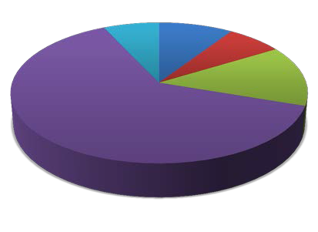
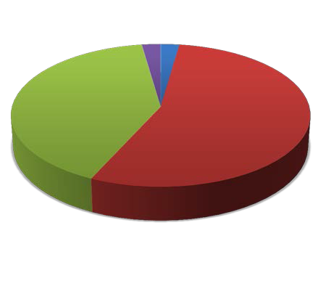
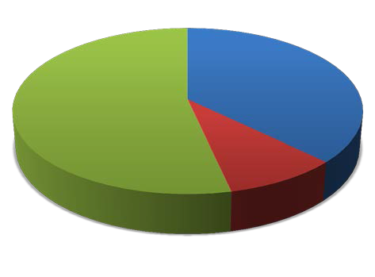
1. Current Employment Information.
7%
9%
Unemployed
7%
14%
Solo
Practitioner Government
63%
Law Firm

Working, but not as a lawyer
I was mentored by an attorney:

2% 2%
41%
Who mentored me plus at
least one other attorney within my firm/organization (circle)
Working in another firm/organization (outside)
55%
Working within my
firm/organization (in-house)
No Response
Were you directly supervised by your mentor?
37%
54%
9%
Yes
No
No Response

2.

3.
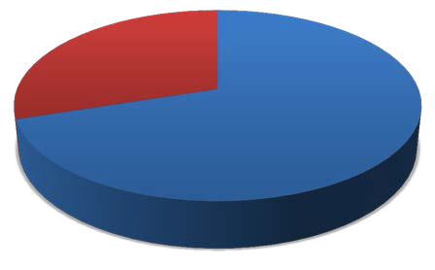
- If yes, were you given any say with respect to having your direct supervisor assigned as your mentor?
30%
70%

Yes No

Program Evaluation

- Did you find the Mentoring Plan that outlined mandatory and elective TIP program elements easy to follow?
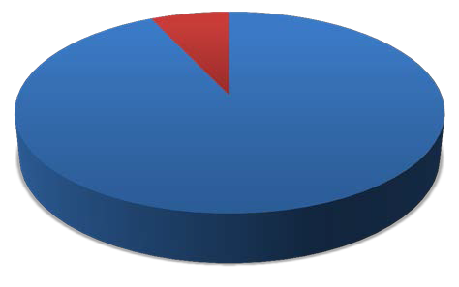

7%

93%

Yes No

- Please tell us if there are any mandatory or elective elements in the Mentoring Plan that you would like to see added or removed in the future, and why.

Although a majority of the TIP requirements could be catered to the fields in which we practice, there were many that I had to complete when they had no relevance to my field. I practice in the government sector so there was no connection between my practice and most of the "law office management" section of the program. There was also a disconnect between my practice and the client communications section of the program.
I think it is a very solid plan. My one complaint is that several mandatory elements were redundant to me because my mentor or other attorneys in my firm and I had discussed them prior to the commencement of the TIP program.
I would like to see an ethics/technology component that integrates the rules and the use of electronic, mobile, and social media. I recently attended a State Bar of Nevada CLE by Michael H. Rubin highlighting these issues which was very informative.
It can be difficult to make time for two attorneys at different firms/agencies to meet. Having a few more cocktail hours could have helped to pace the meeting.
It would be nice to add to the Estate Planning/Probate/Guardianship more as to probate & guardianship - such as, "attend a probate hearing" / "attend a guardianship hearing" - even just attending the weekly probate hearings (not necessarily our own client) would be a good option. Also, "prepare a guardianship/probate petition" and "prepare an affidavit of small estate" would be good options to include.
It would have been helpful to have a definition for each area. For example, "The Legal Community" doesn't tell me what specifically about the legal community you want me to develop such that I can add my own activities at the end. I was quite surprised to see so little about administrative procedure (given number of agencies) and legal

research (given Nevada's two-tier court system and minimal case law) in the Plan.
Many of the requirements were near impossible to complete for new attorneys whose mentor is from a different firm or organization. Perhaps you should better tailor the requirements for each scenario: mentor in same firm vs. mentor in different firm.
My only comment to this is that there is a tremendous amount of overlap and redundancy to the activites within and among the different sections. Often my mentor and I would begin a new section and discover that we had already performed some of the activities in prior sections.
None come to mind. Remove redundant elements.
Sections 1 & 2 were issues taught in law school classes as well as tested on for bar admittance. I didn't think 6 hours
of required discussion were necessary.

- Were there any aspects of the Mentoring Plan that you found to be onerous or difficult to follow?

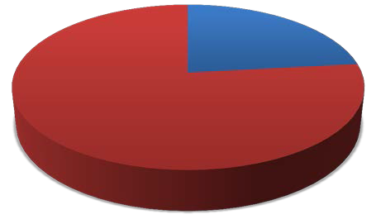
Yes No
23%
77%

Related Comments:

Going through all the rules of professional conduct. However, my mentor and I did have meaningful discussions about the rules, but I think the requirement of going through ALL the rules is a bit much.
Hands on activities
Participating in a trial to completion is not necessarily feasible in the 6 months or even the whole first year. See above
Some of the requirements were redundant for those of us already working The plan was clearly designed for newly minted attorneys. I have been practicing for 4.8 years (5.8 years if one
counts my clerkship). The Plan required discussion of dozens of points with which I am already intimately familiar.
There was a significant time commitment.
- Were there particular sections of the Mentoring Plan that you found to be more time consuming than others?
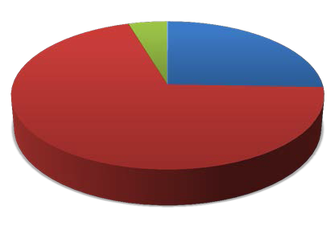

5% 25%

70%
Yes No
No Response

Related Comments:

Hands on activities, court appearances
Section 1 took the longest
Section 5 (practical work) was more time consuming, but I think it should be!
Some discussion topics were very detailed, which made completing the section take longer.
Touring court offices.

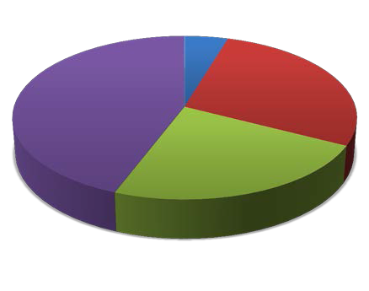
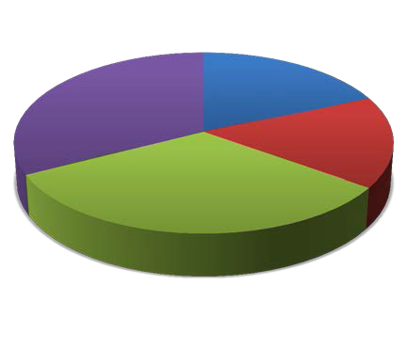
- During the entire six-month TIP cycle, how many hours do you estimate that you spent with your mentor (in person, by phone, etc.)?

44%
5%

23%

28%

Less than 10 hours 10-15 hours

16-25 hours

More than 25 hours

- During the entire six-month TIP cycle, how many hours do you estimate that you spent completing the Mentoring Plan on your own?

33%

32%

19%

16%

1-5 hours
6-10 hours
11-15 hours
More than 15 hours

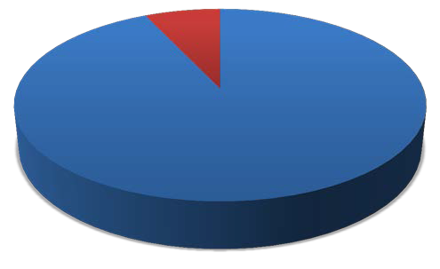
- Did you have sufficient contact with your mentor to complete the Mentoring Plan within the six- month TIP cycle?
7%
93%

Yes No

Related Comments:
None.

- How did you deal with the issue of time constraints?

By careful allotment of time.
COMMUNICATION! We kept each other informed of our schedules and worked around time limitations. When we
meet we tried to cover as much as we could and be productive.
Email, weekends, lunch meetings
Fortunately, when I worked as a judicial law clerk, my department was always willing to allow me to fully participate
in the mentor program.
I didn't have this problem because I work in the same office as my mentor.
I don't understand this question--my time constraints, my mentor's time constraints, or time constraints as they
relate to attorney practice generally?
I had a prior mentoring relationship with my mentor. We made plans for lunch, and if one of us had a hearing or client issue come up, we were both flexible in our meeting dates. I think this would have been a bigger, and more stressful, issue if I had not previously known my mentor.
I just tried to prioritize between work and the requirements of the plan.
It was difficult but manageable
It was easier for me because my mentor was in house and therefore we could schedule meetings during work hours.
It was very difficult as a new attorney to complete all the requirements on time while learning how to perform the duties of my job. Extending the program to allow for 9 months or even a year is something I would recommend on behalf of future participants.
Just did
My mentor and I are both members of Inns of Court, and that provided good opportunities to meet and talk.
My mentor was awesome about working around my schedule and if he needed to cancel meetings he was great
about rearranging the meetings. He made sure that we met at least once a month, but often we met more than that.
NA
Scheduled mentor meetings on firm calendar and treated it as though it was a hearing.
Scheduling and prioritization.
Time constraints were not really an issue. We met almost every week to complete the mandatory requirements. My
mentor allowed me to pick what I wanted to do for elective hours, and when I picked certain things that he was not comfortable mentoring me on (i.e. real estate transactions) he delegated his mentor duties to another attorney in our firm who did specialize in that area.
Use of email and combining mentoring plan components with pro bono work.

We always work under pressure at the firm. It’s part of the job.
We began in May and scheduled weekly or biweekly meetings depending on our schedules and stuck to our plan. I didn't feel too much pressure of timing.
We scheduled a given time each week on Friday to complete a portion of the assignments.
We tried to take advantage of the down time (i.e. travel to Court) that we had together to work on the TIP program.
We typically met over lunch hours to better fit our schedules.
Work with mentor after work hours were completed.

- Please rank, in order of what is most important to you, what you hoped to learn through TIP.

Top Ranked: (1) To learn practical skills needed for my legal career and (2) To get to know an experienced attorney who would assist me as I started my legal career by providing advice and encouragement.

100%
90%
80%
70%
60%
50%
40%
30%
20%
10%
0%

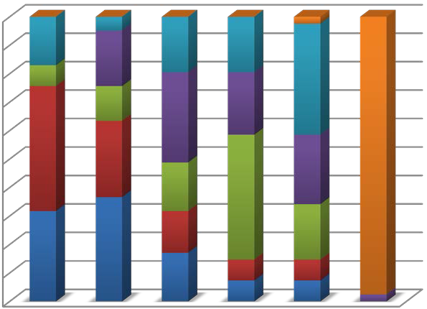
First Second Third Fourth Fifth Sixth
0
7
20
8
0
8
0
8
1
0
3
16
5
9
13
18
11
40
10
7
18
6
8
13
15
7
3
3
3
3
001

Other

To meet the requirement for participation.

To get another perspective of working in [a practice] that is different from mine.

To expand my networking circle.

To learn practical skills needed for my legal career.

To get to know an experienced attorney…

“Other” Comments:

Develop a level of comfort in practicing law.
To find a job.

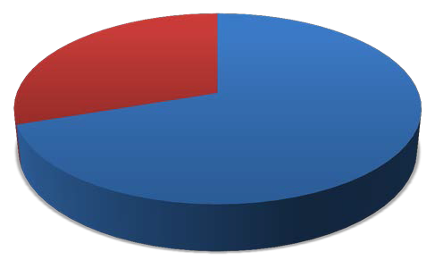
- Are you better prepared for the practice of law because of your participation in TIP? (Please explain)
30%
70%

Yes No

Related Comments:

Although my mentor and I sincerely made an effort to make the most of the situation, the TIPS program was a huge waste of time and money in my case. I graduated law school in 2006 and have been licensed to practice in California since November 2007. I also clerked with a state supreme court for the year before that. Furthermore, I have received ample (and much better structured) mentoring at both national firms for whom I have worked. The TIPS program was clearly designed for attorneys who are (a) fresh out of law school and (b) do not already have the institutional support and framework of a major law firm, neither of which applies in my case.
Although only minimally. Many of the requirements were things I had already completed
Been in the legal career since 2000. Was a litigation paralegal and completed majority if not all requirements previously but was instructed by State Bar to do it all again, Upon receiving TIP booklet, I began, but was then told by State Bar to do it again because I did not wait until the official start date.
Forced discussions about ethics and other practical tips advance my career, I believe.
fulfilling the requirements of the program were no different than what I would have encountered anyway as a first year attorney working under an experienced litigator. I did not have any particularly "new" or innovative experiences under the TIP program that I would not have otherwise had.
Having discussed various aspects of practice that I do not necessarily encounter in my day to day
I am a 5th year attorney.
I believe all of the requirements set forth in the TIP program have prepared me for my first year working as an
associate.
I definitely feel better prepared. My mentor was very thorough and practical in reviewing TIP highlighted issues. He also addressed many personal concerns that I had (finding a job and career development).
i guess so
I have a wealth of new information of the law and practice. I also gained insights into my local legal community.
I learned a lot of practical aspects of law and possible ethics issues.
I think I am better prepared to make good business, ethical and client decisions now. I don't know if it helped my knowledge of law.
I think it is helpful to have been introduced to some more experienced attorneys, so that I am not just some anonymous new guy.
I was blessed with a fantastic mentor who truly took me under his wings and shared his knowledge with me. It is also comforting knowing that I have a highly experienced attorney that I can turn to for advice regarding my legal career or issues with cases in the future.
Made good contacts and got practical pointers.
Most of the preparation and experience necessary came through my work within my own firm.
The practice area electives were extremely helpful.
To certain degree. I'm not sure how useful the TIP program is for first year attorneys working in a firm setting since

my mentor and other attorneys had discussed with me several requirements of the TIP program prior to the commencement of the TIP program. If I was a solo practitioner, it would have been much more useful.
We got to cover the little details that people just assume you know, but no one actually ever tells you or talks about.
Yes, my mentor was good, very knowledgeable, and helpful.

- Did you receive adequate communication from state bar staff about what was expected of you?
2%
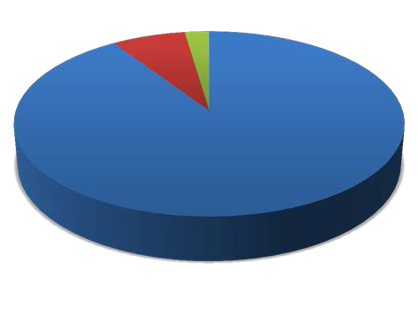

7%

91%
Yes No
No Response

- What can we do better to communicate program expectations, upcoming activities of interest to you and your mentor, and/or available resources?

An error appeared from my response to the question, "Are you better prepared for the practice of law because of your participating in TIP? (Please explain)." My response was Yes, but it wouldn't accept the response. Here is my explanation: In some ways yes, in some ways no. I have a better idea of different things I've accomplished as a result of tracking my work. Honestly, I'm not confident that the TIP program prepares attorneys any better than CLE. I understand the need to address ethical issues that have affected the practice as a result of new attorneys, but this depends on the individual.
Email is fine.
Have a few more live events. They would serve as better benchmarks than emails. I found the communication to be adequate.
I think it was hard to communicate hard line expectations with a new program that was meant to be organic. My
experience was very successful because my mentor took an interest in my development and spent time with me. We did not do a lot of hands on assignments but he really discussed things with me on a practical level, with real life examples. I was able to glean a lot from his experience. I think the program works best when hands-on assignments are integrated with the kind of mentor I had. As a solution to those attorneys who are unemployed upon entering the TIP program I think integrating the use of hypotheticals, case studies, and use of drafting examples helps. My mentor integrated these tools on an information, oral, basis and it worked well. Written simulations in drafting, problem solving, and rule recognition might be helpful so that the process is both organic (personalized) and a little more structured in terms of milestones. /
I think this was fine. My area only had one other mentor-mentee, so we had our own get togethers like Reno and Vegas.
I understood what was expected of the mentoring relationship and my mentor did a great job of planning our own activities to complete the program.
It was very difficult to have a mentor that is not actively practicing litigation. Other than the discussion elements, there wasn't much practical experience that she could provide me. I had already been licensed in UT for three years, so this felt pretty useless.
Monthly reminders of progress. N/a
Nothing

Nothing.
Recommended schedule of benchmarks.
The packet was easy to follow and the email notifications reminded us of the deadlines. Perhaps more activities/get-
togethers/workshops could be sponsored by the State Bar.
You could create a web forum/FAQ.

New Attorney - Mentor Relationship

- Did you and your mentor have practice areas or areas of interest in common?

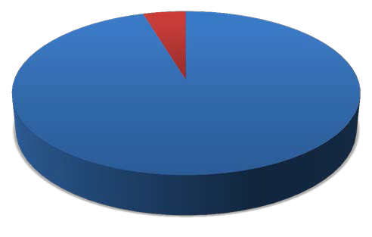
Yes No
5%
95%

- Were you and your mentor aware that the Mentoring Plan could be modified to reflect your professional interests and goals?

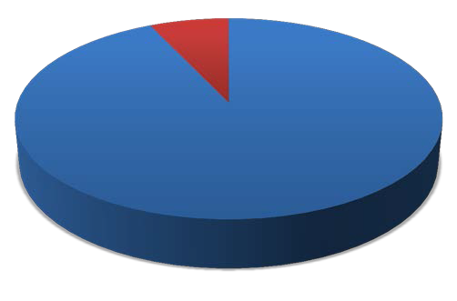
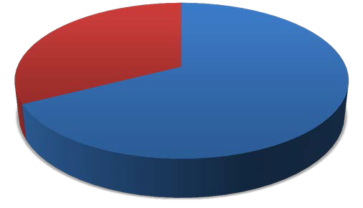
7%

93%

Yes No

- Did your mentor assist you in crafting your Mentoring Plan to meet specific goals?

33%

67%
Yes No

9

Related Comments:

Because I am a staff attorney at the supreme court, I do not practice. My mentor is a former staff attorney, which made it easy for us to discuss relevant information.
Because I have several years of prior practice, my mentor was very accommodating. Yet, I cannot escape the conclusion that the TIPS program had little to offer someone in my position.
Combined elective practice areas. He told me which practice areas would come up and which likely would not.
Most of the electives were focused on areas that I am interested in. Being in a firm, my mentor allowed the
attorneys who specialize in those areas to act as my mentor when it came to those practice areas.
My mentor always asked what I wanted to get out of the program and out of each section of the program and then did what he could to help.
My mentor and I practice in different areas (one of us does crim, the other, civil), and my mentor answered my questions with regard to the field in which I do not practice, but am more interested.
My mentor gave me suggestions and helped guide me in understanding what my goals were because I did not have a clear picture of what my background had to offer.
She asked what electives we thought would be most helpful or interesting to us personally and then worked with us in those areas.
We discussed the areas of law where I had an interest and focused on those areas as much as we could.
We have done a lot of work in the specific area that I am interested in by requiring me to do "real" assignments with research and writing.
We met and she asked what I enjoy doing.
We tailored the requirements we completed to my area of practice. We utilized our current workload in order to meet specific goals of the mentoring program.

- If you and your mentor did not practice in the same firm/organization, did you experience difficulty with issues of maintaining client confidentiality or avoiding conflicts of interest?

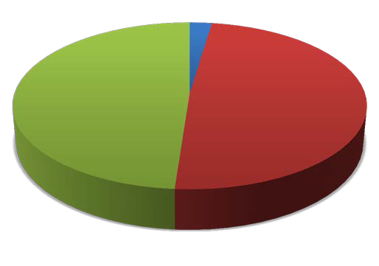
Yes
2%
49%
49%

No

N/A (We practiced in the same firm/organization)

- If you experienced difficulty maintaining client confidentiality or avoiding conflicts of interest, please describe how you were able to resolve them.
by using hypotheticals

- Rank in order the factors that may have made the relationship with your mentor difficult.

Top Ranked: (1) None and (2) Finding time to complete the Mentoring Plan.

100%

90%

80%

70%

60%

50%

40%

30%

20%

10%

0%

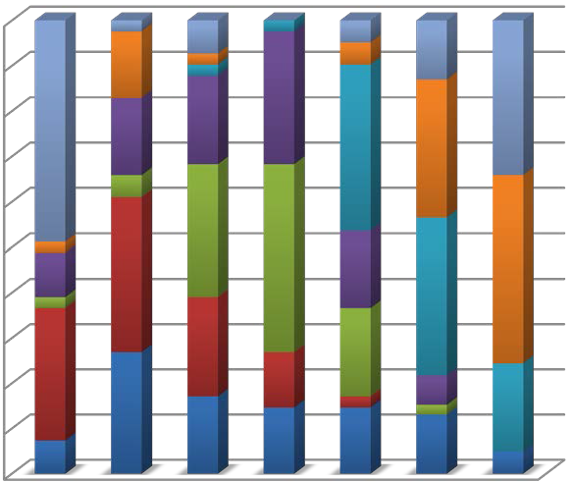
First Second Third Fourth Fifth Sixth Seventh
1
6
0
7
3
01
1
2
2
6
1
12
14
20
8
15
14
2
12
10
4
1
17
14
7
17
16
9
8
12
5
11
7
6
1
6
3
3
01
6
8
0
2

None Other

Personality conflicts with my mentor

Mentoring Plan

Lack of available resources

Finding time to complete the Mentoring Plan

Establishing or maintaining contact with my mentor

“Other” Comments:

As a follow up to the first difficulty, because my mentor and I worked in different firms there was some difficulty finding available times during the work week. Most of the time we met on my off days.
Lack of structure. It's a new program... being a guinea pig always lacks structure. I think it's a good program.
Main issues were time constraints, scheduling, and hands on assignments. These were not major obstacles. I think my mentor wanted to be more hands on with me but he was limited because I was not employed at the firm.
none
NONE

- Did you enjoy meeting with your mentor?

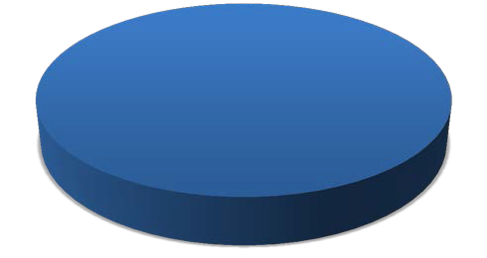
Yes
100%

- How would you rate your relationship with your mentor?
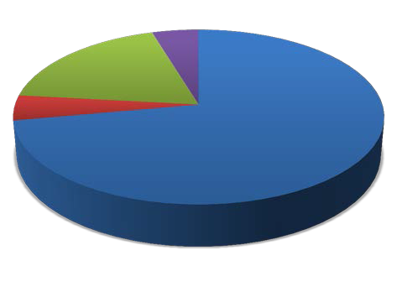

5%
18%

5%

72%

Excellent Good

Very Good No Response

- In your opinion, what were the advantages of having a mentor?

A go-to person to ask any all questions that I had
Different perspective than what I get in my office. Different experiences and another person that I can call on for
assistance.
Forced familiarity
Having a mentor allowed me to ask questions that I would not normally ask other attorneys.
Having a resource to help discuss issues as they arise is invaluable for a young lawyer as he or she is exposed to different real life scenarios.
Having someone who has "been there and done that" and who supports my development as an attorney. My mentor did a fantastic job at sharing his wisdom with me and discussing all of the questions and concerns I had about being a new attorney. It is a wonderful feeling knowing that I have a mentor who is highly experienced, incredibly knowledgeable, and highly respected and who was and is always willing to make himself available to help with my growth and development.
Having someone who has practiced in Nevada for a while.
I am relatively new to the area, so I know only a handful of attorneys in town. Was great getting to know another
attorney who was willing to help me get off my feet and give me encouragement. Also, I work at a firm with all male attorneys - nice to have a female mentor.
In that the mentor was in a different firm/field from me, it was helpful to be able to vent issues about office politics (without naming names) and other administrative issues without fear of retaliation and to get an objective perspective.
It allows the inexperienced attorney to get questions answered that they may not have other outlets to get answered and gives the new attorney valuable networking contacts.
It is wonderful to get a more seasoned perspective on the practice of law.

It's good to build a rapport with someone experience who you can trust. I have not had any professional difficulties
so far, but if I ever do, I feel like I have someone I can turn to for advice. I also learned a lot of the soft skills involved in my position, and in terms of thinking about planning a career.
Law school doesn't teach you how to do a lot of the practical things, especially the day to day office work like preparing bills, that is required in practice. Having a mentor really helps in learning those types of things.
Making an established contact in the legal community. Getting feedback from an experienced attorney. Observing a trial and a settlement negotiation.
Meeting an attorney outside of my firm and seeing how he runs his firm.
Meeting new people, networking
Mine is pretty simple, my mentor hired me when I was done working with my judicial clerkship.
She seems very well connected.
Someone senior to discuss topics.
Someone to provide a different perspective on issues.
Someone who could present a different perspective on lawyering and still understood my field of practice without being in my firm.
The advantage was his experience; not only of the law, but of life. He truly was an attorney and a counselor to me.
The only real advantage for me was that I now know one more attorney in the area.
The true value of the TIP program for me was just being put in a position to meet someone, like Tom Kummer, who I
probably would never have met otherwise. Tom opened my mind. Tom helped me see where my talents were, what the possibilities were in light of those talents - and to think BIG! I would never have been able to have such a clear view of what kind of attorney I wanted to be without his input and I don't think I would have ever met Tom, much less develop a personal relationship, if it were not for my participation in the TIP program. Through Tom, I was also able to meet some of his associates who I feel confident I can develop a great relationship with as well. However, with Tom, I feel like I have a true friend for life, someone I can really trust. That is rare. / /
There was someone to ask advice from when I did not feel comfortable talking to attorneys in my own firm. It gave me insight into different practices in running a small business.
Under my personal circumstances, my mentor would have likely acted as my mentor regardless of the mentor program. However, for a new attorney who did not already have a seasoned attorney to work with I am sure that the program was very helpful.
Very knowledgeable and a great teacher

- Would you recommend to other new lawyers that they request your mentor if he or she is available?

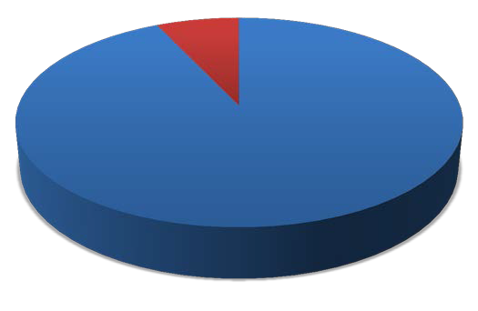
Yes No
7%
93%

- Will you attempt to maintain a relationship with your mentor after your mentoring term concludes?
2%
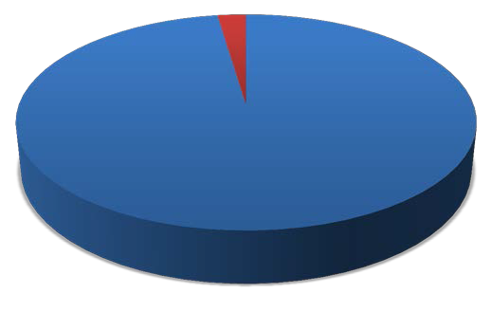

98%

Yes No

Related Comments:

3 offices down from me
Absolutely. A good long term relationship with my mentor will be personally and professionally beneficial.
Actually, I have no idea. He's a nice guy, but I have little reason to keep in touch with him. Indeed, we may even be competing for the same work/clients.
He has invited me to keep in contact with him and is willing to send any form templates I may need.
He works at my firm so I hope so.
I absolutely desire to maintain contact with my mentor.
I feel like a have gained a true friend in a world that is focused on networking.
I hope to have an ongoing relationship with him. I would like to use his expertise in reviewing my work. And as
always, his advice.
I like her
I now work for my mentor.
I plan on checking in from time to time.
I work in the same office as my mentor and work closely with him on a daily basis.
I would refer clients
Like I said, we already had a relationship. It should continue.
My mentor and I work in the same government entity and he previously served in the same position as I now hold. He is an incredible resource and I plan to take advantage of his advice in the future.
My mentor is my direct supervisor in my firm.
She is an awesome boss and I hope she remains my boss for years to come.
The mentor is also a family friend and an exceedingly competent, nice, and funny person.
Very caring attorney who I feel comfortable calling and running issues or questions past.
We discussed trying to meet once a year or so.
We practice in the same fields so I anticipate that we will have a professional association at some point
We work together.
Work in the same firm

- Did you participate in a mentoring program offered through your firm/organization, through a local bar association, or through another state bar while also participating in TIP?

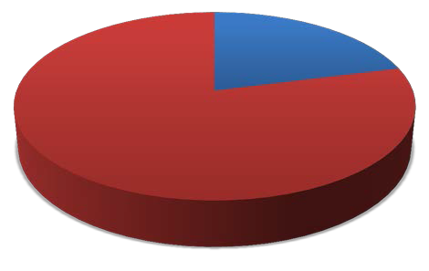
Yes No
21%
79%

- If yes, were you able to incorporate tasks and activities from TIP to the other mentoring program or vice versa?

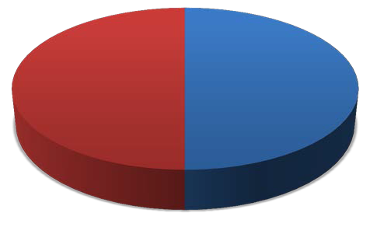
Yes No
50%
50%

Related Comments:
Different mentor

- Did you attend the TIP Kickoff (Las Vegas or Reno) with or without your mentor?

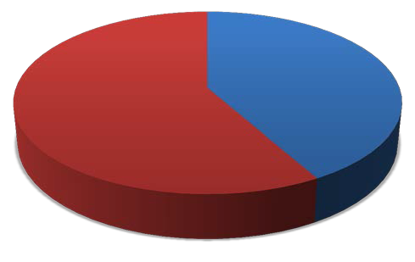
Yes No
42%
58%

- If yes, did you find the TIP Kickoff to be worthwhile?

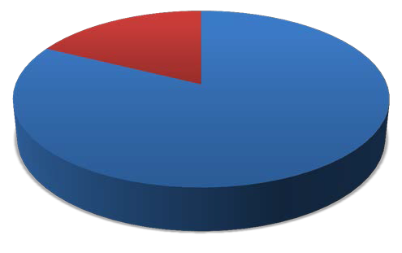
Yes No
18%
82%

Related Comments:

I expected information and guidelines regarding the TIP program to be available at the kickoff but it was essentially a mixer.
I was able to network a little.
I would have gotten the same out of it by hanging out w my mentor at a bar, but drinks would be cheaper.
It helped introduce me to the various departments and activities of the Nevada Bar.
It was an ideal time and place to meet my mentor for the first time and learn about other aspects of the state bar
It was nice to meet other attorneys, both seasoned and new.
It was nice to meet some of the mentors and mentees that I don't regularly interact with.
Networking
Networking events are always worthwhile.
Unfortunately there wasn't a very large turnout.

- Please provide feedback about the TIP Kickoff event that you believe would make it better, or would have enticed you to have attended.

A different smaller venue, like the spring 2012 venue at city hall. The food was better at city hall too. Vdara had the god aweful salmon tar tar stuffed sweet cones.
A little more structure. Maybe a brief presentation regarding the program and how it is supposed to work.
I answered earlier that we had our own "Kickoff Event." It was a good ice breaker.
I didn't attend this event. Ample experience has taught me that networking-for-networking's-sake events are
useless. Also, I am not only a practicing attorney with a heavy case load, I am a father. Therefore, my time is much better spent in other ways. My recommendation is that the bar not hold such events and put our money to better use.
I had to leave the event early, but I liked being introduced the various lawyer services that were represented at the event, as well several local attorneys who I don't regularly deal with.
I simply had a scheduling conflict.
I think the TIP Kickoff could have been structured to encourage people to get to know each other more.
I thought it went well but I think it might have been better attended if you featured potential employers/recruiters
who talked about what they are looking for in hiring new associates, an panel of attorneys talking about their different practice areas, and more comprehensive handouts from the bar sections discussing their various activities.
If bar staff could have facilitated more introductions, that would have been an improvement. Networking events are usually pretty awkward. People are generally grateful when others can serve as ice breakers.
If I knew someone else that was going, I would have been more open to it.

I'm too busy usually. Thank you though.
It sounded fine. Just didn't work with my schedule.
It was on my birthday, so I was unable to attend.
May want to make it more of a mandatory event.
N/A
NA
Please inform the participants exactly what the purpose of the kickoff was. It appeared several participants were expecting more information to be available regarding the program, but there was no central authority to answer questions.
Scheduled during working hours when I was first starting my career. Perhaps would be better on a saturday
We were not able to attend.
Would have been nice if more people would have attended.

Program Evaluation

- Please rate your overall experience with TIP.
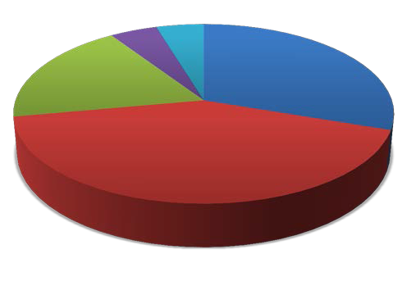

18%
5% 5%

42%

30%

Excellent Good Fair

Poor Very Poor

- Please provide any additional comments about the TIP program in general, experiences you had with the program (positive and negative), and/or suggestions for improvement.

Although I understand the purpose behind each task, I think the mentor should be given more freedom in how he/she wants to conduct the mentorship.
Although my mentor and I sincerely made an effort to make the most of the situation, the TIPS program was a huge waste of time and money in my case. / / I graduated law school in 2006 and have been licensed to practice in California since November 2007. I also clerked with a state supreme court for the year before that. Accordingly, I came to the program having practiced the law for more than 5 years and having been licensed for more than 4.5 years. Furthermore, I have received ample (and much better structured) mentoring at both national firms for whom I have worked. The TIPS program was clearly designed for attorneys who are (a) fresh out of law school and
(b) do not already have the institutional support and framework of a major law firm, neither of which applies in my case. / / I have been very busy this year with my own law practice at my firm. The TIPS program took time away from that practice and unnecessarily made life more difficult for me without providing any real benefit. I do not believe that the program can be amended to provide any substantial benefit for attorneys in my position. / / It should be noted that I applied for but did not receive an exemption. / / My recommendations: / *Provide more flexibility for exemptions. / *Provide an exemption for anybody who has practiced law for more than a single year. /
*Provide an exemption for anybody who practices law with a decent law firm that already provides mentoring. /
*Scrap the program altogether.
Could be given longer than the 6 months to complete to manage time constraints on both parties.
Great program, I think it has a few too many requirements. If you cut down the total number of required tasks to

complete the program, it would be ideal.
I enjoyed the program. It really was life changing because my mentor opened my eyes to new possibilities that are entirely achievable. I was introduced to the practice of law in Nevada and before TIP I had no colleagues or experiences to connect me to the legal community in Nevada, especially since I completed my J.D. in Ohio. I like the practical view that I obtained through TIP and I think the program should expand on the practical view. Although it is more difficult to achieve, integrating more hands-on activities is desirable in my opinion, such as, guided drafting and problem solving based on hypotheticals and case studies. / /
I had a great experience with my mentor being my supervising attorney in the firm where I am working.
I think I have already mentioned that I was surprised to see so little dedicated to administrative procedure.
I think it could be difficult to complete the program for attorneys that don't work together. However, I do think it
gives new attorneys the opportunity to get to know seasoned attorneys in the area and definitely creates an opportunity to learn from someone with experience.
I went to law school in Wisconsin and was licensed there the year prior to becoming licensed in Nevada. I have told my colleagues from law school to encourage the WI State Bar to do this as well - it's been an absolutely excellent experience, from developing a relationship with a respected attorney in town to gaining skills in my practice area, and I'm thankful for the Nevada Bar in that it took the time to implement this program. I think the state is better off because of it.
It is absolutely fantastic. Very organized and easy to understand what is expected.
Lower the cost and/or allow for it to count for CLE credits.
My biggest concern about the program is the fee requirement. When I learned about the TIP program and how I
had to participate in it, I was excited at the idea of having someone much more experienced than myself serve as my mentor. However, my excitement disappeared when I learned of the $350 program fee. It still boggles my mind that I have to pay $350 for a program that I am forced to participate in so that I may retain the license I worked so hard to get, especially when I have no idea what the $350 "program fee" is paying for. Ideally, this program should be free because it feels like new admittees are being forced to pay for a mentorship. Alternatively, the fee should be reduced significantly with consideration given for the expenses many new admittees face after graduating law school and taking the state bar. Or, this program should be offered in conjunction with the former Bridging the Gap program allowing new admittees to decide which program they'd like to participate in.
My biggest gripe with the program was that it started so late (late spring - 5-6 months after admission to the Bar) and many of the requirements had been discussed prior to the start of the program, so there was some redundancy. I assume that if a new attorney is not working in a firm setting that this problem will not likely occur, so perhaps creating different programs or having different timelines for attorneys working in law firms might eliminate the redundancy.
My primary frustration with the program was that I did not feel as though it provided me with any experiences or lessons that were "new," more innovative, or more practical than what I was learning anyway by simply being on the job and practicing law under the guidance of a senior attorney. Therefore, the reporting requirements were only more time consuming and interfered on a varying basis with my ability to actually practice and bill. My different organization mentor was exceedingly nice, helpful, and friendly, and made themselves available as much as possible, but the fact nonetheless remained that having to log mandatory hours interfered with both their schedule and mine, sometimes excessively. Perhaps it would have been more efficient to have a mentor within the same firm, but I am still compelled to think that the program, unfortunately, did not offer anything more than did my first year of practice/experience generally. I know the intent behind the program was good, but I regret to say that it did not substantially contribute to my understanding, appreciation, or enthusiasm for the law. Finally, the fee was excessive. My firm refused to pay it, and I was left footing the bill.
My situation should not happen again, but it was a burden for me to have to do Bridging the Gap last year, TIP this year and also obtain my required CLE credits. I turned in my Bridging the Gap affidavit a few days after TIP was instituted. I still learned from the experience, but I am not sure that requiring mentors for attorneys who have practiced for more than a couple years (coming from out of state) is a good use of resources.
Overall I thought the plan was a waste of time. Before meeting my mentor, I was most intreged by section 5 but my mentor and I were in such different areas of interest/experience that she was unable to help me with that section.
I did however, learn many of the items in prior work experience. I think this program should focus more on networking and in this economy, finding jobs.

Remove redundant tasks. Many of the discussions were not relevant to my area, including a lot of the pro bono stuff. The discussions regarding ethics, etc. were very helpful for presenting a practical perspective on using the ethics rules in practice.
The program is a step in the right direction and well-intentioned. The online presence of the program should be a little stronger and more interactive. I had issues entering time and was told to simply wait until the program was over and then enter all of the dates of completion for individual tasks. I would have liked to be able to enter my time as the program progressed. Additionally, more online resources should be available for mentees.
The purpose behind tips seems reasonable but the execution of the program, specifically the excessive time commitment, needs work. The mentoring plan requires far too much time for this type of program. It would be much more reasonable at about 8 hrs total. The fee for this is also too high. We just paid for law school, more, bar prep, bar, nv bar dues and now this, it is just too much. This program is fine, but it really didn't do much for me.
This program is excellent for very junior attorneys. It honestly should be optional for an attorney with at least 2 years of experience from any state.
Too expensive.
While having a mentor is a great opportunity (particularly from a different firm or office) the program was a bit too
structured and I feel that looser requirements would be more beneficial. Many of the requirements were not very helpful and seemed to just be busy work. The practical personal experience type tips I received from my mentor were far more valuable than any requirement in the program.

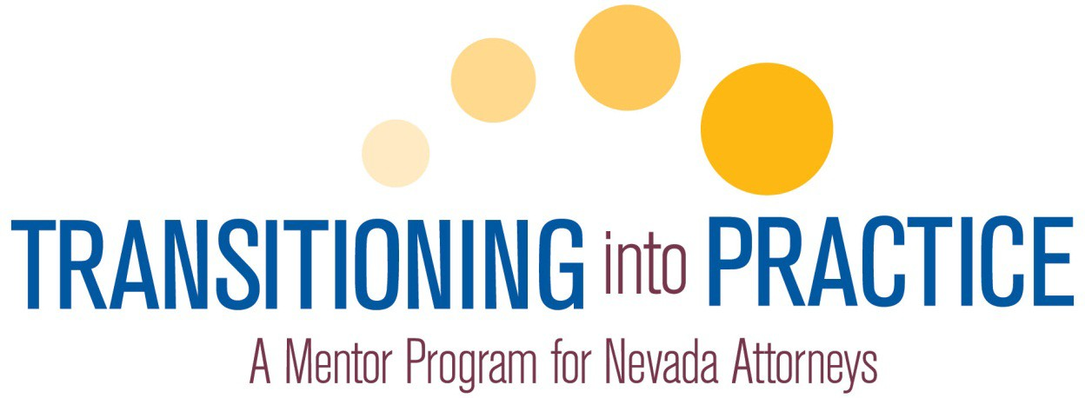

MENTOR PROGRAM
MANUAL

TABLE OF CONTENTS

Introduction 3

Goal 4

Operation Procedures and Policies 5

Mentors 10

FAQs 14

Tips 18

INTRODUCTION
The first years of a lawyer’s practice are a critical time in the development of professional habits, practices and character. To foster this transition, the Nevada Supreme Court, in conjunction with the State Bar of Nevada, has created Transitioning into Practice: A Mentor Program for Nevada Attorneys. The goal of the TIP program is to introduce newly admitted lawyers to the high standards of integrity, professional conduct, professional competence and service to the public.

Shortly after admission, each new lawyer (unless deferred or exempt), will be paired with an experienced lawyer who has practiced for at least seven (7) years in Nevada and has been selected by the Court for his or her commitment to ethics, professionalism and professional skills. Together, the new lawyer and the mentor will develop a curriculum of activities to introduce the new lawyer to the legal community and to the practical application of ethics, civility and professionalism. The new lawyer will also receive practical guidance about client relations and law office management, as well as explore practical skills in a substantive area of the law. The mentor will be a guide as the new lawyer adjusts to the challenges of law practice. Finally, working with the new lawyer will allow the mentor to see the profession through new, enthusiastic eyes and help the mentor understand generational differences.

The TIP program is premised on one-to-one interaction with mandatory and elective activities and experiences. The program is flexible enough to complement and coordinate with existing law firm training programs as well as the special training needs of government, corporate, and public interest practices.

The success of the TIP Program depends on the commitment of both the mentors and the newly admitted lawyers, and the Court and the Bar appreciate the devotion of time, energy and skill that will be required on both sides. We are confident that mentors and new lawyers alike will benefit from the program.

This manual contains information about enrolling in the TIP program, developing an individualized mentoring plan, and certifying completion. It also has some tips for successful mentoring relationships and a link to the Nevada Rules of Professional Conduct. Questions not addressed in the manual can be directed to the state bar CLE Department by calling 702.382.2200 or emailing tip@nvbar.org.

GOAL

The purpose of the TIP program is to introduce newly admitted lawyers to the high standards of integrity, professional conduct, professional competence and service to the public.

The TIP program was developed in order to provide needed transitional support for new attorneys admitted to the State Bar of Nevada. Specifically, the goals of this program are to:

  - Assist new lawyers in acquiring the practical skills and judgment necessary to practice in a highly competent manner.
  - Train new lawyers on Nevada-specific rules and procedures not specifically taught in traditional learning environments.
  - Sharpen and enhance the practical skills necessary to compete in today’s legal environment.
  - Match new lawyers with more experienced lawyers for training in professionalism, ethics, and civility.
  - Provide support, foster relationships and create networking opportunities for newly admitted members.
  - Provide a means for all Nevada attorneys to learn the importance of organizational mentoring, including the building of developmental networks and long-term mentoring relationships.

IF THERE ARE QUESTIONS OR CONCERNS BY THE MENTOR OR NEW LAWYER AT ANY TIME, PLEASE CONTACT A TIP COACH FOR ASSISTANCE.
OPERATING PROCEDURES AND POLICIES
- Enrollment, Exemptions and Deferrals
  - The TIP program will operate in two 6 month cycles each year. The first begins in January (spring) and the second begins in July (fall cycle).

  - Within 4 weeks of admission newly admitted lawyers must either; enroll in the program (with $175), certify they are exempt or request a deferment online at www.nvbar.org/tip.

  - Newly admitted lawyers are exempt from the program if they have engaged in the active and continuous practice of law in another jurisdiction for five (5) or more years prior to admission in Nevada. Newly admitted lawyers are also exempt if they reside and practice outside the state of Nevada. If the attorney establishes a primary residence or principal office in Nevada within the first 5 years of admission, the attorney shall enroll in the next available TIP cycle.

  - Newly admitted lawyers who are unemployed or judicial law clerks, may request to defer participation in the program until they begin practicing, at which time they must enroll in the next available TIP program cycle. The Standing Committee on TIP may grant deferrals for up to two years from the date of admission.

- Mentor Match
  - Newly admitted lawyers employed in law firms, government offices, corporate law departments, or other group practices may select an “inside” or “outside” mentor. An inside mentor is in the same firm or office as the new lawyer. An outside mentor is lawyer not in the same firm or office as the new lawyer. If the mentor requested has not been appointed by the Supreme Court, a conditional match will be made pending the mentor’s appointment.

  - A list of Supreme Court-appointed mentors will be available for the new lawyer to choose from. If a new lawyer does not have an internal workplace mentor they wish to be paired with, they can select a mentor from the list of approved mentors. In the event that a new lawyer’s choice of mentor is not available, the bar will match the newly admitted attorney with a mentor based principally on geographical and practice area.

  - The Bar will confirm the mentor/new lawyer pairings thirty (30) days prior to the commencement of the TIP program cycle, after which written notice of the match and respective contact information will be provided to the newly admitted lawyer and the mentor.
  - The mentor and new lawyer are encouraged to give some time for the mentoring relationship to develop. Both the mentor and/or new lawyer are encouraged to bring any unresolved problems to the attention of the state bar.

- Designing the Mentoring Plan
  - The TIP Model Mentoring Plan includes core concepts and experiences that will introduce new lawyers to practical aspects of lawyering with which all lawyers need to be familiar with for the successful and professional practice of law. The TIP Model Mentoring Plan has five component parts:

    - The Legal Community

    - Personal and Professional Development and Ethics

    - Law Office Management and the Practice of Law

    - Client Communications, Advocacy, and Negotiation

    - Practice Area Basic Skills Electives:
      - Litigation and Transaction Handling
      - Advocacy and Litigation
      - Alternative Dispute Resolution
      - Negotiation
      - Client Interviewing and Counseling
      - Civil Procedure
      - Criminal Law
      - Estate Planning/Probate/Guardianship
      - Family Law
      - Juvenile Law
      - Business Law
      - Tax Law
      - Real Estate Law
      - Employment Law
      - Intellectual Property Law
      - Gaming Law
      - Pro Bono Work
      - Other

Parts 1-4 are comprised of specific topics that the new lawyer must discuss with the mentor and specific activities that the new lawyer must complete and review with the mentor. In the Practice Area Basic Skills Electives component (Part 5), the new lawyer and the mentor select and complete
a minimum of six (6) basic skill activities in one or more substantive practice areas that best match the new lawyer’s interests.

  - During the initial meeting, the new lawyer and the mentor should review the required elements of the mentoring plan and identify the practice areas the new lawyer will focus on during the mentorship.

  - The mentoring plan may include as many practice area activities as the new lawyer and mentor agree are practical, but must include at least six
(6) activities from one or more practice areas. The activities listed in the substantive areas are not exclusive; the new lawyer and mentor may supplement the listed activities or substitute others that they identify as basic competency skills. Similarly, if the new lawyer is interested in a substantive area for which no activities are suggested, the new lawyer and the mentor may develop a customized elective plan of activities designed to build basic skills in that area.

  - A new lawyer employed by a law firm, corporate legal department, or governmental unit may complete an alternate mentoring plan based on the employer’s established training program in conjunction with the model mentoring plan outlined in the TIP program manual.

- Completing the Mentoring Plan
  - The mentoring plan is designed to be completed in six (6) months. While it is expected that the mentor and new lawyer will meet in person at least two hours per month, the actual number of meetings and time will vary depending on each mentoring relationship and the mentoring plan that is developed by the mentor and the new lawyer. In addition to meeting in person, other methods of communication such as conference calls and email are expected to be utilized as a manner in which to review and discuss the various experiences and activities that make up the mentoring plan and to monitor the newly admitted lawyer’s progress.

  - Newly admitted lawyers who are mentored within their law firm, corporate legal department, or governmental unit may complete some of their required activities in small group settings rather than by individual discussion with their mentors.

  - When all mentoring plan activities are concluded, the new lawyer shall submit his or her Mentoring Plan on an online form provided by the bar and pay the remaining $175 fee. Mentors will be provided with a copy of the submitted form and must verify the contents prior to the new lawyer being deemed “completed.”
  - The completed Mentoring Plan and fee must be submitted to the State Bar of Nevada on or before December 31st of the newly admitted lawyer’s first full year of admission. (For example, new lawyers admitted in 2011 will have until December 31, 2012.)

- Noncompliance, Suspension and Reinstatement
  - A new lawyer who fails to complete the TIP program by December 31st of their first full year of admission (and who has not been granted an extension) will be given written notice of non-compliance and subject to suspension and $250 fine upon order of the Board of Governors from membership in the state bar until compliance with the requirements and/or reinstatement is ordered by the supreme court.

  - During a period of suspension, the new lawyer may not engage in the practice of law in Nevada.

  - A suspended new lawyer may apply for reinstatement as soon as the TIP program is completed. In addition to the reinstatement application, the new lawyer must submit the completed TIP Mentoring Plan, Certificate of Completion, the remaining program fee of $175 and any fine associated with the TIP suspension.

  - Upon reinstatement, the State Bar of Nevada shall notify the clerk of the court that the suspended attorney has completed the requirements for reinstatement. Reinstatement is effective upon receipt by the clerk of the court of the notice from the state bar.

  - A reinstatement after suspension for not completing the TIP program has no effect upon any other aspect of the new lawyer’s status, including any suspension for nonpayment of membership fees, MCLE noncompliance or a disciplinary proceeding.

- Confidentiality and conflicts in mentoring
  - The mentor and new lawyer are expected to adhere to the Nevada Rules of Professional Conduct at all times. For example, if the new lawyer shares with the mentor information about unethical conduct of an attorney in the new lawyer's firm that is reportable under SCR 8.3, the mentor will be required to report this information to Bar Counsel.

  - For an inside mentoring relationship, the confidentiality of communications between the mentor and new lawyer may also depend on the firm’s or office’s policies. For an outside mentorship, the new lawyer shall not reveal to the mentor any confidential communications between the new lawyer and the new lawyer’s client.
  - The mentor agrees to avoid providing case specific advice to the newly admitted lawyer while encouraging the new lawyer to avoid revealing details about his/her cases including the names of clients. If discussion of this nature is critical it should only take place using hypothetical scenarios/situations.

MENTORS
Lawyers hear a lot about mentoring, but identifying a mentor when one is brand new to the bar can be a challenge. If you are an experienced attorney interested in sharing your wisdom and guidance with lawyers new to the State Bar of Nevada, Transitioning into Practice is for you!

- Minimum Requirements
  - Be a member of the State Bar of Nevada in good standing with no prior disciplinary actions in the past 10 years.

  - Have at least seven (7) years of practice experience in the state of Nevada.

  - Possess a reputation in the local legal community for competence and ethical and professional conduct.

  - Have not had any sanctions, suspensions or disbarments in any state from the practice of law in the past 10 years.

  - Carry and provide proof of $500,000 minimum malpractice insurance policy (private practitioners only).

  - Sign and adhere to the Mentor Agreement.

  - Maintain aforementioned qualifications once appointed as a mentor and must prove to be an asset to the TIP program as determined by the Mentor Evaluation process at the conclusion of each program cycle.

- Commitment
  - Mentors are expected to participate in all functions of the mentoring program – this includes but is not limited to monthly meetings either at a group function or mentor-new lawyer function.

  - Mentors are appointed by the Supreme Court to two-year terms in which they are expected to be available to participate in at least one six-month cycle each year.

  - Mentors must complete a training program supplied by the state bar prior to the commencement of their first mentoring cycle.

  - The mentor will participate in evaluating the mentoring relationship at the end of the cycle.
  - The mentor is responsible for assessing whether the newly admitted lawyer successfully completed the program.

  - The mentor will be eligible to receive 3 CLE credits (2 ethics) per six-month mentoring cycle in which the mentor participates.

- Apply to become a mentor
  - Submit a completed application and supporting documents to the state bar. This process can be completed online at www.nvbar.org/tip

  - Applicants that are appointed as a mentor by the Supreme Court will receive written confirmation of their appointment with a copy of the Mentor Agreement which has been signed by the state bar.

- Conflicts of Interest Policy
Attorneys appointed as Mentors in the Transitioning into Practice (TIP) mentoring program must act at all times in the best interests of the State Bar and not for personal or third-party gain or financial enrichment. When encountering potential conflicts of interest, Mentors shall identify the potential conflict and as required, remove themselves from any and all participation. Specifically, Mentors of the TIP program shall:

  - avoid placing (and avoid the appearance of placing) one’s own self- interest or any third-party interest above that of the State Bar; while the receipt of incidental personal or third-party benefit may necessarily flow from certain State Bar activities, such benefit must be merely incidental to the primary benefit to the State Bar and its purposes;
  - not abuse their position by improperly using their position as a Mentor to direct staff of the State Bar, or use State Bar, services, equipment, materials, resources, or property for their personal third-party gain or pleasure, and shall not represent to third parties that their authority as a Mentor extends any further than that which it actually extends;
  - not engage in any outside business, professional or other activities that would directly, or indirectly, materially adversely affect the State Bar;
  - not engage in or facilitate any discriminatory or harassing behavior directed toward the State Bar staff, members, officers, directors, meeting attendees, exhibitors, advertisers, sponsors, suppliers, contractors, or others in the context of activities relating to the State Bar;
  - not solicit or accept gifts, gratuities, free trips, honoraria, personal property, or any other item of value from any person or entity as a direct or indirect inducement to provide special treatment to such donor with
respect to matters pertaining to the State Bar without fully disclosing such items;
  - provide goods or services to the State Bar as a paid vendor to the State Bar only after full disclosure to, and advance approval by, the Board, and pursuant to any related procedures adopted by the Board;
  - not persuade or attempt to persuade any member, exhibitor, advertiser, sponsor, subscriber, supplier, contractor, or any other person or entity with an actual or potential relationship to or with the State Bar to terminate, curtail or not enter into its relationship to or with the State Bar, or to in any way reduce the monetary or other benefits to the State Bar of such relationship;
  - disclose, in writing, if the Mentor member is involved in any business or other professional relationship with any staff member.
  - not represent a party in proceedings before the State Bar whose position is adverse to any administrative interests of the State Bar.

- Indemnification Policy – Pending Verification by State Bar Carrier
  - Generally The State Bar shall provide indemnification to qualified indemnities for liability arising out of qualified actions. A qualified indemnitee is a person who is or was an officer, member of the Board of Governors, member of the staff of the State Bar, or is serving at the request or appointment of the State Bar as a member of any board, committee, subcommittee or as a mentor. A qualified action is an action in good faith within the course and scope of the authority expressly or impliedly delegated by applicable Supreme Court Rule, policy adopted by the Board of Governors or by the executive director within his or her authority. Each qualified indemnitee who is party to, or is threatened to be made a party to, or is involved in any threatened, pending or completed claim, action, suit, or proceeding, whether civil, criminal, administrative or investigative, by reason of the fact that the indemnitee or a person of whom the indemnitee is a legal representative, is or was a member of the Board of Governors or officer of the State Bar or a member of a board, committee, sub-committee or a mentor of the State Bar formed by the Board of Governors, shall be defended, indemnified and held harmless by the State Bar to the fullest extent legally possible under the laws of the State of Nevada, as amended from time to time, against all expenses, liability, and losses (including but not limited to attorneys' fees, judgments, fines, and amounts paid in settlement) reasonably incurred or suffered by the indemnitee in connection therewith. Such right of indemnification shall be a contract right that may be enforced by the indemnitee.

  - Cumulative Right Such right of indemnification shall not be exclusive of any other right which such member of the Board of Governors, officer, or
representative may have or hereafter acquire, and without limiting the generality of such statement, each shall be entitled to his or her respective rights of indemnification under any agreement, provision of law, or otherwise.

FREQUENTLY ASKED QUESTIONS

- Is the Transitioning into Practice program mandatory?
Yes. All newly admitted members of the State Bar of Nevada must participate in TIP unless they have already practiced in another jurisdiction for at least five (5) years.

- What if I am unemployed or otherwise not practicing law after admission? New lawyers who do not have plans to begin practicing law immediately after admission, including new lawyers who are working as judicial clerks, may request a deferral in six month increments for up to two (2) years or until such time as they begin practicing law, whichever occurs first.

- When do I enroll in the TIP program?
Unless exempt or deferred, new lawyers must enroll in the TIP program by filing the enrollment form within four (4) weeks after admission to the bar. Unless otherwise arranged, all new lawyers will begin the next available program cycle following their admission to the bar. New lawyers who are granted a deferral must enroll in the next available cycle once they begin to practice law.

- Who are the mentors?
Mentors are active State Bar of Nevada members in good standing who have at least seven (7) years of experience in the practice of law in Nevada. They must have a reputation for competence and for conducting themselves ethically and professionally. Mentors must complete an application process and are ultimately appointed by the Supreme Court of Nevada.

- Do mentors get any special training?
Yes. All appointed mentors are required to participate in a training program prepared by the bar. In addition to familiarizing mentors with the creation and execution of the TIP program, the training program includes ideas and tips for establishing successful mentoring relationships. Mentors are also asked to review this manual in its entirety.

- How do I find a mentor?
There are three (3) ways that mentors will be identified for new lawyers. If a newly admitted lawyer is hired by a firm or organization, their employer may assign a senior associate to serve as their mentor. The second option is for a new lawyer to select a mentor from the published list of Supreme Court-appointed mentors or seek out a respected member of the bar and ask if they are willing to serve as a mentor (in this latter instance, the Mentor will be provisionally
approved pending their appointment by the Supreme Court). In the event that a new lawyer’s choice of Mentor is not available, the bar will match the new attorney with a mentor based principally on geographical and practice area.

- Does my mentor have to be a lawyer in my firm?
Generally, lawyers employed in law firms, corporate legal departments, and government offices will be matched with a mentor in the same firm or office. However, new lawyers may opt to select a mentor outside of their organization.

- Can I choose my own mentor?
Yes. A new lawyer’s request for a specific mentor will be taken into consideration, provided the mentor is qualified and appointed by the court.

- What is the TIP Mentoring Plan?
The TIP Mentoring Plan sets out the activities the new lawyer will work on with the mentor during the mentoring cycle. It is comprised of four areas of required activities and one practice-specific area of electives selected by the new lawyer. The elective activities may be in one or more substantive areas and must include at least six (6) basic skills activities. Several practice area activities are contained in this manual. If a new lawyer wishes to focus on a substantive area not covered in the manual, the new lawyer and the mentor may identify basic skill activities related to that substantive area.

- Can I get credit for TIP Mentoring Plan activities that I have already completed prior to admission?
Any activities completed prior to admission will assist in designing a customized mentoring plan and allow the new lawyer to build on existing knowledge and skills however, will not exempt him/her from completing all of the required activities outlined in the mentoring plan.

- Are communications between the new lawyer and the mentor confidential? In all cases, the Nevada Rules of Professional Conduct should be followed. For an inside the firm or office mentorship, the confidentiality of communications between the mentor and new lawyer may also depend on the firm’s or office’s policies. For an outside mentorship, the new lawyer shall not reveal to the mentor any confidential communications between the new lawyer and the new lawyer’s client.

- Will the mentor supervise the beginning lawyer’s work?
For an inside firm or office mentorship, supervision of the newly admitted lawyer’s work is a matter to be determined by the firm’s or office’s policy. For an outside mentorship, the mentor is not expected to supervise the practice of law by the new lawyer.

- What is the mentor’s role in evaluating the new lawyer?
The role of the mentor in evaluating the work and professional development of the new lawyer within the firm or office is a matter to be determined by the firm’s or office’s policy. In scenarios when the mentor and new lawyer do not work in the same firm, the mentor assumes no responsibility for evaluating the work of the new lawyer. The mentor and new lawyer both have responsibility for evaluating the mentoring relationship. The mentor is responsible for assessing whether the new lawyer has satisfactorily completed the Transitioning into Practice program.

- How much time will the TIP program require?
Transitioning into Practice is designed to be completed in six (6) months. While it is expected that the mentor and newly admitted lawyer will meet in person for about two hours each month, the actual number of meetings and time will vary depending on each mentoring relationship and the mentoring plan that is developed by the mentor and new lawyer. In addition to meeting in person, other methods of communication such as conference calls and email are expected to be utilized as a manner in which to review and discuss the various experiences and activities that make up the mentoring plan and to monitor the new lawyer’s progress. Those participating in the inaugural cycle will be reporting actual hours spent completing the program over the course of the six month period. This information will be utilized to further refine the TIP program.

- Do I have to complete MCLE requirements in addition to the Mentor Program?
No. Nevada MCLE rules require newly admitted lawyers who have practiced law less than five (5) years to complete Transitioning into Practice. The first standard MCLE reporting year for this identified group begins the year following the first full year of admission (see SCR 214).

- Do mentors receive MCLE credit?
Mentors are eligible to receive 3 CLE credits (2 ethics) in Nevada for each cycle in which they participate.

- What do I do if I have a problem with my mentor?
New lawyers are encouraged to give the relationship some time to develop and to remember that the mentor may not be able to satisfy all of the needs for support that the new lawyer may have. If a mentor is not making time for regular meetings or is not providing helpful guidance and coaching through the mentoring plan activities, a new mentor may be assigned. Please contact the TIP administrator at the state bar for confidential assistance.
- What do I do if I have a problem with my new lawyer?
If a new lawyer is not making time for regular meetings and otherwise not participating in the program, please contact the TIP administrator at the state bar for confidential assistance.

- What if I can’t complete my Mentoring Plan within the time allowed?
If a new lawyer does not believe that the December 31st deadline can be met due to health or personal issues, job changes or other circumstances beyond their control, an extension may be granted for good cause shown. A request for an extension must be submitted in writing to the TIP Administrator at the State Bar of Nevada prior to the December 31st deadline. A new lawyer who does not qualify for an extension and who does not complete the plan in time will be given written notice and subject to suspension and a fine. Failure to complete the plan will result in the Board of Governors recommending that the noncomplying new lawyer be suspended from membership in the Bar and, consequently, from the practice of law.

- How do I establish completion of the TIP Mentoring Plan?
When all of the activities of the TIP Mentoring Plan have been completed, the mentor attests to the Certificate of Completion. The new lawyer is responsible for filing the Certificate and a copy of the completed TIP Mentoring Plan with the state bar and paying the $175 fee.

- What if I can’t afford the fee?
At the discretion of the state bar, the TIP program fee may be waived in cases of financial hardship or special circumstances. Requests for a fee waiver must be submitted in writing to the TIP Standing Committee and include the reason for the request accompanied by a summary of the applicant’s income and expenses. All requests for a fee waiver will be kept in confidence.

- How do I get reinstated from a suspension?
A new lawyer suspended for failing to timely complete the mentoring plan can apply to the state bar for reinstatement by submitting the appropriate reinstatement form accompanied by the Certificate of Completion, completed TIP Mentoring Plan, paying the remaining program fee of $175, and paying any related fines. If the submission is satisfactory, the state bar shall notify the clerk of the court that the suspended attorney has completed the requirements for reinstatement.

TIPS FOR SUCCESS
If you are a mentor:
  - Take the time to develop a meaningful mentoring relationship. In an optimal setting, this relationship is an opportunity for mutual learning and growth.
  - Set both expectations and boundaries early on. At the initial meeting, calendar your future meetings. Inform your new lawyer about the best time to call with questions or issues, when they are more likely to get your undivided attention. Alternatively, email may be preferred by both new lawyer and mentor.
  - Be prompt and give plenty of notice when you need to reschedule.
  - Listen to your new lawyer’s concerns and, especially in the beginning, draw out those concerns that the new lawyer may be reluctant to raise.
  - Recognize that new lawyers may differ in what they hope and need to get out of a mentoring relationship. Be willing to modify your own approach to assure you are providing your new lawyer with what he or she is seeking while still meeting the requirements of the program.
  - Create a safe environment for the new lawyer’s growth by being accessible and nonjudgmental, keeping confidences, and inviting open and frank conversations.
  - Acknowledge the issues facing new lawyers who are ethnic minorities, or who may face particular challenges because of their religion, sexual orientation, economic status, national origin or age.
  - Remember that the only stupid question is the one that isn’t asked. Encourage your new lawyer to ask, ask, ask. Be respectful and responsive with your answers.
  - Your responsibility is not to direct or supervise your new lawyer’s work, but to be a guide for the development of professional values and skills.
  - Share your experience and talent freely; be the role model you would want.

If you are a new lawyer:
  - Be respectful of your mentor’s time. Be prompt and give plenty of notice if you need to reschedule a meeting. Make good use of your meeting time; come prepared with a list of things you want to discuss.
  - Your mentor’s “war stories” can be valuable learning tools, especially if you can relate them to a situation of your own.
  - Ask questions! Don’t let your ego get in the way of accepting feedback and constructive criticism from your mentor.
  - Build multiple mentor relationships; your mentor will not be able to advise you in every aspect of your professional or personal life. Develop effective
networks with peers, other lawyers in and outside your workplace, judges, family and friends.
- Your reputation in the community will be based on your interactions with your mentor, your clients, your work colleagues, opposing counsel, court staff and judges. Nurture it and guard it zealously.

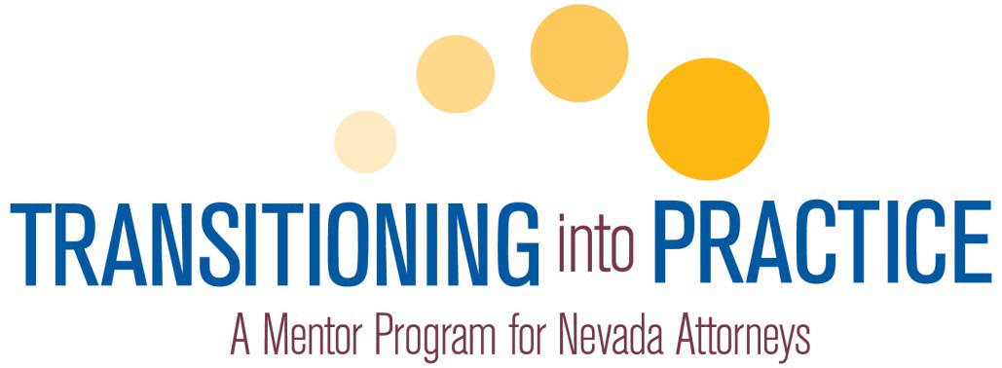

MENTORING PLAN

INTRODUCTION TO THE MENTORING PLAN

The new lawyer’s mentoring plan is the focus of the Transitioning into Practice program. To assist in customizing a mentoring plan, the State Bar of Nevada developed the Model Mentoring Plan which includes required and optional sections and activities. It consists of core concepts, lawyering skills, activities and experiences used as learning activities and topics for discussion between the newly admitted lawyer and mentor. The activities and experiences are an introduction to the topics with which lawyers need to be familiar for the successful and professional practice of law.
The Model Mentoring Plan does not fit all new lawyers’ practice areas, professional interests or goals. New lawyers and their mentors should work together to create a comprehensive plan reflecting the new lawyer’s professional goals and interests while exposing him/her to both the practice and business of law. A thorough, well thought-out plan will help make the TIP mentoring relationship meaningful and productive for both newly admitted lawyer and mentor.
The Mentoring Plan should be developed by the mentor and new lawyer during their first meeting. The finalized Mentoring Plan is a checklist of activities which are to be completed by the new lawyer by the end of the mentoring cycle. In addition to the activities provided in the Mentoring Plan, a new lawyer is encouraged to discuss with their mentor other career issues that arise in their early practice experience.
If the mentor does not practice in all the areas selected and agreed upon by the mentor and the new attorney, the mentor may choose to call on another appointed mentor who practices in the specific area to assist in mentoring the new lawyer in that area.
At the conclusion of the program cycle, the mentoring plan should reflect the activities and experiences completed by the new lawyer. The Certificate of Completion should be attested to by the mentor and submitted by the new lawyer along with the Mentoring Plan and $175 fee to the state bar at the conclusion of the mentoring cycle.

INSTRUCTIONS FOR CREATING YOUR MENTORING PLAN

The following provides general instructions for creating a customized mentoring plan.
Please read these instructions carefully.

- Print and bring this Model Mentoring Plan to the first meeting.
- The mentor and new lawyer should discuss the new lawyer’s professional goals, interests and practice areas to develop and prioritize activities in the mentoring plan.
- Review sections 1 through 4 contained in the Model Mentoring Plan. These four sections contain mandatory items for your Mentoring Plan. In addition to the mandatory items, your Mentoring plan must also contain a certain number of optional selections from sections 1-4. The new lawyer and mentor may also elect to develop activities related to these subjects. NOTE: Activities need not be completed in any particular order.
- In addition to sections 1 through 4, new lawyers must select a minimum of 6 elective activities/experiences to include in his/her Mentoring Plan. These electives are listed under section “5. PRACTICE AREA BASIC SKILLS ELECTIVES.” New lawyers and mentors may create one or more electives covering other subjects of interest deemed appropriate given the newly admitted lawyer’s particular area of practice.
- Indicate which activities will be completed by the new lawyer during his/her mentoring cycle by checking the corresponding box next to each activity description in each section. As activities/experiences are completed record it electronically by visiting www.nvbar.org/tip. Here you can track your progress and make a final submission at the conclusion of the mentoring cycle.
- It is recommended to establish check points for consistent and steady timing in completing the plan. Divide the planned activities and experiences in thirds. Two months into the 6-month cycle you should be about 1/3 of the way through the activities and experiences - at 4 months about 2/3 completed.
- At the conclusion of the mentoring cycle the completed plan should be submitted in the online system at www.nvbar.org/tip. The plan, attested Certificate of Completion and $175 fee are submitted by the new lawyer no later than the end of the program cycle.

QUESTIONS
Contact the state bar at tip@nvbar.org or call 702.382.2200.

WEBSITE INFORMATION
Forms and information about Transitioning into Practice can be found at:
www.nvbar.org/tip
New Lawyer: Bar#

Mentor: Bar#

MENTORING PLAN ACTIVITIES AND EXPERIENCES
- The Legal Community
In addition to the mandatory topics at least two (2) other activities or experiences must be completed from this section keeping in mind that the two additional items within this category can be created through the collaboration of the mentor and new lawyer.

MINIMUM TIME COMMITMENT: 3 hours

Activity or Experience | Check if Selected | Date Completed
Review and have a meaningful discussion about professional conduct by completing the following:  - Review and discuss all of the Nevada Rules of Professional Conduct, making suggestions of practical application of the concepts in the document.  - Reach an understanding on how matters designated as confidential by the new lawyer will be handled.  - Discuss civility and etiquette among lawyers and judges. | MANDATORY
Review all forms contained in the annual State Bar of Nevada membership packet:  - Licensing Fee Invoice  - Report of Child Support  - Professional Liability Insurance Disclosure  - Certification of Compliance & Consent  - Annual Report of Pro Bono | MANDATORY
Acquaint the new lawyer with legal aid agencies in the state, local pro bono agencies, other opportunities for lawyers to engage in pro bono or law-related education activities, and other opportunities for lawyers to engage in civic and charitable work. Discuss how and why a lawyer finds time, despite a busy practice, to engage in volunteer activities and service to the profession and the community. | MANDATORY
If pro bono work is a high interest area, consider the elective track 5q. Pro bono opportunities might also be a great way to cover many activities and experiences in the Mentoring Plan.

Attend a meeting of an organized bar association together (CLE event, pro bono, social). Discuss local, state and national bar association opportunities and the advantages of being involved in local and state bar association activities.
Review and discuss State Bar of Nevada sections and committees and the value of getting involved in State Bar activities and service, including the Young Lawyers Section.
Accompany the new lawyer to the local courthouses, particularly those courts where the new lawyer will be primarily appearing. To the extent appropriate, introduce the new lawyer to members of the judiciary, court personnel and clerks of the court. If available, pay a visit to the self-help center.
As appropriate, escort the new lawyer to the local jails where the new lawyer is likely to have clients and explain the procedures for jailhouse visits.
Record other completed activities in the boxes below.

- Personal and Professional Development and Ethics
In addition to the mandatory topics at least two (2) other activities or experiences must be completed from this section keeping in mind that the two additional items within this category can be created through the collaboration of the mentor and new lawyer.

MINIMUM TIME COMMITMENT: 3 hours

Activity or Experience | Check if Selected | Date Completed
Discuss substance abuse and mental health issues, including possible warning signs of substance abuse or mental health issues; what to do if the new lawyer, a colleague or a superior is faced with a substance abuse or mental health problems. Review and discuss the support and counseling available for a lawyer and family through the program, Lawyers Concerned for Lawyers. | MANDATORY
Discuss potential resources for dealing with complicated ethical issues, including conflicts of interest. Discuss ethical issues that arise with some regularity in the practice setting. Discuss ways to resolve the issues; referring to mentor’s experience, as well as guidance of the Nevada Rules of Professional Conduct. If the mentoring relationship is in-house, discuss the firm’s procedures for assisting with complicated ethical issues. Discuss the grievance process and a lawyer’s duty to cooperate with a disciplinary investigation. | MANDATORY
Discuss the appropriate way to handle situations where the new lawyer believes another lawyer (both in and outside of the new lawyer’s firm) has committed an ethical violation; the obligation to report misconduct; and the appropriate way to handle a situation where the new lawyer has been asked by a senior member of the firm to do something that is unethical or unprofessional. | MANDATORY
Discuss the role of the Nevada Board of Continuing Legal Education and differences between the state bar CLE department.  Include a discussion about the benefits of MCLE requirements and ways to fulfill them. | MANDATORY
Discuss common malpractice and grievance traps (particularly in the new lawyer’s practice area) and how to recognize and avoid common pitfalls. Discuss the lawyers’ obligations in the event of the failure to carry malpractice insurance. | MANDATORY

Discuss the new lawyer’s long term career goals and identify ways to meet those goals. Identify different career paths and resources for exploring options. Discuss to the extent knowledgeable, differences between large firm, small firm, government and non-profit practice and non-traditional legal positions.
Discuss techniques for finding a balance between career and personal life, putting daily pressures in perspective, reconciling job expectations with actual experience.
Discuss practical ways to manage law school debt.
Record other completed activities in the boxes below.

- Law Office Management and the Practice of Law
In addition to the mandatory topics at least two (2) other activities or experiences must be completed from this section keeping in mind that the two additional items within this category can be created through the collaboration of the mentor and new lawyer.

MINIMUM TIME COMMITMENT: 3.5 hours

Activity or Experience | Check if Selected | Date Completed
Discuss practices to maintain client confidentiality. | MANDATORY
Review escrow and trust account rules for handling client funds, including the importance of clearing checks before funds are drawn, authority needed to pay fees from client funds in trust and IOLTA account requirements. | MANDATORY
Discuss good time records, time management skills and techniques. Discuss best practices and current practices regarding records of client- related expenses including billing and filing systems. | MANDATORY
Discuss how to screen for, recognize and avoid conflicts. Discuss the differences between issue conflicts and client conflicts. | MANDATORY
Discuss the issues surrounding leaving a firm, such as how to protect oneself, substitution of counsel, advising clients and withdrawing from cases. | MANDATORY
Review engagement agreement, including method for resolving fee disputes. | MANDATORY
Tour the mentor’s office to demonstrate and explain how the mentor’s law office is managed. Discuss resources where the new lawyer can learn more information about law office management issues.
Discuss roles and responsibilities of paralegals, secretaries and other office personnel and how to establish good working relationships with others in the same office who are support staff, colleagues or senior colleagues.
Discuss how to prevent issues of unauthorized practice of law with staff.
Introduce the new lawyer to the calendar and ‘tickler’ or reminder systems.
Introduce the new lawyer to the information technology systems, the library systems and research systems.
Discuss office politics, including appropriate networking, socializing and personal behaviors.

Discuss the importance of planning ahead for how a lawyer’s practice should be handled in the event of the lawyer’s retirement, death or disability.
Engage in a training session covering the importance of maintenance and retention of client files inclusive of electronic and paper components.
Record other completed activities in the boxes below.

- Client Communications, Advocacy, and Negotiaion
In addition to the mandatory topics at least two (2) other activities or experiences must be completed from this section keeping in mind that the two additional items within this category can be created through the collaboration of the mentor and new lawyer.

MINIMUM TIME COMMITMENT: 3.5 hours

Activity or Experience | Check if Selected | Date Completed
Discuss the importance of client communication and how to maintain good on- going communication, including the use of retention, engagement documents and fee agreements, keeping clients informed about matters, confirming things in writing, being on time, etc. Discuss frequent issues that arise regarding the scope of representation. Discuss ‘dos and don’ts’ of maintaining good ongoing client relations and communications, such as returning telephone calls and keeping clients informed about matters. | MANDATORY
Discuss the responsibilities of the client and the lawyer in decision making, and the importance of open communicate with a client about their case. | MANDATORY
Discuss the relevant issues surrounding effective legal writing, such as techniques for the most effective legal writing, how to avoid common mistakes causing pleadings to be rejected, how to effectively use sample legal pleadings and forms, techniques to efficient legal research, etc. | MANDATORY
Discuss the best ways to evaluate a potential case and how to decide whether to accept a proffered representation. Identify how to deal with the ‘difficult’ client and how to decline representation of the unrealistic or ‘impossible client. | MANDATORY
Discuss how to identify or determine who the client is when practicing in a corporate or government organization.
Engage in a training discussion about client interaction, including tips for gathering information about a legal matter and appraising the credibility and trust of a potential client.
Discuss methods of client development that have been successful for the mentor, and discuss other techniques for business development, including any relevant ethical

concerns and the most professional practices in this regard.
Train, through discussion and client interaction, how to best screen for, recognize and avoid conflicts with the client.
Discuss proper legal counseling techniques, duties and the responsibilities of advising clients. Discuss fee setting for legal services and how to talk with clients about fees. Discuss retainer agreements.
Participate in or observe at least one client interview or client counseling session.
Discuss appropriate ways for dealing with others on behalf of a client.
Discuss tips for the preparation for and proper behavior during depositions.
Discuss the most important points about negotiation with another lawyer and potential issues associated with negotiations.
Discuss the types of alternative dispute resolution (such as mediation, binding and non- binding arbitration, high-low arbitration, early neutral evaluation, court-annexed arbitration, short trial program, etc.) and the benefits and disadvantages of each.
Observe (in person or by streaming video on- line) an appellate argument in a Nevada court and discuss techniques and tips for effective oral argument.
Record other completed activities in the boxes below.

- PRACTICE AREA BASIC SKILLS ELECTIVES
Select and complete as many activities and experiences as feasible within areas a-q. Items selected should be based on the interests and/or practice area of the new lawyer. The minimum number of activities and experiences to be completed is six (6). Keep in mind the activities and experiences completed might all fall under one area or be spread across multiple areas – it’s up to you!

Under each area, you are encouraged to adjust the activities and experiences to your particular practice setting and individual needs.

Other electives that are created and completed by the new lawyer and mentor should be recorded under 5r.

MINIMUM TIME COMMITMENT: 15 hours

5a. ELECTIVES: Litigation and Transaction Handling

Activity or Experience | Check if Selected | Date Completed
Participate in the interviewing of a client.
Participate in the counseling of a client.
Observe or participate in a negotiation and explain relevant background context.
Participate in drafting, amending, or reviewing a contract.
Participate in forming business entities by drafting and reviewing incorporation documents and business agreements.
Participate in drafting demand letter.
Prepare a complaint and a summons.
Review rules regarding alternative dispute program and discuss, if applicable to where you practice
Participate in N.R.C.P. 16.1 or F.R.C.P. 26 conference to discuss discovery plan, initial disclosures and settlement.
Prepare a Joint Case Conference Report
Participate in drafting discovery requests, including interrogatories, requests for admission and requests for production of documents; and discuss applicable rules of procedure
Discuss applicable rules and requirements for initial and rebuttal expert witness disclosures and supplements; participate in drafting expert disclosure
Participate in drafting subpoena duces tecum.

Observe or participate in a deposition of a witness or adverse party in a civil action.
Participate or observe in a preliminary hearing.
Participate in plea negotiations or reviewing a plea agreement.
Participate in drafting a pleading or motion for an administrative body or a state or federal court.
Participate in an administrative hearing.
Participate in an evidentiary hearing in a state or federal court.
Participate in trial preparation.
Participate in a trial in a civil or criminal case in either a state or federal court.
Observe or participate in a mediation or arbitration.

5b. ELECTIVES: Advocacy and Litigation

Activity or Experience | Check if Selected | Date Completed
Discuss specific Rules of Civil Procedure and local rules that apply in either state or federal court pertaining to Court Hearings and trial.
Discuss the mechanics of court appearances, including proper attire, courtroom decorum, role of the court clerk and court reporter, necessity for a translator, etc.
Participate in drafting a dispositive motion.
Attend or participate in a hearing on a motion; discuss.
Participate in drafting an order denying or granting motion for summary judgment.
Participate in drafting a discovery dispute motion (e.g. Motion to Compel).
Attend or participate in a discovery dispute hearing; discuss.
Participate in drafting a Report and Recommendation, if applicable.
Participate in drafting Motion in Limine.
Discuss the mechanics of arbitration, including witness preparation and conduct, handling exhibits, etc.
Participate in drafting arbitration brief.
Attend or participate in an arbitration.
Discuss the mechanics of trial, including witness preparation and conduct in court room, handling demonstrative exhibits and/or electronic court system, exhibits, etc.
Participate or attend pre-trial conference and participate in drafting pre-trial memorandum, if applicable.
Participate in drafting jury questionnaire, if applicable.
Participate in drafting jury instructions.
Participate in drafting voir dire.
Attend or participate in a calendar call.
Participate in drafting Findings of Fact, Conclusions of Law.
Participate in drafting a Trial Brief; discuss applicable rule.
Attend or participate in a trial, including voir dire if a jury trial; discuss.
Attend a trial resulting in a jury verdict and meet with the jurors afterwards.
Participate in drafting mediation or settlement

conference brief.
Attend a mediation or settlement conference.
Participate in preparing settlement documents, including a discussion of any tax implications in a settlement including a monetary award.
Participate in drafting appellate briefing or review and discuss previously filed opening, answering and reply brief.
Attend an appellate argument in the Nevada Supreme Court, or a United States Circuit Court of Appeals.

5c. ELECTIVES: Alternative Dispute Resolution

Activity or Experience | Check if Selected | Date Completed
Discuss different types of arbitration (e.g. grievance, interest).
Review and discuss Nevada’s statutes on mediation including requirement to screen for potential conflict of interest of mediator.
Review various entities and agencies that can assist the attorney in the ADR process, such as FMCS, AAA, JAMs, panel creation by the parties and the benefits and weaknesses of each.
Observe, participate in, or prepare for an actual or simulated mediation.
Observe, participate in, or prepare for, an arbitration and review and discuss Statutes for Arbitration in Nevada and AAA/JAMS rules.
Discuss how to prepare a client for mediation or arbitration.
Discuss the importance of having the insurance carrier involved in the ADR process, if coverage exists for the loss claimed by the plaintiff.

5d. ELECTIVES: Negotiation

Activity or Experience | Check if Selected | Date Completed
Discuss how to prepare for the negotiation of a legal matter (e.g., release of a personal injury claim, lease agreement, collective bargaining agreement, etc.).
Discuss when and how negotiation should be initiated.
Discuss when and how to involve the client in negotiation.
Discuss ethical and professional obligations of negotiators.
Discuss skills needed to be an effective negotiator and how to acquire them.
Discuss statutes that may affect negotiated results or dictate procedures to be utilized in negotiations (e.g. OWBPA requirements for a valid release, NLRA statutory requirements to qualify for ‘good faith negotiations’).

5e. ELECTIVES: Client Interviewing and Counseling

Activity or Experience | Check if Selected | Date Completed
Discuss and review interview techniques (asking the right questions).
Discuss and review counseling techniques (providing the hard advice).
Simulate and discuss the counseling of a client (mentor and new lawyer should alternate being client and lawyer).
Participate in interviewing a client.
Participate in counseling a client.
Discuss early settlement benefits and/or alternative dispute resolution in light of the cost of litigation.
Discuss the ethical considerations with client interviews (e.g. confidentiality, who can meet with a new client to execute fee agreements, etc.).
Discuss when it may be proper to turn down the representation of a client after initially meeting with them.
Discuss ethical considerations regarding client’s desires to delay litigation and/or push your representation beyond the Rules of Professional Conduct and dealing with such clients.

5f. ELECTIVES: Civil Procedure

Activity or Experience | Check if Selected | Date Completed
Participate in trial preparation.
Participate in at least two trials in civil or criminal cases in either a state or federal court, at least one of which should be a jury trial taken to verdict.
Participate in the interviewing of a witness or victim.
Participate in an evidentiary hearing in a state or federal court.
Prepare complaint.
Prepare summons.
Cause summons to be served.
Participate in preparing a NRCP12(b)/FRCP 12(b) motion to dismiss.
Participate in preparing answer to complaint, counterclaim, cross-claim and third-party complaint.
Participate in 26(f) conference to discuss settlement, discovery plan and initial disclosures.
Participate in preparing initial disclosures as required by NRCP 16.1/FRCP 26.
Participate in preparing for and observing, taking, or defending a deposition of a witness or adverse party in a civil action.
Participate in drafting discovery requests, including interrogatories, requests for admission and requests for production of documents.
Participate in identifying expert witnesses and producing expert witness reports.
Participate in depositions including the deposition of expert witnesses.
Participate in preparing motions and memoranda in support of summary judgment.
Participate in preparing pretrial order and making pretrial disclosures of witnesses and exhibits.
Train, through discussion and case review, how to screen for, recognize, and avoid conflicts of interest, either personal or office. Explain to the mentor what actions should be taken if a conflict is suspected or identified.
Discuss the importance of family and life balance, including sharing or not sharing with spouse, friends and others the unsavory and sometimes terrible things with which a

prosecutor deals.
Discuss the mechanics of trial, including where to stand, proper attire, when to stand, courtroom decorum, jury selection, judges’ bench books, etc.
Observe or participate in an appellate argument in a Nevada or Federal Court.
Participate in preparing settlement documents in a civil case, including a discussion of any tax implications in a settlement including a monetary award.
Participate in an administrative hearing.
Participate in drafting, amending or reviewing a contract.
Participate in drafting a civil pleading or motion for an administrative body or a state or federal court.

5g. ELECTIVES: Criminal Law

Activity or Experience | Check if Selected | Date Completed
Screen five different kinds of criminal cases and determine the charges to be filed. Discuss one of the screenings with a law enforcement officer, covering the factors leading to the charging decision. Review the prepared information. Determine whether to request an Arrest Warrant or a Summons.
Discuss with the mentor what should be done when a prosecutor declines to file charges requested by law enforcement; including contact with the officer, victims, what notices should be filed - with whom.
Learn and discuss with the mentor a prosecutor’s disclosure requirements in Brady v. Maryland and other applicable discovery rules and law. Respond to a defense discovery request in a misdemeanor or a felony case.
Participate in at least two trials in civil or criminal cases in either a state or federal court, at least one of which should be a jury trial taken to verdict.
Participate in an evidentiary hearing in a state or federal court.
Observe or participate in a plea negotiation. Explain relevant background and context and prepare or review a plea agreement.
Participate in the interviewing of a witness or victim.
Prepare or participate in the preparation of jury instructions for a misdemeanor or a felony case.
Prepare or review a Statement of a defendant to be used in entry of a guilty plea in either a misdemeanor or felony case. Review and become familiar with NRS 174.035, NRS 174.055 and NRS 174.063.
Review and understand Protective Orders and the penalties for violation of such orders pursuant to NRS 33.020 through NRS 33.400, NRS
200.378 and NRS 200.591.
Prepare a written response to a defense motion.
Become familiar with the Crime Victims’ Bill of Rights, particularly a prosecutor’s responsibilities under the act. Prepare or review required notices to crime victims.
“Ride along” with law enforcement; preferably at least four hours each with at least two

different officers.
Engage in a training discussion about the many different persons a prosecutor is likely to deal with in his or her and their official capacity.
Discuss how to deal with “difficult” situations that are likely to arise between prosecutors and others with whom the prosecutor must deal.
Discuss the mechanics of trial, including where to stand, proper attire, when to stand, courtroom decorum, jury selection, judges’ bench books, etc.
Following the sentencing of a defendant to prison, draft a letter to the Board of Pardons pursuant to the provisions of NRS 213.020.
Observe or participate in an appellate argument in a Nevada or Federal Court.
Review and discuss alternate case dispositions, such as drug court, plea in abeyance agreements, etc. Understand the statutory limitations and office policy regarding each.
Review and understand “No Contest” pleas, “Sery” pleas, “Alford” pleas and pleas of “Guilty and Mentally Ill.” Explain the conditions under which each plea may be offered and when a prosecutor may agree with the entry of each. Understand the provisions that must be contained in the Statement of Defendant for each plea.
Review and discuss Pre-sentence Reports.
Review at least two Affidavits in Support of Requests for a Search Warrant that have been prepared by law enforcement officers and discuss any problems you find with the Affidavits.
Review with a prosecutor experienced in juvenile prosecution the rules and practices in Juvenile Court.
Review a case report and prepare a delinquency petition for filing in Juvenile Court.
Participate in charge negotiations with prosecutor’s office.
Participate in discovery demands on prosecutor, including request for exculpatory materials.
Participate in engagement of private investigator to interview witnesses.
Review information or indictment for constitutional and/or pleading defects.
Research elements of crime charged or under

investigation; discuss.
Review and discuss pretrial diversion requirements.
Review and discuss plea in abeyance statute in a particular case and study applicable statute.
Review and discuss criteria for a one- or two- level reduction of offense in a particular case and study applicable statute.
Participate in discussions with Pretrial Services (bail).
Participate in editing Statement by Defendant in Advance of Plea.
Observe and/or participate in trial.
Observe and/or participate in entry of plea in court.
Review and discuss Presentence Report; participate in filing objections.
Research and participate in analysis of federal sentencing guidelines in particular federal case.

5h. ELECTIVES: Estate Planning/Probate/Guardianship

Activity or Experience | Check if Selected | Date Completed
Participate in drafting and reviewing at least six of the following:
- Wills.
- Revocable living trusts: tax planning.
- Revocable living trusts: non-tax planning.
- Revocable living trusts: generation skipping tax planning.
- Irrevocable trusts.
- Durable powers of attorney.
- Special powers of attorney for health care.
- Advanced Health Care Directives.
- Life insurance trusts.
- Transfer of ownership documents: quit- claim deeds.
- Transfer of ownership documents: assignments.
Assist in gathering and organizing client information.
Prepare diagrams of specific estate plans for clients.
Prepare estate planning binders for clients.
Prepare Crummey notices for life insurance trusts.
Prepare notice to creditors (estate or trust) and arrange for publication.
Prepare inventory of estate.

5i. ELECTIVES: Family Law

Activity or Experience | Check if Selected | Date Completed
Review and discuss the Rules of Civil Procedure specific to Family Law.
Review and discuss local rules, if applicable.
Review and discuss N.R.C.P. 16.2
Review and discuss the Financial Disclosure Form.
Observe or participate at a Case Management Conference, if applicable.
Prepare proposed Case Management Order.
Create a child support Resource.
Observe hearing on motion for temporary orders.
Observe or participate in custody evaluation settlement conference, if permission is granted.
Participate in a collaborative law meeting if permission is granted.
Participate in mediation if permission is granted.
Observe or participate in a family law trial.
Participate in drafting Order regarding child support and custody.
Review and discuss Nevada Revised Statutes and applicable rules of procedure regarding post-trial issues.
Review and discuss rules to seal case and/or have closed hearings.
Attend Family Court Bench Bar Meeting, if applicable.
Participate in drafting court pleadings and papers for an uncontested divorce.
Participate in preparing a premarital agreement or review and discuss statutory requirements, case law, and necessary terms of premarital agreements.
Attend pro-bono session (“Ask-A-Lawyer Session”), if applicable.
Visit local self-help center and/or navigate through the court’s website regarding self-help services.

5j. ELECTIVES: Juvenile Law

Activity or Experience | Check if Selected | Date Completed
Attend or participate in a shelter hearing.
Attend or participate in a disposition hearing.
Discuss the standards for removal with a Department of Child and Family Services (DCFS) worker.
Discuss the role of a juvenile Guardian ad Litem; introduce where possible.
In a Juvenile delinquency case, observe, participate in, or discuss:
- A detention hearing.
- The role of a probation officer in detention cases.
- An arraignment.
- A pre-trial.
- A trial.

5k. ELECTIVES: Business Law

Activity or Experience | Check if Selected | Date Completed
Participate in forming business entities by drafting and reviewing at least one of three categories of documents:
Corporation
- Articles of incorporation
- Bylaws
- Board minutes/resolutions
- Stockholder minutes/resolutions
Limited-Liability Company
- Articles of organization
- Operating agreement
- Manager minutes/resolutions
- Member minutes/resolutions
Limited Partnership
- Certificate of limited partnership
- Limited partnership agreement
- General partner minutes/resolutions
- Limited partner minutes/resolutions
Participate in drafting and reviewing at least three of the following:
- Stockholders’ agreements
- Buy-sell agreements
- Investor rights agreements
- Redemption agreements
- Registration rights agreements
- Noncompetition agreements
Participate in drafting and reviewing at least three of the following loan documents:
- Loan agreements
- Promissory notes
- Security agreements
- Pledge agreements
- Deeds of trust
- UCC1 financing statements
Participate in drafting and reviewing at least three of the following documents related to mergers and acquisitions:
- Letters of intent
- Due diligence checklists
- Asset purchase agreements
- Stock purchase agreements
- Agreements and plans of merger/conversion

- Bills of sale
- Authorizing minutes/resolutions

5l. ELECTIVES: Tax Law

Activity or Experience | Check if Selected | Date Completed
Prepare and analyze tax calculations.
Participate in preparing certain IRS tax forms, including the following:
- Form 2553 (S Corporation Election).
- Form 709 (Gift Tax Return).
- Form 706 (Estate Tax Return).
- Form 1041 (Income Tax for Trusts).

5m. ELECTIVES: Real Estate Law

Activity or Experience | Check if Selected | Date Completed
Search a title at Recorder’s Office or review a title commitment or preliminary title report and all exceptions.
Participate in drafting and reviewing at least four of the following:
- Real estate purchase and sale agreement, conveyancing documents (e.g., grant, bargain and sale deed, declaration of value and assignment of leases) and escrow instructions for commercial property.
- Residential real estate purchase and sale agreement/purchase agreement and earnest money deposit receipt, conveyancing documents (e.g., grant, bargain and sale deed and declaration of value) and escrow instructions.
- Deeds of Trust, Security Agreement and Assignment of Rents and related promissory note and other secured obligation.
- Commercial lease (Free standing premises/shopping center or ground lease).
- Residential lease.
- Covenants, conditions and restrictions for commercial property or common interest community.
- Reciprocal easement agreement, license or easement between adjoining landowners.
- Notice of default and election to sell and notice of sale for deed of trust.
- Short sale application and agreement.

5n. ELECTIVES: Employment Law

Activity or Experience | Check if Selected | Date Completed
Review and discuss the NERC administrative process. Review or participate in drafting a charge or the response to a charge.
Prepare for and participate in the NERC administrative process, including a resolutions conference or an appeal to the NERC mediator.
Participate in drafting a separation or settlement agreement.
Participate in consultation with management on HR issues.
Prepare for and observe or participate in an unemployment benefits insurance appeal hearing.
Review and discuss an ongoing employment law issue, such as a claim under Title VII, the Family Medical Leave Act, the Americans with Disabilities Act, or other substantive federal law or its state counterpart.
Participate in the ENE program or settlement conference.
Observe an investigation into workplace misconduct.
Attend a presentation/training given by a lawyer, on sexual harassment.
Discuss in depth the process for new client intakes.
Opposition to Summary Judgment Motions: attend a hearing on dispositive motion.

5o. ELECTIVES: Intellectual Property Law

Activity or Experience | Check if Selected | Date Completed
Observe or participate in a client interview.
Participate in patent search/evaluation.
Participate in drafting and filing a patent application.
Participate in filing an Information Disclosure Statement (IDS).
Participate in drafting an Office Action response.
Participate in a telephone conversation with an Examiner.
Participate in preparing and drafting an appeal brief.
Discuss and review techniques for successful patent prosecution.
Discuss and review techniques for successful patent prosecution.
Observe or participate in a client interview.
Participate in trademark search/evaluation.
Participate in drafting and filing a trademark application.
Participate in drafting an Office Action response.
Participate in preparing and drafting an appeal brief.
Discuss and review techniques for successful trademark prosecution.
Participate in trademark litigation.
Participate in drafting and filing a copyright application.
Participate in drafting an intellectual property license agreement.
Participate in drafting an internet privacy policy.
Participate in drafting an internet terms of use agreement.
Participate in drafting a take down procedure under the Digital Millennium Copyright Act.
Prepare a domain name purchase agreement.
Participate in a UDRP dispute.
Participate in drafting a name and likeness release or model release.
Read and discuss the Nevada privacy and encryption statute.
Review the FTC red flat rules.
Prepare a nondisclosure agreement.

5p. ELECTIVES: Gaming Law

Activity or Experience | Check if Selected | Date Completed
Review and discuss the two-tier regulatory structure of Nevada including roles of the Nevada Gaming Control Board, its divisions, Nevada Gaming Commission and the Nevada Attorney General’s Office, including voting rules of the Board and Commission.
Review and discuss the gaming application process, including burden of proof, no constitutional right or entitlement to a license, no right of judicial review, non-restricted vs. restricted gaming (as well as forms and levels of review), private vs. public companies, transfers of interest, the necessity of all applicants to exercise full disclosure and cooperate in the Board’s investigation, denial implication (legal and reality, including Gray List pursuant to NRS 463.165(8)), withdrawal of applications (only by the Board, with and without prejudice and when to seek a withdrawal).
Participate where possible in preparing applications (individual and entity applications, including continuous or delayed public offering or shelf applications)
Review and discuss the disciplinary process, including burden of proof, roles of the Board, Commission and Attorney General’s Office, types of disciplinary actions (i.e., regulatory violation letters, order to show cause and complaints filed with the Nevada Gaming Commission pursuant to NRS 463.310) and evidentiary standard (“any evidence” standard per Regulation 7.160(2), Nevada Gaming Comm’n v. Consolidated Casino Corp., 94 Nev. 139, 141, 575 P.2d 1337(1978)).
Participate where possible in the disciplinary process, including settlement discussions and evidentiary hearings where settlements cannot be reached (i.e., answering complaints, discovery, motions and hearing before the Nevada Gaming Commission).
Attend a Nevada Gaming Control Board and/or Nevada Gaming Commission hearing.
Review and discuss gaming taxation (gross gaming revenue and live entertainment taxes), claims for refund vs. petitions for redetermination, settlements and evidentiary hearings, as well as understand the ramification

of NRS 463.270(8) regarding involuntary surrender of gaming license for failure to renew by paying gaming fees and taxes in timely manner.
Participate in drafting memorandums of points and authorities pursuant to Regulation 6.170 and 6.180.
Review, discuss and participate where possible in miscellaneous matters, including patron dispute process, work card appeals, new games vs. modifications, regulation adoption/amendment process, compliance programs and List of Excluded Person, aka “Blackbook.”

5q. ELECTIVES: Pro Bono Work

Activity or Experience | Check if Selected | Date Completed
Visit a legal aid office to become familiar with the legal resources available for low income individuals in your community.
Visit a legal aid office to learn about pro bono opportunities available to assist low income individuals in your community and how the clients can access these legal services.
Attend a pro bono event (a Celebrate Pro Bono Week event, a pro bono reception, a pro bono luncheon).
Co-counsel a pro bono case.
Accept a pro bono case.
Participate in an Ask-A-Lawyer program.
Participate in a clinic assisting low income clients.
Attend a CLE program sponsored by a legal aid office or pro bono program and accept a case or Ask-A-Lawyer shift.
Attend a pro bono support lunch where pro bono attorneys discuss their pro bono cases.
Author an article for publication on pro bono service.
Volunteer for a pro bono project with the Access to Justice Commission.
Recruit lawyers in the community to perform pro bono work.
Volunteer for a pro bono project with a legal aid or pro bono organization in your community.
Prepare brochures/materials/pamphlets for a legal aid or pro bono organization.

5r. ELECTIVES: Other

Activity or Experience | Check if Selected | Date Completed

2013 TIP Supplemental Report
The 2012 fall TIP cycle ended on February 1, 2013 and provided the bar with another opportunity to survey participating mentors and new attorneys. The fall cycle was smaller than the first pilot group – 73 new attorneys total, with all but 12 practicing in southern Nevada.
This supplemental report provides an overview of TIP program services, mentor recruitment and feedback from the participants.
Integration into the legal community/educational opportunities

Transitioning into Practice kickoff events were held in Reno (Vivaldi Café) and in Las Vegas (City Hall). Both events were well attended by new attorneys, mentors, members of the judiciary and bar staff. The events, which will be held during each TIP cycle, give new attorneys a chance to get to know each other as well as members of the legal community.
Those attorneys practicing in southern Nevada were also provided with an opportunity to meet local judges and learn about pro bono at a luncheon event hosted by Legal Aid Center of Southern Nevada. The lunch, which is also held each cycle, was recorded and has been made available to all participants at no cost.
Participants were also afforded opportunities to enroll in SBN-sponsored CLE programs at discounted rates. This benefit was made available as both a resource for mentors and as a foundation for new attorneys prior to beginning their first full year of CLE reporting requirements. Furthermore, based on feedback from the Nevada Board of Continuing Legal Education regarding the rate of CLE suspensions among newly licensed attorneys, emphasis was added to all discounted CLE program messages about MCLE requirements.

Appointment of Qualified Mentors

The recruitment and appointment of qualified mentors continues to be an important aspect of the TIP program’s continued growth and success. To that end, the State Bar of Nevada has actively engaged in the recruitment of mentors through advertisements in Nevada Lawyer (including publishing the lists of mentors who serve and their firms), e-News advertisements, public recognition at events such as the TIP luncheon at the 2012 Annual Meeting, and direct contact in person, by phone and email.
To date, more than 280 attorneys have been appointed or are pending appointment by the Supreme Court.
Participant Feedback

As with the first TIP cycle, mentors and newly admitted attorneys were provided with an opportunity at the end of the cycle to comment on their experiences and provide feedback for improvement. Of those participating in the fall 2012 cycle, 11 mentors and 20 new attorneys responded to the survey.
As with the first cycle participants, the overall program rating was very good, with 100% of mentors ranking their satisfaction as “satisfied” or “very satisfied” and 95% of new attorneys ranking their relationships with their mentors as “excellent” or “very good.”
Comments received from some of the participants are as follows: Mentors:
Advice to New Mentors: “Getting involved as a member of our bar as a mentor will enhance the
professionalism of our bar in the way we deal with each other.”

About the TIP Kickoff: “It was nice to introduce the mentee to the members of the Judiciary
and some of the stalwart lawyers that attended. Knowing that members of the Judiciary are present is valuable.”
Suggested Improvement: “Perhaps a large group gathering with Mentors and Mentees together
might have been helpful for networking and discussion during the TIP process.”

Newly Admitted Attorneys:

Advantage of Mentoring: “It was great to see the legal profession through the eyes of a practicing
attorney. We learn about the practice in school, but it is invaluable to see it in action.”
TIP Time Commitment: “I was very lucky. My mentor invited me to almost everything he had on
calendar and was very available for questions and concerns. My main time constrain was my own job. It is difficult taking so much time off of work as a new attorney. Well worth it though. I think educating employers on this program would be helpful to participants.”
Experience with TIP: “Thank you for this great opportunity! Some of the discussions (drugs,
alcohol, gambling, etc.) were a little uncomfortable, but I'm glad there was some room made to address these topics.”

., 1
2
J

IN THE SUPREME COURT OF THE STATE OF NEVADA

In the matter of Amendments to $CR 214, SCR 98 and SCR 121.I regarding

completion ofthe Introduction.to
4 Nevada Practice and·Procedure
5 Program,. establishing mentorship
program, and suspending an attorney's
6 license for noncompliance, respectively 7
8 PETITION
ADKT NO.: fJf b 'f
FIL



9 The Board of Governors of the State Bar of Neva® (State Bar) hereby
- petitions this Court to atnend SCR. 214 reding exemptions to minimum
- continuhig legal education requirements as defined in SCR .210. The State Bar
- also petitions this Court to amend SCR 98 establishing a mandatory mentorship
.13 program, Transitioning. into Practice (TIP), and SCR 121.1(1) conceniing the
- entity responsible for suspending an attorney's license for noncQmpliance .
- The proposed rules as amended, are attached hereto in: their entirety as

- Exhibit A.
- DlSClJSSION
- The proposalwould amend SCR214(1) in relevant part to read; 19
20 1. The followingattorneys are entitled to an exemption from the requirements of Rule 210:
21 (a) Any active member who has successfully completed the Nevada state bar examination in the present calendar year. The exemption shall be for the
22 remainder of the calendar year in which the examination was successfully
- completed· and the first full calendar year thereafter. Commencing on January 1of the second calendar year after the successful completion of the
- examination, the active member becomes subject to these rules. Notwithstanding this exemption, each active member of the state bar,
 [within the first ye&F] following admission shall. complete the [Introduction
1

1
•
2
3
4
5
6
7
8
9
10
11
12
· 13

te Nevada Praetiee and· Pfoeedure program] Transitioning into Practice
program

The proposal would also amend SCR 98(2) establishing the Transitioning into Practice (TIP) program as mandatory. for all active members upon admission.

2. Active practice in Nevada. Every person actively engaged in the practice of law in this state shall enroll as an active member. Every active member admitted on or after November 16.2011, shall. within 4 weeks, enroll in the Transitioning into Practice (TIP}program, certify ex.emption from TIP, or request. deferment Completion of TIP, pursuant to ·the guidelines. established. by the Standing. Committee on Transitioning into Practice, shall. be by December 31ofthe firstJull calendar year following admission.
.00 &emption. Members may certify exemption from TIP based on prior
practice in another jurisdiction or current residency as set forth in the Mentor Program Manual.
{hl Deferral: Active members who are unemployed or judiciallaw clerks
may requestdeferral from TIP until they begin practicing, at which time

.14 they must enroll in the next available TIP cycle.. The Standing
Committee on Transitioning into Practice may grant deferrals for up to
- two years from the date of admission.
@ Penalty.fpr noncompliance An attorney subject to this rule, who fails to
- timely comply with its provisions shall be· subject to suspension and. a
- $250 fine.upon order of the. board of governors from. membership in the state bar until comgliance with the requirements of thisrule is met.
- @ Confl icts and confidentiality in. outside. mentoring. An outside
- :mentoring relationship exists when. the .mentoring; lawyer and new lawyer are notmembers of the samelaw firm or organization.
- i. The mentoring lawyer may provide ot the new lawyer may seek
short-tenn limited guidance · or counsel within the mentoring
- relationship, without expectation by either lawyer or the new
- lawyer's client(s) that a lawyer-client relationship has been formed or that representation is being provided in the matter by the
- mentoring. attorney.
24 ii. Where practical, the mentoring lawyer and the new lawyer shall discuss new lawyer client specific issues in hypothetical terms. If
- hypothetical terms are not practical under the circumstances as

2

1 determined by the lawyers, Nevada Rule of Professional Conduct 1.6(b)(4) applies..
•
2
- The proposal would also amend SCR 121.1(1) making the State Bar the entity
- responsible for issuing notices of suspension for failure to timely complete TIP.
5 1. Entity responsible..If the attorney's suspension was imposed under Rule 98 for failure to pay state bar dues or under Rule 214(1) for failure to
6 timely complete TIP, then the state bar shall be responsible for issuing
7 the notices required by Rule 121.1(2) and (3). If the attorney's suspension was imposed under Rule 212 for failure to comply with
- continuing legal education requirements, then the board of continuing
- legal education shall be responsible for issuing the notices required by
Rule 121.1(2) and (3). In all other cases, bar counsel shall be responsible
- for issuing the notices required by Rule 121J(2) and (3).
11
12 Overview

  - For years, the State Bar has operated the Introduction to Nevada Practice
- and Procedure program, commonlyreferred to as "Bridge the Gap.'' This one-day
- program. was designed as a one-size..fits.;all model for attorneys, regardless of the
- attorney's area of practice or level of experience. To make this program more
17 meaningful to those attorneys inattendance, the State Bar, in conjunction with the
- Professionalism Summit Committee, developed TIP to replace Bridge the Gap and
- provide a more personal experience·to newly admitted attorneys.
- The TIP program is modeled after similar programs in Georgia, New
- Mexico, Oregon, Texas, Utah and Wyoming where experienced attorneys are
22 paired with new attorneys practicing in the same or similar areas of law. These
- programs are designed to introduce new attorneys to the high standards expected
- in the profession, including, but not limited to: integrity, professional conduct,

•25
professional competence and service to the public.

3

.1 Program Goals
2 The TIP program provides transitional support to newly admitted attorneys
- as they enter into the practice of law. The program is not intended to provide
- substantive advice or training in the practice of law. Instead, the goals of the
5 program are to:
6· • Assist new lawyers in acquiring the practical skills and judgment

- necessto practice inahighly competent manner;
- • Train new lawyers ·on Nevada-specific rules and procedures not
- specifically taught in traditionaLleaming environments;
- • Sharpen and enhance the practical skills necessary to compete in today's
- legal environment;

.1123
    - Match new lawyers with more experienced lawyers for training in

professionalism, ethics and civility;
- • Provide suppa foster relationships and create networking opportunities
- for newly achnitted members; and
- • Provide a. means for all Nevada. ·attomeys to ·1eam the importance of
- organizational mentoring, including the building of developmental
- networks and long-term mentoring relationships.
- Program Operation
- Within four (4) weeks of admission to the State Bar, unless exempt or
- granted deferment by the State Bar's Standing Committee on TIP, all newly
- admitted attorneys must enroll in TIP. Subject to Court approval, the TIP progran,1
- will operate on two (2) six (6)-month cycles per year, beginning in January 2013.
- Upon completion of TIP and no later than December 31 of the first full year admitted to practice, the attorney must submit to the State Bar proof of program


4

1 completion, which is verified by the mentor. Those not completing this ·
•
- requirement will be subject to suspension and a $250 fine. The State Bar will be
- responsible for monit<>ring timely completion of TIP and will be responsible for
4 administering orders of suspension pursuant to Rule 121.l and imposing the fine.
5 TIP Curriculum
6 The State Bat has established a TIP Mentor ·Plan that sets forth a core
7 curriculum of mandatory activities and elective elements that must be completed
- during· the si (6) month program cycle. The curriculum is designed to cover
- topics such as:
- a. The Nevada legal community;
- b. Personal and professional development and ethics;
- c. Law office management and the practice of law;. and
- d.. Cliellt communications, advocacy and negotiation.
14 In addition to these topics, mentors and attorneys are encouraged to develop
15 and complete electives in the attorney's area of practice, as well as in other
- elements such as:, litigation and. transactions; alternative dispute resolution;
- negotiation; and client interviewing and counseling.
18 Attorneys and their mentors are encouraged to meet at least once a month.
19 Thenumber of metings and time needed to complete the program vary depending
20 on each mentoring relationship and the mentoring plan developed between each
21 attorney and mentor. Meetings may occur in persoll, by conference call or
22 videoconference, and through email communication. Additionally, attorneys
23 mentored within. their law firm, corporate legal department or governmental unit
24 may complete some of their required activities in small group settings.

.25

5.

.l TIP Mentors
- Potential mentors submit an application with the State Bar and provide a
- general profile including practice type,, office size and area(s) of practice. Mentors
- must ,be a member in good standing for at least seven (7) years; however, the
5 Standing Committee on TIP and the Board of Governors may grant a waiver for
- years of service if the attorney can demonstrate sufficient experience in an.other
- jurisdiction. State Bar staff screens each applicant for prior dfaciplinacy actions
- and pending cQmplaints and submits the applications for approval by the Standing
- Committee on TIP and the Board of Governors. Following formal appointment by
lO the Court, mentQrs undergo training and are provided a TIP manual outlining
11 program policies and procedures, including instruction on how to engage in
12 communications that do notreveal client confidentiality.
  - 3 There are currently 227 Court appointed mentor$ located throughout the
- State. Newly admitted attorneys may select a mentor from a list of approved
- mentors or ask to be assigned a mentor. In the event an attorney's mentor of
- choice is not available. or a specific mentor is not requested, the. State Bar matches
- the attorney with a mentor based principally on geographic location and practice
- areas.
- Mentor recruitmentwill continue on an ongoing basis and the State Bar will
- submit petitions to the Court to appoint new mentors on a semi-annual basis.
21
22
23
24



6

•l Program Evaluation
  - On November 16, 2011, the Court submitted an order suspending Bridge
  - the Gap and establishing the TIP pilot program. The first six (6) month TIP pilot
  - cycle began in April 2012 and ends on October 30, 2012. The second six (6)
5 month TIP pilot cycle began in August 2012 and will end inFebruary 2013.
- Throughout the TIP cycles, State Bar staff solicited comments from
- program participants informally. In September 2012, the State Bar conducted
- fc,cus group program evaluations with mentors participating in the first pilot cycle
- innorthern and southern Nevada. The State Bar also sent surveys to all mentors 10 and. attorneys participating in that cycle The purpose of the focus group
- evaluations· and surveys was to gain insight into how weU the progra.rn operate
- and gain suggestions for future. program changes. The comments received from
. 3 the focus group .evaluations and surveys generally support the concept of TIP and
- provided .suggestions for improvement related to mentor resources,. training and
- communication.
16
17
18
19
20
21
22
23 ....
.245

7

.l CONCLUSION
  - The State Bar of Nevada supports the TIP program as an effective means of
  - introducing newly admitted attorneys to the practice of law in Nevada. The
  - program creates one..on-one mentoring relationships, networking opportunities
  - and important instruction critical to the cf.evelopment of professional habits
  - practices and character. Additionally, TIP is flexible enough to compliment and
  - coQrdinate with existing law firm aining programs as well as the special training
  - needs of govemtnen corporate, and public interest practices.
  - Respectfully submitted this day of October, 2012. 10

11
.1123
FRANCIS C. FLAHERTY, Presi ent
- Nevada Bar No. 5303
- State Bar of Nevada
600 East Charleston Boulevard
- Las Vegas, Nevada 89104
17 (702) 382-2200
18
19
20
21
22
23
24

. 5

8

1
•
2 Rule 214. Exemptions.
EXHIBIT A

  - The following attorneys are entitled to an exemption from the requirements
- of Rule 2lO:
- (a) Any active member who has successfully completed the Nevada state bar examination in the present calendar year. The exemption shall be for the
- remainder of the calendar year in which the examination was successfully
- completed and the first full calendar year thereafter. Commencing on January 1 of the second calendar year after the successful completion of the examination, the
- active member becomes subject to these 1:'llles. Notwithstanding this exemption,
- each active member of the state bar, [Withi& the fiffit year] following admission shall complete the [Introduetiefl to Nevada. Pmetiee and Preeedl:Jfe J'f68f'am]
- Transitioning into Practice program
(b) Any active member who is a. full-tune member of the federal judiciary.
- (c) Any member of the state bar who, while not in default of the. obligations
- imposed b:Y these rules,has been voluntarily placed oninactive statuS; provided,
however, that such voluntary placement must have been given in writing to the

.1132.
state bar and the board prior ti) the expiration of the applicable calendar year for

which the exemption is claimed.
member who has attained the age of 70 years.
(d) Any·active
- (e) Any active member who isdeployed on full-time active duty in the armed
- fc,rces of the Uniteq States,until the metnber' srelease from active military service and resumption of the practice of law.
- 2. The board, in its discretion, may grant an attorney subject to these rules an
exemption upon circumstances constituting exceptional, extreme and undue
- hardship unique to the attorney, subject to the following:
- (a) The attorney seeking the exemption shall promptly file with the board a verified application, specifying in detail the circumstances which the attorney
- believes afford a basis for an exemptiol).;
20 (b) The board may, but need not, exempt the attorney from allor a portion of these rules.; and
21 (c) The board may condition the exemption upon suchterms and .conditions,
and limit the ex.emption or partial exemption to such period of time, as the board
22 may deem appropriate.
23
.254

9

1 Rule 98. Membership in state bar; classes; resignation; membe:rship fees; penalties for nonpayment of fees; register of members.
•
2
l. Classes. Members of the state bar shall be divided into four classes:
- (a) Active members admitted to practice in anyjurisdiction 5 years or more.
- (b) . Active members who are also members of the federal judiciary, regardless
ofyears ofadmission prior to practice in anyjurisdiction.
s
(c) Active members admitted to practice·in anyjurisdiction lessthan 5 years..
- (d) Inactive members.
  - Activepractice in Nevada. Every person actively engaged. in the practice of
- law in this state s.hall enroll as an active member. Every active member admitted
- on or after November 16, 2011, shall, within 4 weeks, enroll inthe Transitioning into Practice: (TIP) program, certify· exemption from TIP, or request deferment.
- Completion of TIP, pursuant to the. guidelines established by the Standing Committee on Transitioning into Practice, shall be by :December 31 of the first full.
- calendar year following admission.
- (a) Exemption. Members may certify exemption from TIP based on prior practice in another jurisdiction or current residency as set forth in the Mentor
- Program Manual.
(b) Deferral. Active members who are unemployed or judicial law clerks may
.13 request deferral from TIP until they begin practicing, at ·which time they must
- enroll in the next available TIP cycle. The Standing Committee on Transitioning. into Practice may grant deferrals for up to two years from the date of admission.
- (c) Penalty 'fornoncomplitlffCe. An attorney subject to this rule who fails to
- timely comply with its provisions shall be subject to suspension and a $250 fine upon order of the board of governors from membership in the state bar until
- compliance with therequirements ofthis rule is met.
- (d) Confl icts and confide ntiality in outside mentoring. An outside mentoring relationship exists when the mentoring lawyer and new lawyer are not employed
- by the samelaw tirm or: organization.
- i. The mentoring lawyer may provide or the new lawyer may seek short term Hmited guidance or counsel, within the mentoring relationship, without
- expectation by either lawyer or the new lawyer's client(s) that a lawyer-client relationship has been formed orthat representation is being provided in the matter
- by the mentoring attorney.
- ii. Where practical, the mentoring lawyer and the new lawyer shall discuss new lawyer client specific issues in hypothetical terms. Ifhypothetical terms are
24 not practical under the circumstances as determined by the lawyers, Nevada Rule of Professional Conduct 1.6(b)(4) applies.
•5

10

1
•
2
3
4
5
6
7
8
9
10
11
12
•13
14
15
16
17
18
19
20
21
22
23

  - Active practice in otherjt,!risdictions. . Members of the state bar residing i other jurisdictions and engaging in the practice of law therein may enroll as inactive members of the state bar if they are not actively engaged inthe practice of law in this state. · · ·
- Inactive status. Any member of the state bar who is not·actively engaged in the practice of law in this state, upon written request, may be enrolled as an inactive member. No member of the state bar actively engaged inthe practice of law in this state, or holding any judicial office in this state, or occupying a position in.the employ of ot rendering any legal service for an active member, or occupying a position where he is called upon to give legal advice or counsel or examine the.Jaw or pass upon the legal effect of any act, docurnent or law inthis statet shall be enrolled as an. inactive member Law clerks and·staff attorneys of the supreme court, and law clerks and legal assistants employed by the state and
federal courts, who are precluded by their employers from actively engaging in
thepractice oflaw, :m.ay enroll as inactive members.
Act:ive members who retire from practice shall be enrolled as inactive :members at their request.. Inactive. members shall not be entitled to hold office or vote. They may, cm application and payment of all registration fees required,. become active members. Inactive members shall have such other privileges,not inconsistent with
these rules, as the board of governors may provide.
- Resignation. ·
- By members in general. Any member of the state. bar who is not actively engaged in the practice of law in this state, upon written application on a form approved by the state bar, may resign from membership in the state bar if the
member:
  - has no discipline, fee dispute arbitration, or clients' security fund matters
pending and
  - is current on all memb¢rShip fee payments. and other financial commitments relating to the member's practice of law in Nevada. Such resignation shall become effective when filed with the state bar; accepted by the board ofgovernors, and approved by the supreme court.
- By members withpending discip/inary charges. A member of the state bar
against whom disciplinary charges are pending may tender a written application resigning from membership inthe. state bar and relinquishing the right to pctice law. No such resignation shall become effective·. unless and until ordered by the supreme court after consideration and recommendation by bar counsel.
- Resignation is i"eYocable. A member who has resigned may return to the

- practice of law in Nevada by making application as a new admittee, subject to the
provisions of these rules and applicable law, including the requirements that the
resigned member:

11

  - demonstrates that he or she is of good moral character and willing and able
•
1 to abide by the high ethical standards required of attorneys and counselors at law
- and ·
  - takes and passes the Nevada State Bar Examination.
- ( d)State bar's continuingjurisdictio n.. The state bar shall retain jurisdiction to
- investigate and take action with respect to matters involving a past member's conduct prior to the member's resignation from the state bar.
5 (e) Notic. An attorney who resigps must comply with Rule 115. If the
- attorney fails to do so, then the state bar shall proceed under Rule 118. The state bar shall also comply with Rule 12l.1.
- 6. Transfer from active to inactive member. An active member, if in good standing, may be enrolled as an inactive member upon written request, and there
- shall be no rebate of an.y membership fee after March. l of the year in which such

request is filed.
7.. Transfer fr om inactive·to active member. An inactive member,·if in good
10 standin8' may be enrolled as an active. mernber upon written request. Upon the
11 filing of 9h request an'd the payment of a $1 registration fee and the· full an.nual membership fee for an active member, for the current calendar year, less any
12 membership fee paid by him as an inactive membe:r for such year, the applicant shall beittunedfately trsferred from the inactive to the active toll.

•13
- Riwrts of inactive members. Aninactive member may attend the annual and

- pecial meetings and participate in any debates at such meetings, may be appointed by the board of governors upon any committee other than a local
- administrative committee, and may be employed ina clerical position by the state
- bar.
- Membership fee:s. Subject to approval by the supreme court, the board of
17 governors shall have the power to fix annual membership fees. The an.nual
18 membership fees are:
- Active. members admitted to practice in any jurisdiction 5years or more•... $450 Active members who are also members of the federal judiciary, regardless of
- years of admission to practice law inanyjurisdiction. ................................... $100
- Active members admitted to practice in any jurisdiction less than 5 years... $250 Inactive: members: ..............................................................................................·$125
22
23 I 0. Payment offees. Membership fees cover the calendar year and shall be due on January 1of each year and shall be payable by those already members of the
24 state bar on or before March 1 ineach year, and shall be due and payable by those admitted to practice at the time of admission and registration.
•5

12

- No part of the membership fee shall be apportioned to fractional parts of the year and no part of the membership fee shall be rebated by reason of death,
•
- resignation, suspension or disbarment.
I I .Delinquen t fees. On March 2 of each year a penalty shall attach to all
- delinquent membership fees as follows: 4
Membership Category Penalty Amount
5 Active......... mo;················'!·!·-···'!········ ···············································4'.·· ··· $100..00
6 Inact.ive ........................,............._, .................. ......,... ································· $·50.00
- 12.Suspe-nsionfo rfailure topay fe es. Any member, active or inactive, failing to pay any fees after the same become due, and after 2 months' wrien notice of
- his or her delinquenoy, must be suspended from membership in the state bar, but
- may be reinstated upon the payment of accrued fees and such penalties a.s may be bnpQsed 1:>y the board Qf govemors, not exceeding double the amount of the
- delinquent fees.All fees shallbe paid into the treasury of the state bar, and when
- so paid shallbecome part of its funds.
- Upon the expiration of a period of 70 days after the date of mailing the notice
provided in these rules the executive secretary shall deliv to the board of
governors, a 1jst of all members who have failed to mal<: the required payment,, with proof of the mailing of the notice to them. The board of govemors shall make

- an
order
suspending the delinquent members, and a. certified copy of such order

thereupon shall be. filed with the clerk of the. supreme court. and with the county
- clerk of each cotmty.
- A member who is suspended for failure to pay dues must comply with Rule
115.If the member fails to comply wi·th Rule 115, then the state bar slu!.11 proceed
- under Rule 118.The state bar shall also comply with Rule 12.1.l.
- 13.Reinstatement after fee suspension. Whenever a member so suspended for · nonpayment of membership fees has paid all accrued fees and penalties, the
- executive secretary may reinstate him as a member of the state bar, and shall thereupon certify his reinstatement to the clerk of the supreme court and to the
20 county clerk of each county. The state bar shall also comply with Rule 121.1.
21 14;Membership records.. The state bar tmder the direction of the executive director shall maintain a database and oth records of the membership of the state
22 bar. In appropriate places therein entries shall be made showing the address of
- each member, date of admission and category of membership; date of transfer from one category to another, if any, date and period of suspension, if any, and
- such other useful data as the board of governors may from time to time require each member to furnish.
•5

13

1
•
2
3
4
5
6
7
8
9
10
11
12

•13
14
15
16
17
18
19

Every member shall at a minimum furnish the following information to the state bar inwhatever form requested:
{a) Surname·and given name ornarn.es.
- AU information and disclosures required by Rule 79
- When admitted to practice in Nevada, giving date.
- Places and dates of practice priorto admission in Nevada (city and state)
- Date and place of birth. If not born in the United States, stating when and where naturalized.
- If admitted to U.S. District Court, U.S. Circuit Court of Appeals, or U.S.
Supreme Court ·
- Membership, if any, in bar associations,. giving name of each..
- Whether ever disbarred, and if so; when and where, and when readmitted.
- Whether any disbarment or other proceedings of a like nature have ever been instituted against him, or whether by resignation, witp.drawl or otherwise the member has terminated or attempted to terminate his office as an attorney, and, in either or any of the cases above referred to,giving full particulars.
15.Exemptionfrom payment offees. A person licensed to practice law in this state who has reached the age of 70 years, shall be exempted from the payment of
annual membership fconunencing with the calendar year succeeding the year
in which the member reaches age 70.

Rule 121.l.Dissemination of discipline and disability information.
1. Entity responsible. If the attorney's suspension Was imposed under Rule 98 for failure to pay state bar dues or under Rule. 214{1) for failure to timely complete TIP, theJi the state bar shall be responsible for issuing the notices required by Rule 121.1(2) and (3). If the attorney's suspension was imposed under Rule 212 for failure to comply with continuing legal education requirements, then the board of continuing legal education shall be responsible for issuing the notices required by Rule 121.1(2) and (3). In all other cases, bar counsel shall be responsible for issuing the notices required by Rule 121.1(2) and (3).

ZO 2. Public notice of change in license status and discipline imposed. The entity
- responsible under Rule 121.1(1) shall cause notices of orders that subject an attorney to disbannent or any form of suspension, including suspension under
- Rule 98 or Rule 212, that transfer an attorney to or from disability inactive status,
- that reinstate an attorney to the practice of law; or to be published in the state bar publication. The responsible entity also, shall make these notices available to a
- newspaper of general circulation in judicial district of this state in which the
.;,5 attorney maintained an office for the practice of law or carried. on a substantial
  - portion of his or her practice.

14

The responsible entity shall also cause a notice of a public reprimand issued by
•
- the supreme court to be published in the state bar publication
- The entity responsible for compliance with this provision has discreion in drafting public notices required by this rule, which may consist simply of the
- orders themselves. However, notices of orders that impose discipline should
4 include sufficient information to adequately inform the public and members of the bar about the misconduct found, the rules violated, and the discipline imposed.
5 3.Notice to the courts. The entity responsible under Rule 121.l(l) shall

promptly advise all courts in this s4lte of orders that uspend or disbar an attorney, that transfer an attorney to or from disability inactive status, that approve an
- attorney's resignation, or that reinstate an attorney to the practice of law.
4. Disclosure to National Discipline Data Bank. Bar counse1 shall notify the

National Discipline Data Bank maintained by the American Bar Association
- Standing Committee on Professional Discipline of all public discipline imposed by the supreme court on an attorney, transfers to or from disability inactive status,
- reinstatements to the practice of law, and resignations with discipline pending.
- 5.Publication of sZ1preme court orders, The clerk of the supreme court shall cause any orderissued by the supreme court that subjects an attorney to any form

12 of public .reprimand, suspension or disbarment, that trapsfers an attorney to or from disability inactive status, that approves an attorney's resignation, or that
.13 reinstates art attorney to the practice of law to be published in pamphlet form and
14 disseminated to all subscribers of the advance sheets of the Nevada Reports and to all persons and agencieslisted inNRS 2.345.
- 6.. Publication. ofpublic reprimand issued bystate bar. Bar counsel shall cause

a.public reprimand issued by the state bar under Rule 113 to be published in the state bar publication.
17
18
19
20
21
22
23
24

15

