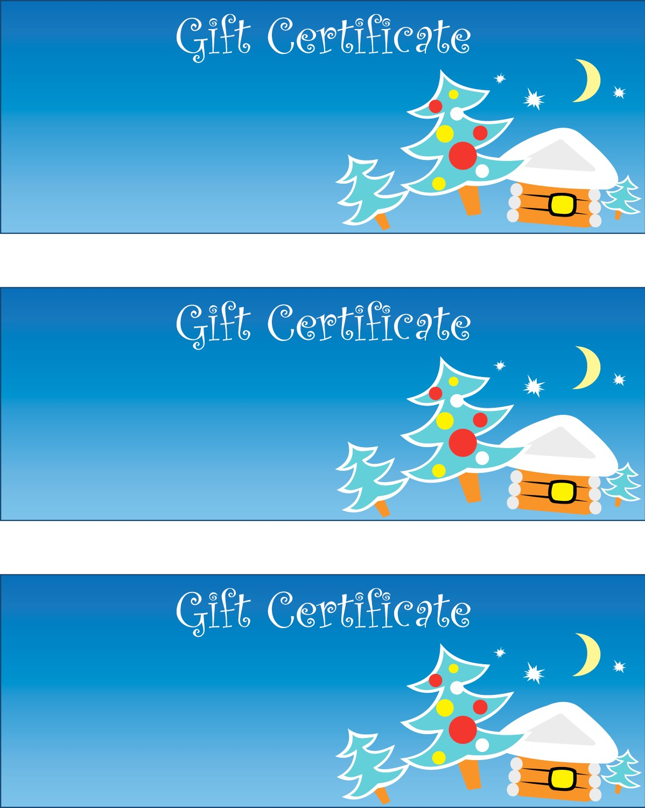

The

Gift of

For

From

The

Gift of

For

From

The

Gift of

For

From