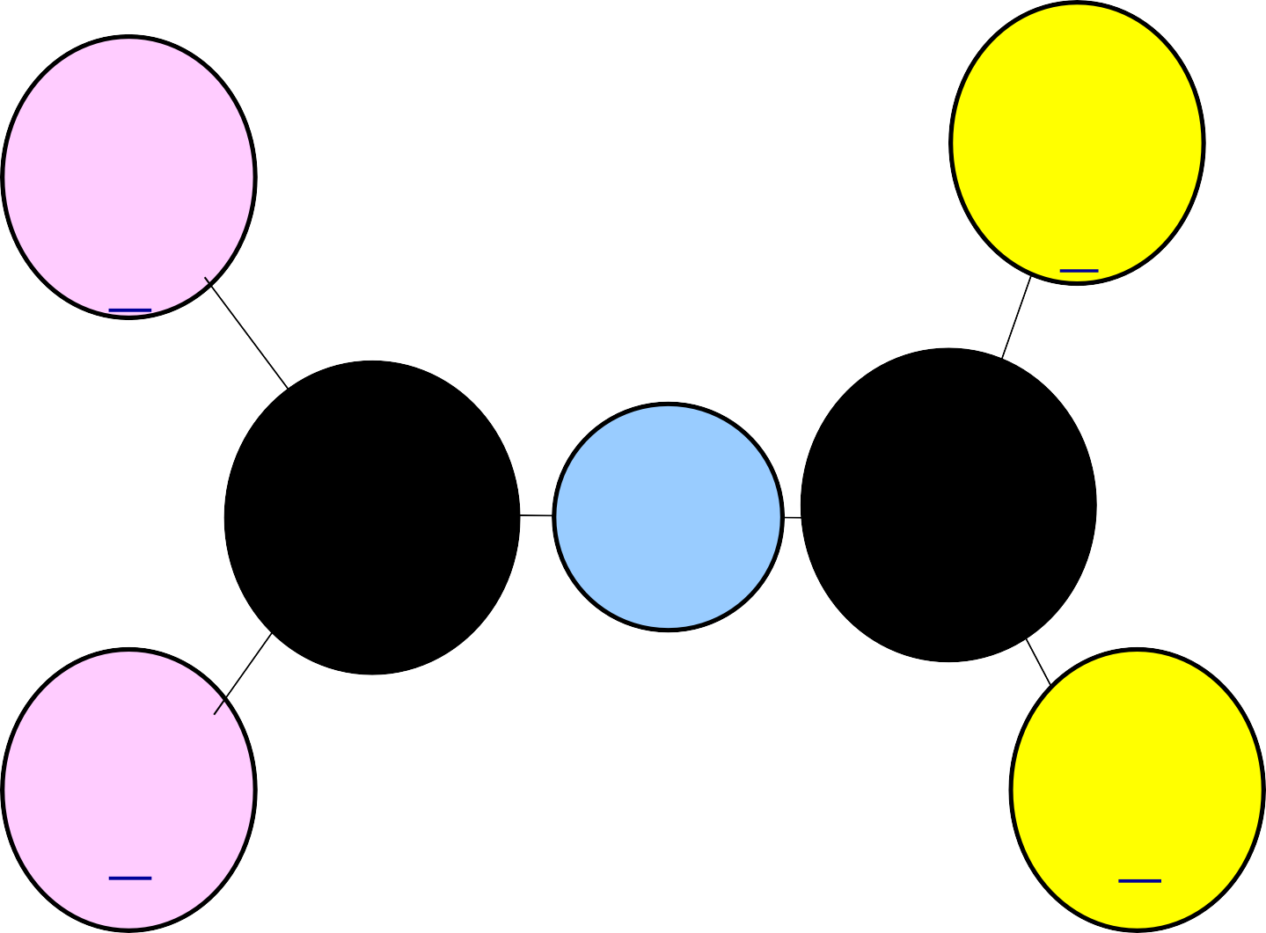

**Number of Testing Days**

Total Testing

Days for grades 3 – 8 with SSI retesting =

**27**

Total Testing

Days Grades 3 – 8 with SSI retesting =

**27**

**4th & 7th writing now a 2-day test**

**Most of the EOCs are 2- day tests**

**All EOCs offer 2 additional testing opportunities per year**

•

**STAAR**

**EOC**

•

Both will have

Tests, Make up Days, and Re- tests

**TAKS**

•

**Total Testing Days for grades 9th – 11th with Exit Level retesting =**

**25**

**Total Testing Days for 9th – 12th grade EOCs with retesting =**

**45**