Bubble Map

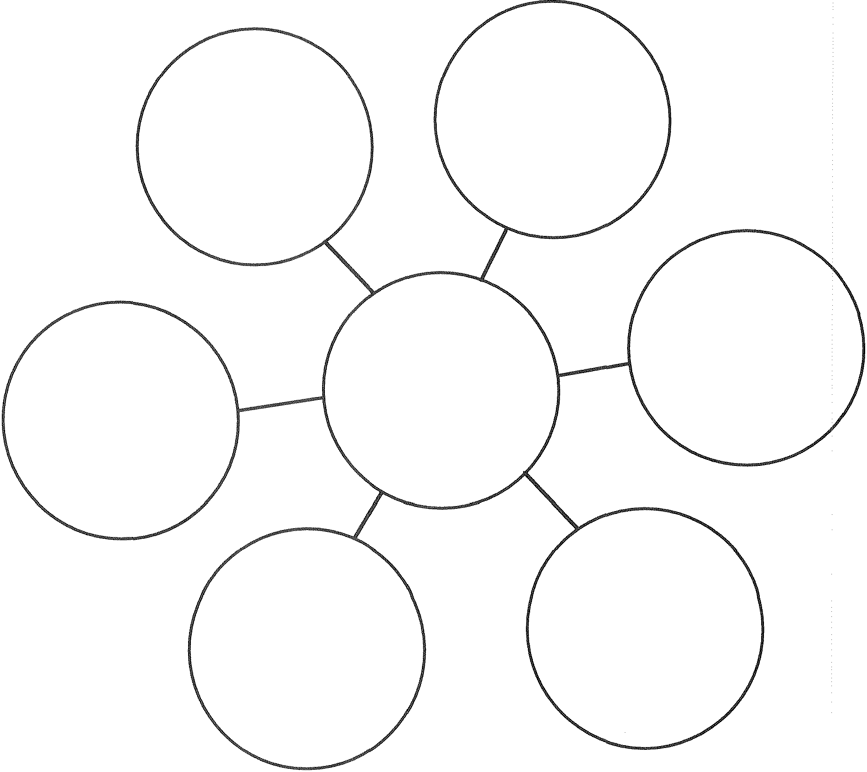

Bubble Map for Describing Using Adjectives and Adjective Phrases