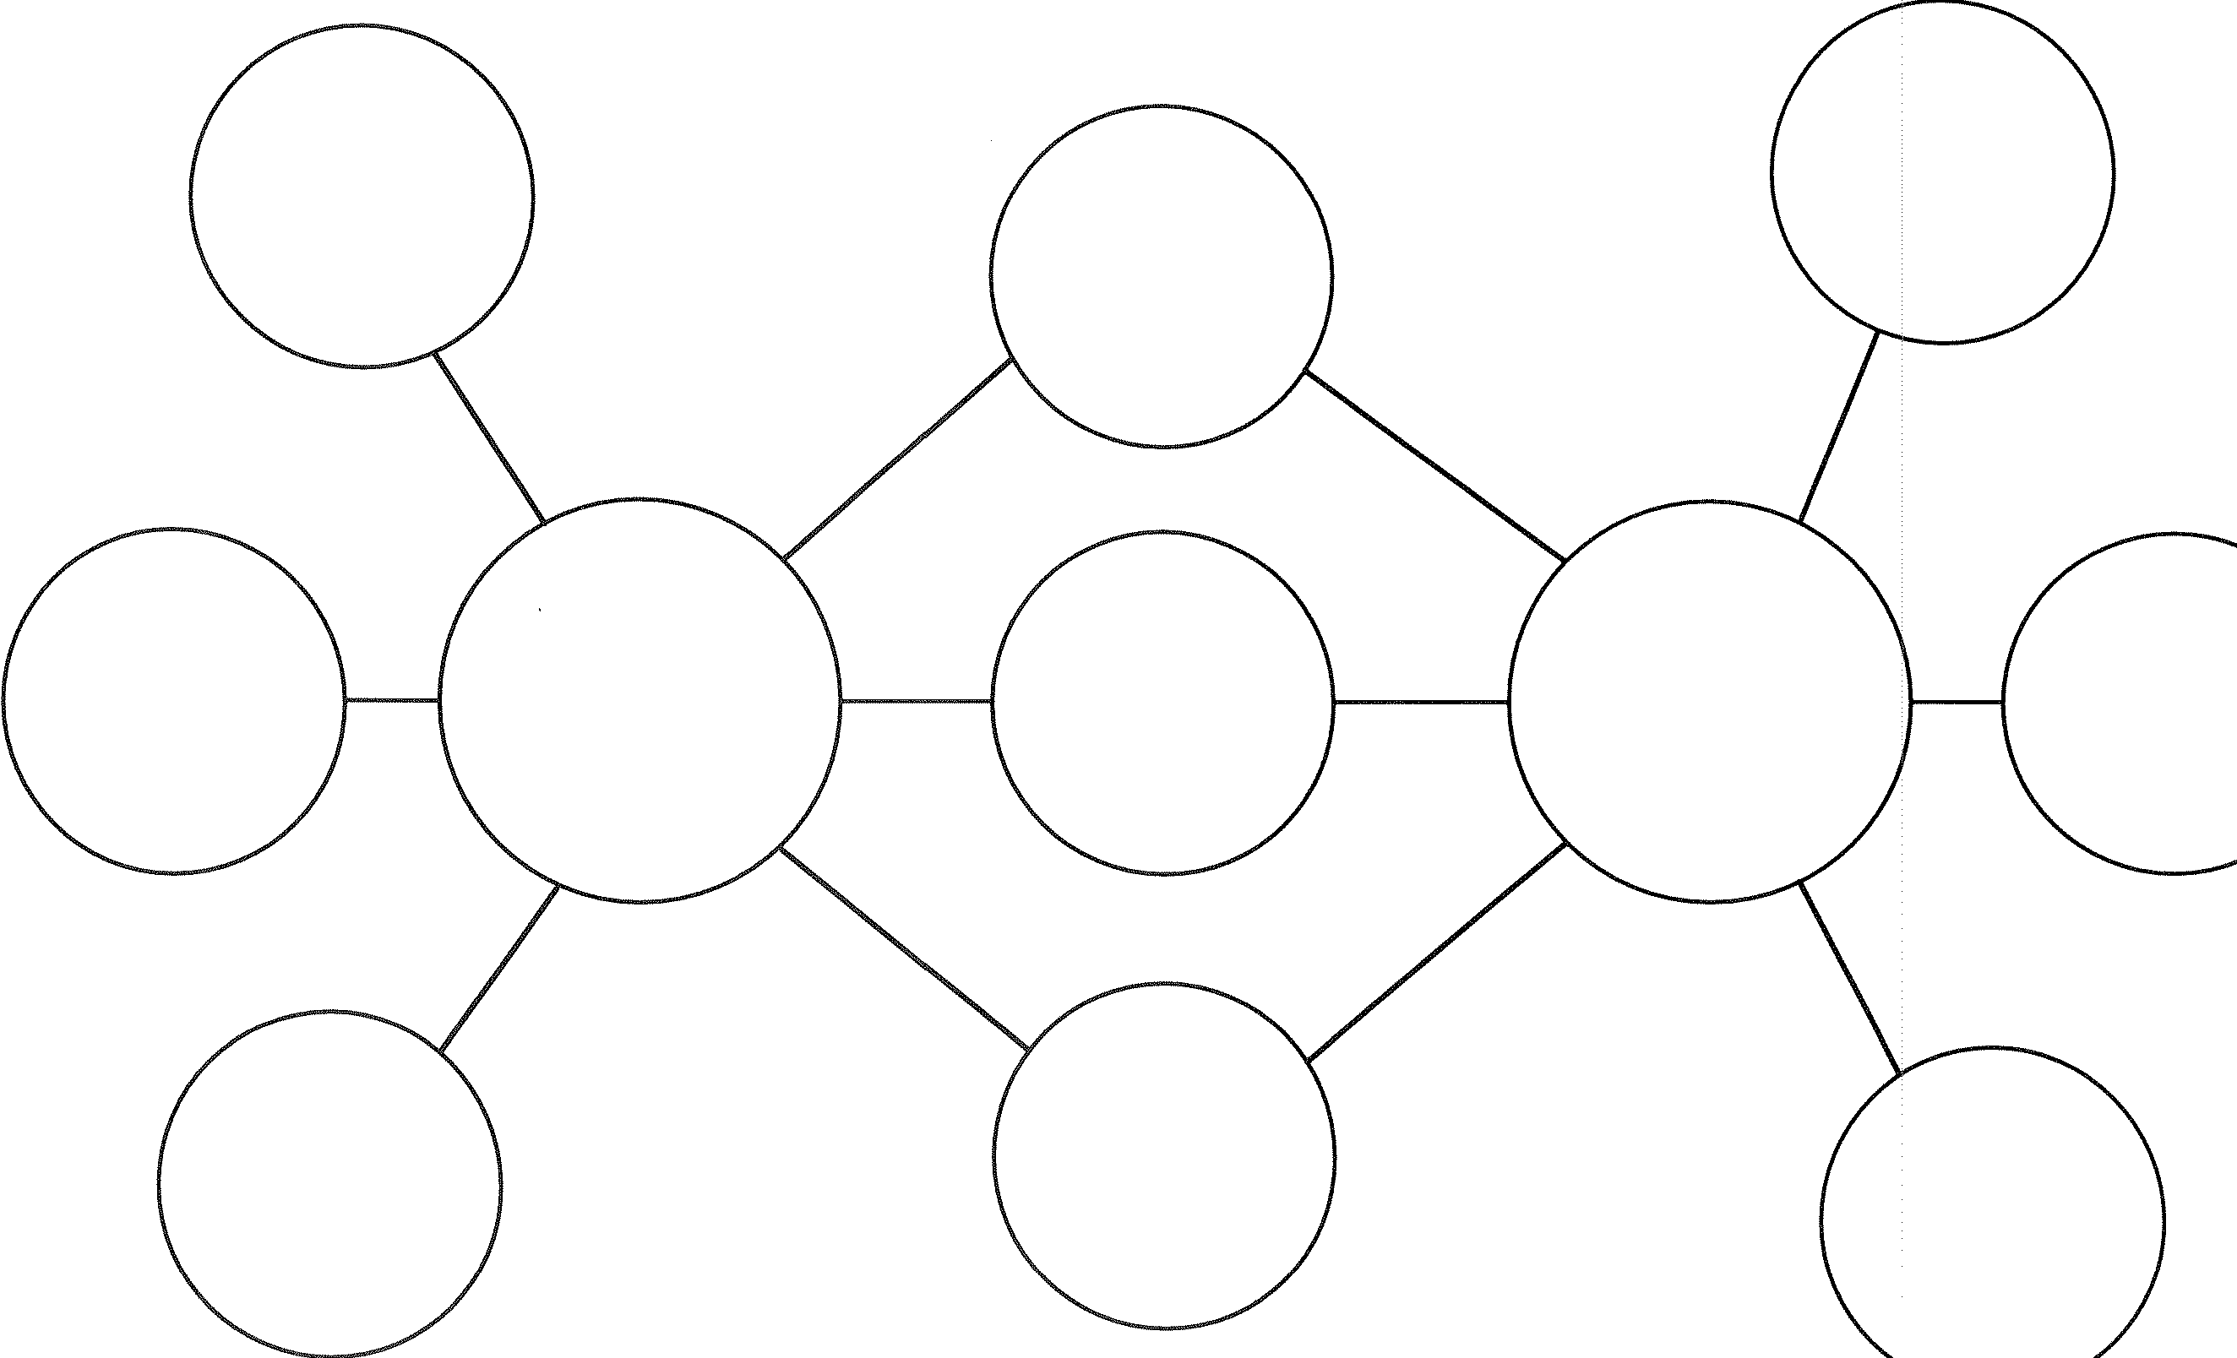

Double Bubble Map

Double Bubble Map for

Comparing (similarities) and Contrasting (differences)