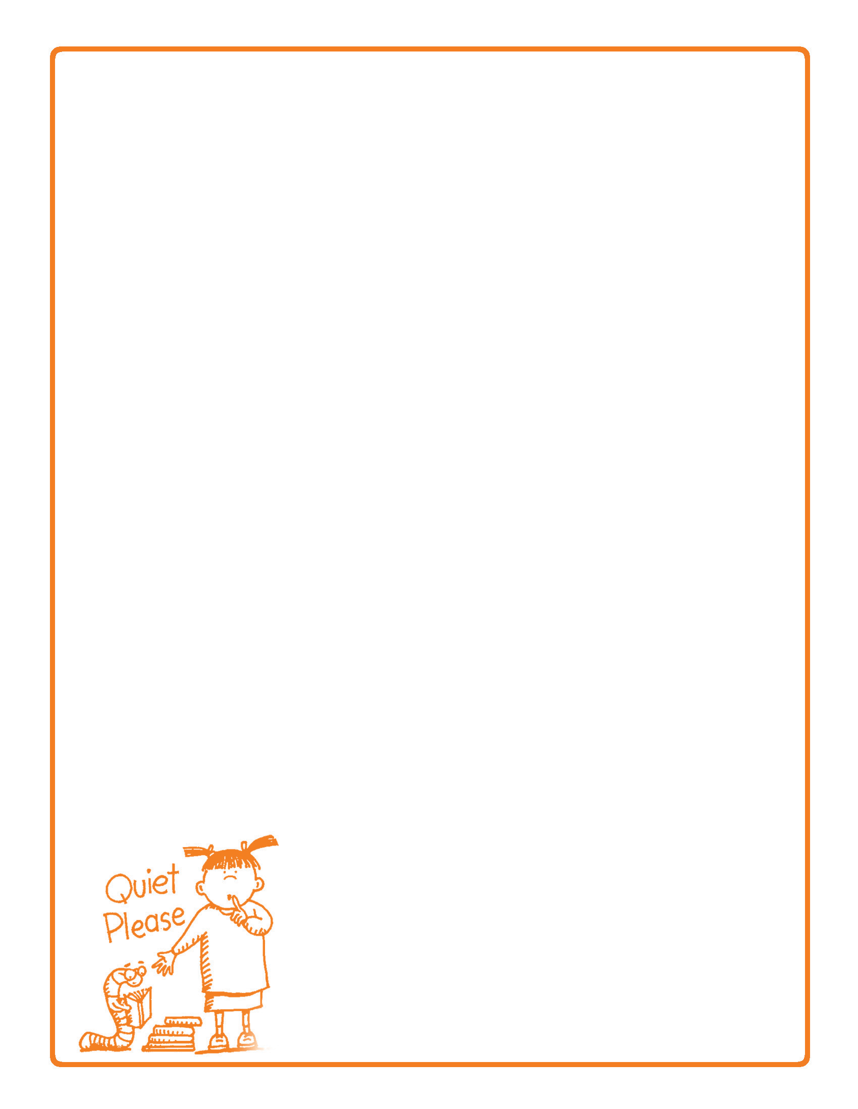

**Behavior Contract**

Date:

I promise to work on these behavior expectations:

Choose 3 of the following or create your own.

I will avoid whining

I will go to bed when asked

I will not interrupt

I will complete my homework on time

I will not hit

I will use good manners

I will respect the property and privacy of others

I will avoid places and objects that are unsafe or dangerous

I will be sensitive to the feelings of others

I will present a positive attitude instead of being negative, pessimistic

or rude

I will not tattle

I will get ready for school on time

I will take responsibility for my actions and not blame others

I will pick up after myself

I will keep good hygiene

I will eat healthy foods

I will

I will do my chores

I will

I will

Reward for meeting these expectations:

Consequence for not meeting these expectations:

Child Signature: Date:

Parent Signature: Date: