BUSINESS FINANCIAL PLAN

FINANCIAL OVERVIEW
Use this section to discuss the key points and takeaways of the financial data you will provide in the following sections of the financial component of your business plan.

ASSUMPTIONS
Each financial projection provided is based on assumptions. Use this section to outline realistic assumptions made to support the values you provide throughout your financial plan, and provide credible references that can be verified.

KEY FINANCIAL INDICATORS AND RATIOS
Use this section to highlight key financial indicators and ratios extracted from your financial statements. Financial ratios are used by bankers, analysts, and investors to evaluate the financial health and position of your business. Examples can include:

- Operations ratios
- Liquidity ratios
- Debt ratios
- Profitability ratios
- Working capital

break-even analysis
Use this section to include a table and/or chart that provides information on the number of units your business needs to sell to cover your costs and make a profit.

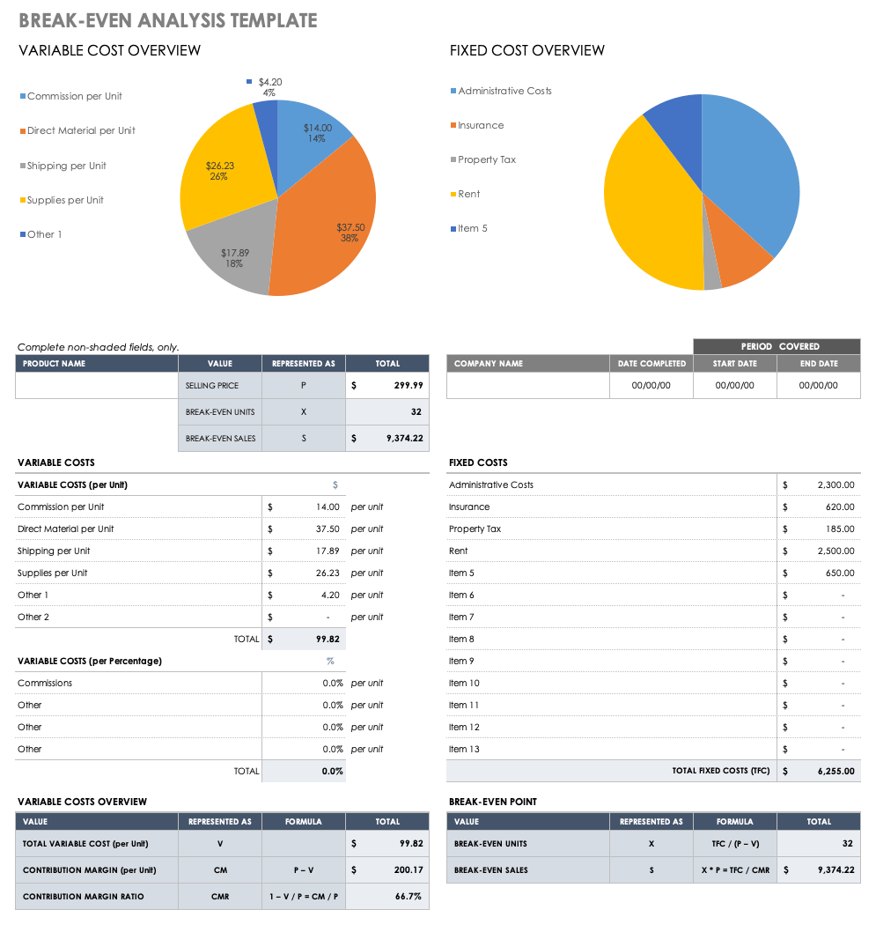

financial statements

PRO FORMA PROFIT AND LOSS STATEMENT
Use this section to provide a pro forma profit and loss statement, also known as a projected income statement, that details sales, cost of sales, profitability, and other vital financial information to stakeholders.

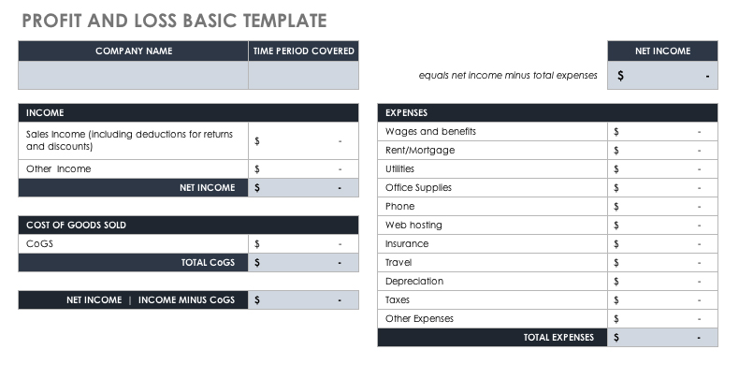

PRO FORMA CASH FLOW STATEMENT
Use this section to provide a cash flow statement that provides details around the projected cash inflows and outflows your business generates from operating, financing, and investing activities during a specific timeframe.

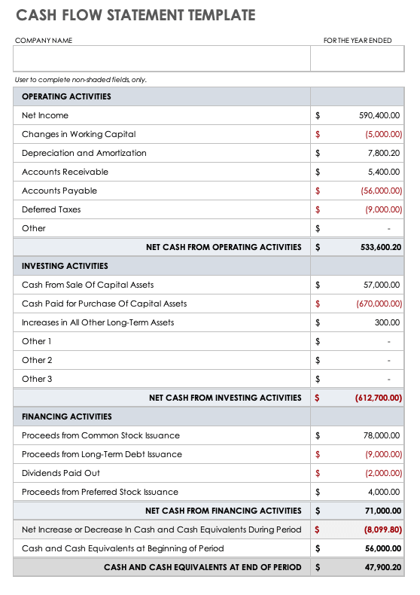

PRO FORMA BALANCE SHEET
Use this section to add a projected balance sheet statement that provides details on how your business plans to manage assets, including receivables and inventory.

