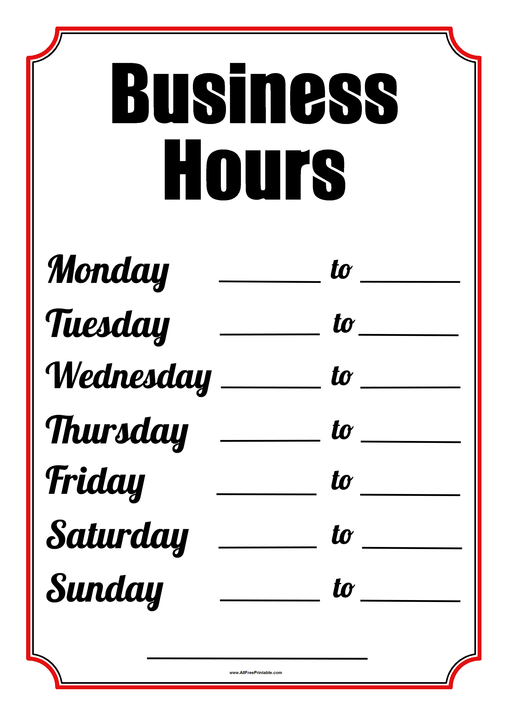

**1-800-456-7890**

5:00 pm

5:00 pm

5:00 pm

5:00 pm

5:00 pm

5:00 pm

5:00 pm

8:00 am

8:00 am

8:00 am

8:00 am

8:00 am

8:00 am

8:00 am