Sales Sheet

Club Name Member

Name | Phone # | 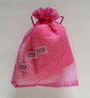 | 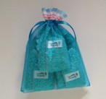 | 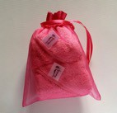 | 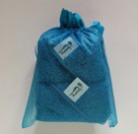 | AMOUNT | WASHDOLLY PRICE | TOTAL PRICE
 |  | Three, 15x20cm PINK OMBRE | Three, 15x20cm SMALL BLUE | Two, 30x30cm LARGE PINK | Two, 30x30cm LARGE BLUE |  | $21.00
GRAND TOTAL:

Start Date: Finish Date:

All Washdolly are - $21.00

*prices include GST

Have Questions?
Contact: Lisa @780-624-0911 Email: lisa@washdolly.com

Your Club receives 40% of the sales less the GST.

