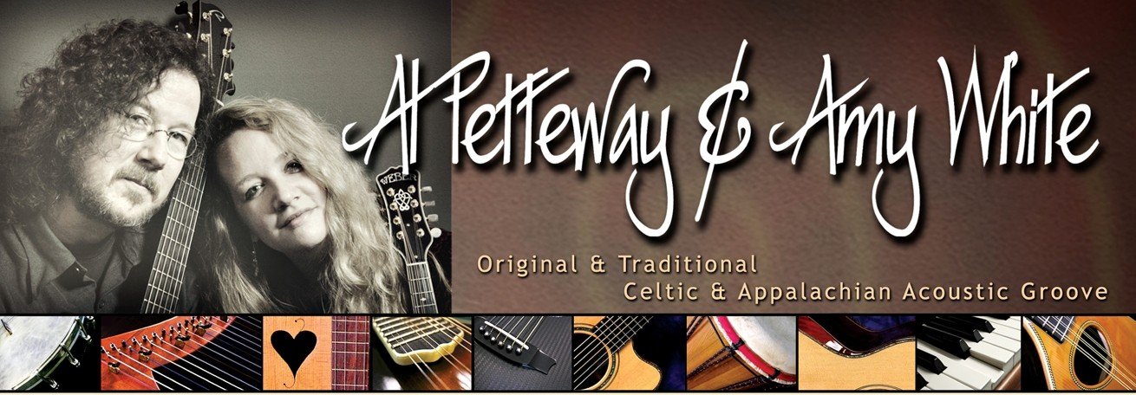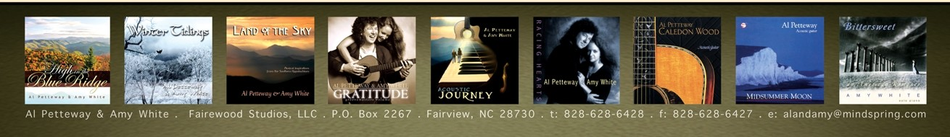

**GRAMMY AWARD-WINNING GUITARIST . INDIE AWARD-WINNING DUO**

as heard on the Ken Burns documentary, *The National Parks: Amer ica's Best Idea*

Award-winning, critically acclaimed, passionate and playful, Al & Amy offer an intoxicating blend of musical styles. Their repertoire includes original, traditional, contemporary Celtic- and Appalachian­ influenced music with occasional nods to rock and jazz. Their performances feature acoustic guitar, mandolin, Celtic harp,piano, banjo, lap dulcimer, world percussion, and a touch of vocals.

Before moving f rom the Washington, DC area to the mountains of Western North Carolina, Al & Amy won 50 WAMMIE Awards from the Washington Area Music Assoc iation.In addition, they were awarded 5 separate grants from the Maryland State Arts Council for both music composition and instrumental performance. They won an INDIE from The Assoc iation for Independent Music,and Alwon a GRAMMY from the National Academy of Recording Arts and Sciences.Al was voted one of the Top 50 Guitarists of all time by the readers of *Acoustic Guitar Magazine* and in 2008 he won Silver and Bronze medals in the magazine's "Players' Choice Awards."

Al & Amy's music was featured throughout the soundtrack of the 2009 Ken Burns EMMY-winning documentary , *The National Parks: America 's Best Idea.* And in 2010, their album, *Caledon Wood,* (which includes the main theme of the *National Parks* documentary) was counted among the essential albums of the past 20 years in the *Acoustic Guitar Magazine* 20th anniversary issue.

Al & Amy enjoy living in their mountain aerie at 4300 feet elevation,with stunning long-range views and wildlife as constant inspiration. This mountain-top setting has greatly influenced their recent musical works,and has also spurred their return to photography. Both Al & Amy's photographs are represented by The National Geographic Society's Image Collection, where Al worked as an image editor for 18 years. In addition to concerts and workshops, Al & Amy now also offer winter-themed and 4-season multi-media shows which feature live music performed against a backdrop of nature photography.

Among many other pursuits, Al continues to teach private lessons and records video lessons for "Dream Guitars," a high-end music store in the Asheville area. He also coordinates "Guitar Week" for the world famous music camp, *The Swannanoa Gathering.* And in early 2010, Amy launched Cat Angel Press which released its first full-color gift-book ,*Cat Angels: The Secret Lives of Cats.* There are more angels and books to come.

*High in the Blue Ridge,*Al & Amy's most recent recording of Appalachian- and Celtic-inspired melodies, was released in early 2011. Due to high demand, the duo is currently planning a DVD of nature photography and original music as a companion to their popular multi-media shows. In the meantime, you are welcome to follow Al& Amy on Facebook and YouTube. You can also sign up on their mailing list to be alerted to their new releases, upcoming concert dates, and more.

"...caffeinated, jazz-spiked acoustic brew."

-- *THE WASHINGTON CITY PAPER*

"...music of transporting power and beauty...shaped not only by a keen sense of lyricism and dynamics, but also a quiet soulfulness that continually draws in the listener:'

-- *THE WASHINGTON POS T*

"...a sonorous and often sensual spell which is impossible to shake off...

a musical odyssey worth investigating:'

*--FOLK ROOTS MAGAZINE*

"Simply one of the finest albums of Celtic­ influenced music you are likely to hear... stunning...awesome...majestic..."

-- *DIRTY LINEN*

"Mesmerizing tone poems... just pure music...

sumptuous portraits of life situations with a remarkable measure of clarity and color."

-- *JAZZTIMES*

"Petteway's guitar and White's piano twist and climb with a sharp, deep playfulness through essentially bittersweet territory... I felt as if I had been escorted over the hard edge by angels:'

-- *THE WASHINGTON POS T*

*Avail abl e for* Con certs,

[**www.AlandAmy.com**](http://www.AlandAmy.com/)

*M ul ti-M ed ia Per forma nces, Work shops* & *M aster Cl asse s* in *Fi ng er st yl e G uita r* & *Alt e red* Tu n i n gs

[**www.facebook.com/**](http://www.facebook.com/) **AlandAmy**

[**www.youtube.com/user**](http://www.youtube.com/user) ***I*AIPetteway AmyWhite**