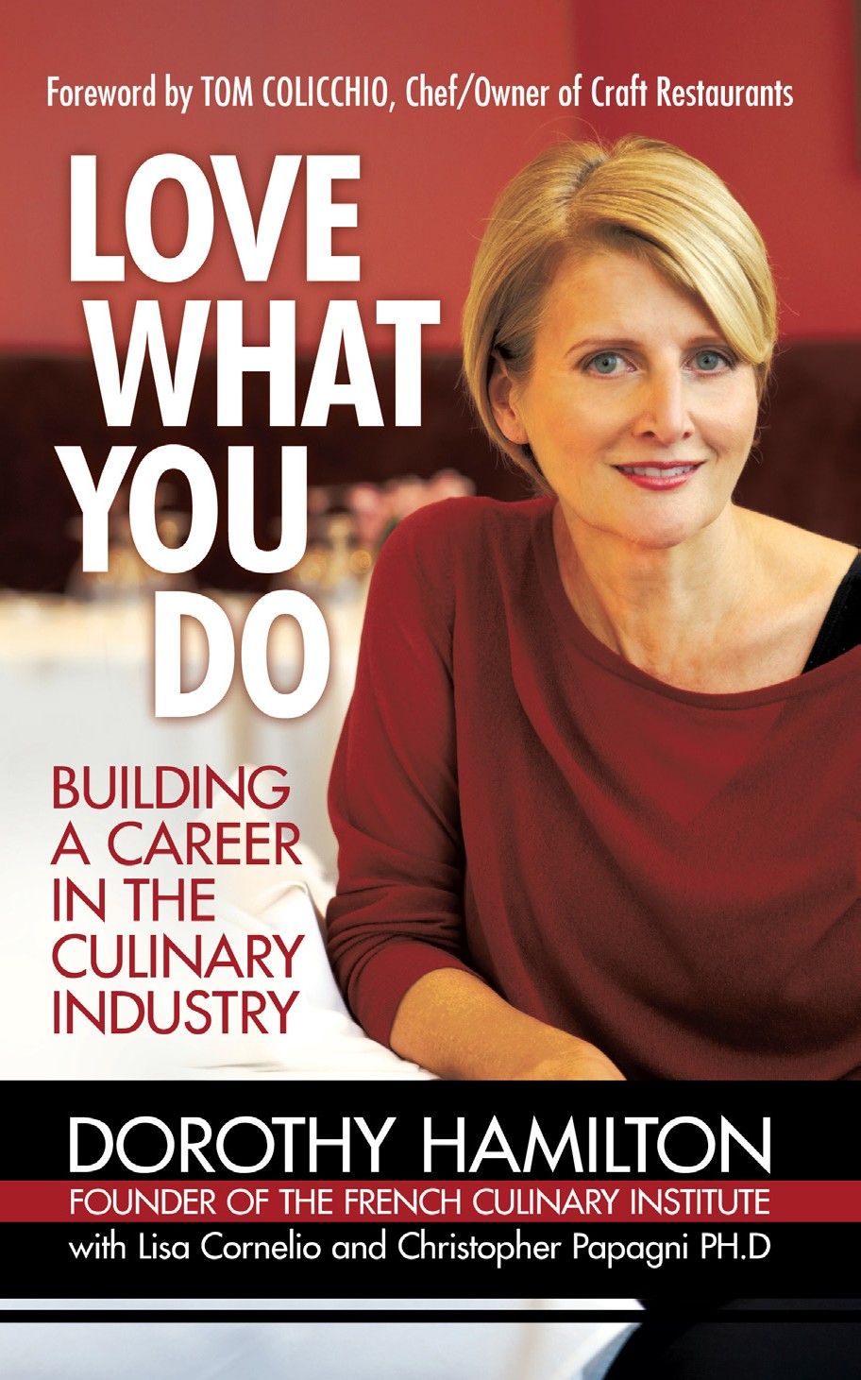

Love What You Do

Building a Career in the Culinary Industry

Starting or changing careers can be an intimidating process. *Love What You Do* demys- tifies the career decision process for any job hunt. It also helps people prepare for and find careers of all kinds in the culinary world.

*Love What You Do* begins with DECIDING; we ask readers to take a thorough self- inventory to uncover their goals, passions, strengths, and weaknesses. Section two, TRAINING, outlines the steps needed to begin a successful culinary career. Both culinary school and on-the-job training are discussed as possible options. The final section, LAUNCHING, is all about jobs, from what kinds of positions might be best for their needs and interests to conducting an effective job hunt.

Interspersed throughout the book are brief profiles of people in the culinary world, as well as facts and exercises, and quotes from prominent chefs.

Careers

Selling Points

•

Dorothy Hamilton, founder and CEO of The International Culinary Center,

home of The French Culinary Institute, is revered as one of the premier authorities in culinary education

The French Culinary Institute is one of the most prominent teaching institutions in the culinary world

*Love What You Do* has multiple target audiences: high school/college graduates, adults looking to change careers, parents of college students and young career changers, career/guidance counselors, and career/life coaches

Foreword written by Tom Colicchio, Head Judge of Bravo TV’s *Top Chef* and Chef/ Owner of Craft Restaurants

•

*•*

•

Marketing & Publicity

•

Marketing and Publicity will be overseen by Suzanne Sobel and Tara Hill, former Martha Stewart Living executives. Wendy Knight, senior public relations consult- ant and The French Culinary Institute’s publicist will act as personal publicist for Dorothy Hamilton. iUniverse has secured the services of a New York-based public- ity firm to work in tandem with Ms. Knight.

Targeted online“paid” search campaign (Google/Yahoo)

Advertise on job search Web sites that include but are not limited to StarChefs. com, Monster.com, jobs.acfchefs.org, ihirechefs.com

Local book tour with Dorothy Hamilton, including national, independent, and campus bookstores as well as culinary retailers (Barnes & Noble, Borders, the Strand, Sur La Table, Williams Sonoma)

Promote on FCI-related blogs, Web sites including FCI’s blog“Hot Plate,” cookingissuesblog.com, and pastryscoop.com

*Love What You Do* Web site/portal/social network site that will evolve to include the following features:

•

•

•

•

*•*

Learn how to turn your passion for food into a career, because everyone deserves to love what they do.

•

•

*•*

•

•

•

Self-assessment test “Ask Dorothy” live chat

*Love What You Do* content

Links to purchase *Love What You Do*

Link from The FCI Web site

Blog area for users to interact and share experiences

Love What You Do

Building a Career in the Culinary Industry

About the Authors

Dorothy Hamilton, founder and CEO of the world-renowned French Culinary Institute (FCI), has educated more than 10,000 students in the fundamentals of cuisine. The FCI and The Italian Culinary Academy, both located at The International Culinary Center in New York City, count many of America’s most prominent chefs among their graduates.

Author: Dorothy Hamilton with Lisa Cornelio

and Christopher Papagni PhD Foreword by Tom Colicchio Format: 5x8 Paperback Pages: 120

Price: $12.95

ISBN: 9781440156700

Co-op is available for this book.

Lisa Cornelio graduated with a BA in English from Princeton University. Lisa is a free- lance writer and educational consultant who has worked with hundreds of students and their families in the college admissions process, helping to select schools, prepare for interviews, and complete applications.

Christopher J. Papagni, PhD is the school director and vice president of student affairs for The International Culinary Center, home of The French Culinary Institute and The Italian Culinary Academy. Dr. Papagni holds a master’s degree in education from the University of South Carolina, earned his PhD at New York University, and studied classic culinary arts at The French Culinary Institute.

Contact [jweimer@authorsolutions.com](mailto:jweimer@authorsolutions.com) for order information