

LEIGHANNHEIL.COM

HOW TO WRITE A

Speaker One-Page for Public Speaking

TEMPLATE AND CHECKLIST



WRITING YOUR SPEAKER PAGE; TEMPLATE

Building a Compelling

Public Speaker One-Sheet

Are you ready to grab the mic and start speaking? Sure, it's easy to speak at any events you create, but how do speakers get booked at big conferences?

A Public Speaker One-Sheet helps secure significant speaking opportunities.

If you don't have a speaker page, you're not a pro-speaker, and you'll be

passed over for any big event. Conferences and agents book their speakers using one-sheets.

**You can't do everything, so don't say,**

**"I change the speech according to your audience!"**

Let's say you were hiring a band to play a party. You expected jazz, but this

band plays classic rock music. The band can't change the music to fit your audience because the music isn't the right fit from the start!

WHAT DOES A BOOKING AGENT WANT?

If you're the right fit for their audience. You wouldn't advertise yourself as an

entrepreneur who, "changes niches according to the customer," right?

Get specific on how your message benefits audiences.

Identify:

# What you can do for your prospective audiences.

1. **Why you are the best speaker for the job!**

In this template, you'll be able to easily show an agent that you are the right

speaker for their opportunity. See you onstage!



WRITING YOUR SPEAKER PAGE

Choose Your Speech Title and Topic

Decide what you want to speak about and choose a great title to go along with it. Make sure to use exciting, compelling language

**WILL THE SPEECH BE INSPIRATIONAL OR WILL YOU TEACH YOUR AUDIENCE**

**SOMETHING?**

**WHAT DO YOU LOVE SPEAKING ABOUT ON LIVE-STREAMS OR PODCASTS?**

**DOES THIS TOPIC HAVE BROAD APPEAL BUT STILL REFLECT YOUR BRAND?**

**HOW CAN YOU ADAPT IT FOR DIFFERENT AUDIENCES?**

LEIGHANNHEIL.COM



WRITING YOUR SPEAKER PAGE

Describe the Audience's Journey

**WHAT DOES YOUR AUDIENCE FEEL BEFORE YOU SPEAK TO THEM? DESCRIBE THEIR EMOTIONS; ANXIOUS, EXCITED, DISCOURAGED, ETC.**

**AFTER THEY HEAR YOUR MESSAGE, WHAT IS THEIR TRANSFORMATION ON**

**AN EMOTIONAL LEVEL? PEACEFUL, INSPIRED, CONTENT, MOVED, ETC.**

**HOW DO YOU WANT THE AUDIENCE TO CHANGE? THEIR EMOTIONS,**

**ACTIONS, THOUGHT PROCESS, OR SOMETHING ELSE? DESCRIBE IT.**

**WHAT ARE THE STEPS IN THE SPEECH YOU WILL GIVE TO MOVE YOUR**

**AUDIENCE FROM THEIR FIRST EMOTION TO THE LAST?**

LEIGHANNHEIL.COM



WRITING YOUR SPEAKER PAGE

Describe Your Own Journey

**WHY ARE YOU THE BEST ONE TO DELIVER THIS SPEECH? WHAT HAVE YOU DISCOVERED OR OVERCOME TO MAKE YOU UNIQUELY QUALIFIED?**

**LIST YOUR PREVIOUS SPEAKING ENGAGEMENTS OR TESTIMONIALS.**

**WRITE YOUR BIOGRAPHY AND INCLUDE YOUR UNIQUE QUALIFICATIONS,**

**CERTIFICATIONS, AWARDS, NOTABLE AND FAMOUS COACHES YOU'VE WORKED WITH. WRITE IN THIRD PERSON.**

LEIGHANNHEIL.COM



FORMAT FOR YOIR SPEAKER PAGE

Put it all together

Top of page, who you are as a speaker; fun, authentic, warm, exciting.

Examplle: Jane is a warm, authenitic speaker who uses stories as tools to engage with audiences.

Talk about the transformation you will give their audience.

“She provides a gentle way for your audiences to better understand their fears and change their own narrative.”

Give the title of your speeches and more detail as to the transfornative process

in each speech. Ideally, you should have 3 speeches to choose from, educational, inspirational, and a combination of inspiring and teaching,

Write a biography and include your achievements and accomplishments, what

type of transformation youve experienced, and why you feel called to speak about your topics.

Testimonials of happy clients, booking agents, or conference leaders. Any

additional media youve been featured in, and books youve written. Be sure to include a button or form for booking inquiries!

LEIGHANNHEIL.COM

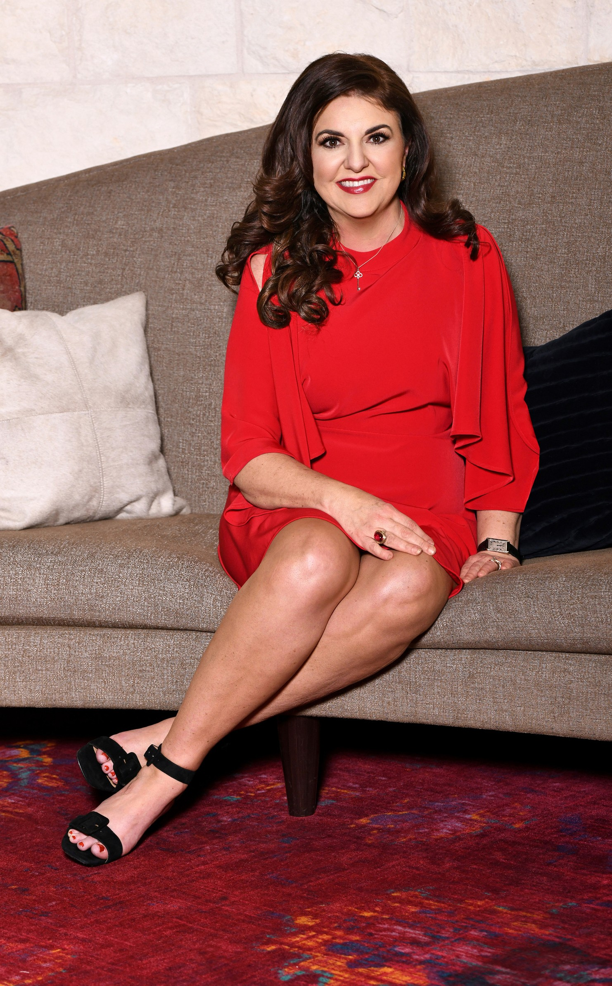

What's Next?

Are you still confused about how to get onstage as a professional?

Hi, I'm LeighAnn and I help coaches and

creatives get onstage to increase their influence, income, and book more clients.

I've been featured in every major news

outlet and charted on Billboard top 100. With coaching credentials from Yale and UCLA, a Master's in Theatre, an Opera degree, and over 800 live stage performances.

I know how to get you onstage in a

powerful way. My Coaching programs refine your message and move your business towards the global stage.

#1 Create Your Signature Speech

#2 Refine Your Voice Quality

#3 Captivate Your Audience With Your Presence

#4 Book 4-5 Clients With Each Engagement

#5 Lift Your Brand Out of The Saturated Market

**CLICK HERE TO LEARN MORE**

***"LeighAnn gave me more value in a 30-minute call than a 10K***

***coach did in 6-months, she'll help you live your dreams."***

Kelsie Sisler

LEIGHANNHEIL.COM