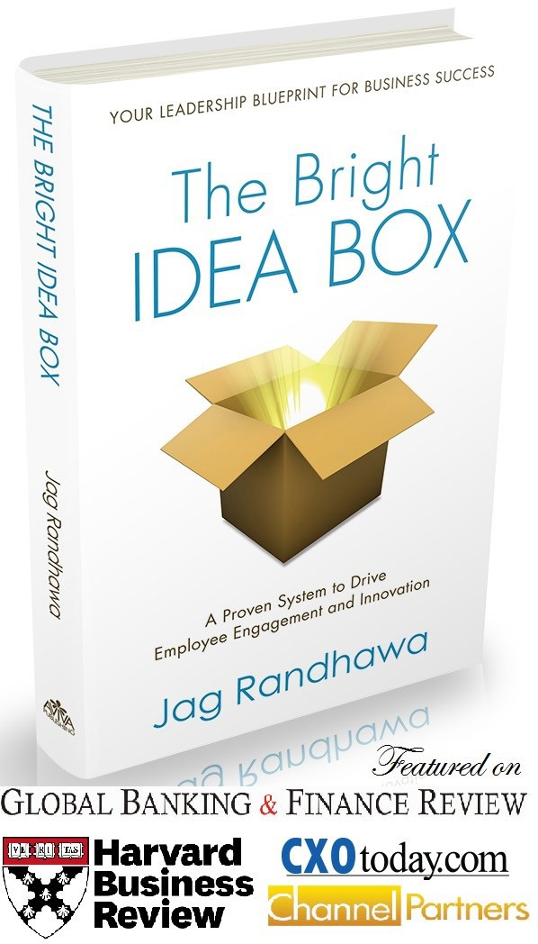
JAG RANDHAWA
Author, Speaker, Coach

I N N O V A T I O N A N D E M P L O Y E E E N G A G E M E N T
A R E T H E T O P T W O P R I O R I T I E S F O R E X E C U T I V E S T O D A Y

Innovation and Employee Engagement are consistently ranked as top priorities year after year by business executives, but most struggle with how to get start- ed. Jag presents simple and proven system to increase employee engagement, create a culture of innovation, and fuel business growth.
Jag’s Most Requested Speaking Topics:
- Creating a Culture of Innovation—How to Engage Employees, Accelerate Innovation, and Grow the Business.
- Innovator’s Mindset—How to Spot Ideas in Everyday Life and Transform Frustrations into Opportunities.
- Employee Engagement—Tools and Techniques to Motivate Employees, Reduce Turnover, and Build High Performance Teams.
- Future of Technology and Business—How Consumer Technology Obses- sion, Internet of Things, and Big Data will Changes Businesses in the Future.

R A V E S

- Aha moment: innovation does not equal invention—CIO, Infoblox
- I emailed my boss in the middle of the presentation to implement Jag’s program—Vice President, CMD Media
- Jag has enthusiasm for the topic, which bleeds into the audience—Program Director, Int E&O insurance Assn

Jag Randhawa

Jag Randhawa is the award-winning author of The Bright Idea Box, and he has been credited with creating a wave of bottom-up innovation culture and empowering employees to grow the business. Jag’s MASTER Innovation program, a six-step for- mula for creating a culture of innovation, has been praised by leading business au- thorities and journals, including Harvard Business Review. As a twenty-year veter- an of the technology industry, Jag shares real life stories of building high perfor- mance teams, award-winning products, and fostering a culture of innovation.

Jag@IdeaEmployee.com (888) 804-6919 TheBrightIdeaBox.com

