Popular Presentation Topics:
Next-Level Leadership
Remove the blind spots that could be sabotaging your success
Strategic Personal Branding Accelerate your career by communicating your value with 3-D impact
Leadership Presence
Optimize your influence by making subtle yet powerful changes
Emotional Intelligence
Learn how to incorporate the behaviors of the world’s most effective leaders
Power, Presence & Prosperity for Women
Develop the attributes and attitude to fuel your professional advancement

Available For:
- Keynotes
- General & Breakout Sessions
- Workshops & Seminars
- Panel Discussions
- Executive Coaching
Sara Canaday is an engaging speaker and leadership strategist known for her ability to help people identify the elusive blind spots that are preventing them from taking their careers (and their companies) to the next level.

Drawing on 15 years of corporate experience, Sara has a unique gift for connecting with her audiences and ensuring they walk away with actionable strategies for positive change -- strengthening leadership skills, improving business relationships, and enhancing performance.

Using her passion, energy and warmth, Sara has shared her expertise with thousands of talented, high-potential professionals in Fortune 500 companies, entrepreneurial
start-ups, top industry groups and trade organizations. She has also extended the reach of her message as the author of a new book,
“You - According to Them: Uncovering the blind spots that impact your reputation and your career,” and a highly acclaimed workbook, “Career Acceleration: Speed up your success with strategic personal branding.”

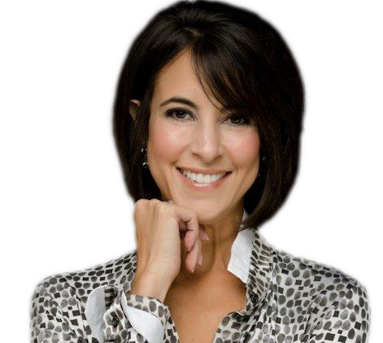
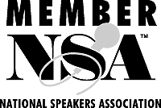
512.343.7991 . Sara@SaraCanaday.com . www.SaraCanaday.com
facebook.com/CanadayandAssociates . twitter: @saracanaday

While earning an MBA and moving up the corporate ladder at a major company, Sara repeatedly observed that career success
was tied less to IQ and job skills and much more to the ability to collaborate, communicate and influence others. Subordinates and superiors alike recognized her rare talent for applying that insight and pinpointing the attributes that could make or break a career. In fact, Sara’s co-workers frequently approached her for career advice, including strategies to help them avoid professional pitfalls and advance more rapidly. Despite reaching an executive position in operations, Sara realized that helping others to maximize their career potential was truly her life’s work.

Today, Sara’s clients consistently rave about the breakthroughs they’ve achieved using her fresh approach to leadership development. Whether she is delivering a keynote or presenting a workshop, Sara’s engaging style and compelling messages are famous for producing light-bulb-moment understanding and targeted actions that lead to bottom-line impact. When you want results, Sara Canaday is the speaker you need.
Partial Client List:
- Allstate Insurance Company
- Austin Board of Realtors
- Capstone Properties
- Dell Inc.
- Deloitte Consulting LLP
- Fidelity Investments
- IBM Global Services
- Keller Williams
- McCombs School of Business
The University of Texas at Austin
- State Farm Insurance
- Texas Society of Assoc. Executives
- UniMed Direct
- Vistage

“Sara spoke recently at our Vistage meeting, the largest CEO network in the world. Everyone gave her rave reviews, both at the time and for subsequent months. We will have Sara come back to speak to us about anything, anytime.”
Vikki Loving
Vistage Trusted Advisor and CEO, Intersource Companies

“Sara created a two-day course that was perfectly tailored to the dilemmas we face. I recommend her for any organization desiring to improve all impressions to be made. Sara is the kind of person you are glad is on your team.”
Gregory Smith Jamail & Smith

“Sara grabbed the audience’s attention immediately and received glowing feedback.”
Nichelle McLemore Deloitte Consulting LLP

“Sara is always energetic, informative, sincere and relevant.”
Loretta C. Fellers
Dell Inc.

“Sara was absolutely fabulous!”
Christi Davidson Keller Williams

512.343.7991 . Sara@SaraCanaday.com . www.SaraCanaday.com facebook.com/CanadayandAssociates . twitter: @saracanaday

