THE Presentation Skills Expert
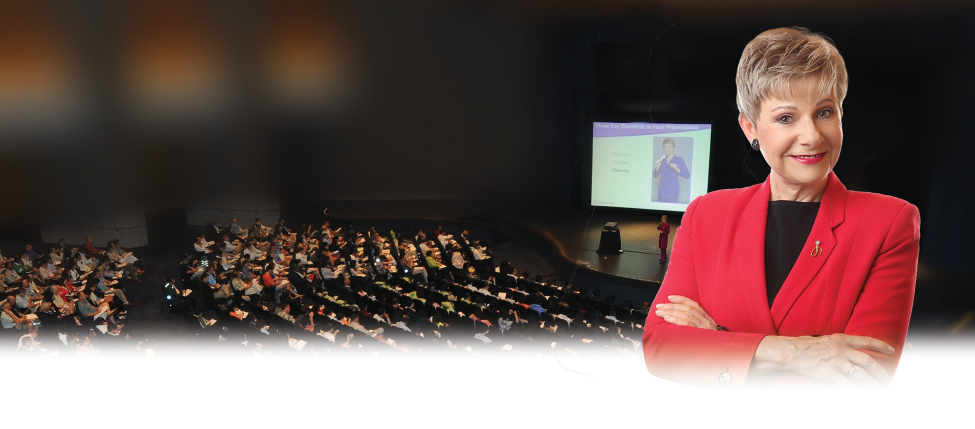

Patricia Fripp, CSP, CPAE

Hall of Fame Keynote Speaker Executive Speech Coach Sales Presentation Skills Expert

Popular speech titles:

Powerful, Persuasive Presentations: Your Competitive Edge
Leadership Presentations: How to Build Action and Commitment
How to Effectively Sell Yourself, Your Ideas, and Your Services
Superstar Sales Presentations: The Inside Secrets
Under the Magnifying Glass: Good to Great Presentations
“For 21 consecutive years we have hired Patricia Fripp to deliver keynote speeches, breakout sessions, a speaker school for our industry and conference speakers, and coaching of our leaders with their presentations. Patricia is the best speaker investment you could make. I have no idea how she continues to get better. I feel enormous pride calling her one of my best and most trusted advisors.”
- Dan Maddux, Executive Director,
American Payroll Association
“Patricia Fripp is the BEST! She keynoted our major client conference, Meeting of the Minds, and was a HIT! Not only as the opening keynoter, but also for conducting five of the ten best breakout sessions of the 115 presentations offered.”
- Dave Larson, Conference Chair, Vice President of Marketing, ADP National Account Services

Companies engage Patricia when they want to gain a competitive edge by mastering conversations and presentations. When your message must be memorable, your conversations persuasive, and your sales successful, Patricia Fripp can help. Whether you need a dynamic and content-rich keynote speech, an audience-involved breakout, or customized training from a proven expert, you owe it to yourself to contact Patricia Fripp.
Being a dynamic, inspiring, and persuasive communicator is no longer simply a nice skill to have. It’s a matter of business life and death! Patricia Fripp simplifies the process of preparing and presenting persuasive conversations, speeches, and sales presentations.

Most clients engage Patricia to deliver a keynote speech and multiple breakout sessions at the same conference.
This will maximize your budget and reinforce a consistent message.

Patricia Fripp • (415) 753-6556 • pfripp@ix.netcom.com • www.fripp.com

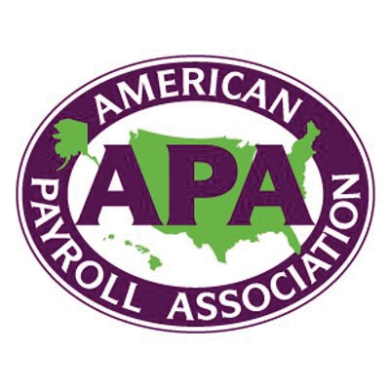
Trusted by clients such as these:

“The leadership of FOCUS Learning Corporation appreciates your efforts toward our conference success. Your preparation for your keynote, “How to Take the Conference Home,” was amazing. Even with your preparation interviews of our clients, our president had no idea it was possible to deliver an upbeat keynote on technical issues. You did your homework and brought us an outstanding wrap-up that tied the meeting together. It takes talent and skill to be such a powerful speaker.”

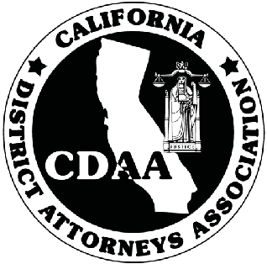

Dianne Moore, Conference Coordinator, FOCUS Learning Corporation

“Your presentation was exciting, inspirational, moving, entertaining, funny, and filled with substance. For many of the attendees, your presentation was the pinnacle. In point of fact, I have never worked with a speaker who takes their job as seriously as you do. Your interest in our association, our industry, and our needs, your tireless preparation and thought over the past year proved to be obvious when you stood in front of our group. You sure showed the celebrity keynote speakers how to deliver a speech!”
John E. Welshons, Convention Chair, American Cemetery Association

“Patricia Fripp received the highest reviews of any of our professional keynote speakers in our company’s history. We have hired dozens of top-level professional speakers. Patricia is the best. Her subject of “Speaking Your Way to Success” and her interactive breakout where she coached our financial professionals on their marketing presentations were very well received. Patricia has received repeat invitations.”
Ron King, President, Centarus Financial

Most clients engage Patricia to deliver a keynote speech and multiple breakout sessions at the same conference.
This will maximize your budget and reinforce a consistent message.

Patricia Fripp • (415) 753-6556 • pfripp@ix.netcom.com • www.fripp.com

