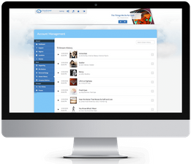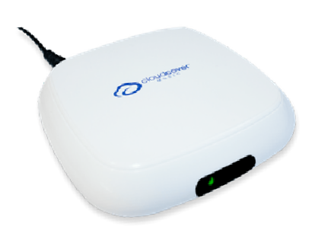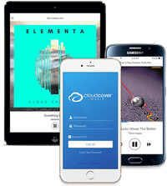

Built for Business

**IN-STORE MESSAGING**

**DRIVE SALES & MOTIVATE STAFF**

MESSAGING

Recording & Use

**UNLIMITED STORAGE**

Our cloud-based servers will let you host an unlimited number of messages in your Library. Use messaging to influence behavior including:

**UPLOAD YOUR OWN**

You can send us any pre-recorded messages foruploading into your account. We have some recommended volume guidelines listed in the software supporttab.

**Get 4 FREE custom messages per company from our LA Sound Studio.**

Advertise sales and specific products Enforce your brand loyalty

Highlight reward programs

Make Public Service Announcements Announce special events

Motivate production teams

**Every location can play different messages.**

Messages willbe loaded onto your accountwithin one business day and can be played immediately atyour

locations.

**Change messages as often as you like. No additional costs.**

**Messages changes happen immediately.**

**UNMATCHED FLEXIBILITY**

Our messaging options give your business the utmost flexibility to increase sales, reinforce branding and motivate your staff. No matter what your business goals are, this messaging system can get it done.

**FREQUENCY OPTIONS**

You choose how often the messages are going to play. Messages play in-between songs. We use 3-3.5 minutes as the average song length. You choose how many songs to play before a message is heard so that every person in your business has the chance to hear them during their visit.

**TRACK SALES WITH REPORTS**

Use Enterprise reports to tie messages directly into your sales numbers. Our report tells you the date, time, location and messages that played. Use our robust system to test specific offers and get the exact buying behavior or staff motivation that you need.

**Would you like a free trial of messages to see how they sound at your**

**location? Just ask!**

**OUR LA SOUND STUDIO**

**SCHEDULING FEATURES**

Our plans come with either 4 or 8 messages per group. You can create as many groups as you want, and then assign them to play at your locations. Schedule the messages into a group, set the frequency, and then turn it on at the location.

Our LA Sound Studio incorporates top talent in both voice acting and editing. Some of their other clients include

Disney and NPR.

You have the choice of numerous voice styles and genders. Our order form also lets you choose background music and

chime options.

[info@cloudcovermusic.com](mailto:info@cloudcovermusic.com)

**$29.95/mo**

4 Live Messages

cloudcovermusic.com

(424) 272-1814

1634 19th Street

Santa Monica, CA 90404

**$34.95/mo**

8 Live Messages