**FUNDRAISING GOAL THERMOMETER**

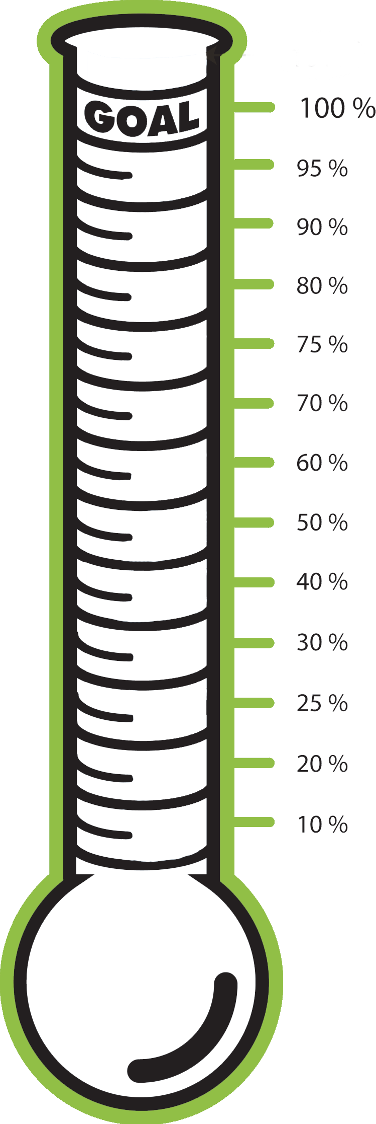

100%

90%

80%

**UW Department**

70%

60%

50%

40%

30%

20%

10%

**$**