Fund Goal Progress

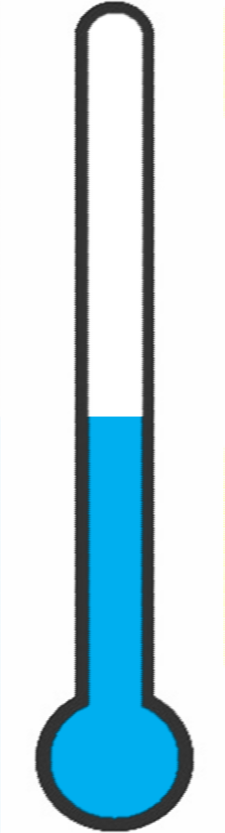
100%
50%

90%

80%

70%

60%

50%

40%

30%

20%

10%

0%

Goal: | $1,000.00 | 100%
Goal Achieved: | $500.00 | 50%

