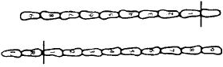
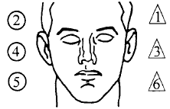
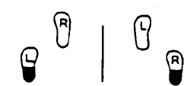
NAME:
BLINDNESS: NONE
LEFT EYE RIGHT EYE
TRACKING:
EQUAL UNEQUAL
EYES:
NORMAL BLOODSHOT WATERY
ABLE TO FOLLOW STIMULUS: YES NO
EYELIDS:
NORMAL
DROOPY
LACK OF SMOOTH PURSUIT
LEFT EYE
RIGHT EYE
VERTICAL NYSTAGMUS YES NO
NYSTAGMUS AT MAXIUM DEVIATION
CORRECTIVE LENS: NONE GLASSES CONTACTS: HARD SOFT

NYSTAGMUS PRIOR TO 45’
PUPIL SIZE: EQUAL UNEQUAL (EXPLAIN)
DESCRIBE TURN
CANNOT DO TEST (EXPLAIN)
MODIFIED ROMBERG BALANCE
INTERNAL CLOCK

ESTIMATED AT 30 SEC.
OTHER FIELD SOBRIETY TESTS
NAME OF TEST:
DESCRIBE PERFORMANCE:
PRELIMINARY BREATH TEST RESULTS:
RESULTS . %
REFUSED INSTRUMENT #:
TICKET NUMBER:
HORIZONTAL GAZE NYSTAGMUS
WALK AND TURN TEST
CANNOT KEEP BALANCE

STARTS TOO SOON
1st 9 2nd 9
STOPS WALKING

MISSES HEEL -TOE STEPS OFF LINE RAISES ARMS
ACTUAL STEPS TAKEN
ONE LEG STAND
(
) SWAYS WHILE BALANCING (
)
(
(
(
)
)
)
USES ARMS TO BALANCE (
HOPPING
PUTS FOOT DOWN
(
(
)
)
)
FINGER TO NOSE

RIGHT LEFT
DRAW LINES FROM SPOTS TOUCHED

New York State DWI Investigative Notes

LAST FIRST

DOB: TIME: DATE: LOCATION:
INITIAL OBSERVATIONS: OBSERVATIONS OF DRIVER:

OBSERVATION OF STOP: OBSERVATION OF THE EXIT:

SPEECH: COORDINATION:

ATTITUDE: FACE:

BREATH: FOOTWEAR:

ODORS: OTHER:
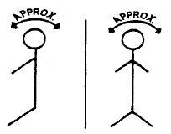

CHEMICAL TEST/MIRANDA WARNINGS: GIVEN BY:
WHAT HAVE YOU EATEN TODAY? WHEN?

TIME NOW? WHEN DID YOU LAST SLEEP?
HOW LONG?
ARE YOU SICK OR INJURED? DO YOU TAKE INSULIN?

DO YOU HAVE ANY PHYSICAL DEFECTS?
ARE YOU TAKING MEDICATION OR DRUGS?

ARE YOU DIABETIC OR EPILEPTIC? ARE YOU UNDER THE CARE OF A
DOCTOR OR DENIST?

WHAT HAVE YOU BEEN DRINKING? HOW MUCH?
STATEMENTS:
TIME OF LAST DRINK?

HAVE YOU EVER BEEN ARRESTED FOR DRIVING WHILE INTOXICATED? YES NO HAVE YOU EVER BEEN CONVICTED OF DRIVING WHILE INTOXICATED? YES NO
IF YES: WHERE, WHEN WHAT AGENCY:
Officer Name/Rank Shield

Police Agency Incident Number

-OVER-

