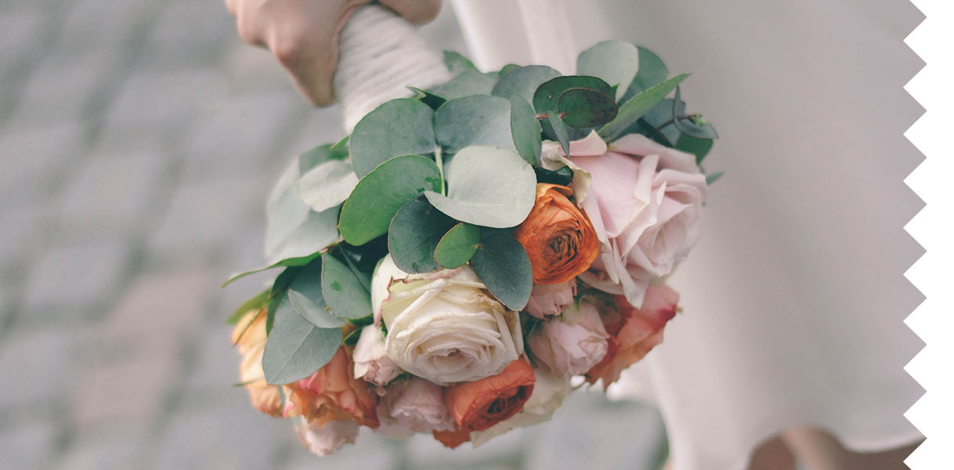

The Bride

FREE SEATING

**ADMIT ONE**

**Directed by John Doe**

12-12-19

**SUNDANCE PRODUCTION PRESENTS**

The Bride



Ticket no. 0124356