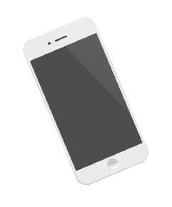

**TECH SHOPPING CENTER**

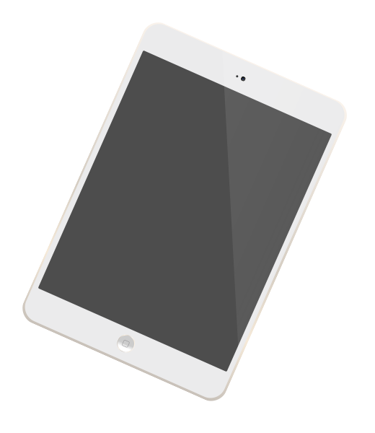

**GIVEAWAY**

Drawing on January 5 2019

Join the raffle and be one of the 10 winners.

**GADGET**



EMAIL:

ADDRESS:

PHONE:

NAME: