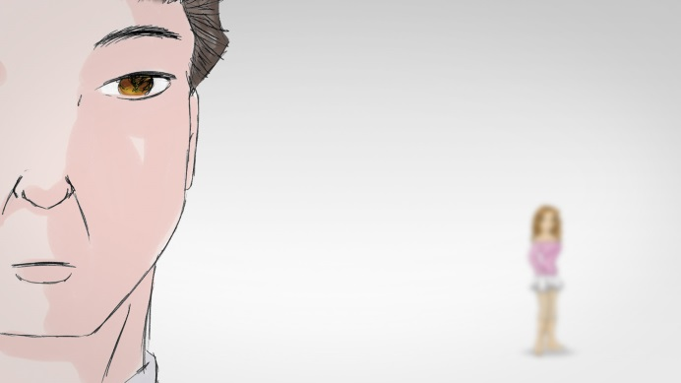
1 | Description goes here | 2 | Description goes here | 3 | Description goes here
BLOGGER
Where does the dialogue go?
TIM
Here
4 | Description goes here | 5 | Description goes here | 6 | Description goes here

