**Amazon Discount Coupon**

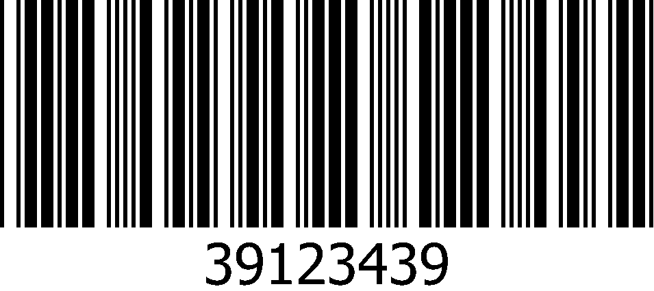

Save $50 when spend $50 - Save $50 when spend $50 - Save $50 when spend $50



*Expiry Date: 30-Dec-2014*