$3.00 Off

Name of PRODUCT

$3.00 on any ONE package of ________®

Little Snugglers Diapers

FDP78590

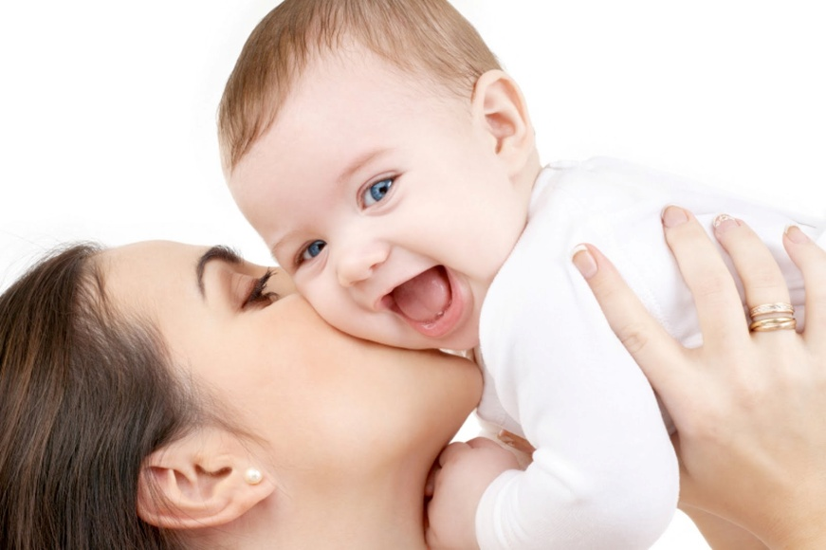

FDP78590

$3.00 Off

Name of PRODUCT

$3.00 on any ONE package of ________®

Little Snugglers Diapers