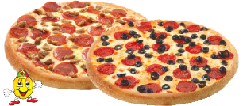

**Redeem Now**

**50% OFF**

**PIZZAS ONLINE**

Medium and Large Pizzas when

You sign up for Hut Lover’s Email

**Redeem Now**

**50% OFF**

**PIZZAS ONLINE**

Medium and Large Pizzas when

You sign up for Hut Lover’s Email

**Redeem Now**

**50% OFF**

**PIZZAS ONLINE**

Medium and Large Pizzas when

You sign up for Hut Lover’s Email