My Family Tree
______________________
______________________
______________________
______________________
______________________
______________________
______________________
______________________
______________________
______________________
______________________
______________________
______________________
______________________
______________________
______________________
______________________
______________________
______________________
______________________
______________________
______________________
______________________
______________________
______________________
______________________
______________________
______________________
______________________
______________________
______________________
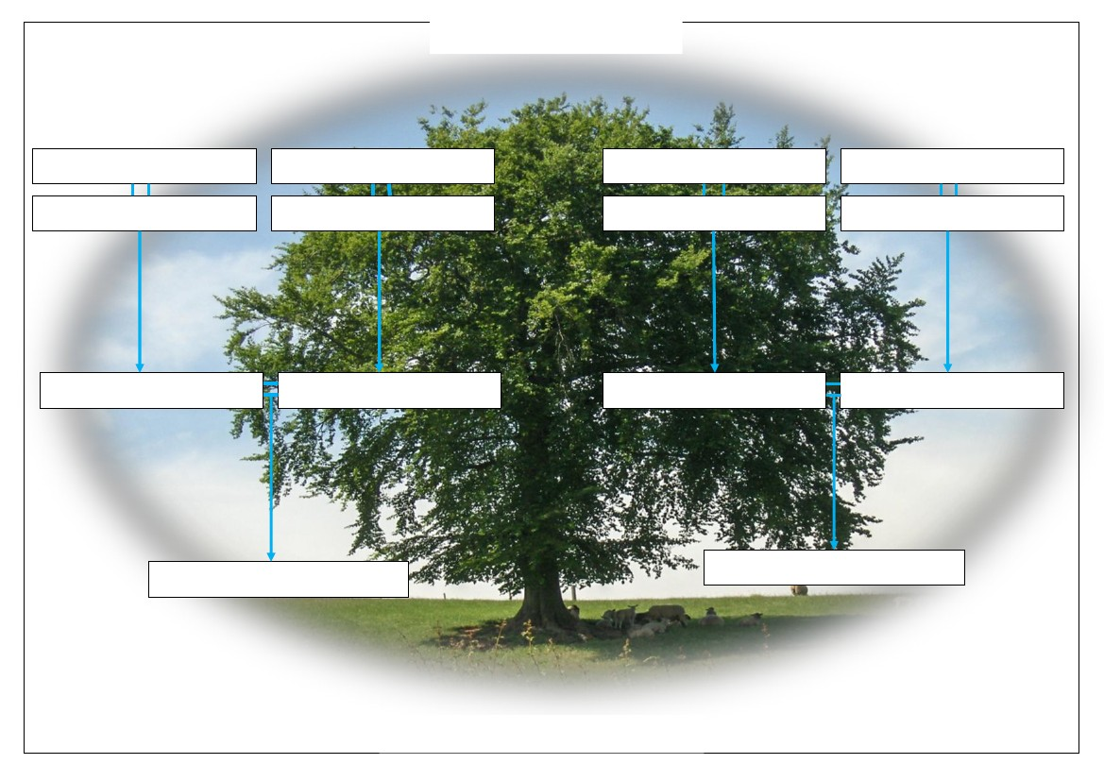
My Family Tree
My Family Tree
My Family Tree
______________________
Copyright www.Irish-Genealogy-Toolkit.com

