Title of Meeting
Track 1
Track 2
Track 3
Track 4

Meeting Agenda

MONDAY, Date
8:00 am – 4:00 pm | Registration
9:00 am – 10:30 am |  | Opening Ceremonies
10:45 am - 12:00 pm |  | Topics
12:00 pm – 1:30 pm |  | Lunch Break
1:30 pm – 3:00 pm |  | Topics
3:15 pm – 5:00 pm |  | Afternoon Session

TUESDAY, Date

WEDNESDAY, Date

Map of Conference Center Location

and Floor Plan

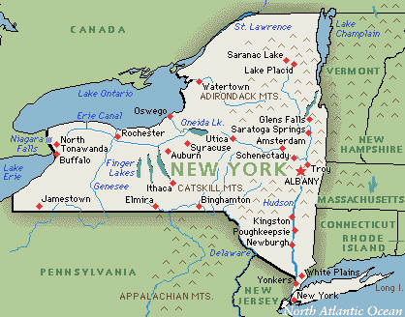
Lobby

Grand Ballroom
South Hall
North Hall
West Hall
East Hall

