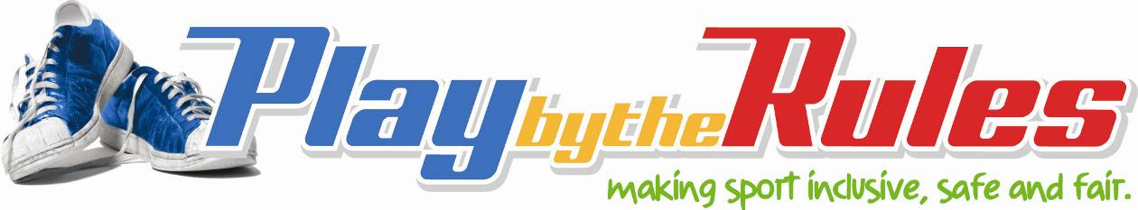

Club Questionnaire survey template

Template 1: Pre-season survey

<INSERT CLUB LOGO AND NAME>
At our club everyone is welcome regardless of their ability or where they come from. We think it’s important to have fun and that our members feel valued and a part of the club. We want people who are good sports and who behave respectfully to others – both on and off the field.
To help us improve our club we would like you to fill out this short survey. You do not need to provide your name as individual responses are not reported on.

1. Why did you join our club?
- To be with friends | - To have fun |  | - To be involved with your community
- To be part of a competition | - To keep fit

2. Do you and your family feel welcome at our club?
- Yes |  | - No

3. Are our facilities clean and tidy?
- Yes |  | - No

4. Do you know that our club has flexible fee payment options and a uniform and equipment loan scheme?
- Yes |  | - No

5. Do you know that our club may be able to help out with transport to games?
- Yes |  | - No

6. Have the rules of the game and our club been explained to you?
- Yes |  | - No

7. Are you aware of our Member Protection policy and Codes of Conduct?
- Yes |  | - No

8. Are you aware of our complaints policy?
- Yes |  | - No

9. Do you know who to contact if you have any issues or concerns?
- Yes |  | - No
Thank you for taking the time to fill out our survey.

Template 2: End of season survey

<INSERT CLUB LOGO AND NAME>
The Committee would like to thank all members and their families and our other volunteers for their contribution over the past season. It is important to us that our club is welcoming and safe and that everyone gets a fair go.
To help us prepare for our next season we are keen to get your feedback about your experiences with our club. You do not need to provide your name as individual responses are not reported on.

1. Do you think the club has got the right balance with providing opportunities to:
Be with friends and family | - Yes |  | - Somewhat | - No
Keep fit | - Yes |  | - Somewhat | - No
Have fun | - Yes |  | - Somewhat | - No
Play competitively | - Yes |  | - Somewhat | - No
Be part of the community | - Yes |  | - Somewhat | - No

2. Is participation seen to be as important as competing to win in our club?
- Yes |  | - No

3. Were you and your partner or family invited to all social activities?
- Yes |  | - No

4. Did you feel welcome to attend all of the club functions/social activities?
- Yes |  | - No

5. Did social activities take consideration of cultural differences (for example serving Halal sausages)?
- Yes |  | - No

6. Did club photos and other promotional material reflect the membership of our club (for example
- Yes |  | - No

7. Were our facilities clean and tidy?
- Yes |  | - No

8. Could you access showers and change rooms when you needed them (for example, after your game)?
- Yes |  | - No

9. Was your privacy respected in the showers and change rooms?
- Yes |  | - No

10. Did our club support your participation with flexible fee payment options
- Yes |  | - Not applicable to me as I didn’t need this assistance
- No

11. If you didn’t understand the rules of our sport did someone explain these to you?
- Yes |  | - No

12. If you were a new member, were you offered a ‘buddy’ to help you feel part of the team?
- Yes |  | - No

13. If not, would having a buddy have helped you?
- Yes |  | - No

14. Were you encouraged to apply for a position on the Committee or as a coach or umpire?
- Yes |  | - No

15. Did you feel uncomfortable about the treatment of women/girls around the club at any time throughout the past season?
- Yes |  | - No

16. Are women and girls encouraged to be involved in all club-related activities, whether as players, coaches, umpires, spectators, members of committees?
- Yes |  | - No

17. Would you agree that the Club welcomes or involves people from diverse cultural backgrounds?
- Yes |  | - No

18. Do you think our Club is broadly representative of the surrounding community (in other words, has people from all of the backgrounds that make up our neighbourhoods)?
- Yes |  | - No

19. Were coaches and others in positions of leadership good role models?
- Yes |  | - No

20. If there was any inappropriate behaviour did our club take the matter seriously and act quickly?
- Yes |  | - Not applicable
- No
Thank you for completing our survey. We will share the collated survey results with all members.

