Dear Parents,
This year our class will be participating in the Flat Stanley Project. The students and I have read a funny book called Flat Stanley by Jeff Brown. The book is about a young boy named Stanley who is accidentally squished “as flat as a pancake” when a bulletin board falls on him. Stanley is very flat but otherwise fine. Now that Stanley is flat one of his favorite things to do is visit friends via mil. Our class has decided that we would like to do same with our “Flat Stanley’s, and we need your help.
Please send Flat Stanley to visit a friend or relative. If possible, try to think of people who live in different states or countries. We will be keeping track of all the places our Flat Stanley to visit. Please make any contacts with these family members or friends and let them know about Stanley ahead of time before you mail him. We will ask each host to keep him for a short visit and then send him back telling us something about their city and the exciting things Flat Stanley saw or did while he was there. Some great Flat Stanley’s we have heard about have come back dressed in clothing from the area, with souvenirs, area-appropriate mementos travel brochures and more.
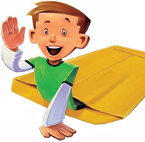
We are very excited about this project and cannot wait for our Stanley’s to be returned to us.
Thank you for all your support!
Sincrely,
_________________

