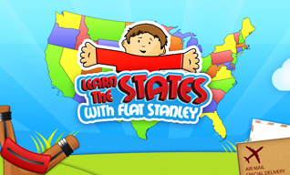

Dear Parents,
We took some time to read a book Flat Stanley by Jeff Brown. In this story, Stanley is flattened by a bulletin board and has many new adventures. He is even mailed to California to visit a friend.
We will be making “flat people” at school to send on an adventure. This coincides with our study of the different regions of the United States. We plan to send your child’s “flat person” to friends or relatives who would be willing to spend some time helping with our project. We are asking that you take your child’s flat person on an adventure.
Please discuss this project with your child and decide upon a relative or friend who might be willing to help.
The kids are so excited about this worthwhile and educational project. Thanks for your help and please call or jot me a note if you have any questions or concerns.

Sincerely,

Mrs __________

