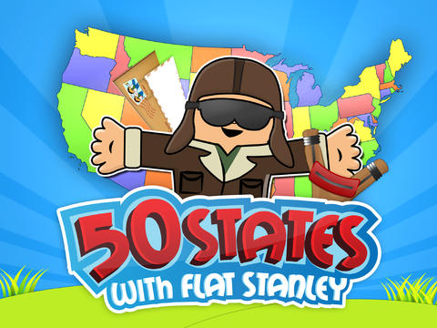

Date
Dear Grace,
Thank you for sending Flat Stanley. We had a wonderful time visiting around southern Arizona. On Saturday, we visited the Farmer’s Market. Flat Stanley helped us picked out carrots, potatoes, broccoli, tomatoes, and bread and lemon cake. Then we drove to Sangurao National Park.
Our first stop was the visitor’s center to get a map and directions. We walked on a nature path and learned about the different kinds of plants and animals. Flat Stanley sat on a Sagurao, teddy bear cholla, fishhook cactus, prickly pear cactus, and ocotillo cactus. Since he is made of paper, the sharp spines didn’t hurt him.
A bird watched us have a picnic. We took phtos with camera and drew pictures in the sketchbook. When we saw a trash on the trail, we picked it up and put it in the trashcan.
At the end of the trip, we saw rock art called petroglyphs left by American Indians long ago.
Flat Stanley helped us make a comic book of our adventure. You can read the comic book of our adventure.

Thanks for sending Flat Stanley to visit!

From your friends,
_________________________

