Dear Friend,

My name is _________________ and I am ______________ years old. I am working on a Flat Stanley Project and as part of my homeschool work this year. Flat Stanley is a book about a boy who is flat instead of three—dimensional and is able to mail himself to all kinds of adventures. I will be tracking Flat Stanley and all of his adventures on a map and learning more about the places he visits.
I am hoping you will take Flat Stanley on some adventures with you around your city/town and then write and tell me about it as well as sending along a picture or two of Flat Stanley hanging out with you. I would love to hear all about you live and what is special about it to you.
If you keep Flat Stanley for more than two weeks and then please mail him and this letter to another friend willing to participate, I would really appreciate it. I am hoping to keep Flat Stanley travelling all over the country until April. If you receive Flat Stanley at the end of March or beginning of April, please mail him back to us along with your letter so he can come home. If for some reason, you cannot pass him along to someone else, please mail him to me as well and I will find another adventure for him to take.

If you have any questions, please contact me at __________________.
We will probably add our adventure letters to a website to share the journey.
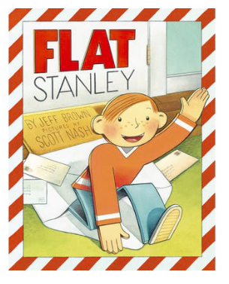
Jack

